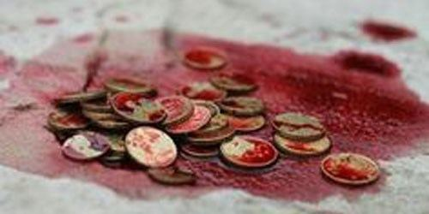
weregild

Adolf Hitler: Nazi Party Leader
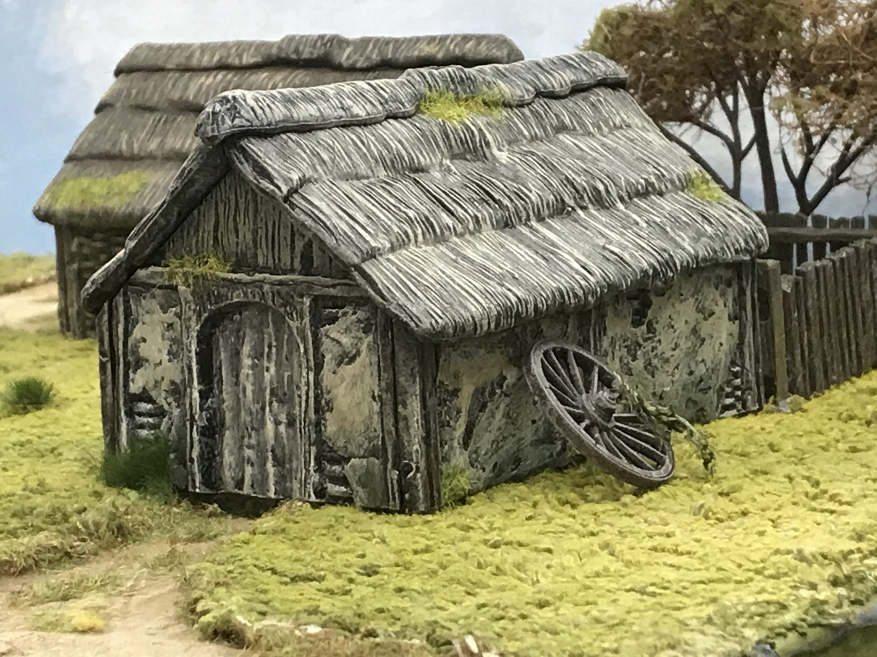
wattle and daub
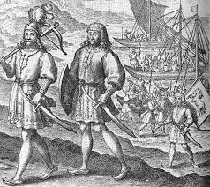
Hengist and Horsa

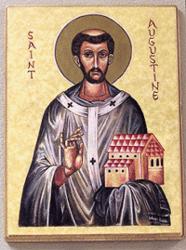
Monk Augustine
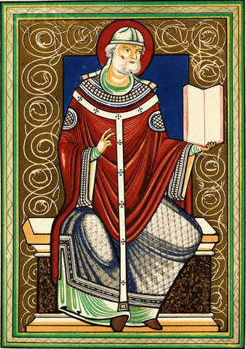
Pope Gregory

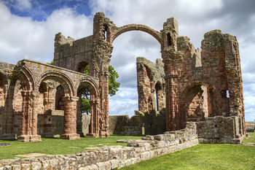
Lindisfarne Priory

Y4 Knowledge Organiser: History
Anglo Saxon
Key Knowledge:
- Knowledge and understanding of events, people and changes in the past:

Where did the Anglo Saxons and Scots come from and why? What were the Anglo Saxon tribes called, and where did they settle?

- Chronological understanding:

When did the Romans leave Britain? When did the Vikings invade? When did the period last from and to?

- Historical interpretation

What type of settlements did the Anglo Saxons live in? How was this different to the Romans? What were the key features in these settlements?

- Knowledge and understanding of events, people and changes in the past:

How did the Anglo Saxons live? What differences are there with the modern era? What was life like as a child?

- Organisation and communication:

What belief systems did the Anglo Saxons convert from and to and why? Who were the key people responsible for this?

Vocabulary
Angles
Saxons
Jutes
tribe
settlement
monasteries
monks
Christianity
Pagan
kingdoms
invasion
artefact


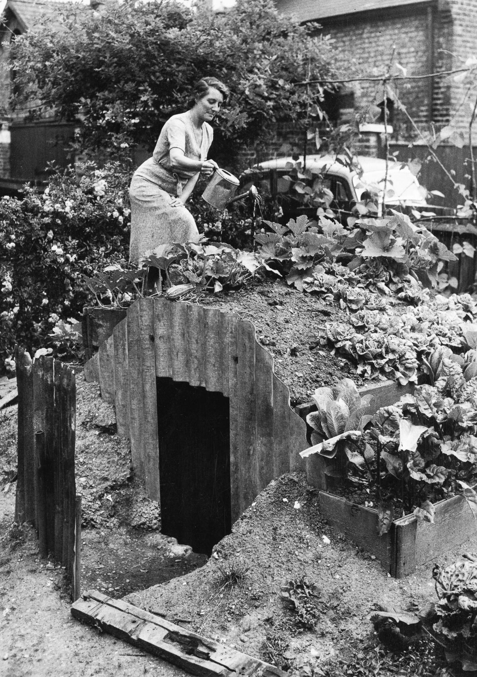
Anderson Shelter
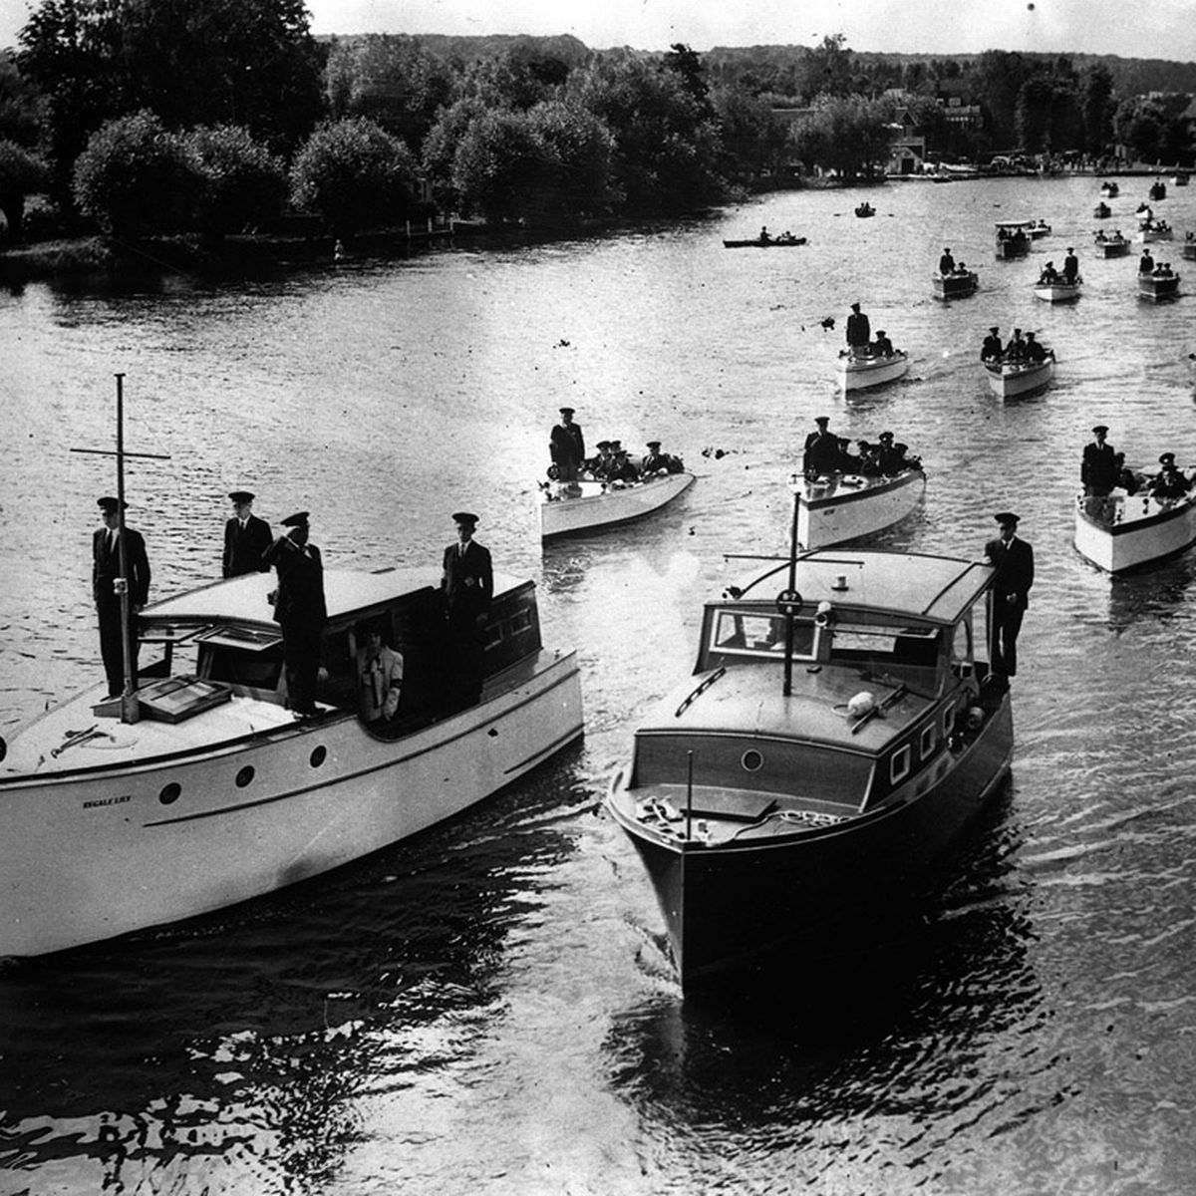
The Little Ships of Dunkirk
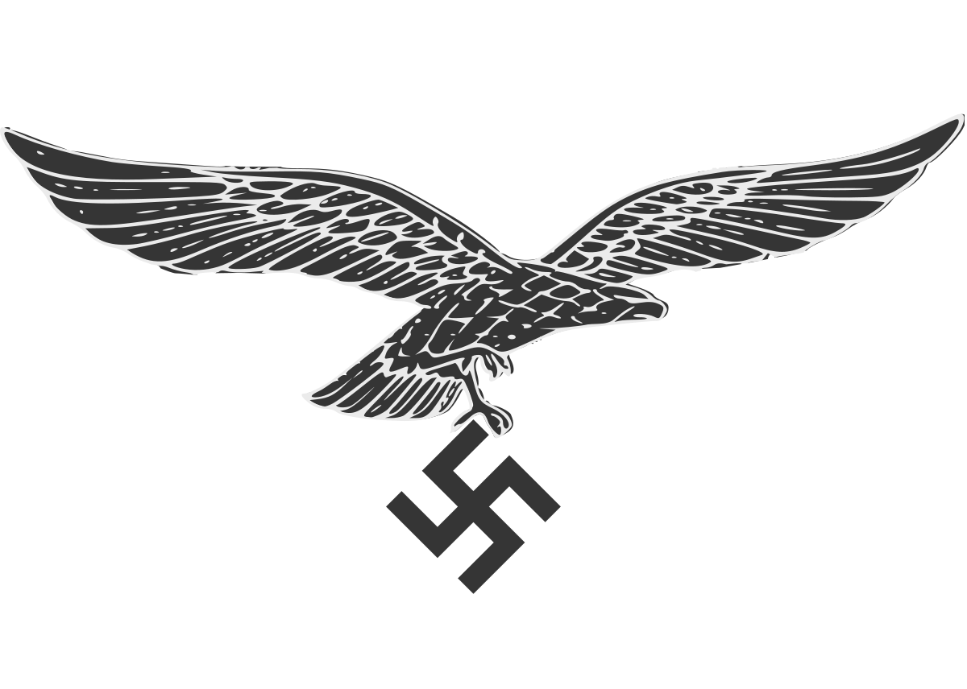
Luftwaffe (German Air Force)
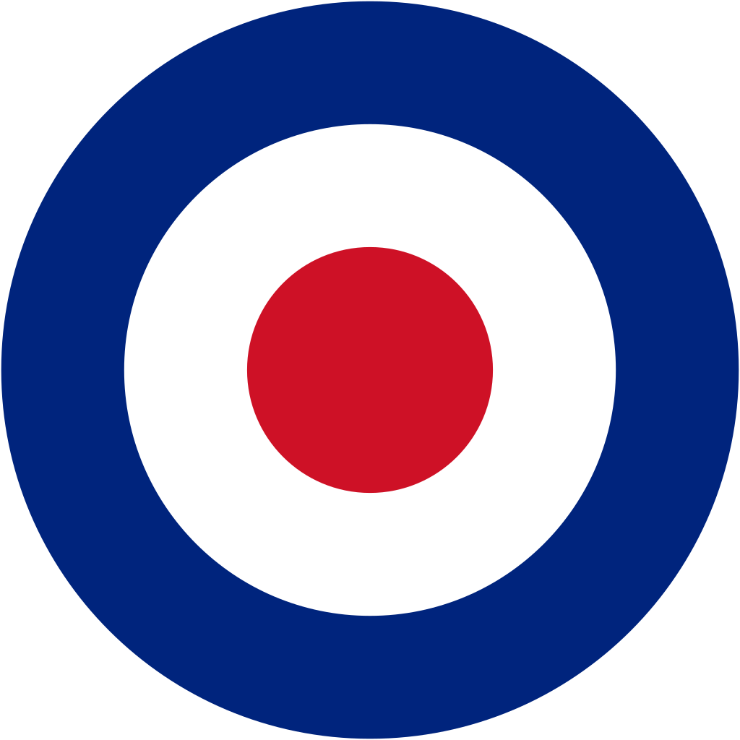
RAF (Royal Air Force)
Vocabulary
The Nazi Party
Adolf Hitler
Allies
Axis
RAF (Royal Air Force)
Luftwaffe (German Air Force)
The Little Ships of Dunkirk
Blitz (Lightning War)
Air raid shelters

