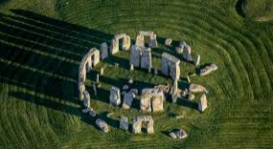
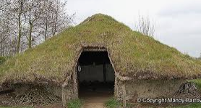
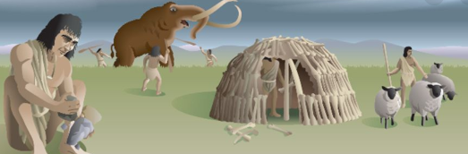
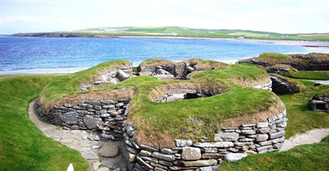
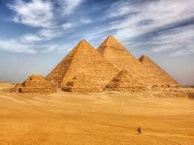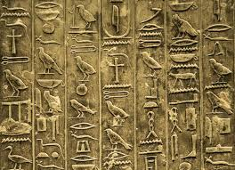
Skara Brae

Stone Henge
Wattle and daub house
Neolithic

Mesolithic


Palaeolithic 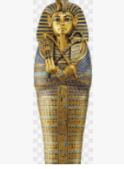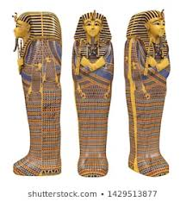CV
Year 3 Knowledge Organiser: History
Stone Age to Iron Age
Vocabulary
Paleolithic
Neolithic
Mesolithic
BC/AD
wattle and daub
Prehistory
Prehistoric
hunter gatherers
Skara Brae
Star Carr
Key Knowledge:
- Chronological understanding: When did the 3 stage begin and end? Where did they fit on the timeline? What are the different periods?

- Historical enquiry: How have lifestyles progressed over the three stages of Stone Age?

- Knowledge and understanding of events, people and changes in the past: What is the order of the three stages of the Stone Age? What were the key changes within each stage?

- Historical interpretation: How did they write and record? What were reliable/unreliable sources?

- Knowledge and understanding of events, people and changes in the past: How have people developed their lifestyle/communities over the three stages?

