Key Knowledge:

- Knowledge and understanding of events, people and changes in the past: What was the Nazi party? What were their beliefs, motives and aims? How were they viewed by Allied countries?
- Chronological understanding:
When did WWII begin? How did it begin? What were the main events during WWII? When did it end?

- Historical enquiry:
Which countries were Allies / Axis? Who were their leaders?
- Organisation and communication:
What happened in Dunkirk? How were Allied soldiers rescued?
What was the Blitz? How did it impact Britain? How did Britain survive these attacks?

- Knowledge and understanding of events, people and changes in the past: What was the RAF? What was the name of the German Air Force? What was the key to the RAF’s success? Why was this victory a turning point in WWII?

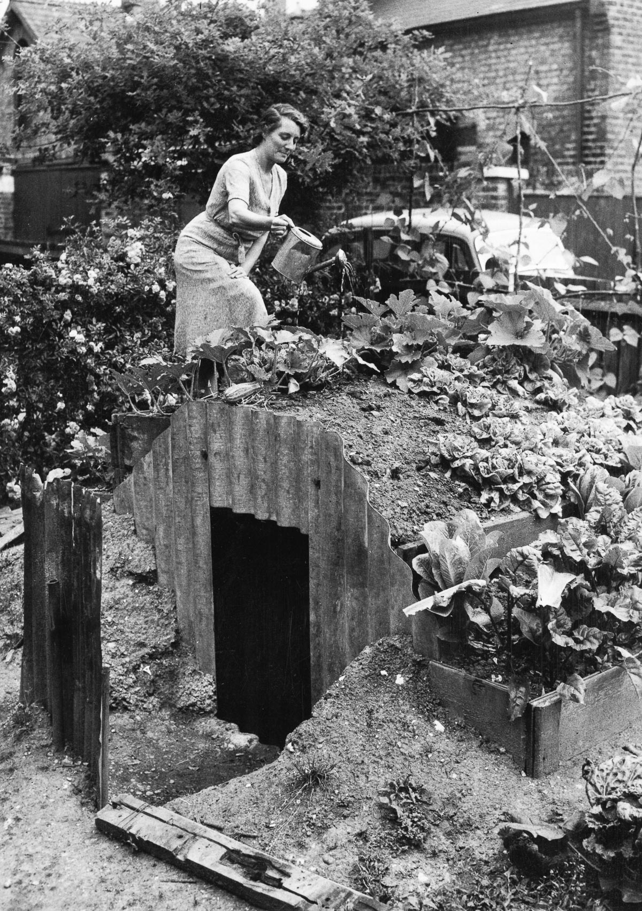
Anderson Shelter
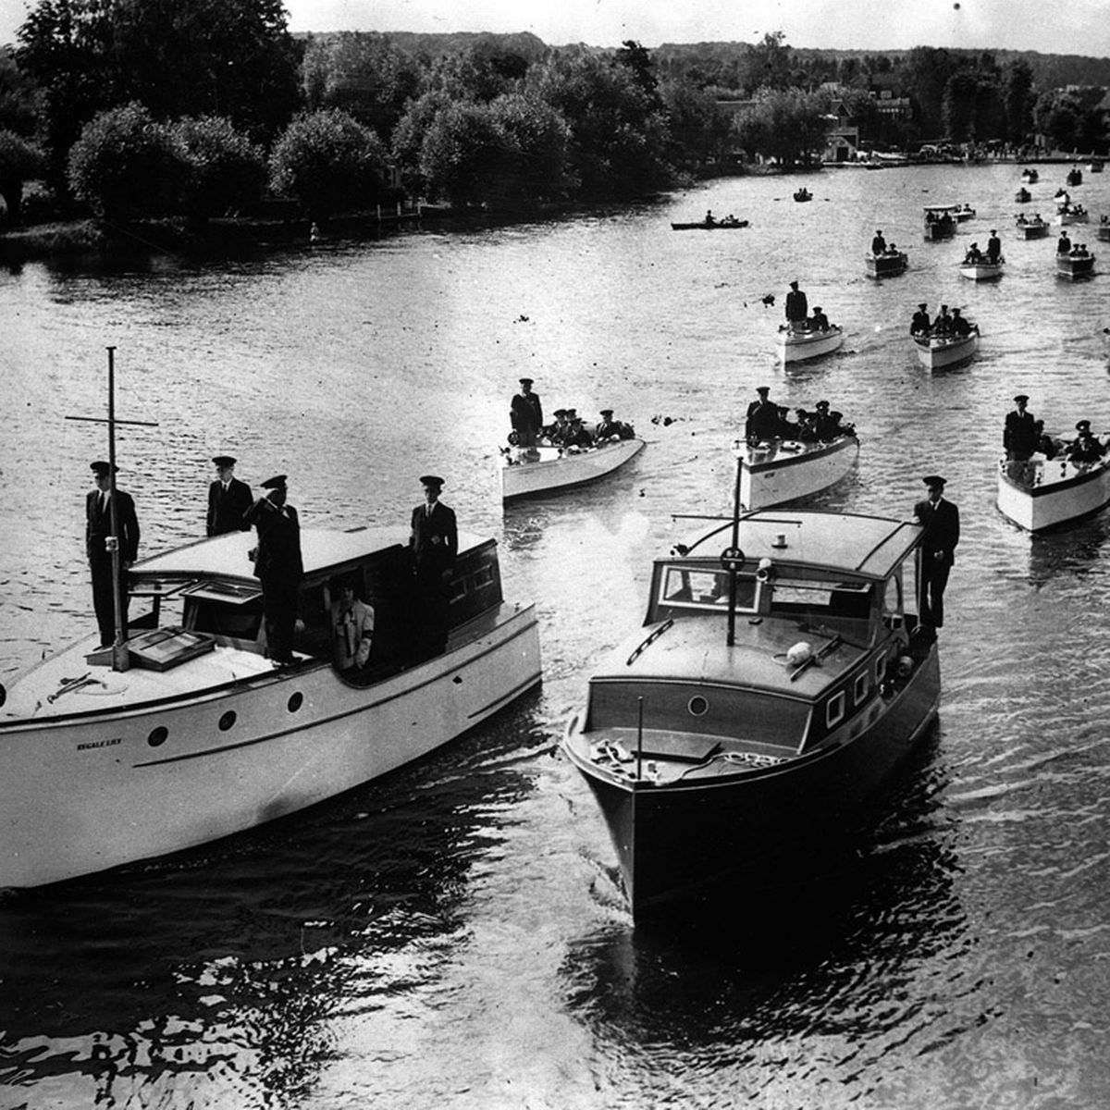
The Little Ships of Dunkirk
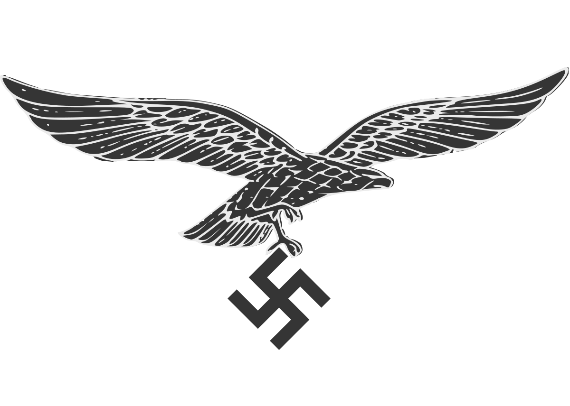
Luftwaffe (German Air Force)
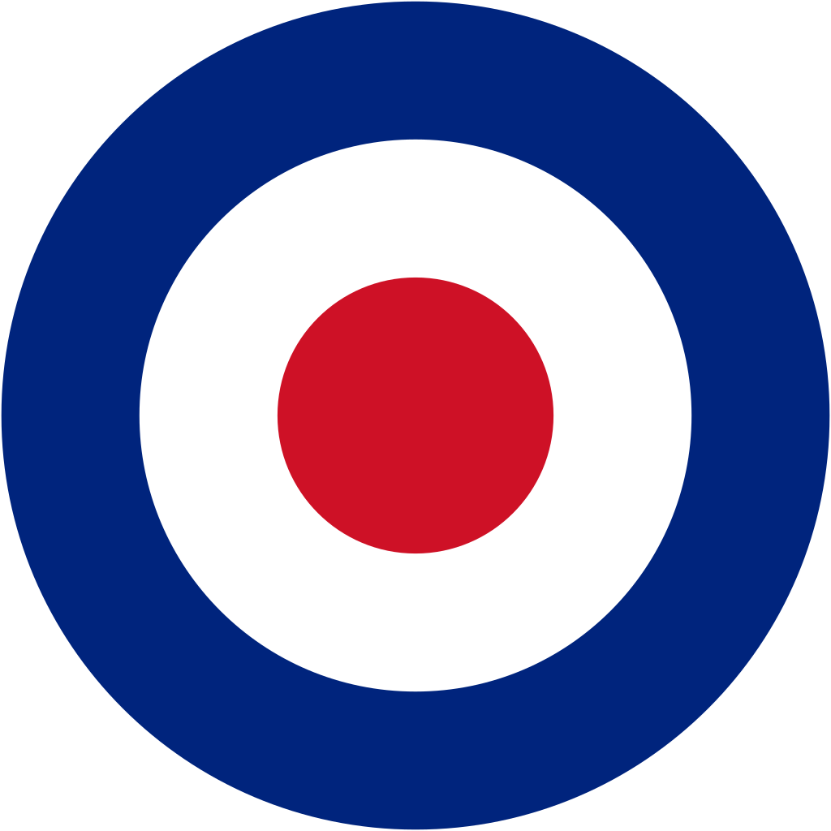
RAF (Royal Air Force)
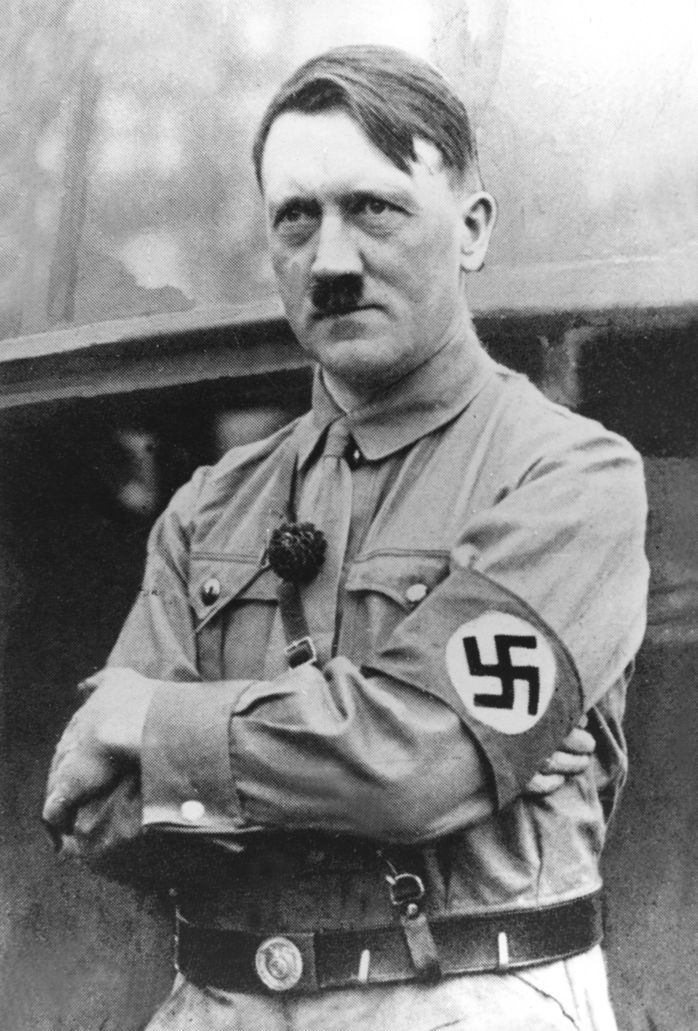
Adolf Hitler: Nazi Party Leader
Vocabulary
The Nazi Party
Adolf Hitler
Allies
Axis
RAF (Royal Air Force)
Luftwaffe (German Air Force)
The Little Ships of Dunkirk
Blitz (Lightning War)
Air raid shelters
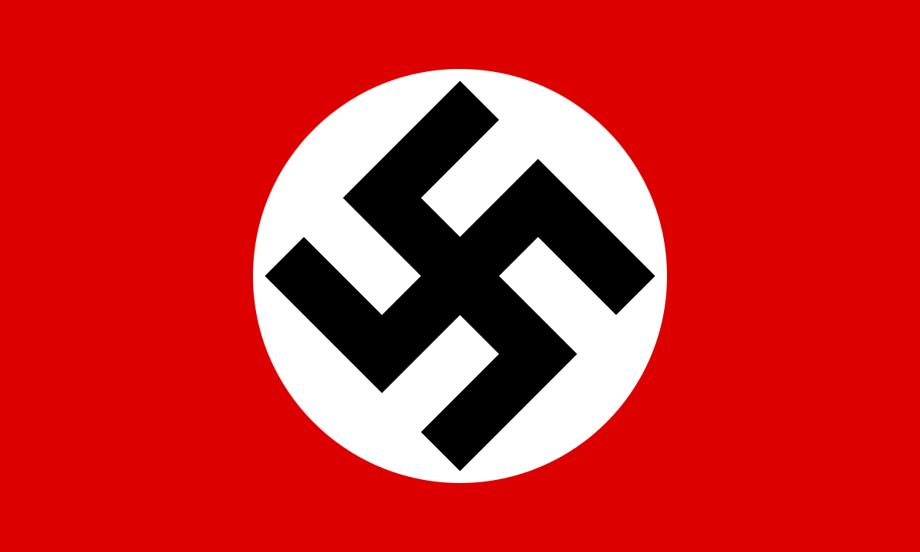
The Nazi Party symbol: Swastika
Year 6 Knowledge Organiser: History
The Battle of Britain



