Vocabulary
The Romans
conquer
invasion
invade
empire

rebellion

Julius Caesar

Claudius

Hadrian’s Wall

Boudicca

Celts

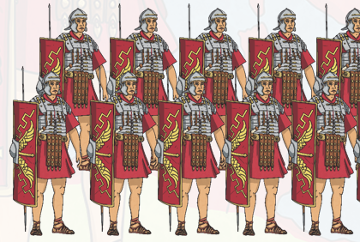
The Roman Army
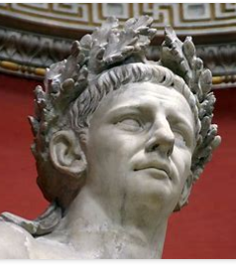
Claudius

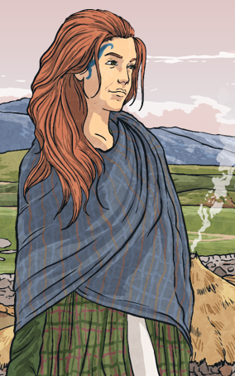
Boudicca
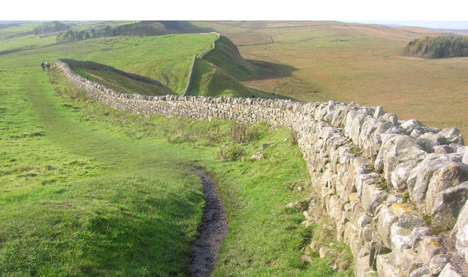
Hadrian’s Wall

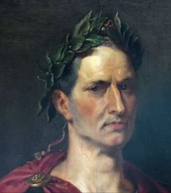
Julius Caesar
Key Knowledge:

- Knowledge and understanding of events, people and changes in the past: Which countries were taken over by the Romans? Where did it all start? What does ‘conquered’ mean?
- Chronological understanding:
When did the Romans invade Britain? How did it begin? What were the main events during Roman Rule? When did it end?

- Historical enquiry:
What was the Roman Empire? Who were the key people from the Roman Era?

- Organisation and communication:
What is Hadrian’s Wall. Why was is built? Why was it so important?

- Knowledge and understanding of events, people and changes in the past: Who was Boudicca? Who were the Celts? How did they fight off the Romans?
Year 5 Knowledge Organiser: History
The Roman Invasion
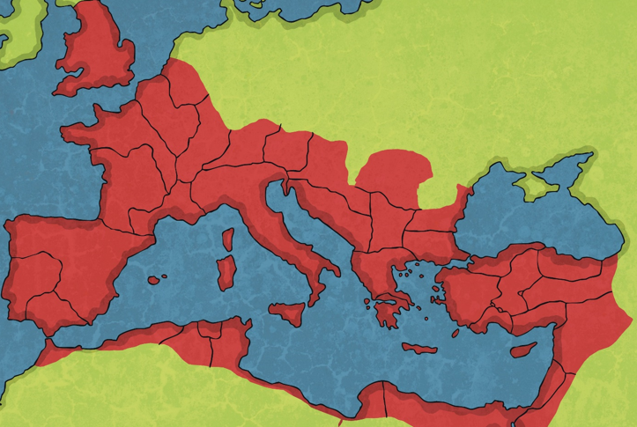
The Roman Empire



