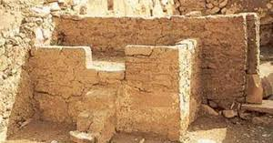
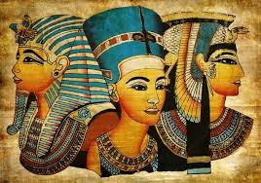
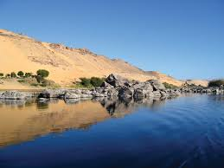
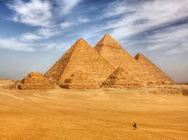
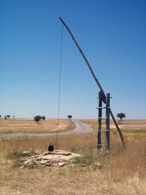
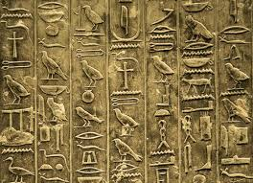
Egyptian settlements

Sarcophagus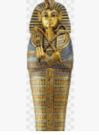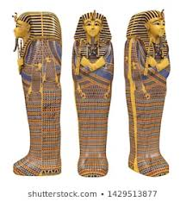CV
PharaohsCV
Pyramids of Giza

Shaduf
Hieroglyphics
Vocabulary
culture
leisure
ancient
ancient civilisation
archaeology / excavate
lifestyle
religion / belief(s)
invade / invasion
myths
legends
settlement / buildings
Before Christ BC
AD – Anno Domini
decade (s) / century(ies)

Year 3 Knowledge Organiser: History
Ancient Egypt
Key Knowledge:

- Chronological understanding: When did the Ancient civilisation begin? How long did Ancient Egyptians rule? When and why did it end? How excavated items?

- Historical enquiry: Who were the significant Pharaohs? Why are they so famous?

- Knowledge and understanding of events, people and changes in the past: What were the main similarities and differences between Ancient Egyptian culture and settlements compared to modern day?

- Historical interpretation: What were their main beliefs, who did they worship? How did they carry this out? How did they write and record?

- Knowledge and understanding of events, people and changes in the past: What were the main technological developments during the time Egyptians ruled? How has it made an impact on life today? What were the main farming seasons?



