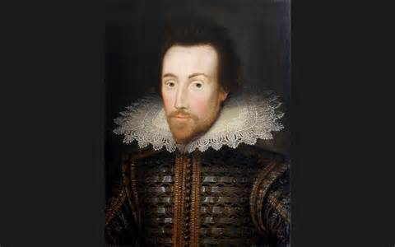
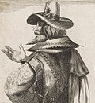

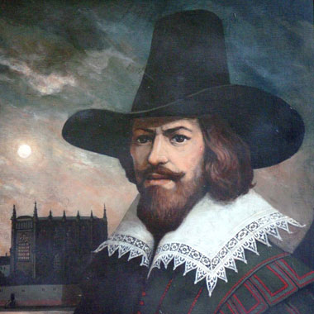
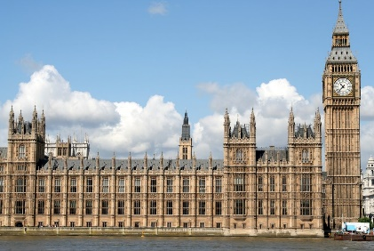
This Photo by Unknown Author is licensed under CC BY-SA
Robert Catesby
This Photo by Unknown Author is licensed under CC BY-SA


Gunpowder
This Photo by Unknown Author is licensed under CC BY-SA-NC
Year 2 Knowledge Organiser: History
The Gunpowder Plot
King James I
This Photo by Unknown Author is licensed under CC BY-NC

Vocabulary
Bonfire
Catholics
Christians
Protestants
Government
Houses of Parliament
Gunpowder
Plot
Treason
Monarch
Wealthy

Key Knowledge:

- Chronological understanding: When did the Gunpowder Plot happen? What day do we celebrate the gunpowder plot?

- Historical enquiry: Who were the Gunpowder plotters? Who did they plot to kill?

- Knowledge and understanding of events, people and changes in the past: How was life different during the time of the gunpowder plot to life now?

- Historical interpretation: Why did Guy Fawkes and his conspirators plan to blow up parliament? How did they carry this out?

- Knowledge and understanding of events, people and changes in the past: How did Guy Fawkes get caught? What happened to him and the other people for committing treason?
Guy Fawkes
Houses of Parliament

