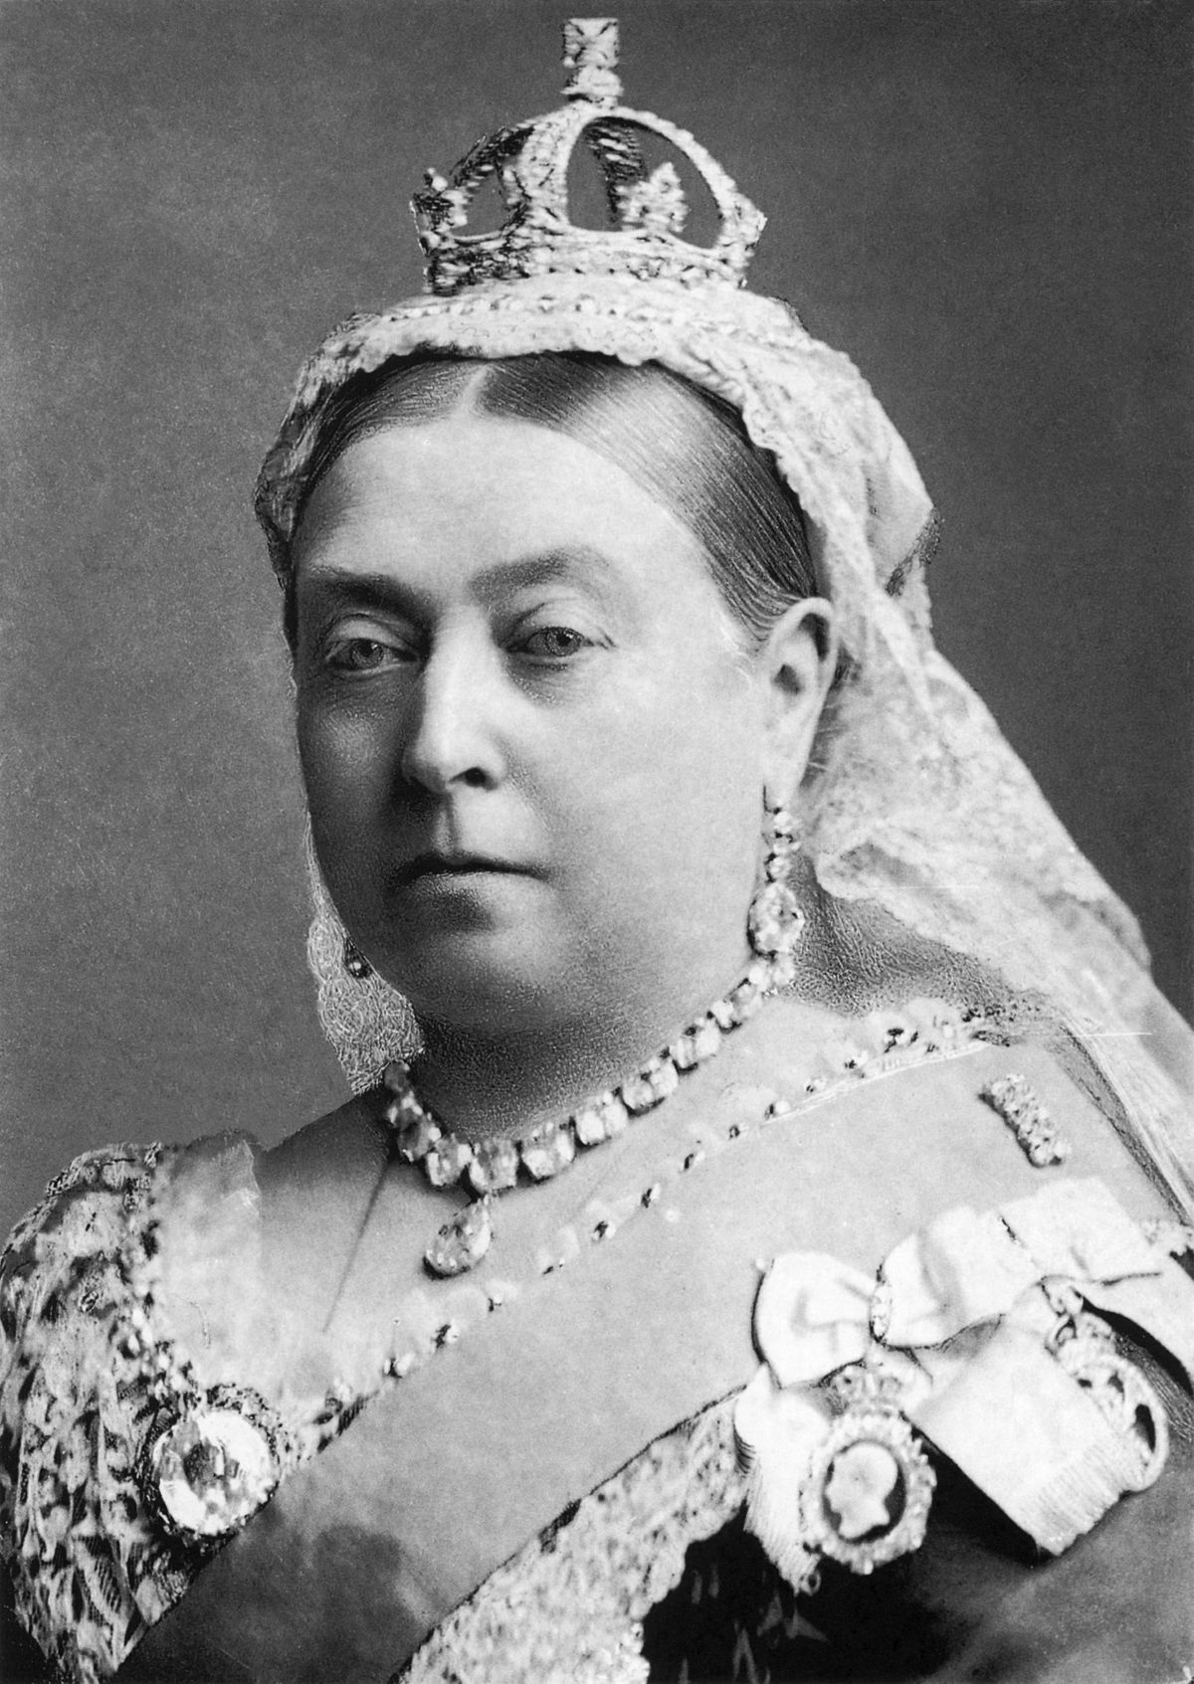
Queen Victoria

electric train set

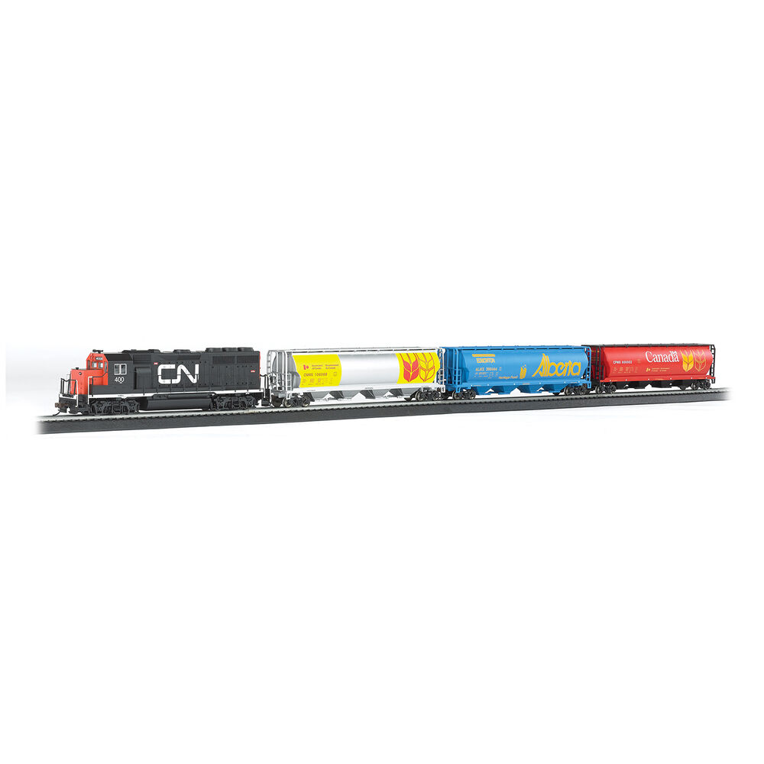
porcelain doll

clockwork train

wooden peg dolly

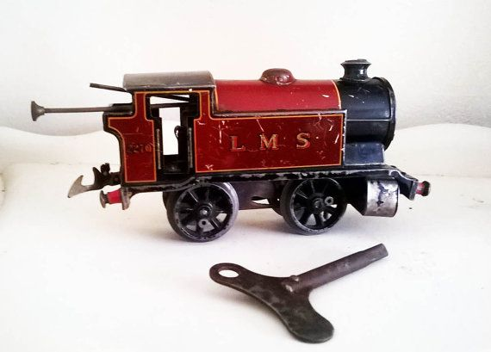
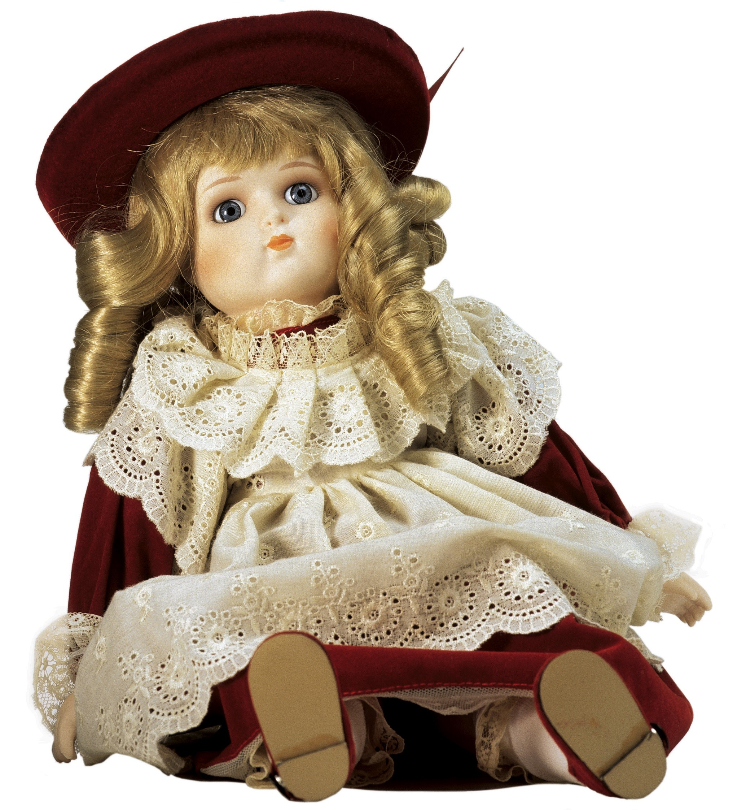
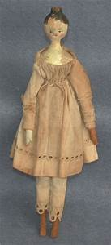
Vocabulary

past
present
old
new
Victorian
same
different
timeline

Key Knowledge:

- Knowledge and understanding of events, people and changes in the past:
What toys do you play with? What toys did your parents and grandparents play with? What toys did children play with in Victorian times?

- Historical enquiry:
What toys did children play with in the past? How are toys from the past different to the ones played with today? What were they made from?

- Historical interpretation:
What similarities/differences do toys in the past have with toys today?

- Historical interpretation:
What toys did rich/poor children play with?

- Chronological understanding:
Which toys are older/newer? Can you order toys on a timeline?

Year 1 Knowledge Organiser: History
Toys Past and Present

