Early Years
Admissions Policy

Hebburn Lakes Primary is a happy, successful, supportive school where we aim to be the best we can be. We take pride in our children learning in a positive, safe and welcoming environment, and through the delivery of a rich and varied curriculum we:
Work Together setting the highest expectations and levels of respect for each other,
Learn Together by having the courage and confidence to take risks and
Achieve Together through aspiring to be the best we can be throughout our journey to become independent lifelong learners.
PoliCy Approved by Governing Body:
Chair of governors 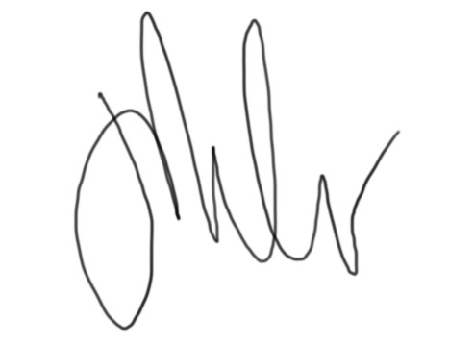 Date October 2023
Head Teacher: 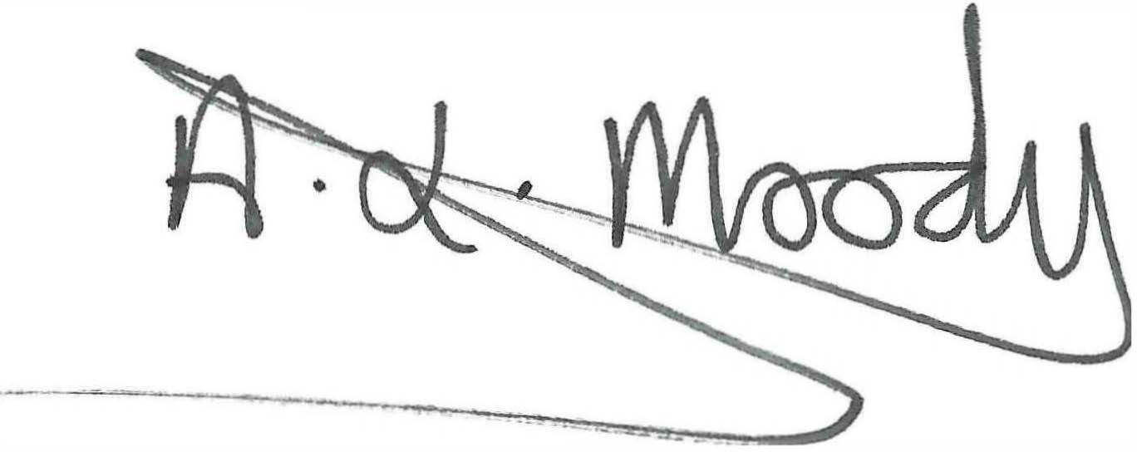 Date: October 2023
Review Date: July 2024
All eligible three and four year olds are currently entitled to 570 hours of free provision a year, over a minimum of 38 weeks of the year. This equates to 15 hours free early learning and care per week, for 38 weeks per year during term time, across a minimum of three days.

An additional 15 hours of free childcare per week (up to 570 free hours) is available for families where both parents are working (or the sole parent is working in a lone parent family) and each parent earns the equivalent of 16 hours a week at the national minimum or living wage and earns less than £100,00 a year.

Our aims are:
  - To ensure access and entitlement to the benefits of high quality child centered nursery education on a fair and equitable basis.

  - To help promote consistency of practice and procedure between Early Years education and Key Stage 1.

  - To ensure, as far as possible, that all children who gain a place will fully benefit from nursery education so we will make the very best of our resources.

  - To provide high quality child centered nursery education to children and families in our local community within a school setting.

Nursery Session Options
  - All children aged 3 and over are entitled to 15 hours government funded nursery education per week during term time.

  - Parents will be asked to state a preference for either 5 morning sessions or 5 afternoon sessions for their 15 hour entitlement. Children eligible for the additional 15 hours (extended entitlement at 30 hours) can state their preferred additional hours on the relevant page of the application form.

  - Whenever possible first preference of sessions will be offered, but preferences will be allocated subject to availability and are not guaranteed. If the preferred session is unavailable, the child will be offered an alternative session.

  - Offer times (Mondays to Fridays during term time, with the exception of staff training days).

Part Time and Full Time Places

The nursery offers full time places which will be offered in priority to children in accordance with our admissions criteria. This care may form part of the extended 30 hours entitlement introduced by the government in September 2017 to parents who meet the eligibility criteria

Provision offered at Hebburn Lakes Nursery
Extended full time care: |  | 8.30 am- 3.30 pm
Morning session: |  | 8.30am to 11.30am
Afternoon session: |  | 12.30pm to 3.30pm
Extended hours for lunchtime known as “Wraparound Care” – incurs an extra cost. |  | 11.30-12.30pm £1.80 daily extra cost  NB. The daily cost of Wraparound Care” can be used as Tax Free, via HMRC; however this payment must be paid in advance as it secures the child’s place over lunchtime and it is to be paid when the child is absent to continue to secure the place.
Meal time arrangements |  | School lunch available at £2.20 daily or parents may provide a home packed lunch

Parents and carers should note that a place in the nursery unit does not guarantee a place in reception. Parents wishing their children to attend Hebburn Lakes Primary School must still go through the usual admissions procedure within the specified time frame.

Expressions of interest list
- The school will maintain a list of the name, address and telephone number of parents who are interested in a place in the nursery for their child, together with the name and D.O.B. of the child and the date of registration.

- No child will be placed on the list until the term of their second birthday.

- The list will not operate on a "first come, first served" basis. The length of time children are on the list in no way influences the decisions about places. The children will be offered a place in our nursery the term after their third birthday if there is a place available.

- Parents will be sent an application form accompanied by an information letter the term before their child is due to begin nursery, with planned dates to invite children and parents/carers to ”stay and play nursery workshops.” Completed forms should be returned to the school by the return date shown. Parents must confirm acceptance of the offer of a place by the confirmation date on the forms so that children on the waiting list can be offered unfilled places.

- Parents will be offered the opportunity to visit the nursery, prior to submitting a completed application.

Criteria for admission to the nursery
The nursery at Hebburn Lakes Primary School has 26 places in each of the morning and afternoon sessions, i.e.26 children in the morning and 26 children in the afternoon. The nursery operates on the basis of three intakes per school year, September, January and April. Children are eligible to take up a place in the nursery in the term following their third birthday. Places will be awarded in accordance with the following order of priority:

In all cases of twins/multiple birth children, the school will guarantee that all children will be offered places.

A 'Looked After Child' or a child who was previously looked after but immediately after being looked after became subject to an adoption, residence, or special guardianship order.

Children with an Education Health Care

Concurrent sibling link (an older brother or sister attending the school at the same time and residing at the same address, to include adoptive siblings, half siblings, step siblings and long term fostered children).

3.1 Children living within the School catchment area.

3.2 Children living outside of the School catchment area.

- Children without a sibling link
4.1 Children living with the School catchment area
4.2 Children living outside of the School catchment area
Where more than one child meets the criteria, those living closer to the school will receive higher priority. This will be determined by the shortest distance measured as a straight line, from the Ordnance Survey coordinates for the parental home residence (including flats) to the school main entrance, using South Tyneside Council’s Geographic Information System (GIS

Nursery intake and operation of the waiting list

The nursery will have a three term point of entry at the beginning of each term for children who are already 3 years old.

If the child is born between | They are eligible for a free 15 hour placement or if meeting financial criteria a free 30 hour placement
1st September and 31st December | Spring term
1st January and 31st March | Summer term
1st April and 31st August | Autumn term

There will be the opportunity for children and parents to attend ‘stay and play’ workshops in nursery during the term before they start.

Admission decisions
The Governing Body makes the final decision to offer a place and this will be based on the criteria and procedures laid out in Section 6 of this admission policy. Being offered a place does not guarantee first preference with regards to session options. Parents can refuse the offer made.
The offer of a nursery place DOES NOT in any way mean automatic entitlement to a place in the Reception Class at Hebburn Lakes Primary.
Oversubscription Policy
When the nursery is over-subscribed for a three-year-old place, applications for entry in the school year will be ranked according to the criteria set out in section 6 of this policy.
Leavers during the year
Parents or carers wishing to withdraw their child from nursery will forfeit the place and need to re-apply through the normal admissions policy

Attendance and loss of nursery place
If a child’s attendance and/or punctuality are poor (less than 80%) or erratic the nursery teacher will talk to parents/carers and remind them that for the child to benefit fully from nursery education, attendance needs to be regular and punctual due to the great demand for places.
5.2 If after a period of two weeks’ attendance and punctuality remain poor, a letter will be sent to the parents/carers inviting them to meet with the Head Teacher or member of the Senior management team.
5.3 If, following the meeting, there is no sustained improvement in attendance within an agreed period, then the child may lose their place. Parents/carers will be notified of the loss of place in writing.
5.4 If a child is absent for a period of three weeks without any contact from the parents/carers and the school has been unable to make contact within this time, the child may lose their place and it may be offered to someone else. This will be decided by the Head Teacher, and a letter explaining the situation will be sent to the parent/carer.
5.5 As a school, we do not authorize holidays in term time. If you feel there are exceptional circumstances as to why you need to take your child out of school during this time, a holiday request form must be completed.
Transfer from nursery into reception

6.1 All parents and carers must be aware that a place in the nursery does not guarantee a place in the school and that they must still go through the correct South Tyneside Council admissions procedure to obtain a place in Hebburn Lakes Primary School for their child/ children.

September 2023 8.30am | Common Application form made available to parents on-line or paper copy (on request only)
16th January 2024 NATIONAL CLOSING DAY | Deadline date for applications to be received. Any applications received after this date will be considered as 'late' applications.  Online system is not available after the deadline date.
By the end of February 2024 | All parents who have completed and returned their application will be sent an acknowledgement to confirm that we have received and are processing their application.  If you applied online, you will receive an acknowledgement to your email account.  If you completed a paper application, you will be sent an acknowledgement letter through the post.
Tuesday 16th April 2024 | 'Offer Day' - Parents will be notified which school their child has been offered.  If you applied online, you will be notified by email.  If you completed a paper application, a letter will be sent to you by 2nd class post.
April 2024 (dates TBC) | Deadline for parents to:  accept the school place offered (for oversubscribed schools only)  request to place their child's name on a waiting list  request an appeal form for primary schools
April 2024 | Appeal forms sent out where requested.

April 2024 | Any places that have become available will be allocated from the waiting list in criteria order.
May 2024 | Where parents have not accepted the school place offered for oversubscribed schools, we will withdraw the offer of the school place (community schools only).
May 2024 | Deadline for appeal forms to be returned.
June-July 2024 | Appeals to be heard.

