Hebburn Lakes Primary School
Timings of the School Day

Dear Parent/Carer,

The Department for Education White Paper, published last term, has outlined the need for all schools to offer a 32.5 hour week to all children from September 2023. The time of which starts from the moment the register is taken to the end of the school day. It does not count the additional time we offer via breakfast club and after school club provision.

Currently our school day is 8.55am until 3.15pm, with a flexible 15 minute window of time to collect your child up until 3.30pm. As most children are collected at 3.15pm, this means we will not meet the new expectations moving forward.

In order to help us to decide what our next steps should be, I have created a simple questionnaire for parents and staff. Once the results of these are known, the governors will consider the responses and determine how and when our opening hours will change.

We do not expect Breakfast club and afterschool clubs to be affected by any changes made.

With regards,
Mrs Moody

Results:
Parent View

Timings of the school day - Which of the three options do you feel would be the most suitable opening hours? This is from the time the children need to be in class for registration until they leave at the end of the day.

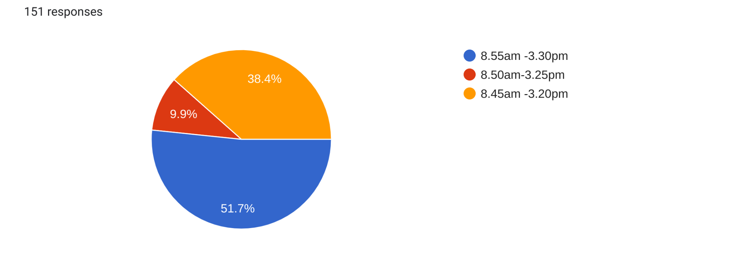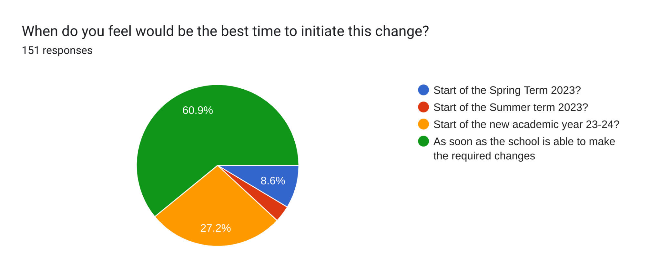

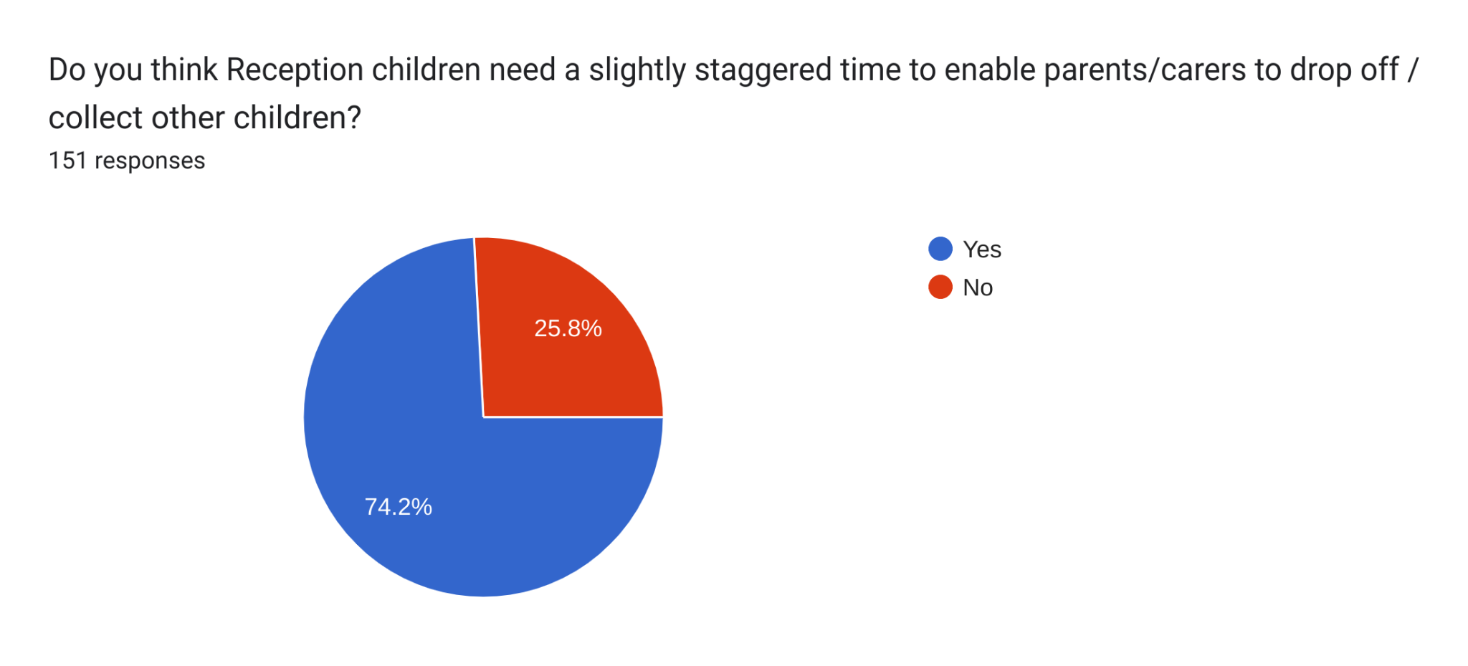

Staff View

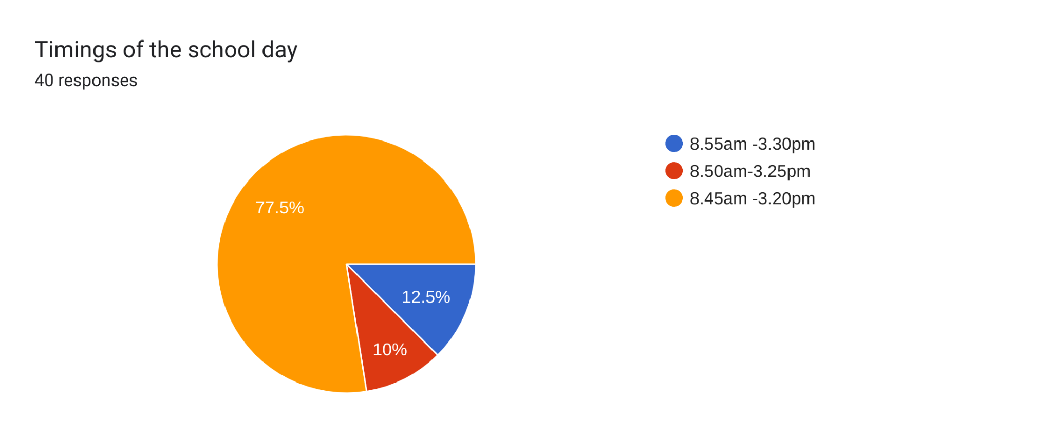

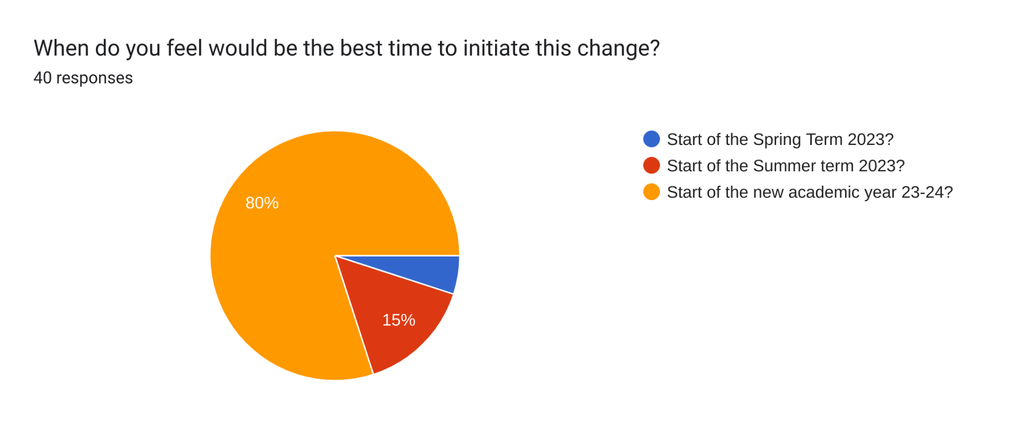

Outcome:
Following a meeting of the Governing Board, a decision has now been made to adapt the school day as follows. This will take effect from September 2023.

Nursery: Morning 8.30am - 11.30pm Afternoon 12.30pm-3.30pm

Reception: 8.55am - 3.30pm

KS1&2 (Y1-6): 8.50am - 3.25pm

7 Red and 7 Blue timings will remain the same.

