**Hebburn Lakes Nursery**

**Diary of Events for December 2022**

**From Thursday 1st December**

Instead of sharing Christmas cards this year we have a

Christmas tree in the yard. Please make a tree decoration with

your family and hang it on our tree.

**Tuesday 13th December**

Reception and Nursery morning & afternoon Performance 9.15am – 10.15am

Parents Welcome

*‘Snowman at Sunset’*

Afternoon Nursery children/parents may attend if they would like

to be involved in this performance. Afternoon Nursery will run as usual.



**Thursday 15th December**

Christmas Jumper Day

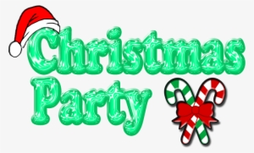Children may wear Christmas jumpers, T-shirt, hat or tinsel

**Friday 16th December**

Christmas Party

Children to come to school in their party clothes

and will receive special party themed snacks.

**Wednesday 21st December**

Polar Express

Children in Nursery are having a Polar Express day. We encourage children to come to school dress in their pyjamas but may need a t-shirt and leggings underneath as well as a warm jumper or dressing gown. Children will also need their outdoor coat for playing outside.

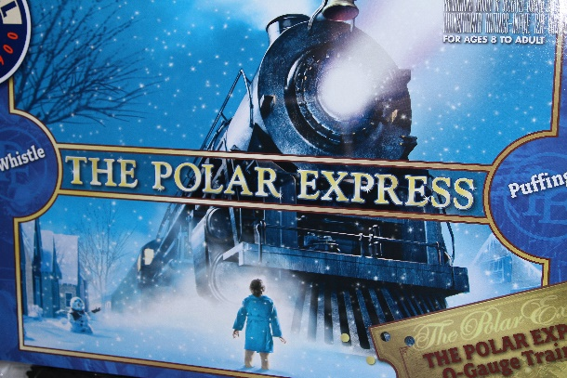

**Friday 23rd December – Last Day of Term**

Children may wear Christmas Jumper, T-Shirt, Hat or Tinsel

Afternoon Nursery is closed but children are welcome to attend the morning session at 8.30-11.30am

**Children return to school Monday 9th January 2023**

**We wish you all a Merry Christmas and a Happy New Year**

