**Hebburn Lakes Primary School**

**Diary of Events for December 2022**

**From Thursday 1st December**

Instead of sharing Christmas cards this year we have a

Christmas tree in the yard. Please make a tree decoration with

your family and hang it on our tree.

**Tuesday 6th December KS1 Pantomime at the Customs House**

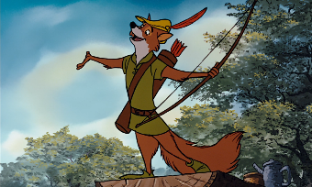 Reception, Year 1, Year 2 & 7 Red

*‘The Adventures of Robin Hood in Cooksonville’*

**Leaving 9am prompt**

**Lunch will be a hot packed lunch**

*(please order with the teacher in the usual way)*

**Friday 9th December KS2 Pantomime at Sunderland Empire**

Year 3, Year 4, Year 5, Year 6 and 7 Blue

*‘Aladdin’*

**Returning approximately 4.15pm.**

***The children will return to their classroom and will be***

***Dismissed from the doors in the usual way.***

KS2 clubs will be cancelled

**Lunch will be a hot packed lunch**

*(please order with the teacher in the usual way)*

**Tuesday 13th December**

Reception and Nursery morning & afternoon Performance 9.15am – 10.15am

Parents Welcome

*‘Snowman at Sunset’*

*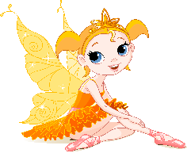***Wednesday 14th December**

Year 1, Year 2 & 7 Red Performance 9.15am – 10.15am

Parents welcome

*‘Fairyland Nativity’*

**Thursday 15th December**

Christmas Lunch

Children may wear Christmas jumpers, T-shirt, hat or tinsel

*(please order lunch with the teacher in the usual way)*

**Friday 16th December KS2 Performance at St Johns Church**

Year 3, Year 4, Year 5 and Year 6 at 9.30am – 11.30am

Parents welcome

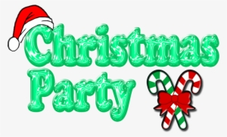**Christmas Party**

**Children to come to school in the morning**

**in their party clothes**

**Friday 16th December** - Reception

**Monday 19th December** – Year 1, Year 2 and 7 Red

**Tuesday 20th December** – Year 3, Year 4 and 7 Blue

**Wednesday 21st December** - Year 5 and Year 6

**Lunch will be a cold Christmas themed packed lunch**

*(please order with the teacher in the usual way)*

**Friday 23rd December – Last Day of Term**

Children may wear Christmas Jumper, T-Shirt, Hat or Tinsel

You may pick you child up any time after 1.30pm

**Children return to school 9th January 2023**

**We wish you all a Merry Christmas and a Happy New Year**

