Hadrian School IT and E-Safety Policy
Dave Robinson – IT Curriculum and E-Safety Lead
February 2026
1. Aims
Hadrian School aims to:
- Have robust processes in place to ensure the online safety of pupils, staff, volunteers and governors
- Deliver an effective approach to online safety, which empowers us to protect and educate the whole school community in its use of technology
- Establish clear mechanisms to identify, intervene and escalate an incident, where appropriate
- Identify and support groups of pupils that are potentially at greater risk of harm online than others
- Offer an IT curriculum which provides an engaging, accessible and functional use of IT with a focus on pupil’s preparation for life.

2. Legislation and Guidance
This policy is based on the Department for Education’s (DfE’s) statutory safeguarding guidance, Keeping Children Safe in Education 2025, and its advice for schools on:
- Teaching online safety in schools 2023
- Preventing and tackling bullying 2017 and cyber-bullying: advice for Head Teachers and school staff 2017
- Relationships and sex education 2025
- Searching, screening and confiscation 2023
It also refers to the DfE’s guidance on protecting children from radicalisation 2023.
It reflects existing legislation, including but not limited to the Education Act 1996 (as amended), the Education and Inspections Act 2006 and the Equality Act 2010. In addition, it reflects the Education Act 2011, which has given teachers stronger powers to tackle cyber-bullying

3. Roles and Responsibilities
The Governing Body has responsibility for ensuring this policy is monitored, reviewed and implemented. Governors must ensure the school’s online safety arrangements are sufficiently robust and appropriate for all.
The Head Teacher and Senior Leadership Team have overall responsibility for online safety. They must ensure staff understand procedures, training is up to date and that responses to allegations or incidents are handled in accordance with existing school policies.
The IT Lead coordinates day-to-day online safety practice, ensuring consistent implementation of this policy, overseeing filtering and monitoring systems, supporting staff, leading incident responses and liaising with external agencies where required. The IT Lead has responsibility for developing and implementing the Hadrian School IT curriculum.
Technical staff maintain secure networks, password systems, filtering controls, monitoring systems and virus protection. They monitor network usage and report concerns to the IT Lead.
Teaching and Support Staff must act as role models in safe and responsible use of technology. They must supervise digital activity, embed online safety throughout teaching, report concerns immediately and where necessary, guide pupils to appropriate online resources.
Pupils are expected, where appropriate, to follow acceptable use expectations, report concerns and behave safely and responsibly online.
Parents and Carers must support safe behaviour at home, follow school guidance, avoid sharing school images online and work collaboratively with staff to reinforce online safety expectations
4. Education – Pupils
The IT curriculum at Hadrian School is designed to provide a broad, ambitious, and engaging digital learning experience for all pupils across pathways, ensuring access to creativity, communication and functional digital skills. IT is delivered both as a discrete subject and across the wider curriculum. Pupils engage with a wide range of technologies—including laptops, iPads, VOCA devices, smartboards, accessible keyboards, digital cameras, and programmable devices—to develop skills in digital art, word processing, photography, video, publishing, basic programming, and information searching. Learning is adapted according to pathway (Explore & Discover, Investigate & Apply, Sensory & Therapeutic), with opportunities for repetition and consolidation of key concepts built into the yearly cycle.
Online safety advice is delivered to Investigate and Apply classes and other identified children where appropriate. Teaching focuses on recognising unsafe behaviour, staying safe online, dealing with cyberbullying, understanding digital footprints and knowing how to report concerns.
Where internet use is planned, staff will guide pupils to appropriate websites. When pupils are permitted to search independently, staff must supervise closely and respond immediately if unsuitable content appears
5. Education – Parents and Carers
Hadrian School recognises that many parents have limited awareness of online risks. Support will be offered through the Hadrian School website as well as other online sources. Parents are welcome to speak to school staff to be signposted for more specific advice and support. Parents are encouraged to adopt consistent safety practices at home.
6. Technical Infrastructure, Filtering and Monitoring
The school’s technical systems ensure safe and secure digital access for all users. Filtering prevents access to harmful or illegal content, including material blocked through the Internet Watch Foundation CAIC list.
Monitoring systems log user activity, allowing staff to identify concerning behaviour early. Access rights are assigned based on role, and all users must maintain secure passwords.
Servers, wireless systems and cabling are protected physically and digitally. Antivirus systems, firewall protections and software updates are maintained regularly. Requests for filtering changes follow strict approval protocols.
7. Use of Digital and Video Images
Digital images can pose safeguarding risks if shared or published inappropriately. Where appropriate, staff will educate pupils about safe image use and ensure all images reflect pupils in safe, appropriate contexts.
Staff must use only school equipment when taking images. Images must be stored securely, not shared on personal devices or accounts, and may only be used with parental consent.
Parents must not share photos of school events online. Pupils must not take, publish or distribute images of others without permission. Full names will not be used alongside photographs, and vulnerable pupils will be protected at all times through the use of our ‘Consent’ document.
8. Communications
All communication must be professional and carried out using official school systems. Emails and messages may be monitored. Any communication that causes concern must be reported immediately and not responded to.
Personal contact details must not be shared, and only official email addresses may identify staff publicly.
9. Social Media – Protecting Professional Identity
Staff must maintain clear professional boundaries and must not reference pupils, families or colleagues on personal social media. Personal opinions must not be presented as representing the school.
Staff are encouraged to use strong privacy settings on all social media and are to avoid engaging in online discussions that compromise professionalism. Misuse may result in disciplinary action.
The school may monitor public content relating to the school and respond to concerns as required.
10. Unsuitable or Inappropriate Activities
Illegal or harmful online activities are strictly prohibited. This includes accessing child sexual abuse images, extremist material, discriminatory content, pornography or threatening behaviour.
Using proxy sites, attempting to bypass filters, downloading large files, using social media without permission, file-sharing and accessing inappropriate sites are unacceptable.
The school provides clear guidance on acceptable, restricted and banned activities. (Appendix 1)

11. Responding to Incidents
Staff must follow established procedures, ensuring more than one senior member of staff is involved. Investigations must use a designated device, and evidence must be recorded carefully, including URLs and screenshots.
If illegal content is suspected, staff must stop immediately, isolate the device and contact the police. The device must not be altered.
All incidents are logged on CPOMS and managed proportionately, with actions ranging from internal responses to involvement of external agencies. (Appendix 2 and 3)
12. Sanctions
Sanctions for misuse depend on severity and may include warnings, removal of device access, meetings with parents, formal disciplinary action or police involvement.
Repeated or serious misuse will result in escalated responses, ensuring safeguarding remains the priority. (Appendix 2 and 3)
13. Review
This policy will be reviewed biannually by the Governing Body, or sooner if required by legislative or procedural changes. All updates will be communicated to staff and families accordingly.
14. Linked Policies
- AI Policy
- Data Protection Policy
- Safeguarding Policy

Appendix 1 – Acceptable, Restricted and Banned Activities
User Action | Acceptable at Certain Times | Acceptable for Nominated Users | Unacceptable | Unacceptable & Illegal
Child sexual abuse images – making, production, or distribution (Protection of Children Act 1978) |  |  |  | X
Grooming, incitement, arrangement or facilitation of sexual acts against children (Sexual Offences Act 2003) |  |  |  | X
Possession of extreme pornographic images (Criminal Justice & Immigration Act 2008) |  |  |  | X
Criminally racist material intended to stir up hatred (Public Order Act 1986) |  |  |  | X
Pornography |  |  | X
Promotion of discrimination |  |  | X
Threatening behaviour, including promoting physical or mental harm |  |  | X
Promotion of extremism or terrorism |  |  |  | X
Offensive material or anything that harms the school’s ethos or reputation |  |  | X
Using school systems to run a private business |  |  | X
Bypassing filtering or safeguarding systems |  |  | X
Infringing copyright |  |  |  | x
Revealing or publicising confidential information (e.g., financial, personal, passwords) |  |  | X
Creating or spreading viruses or harmful files |  |  |  | x
Unfair usage (e.g., large downloads/uploads that affect others) |  |  | X
Online gaming – educational | X
Online gaming – non-educational |  |  | X
Online gambling |  |  | X
Online shopping / commerce |  | X
File sharing |  | X
Use of social media |  | X
Use of messaging apps |  | X

Appendix 2 – Responding to Only Safety Incidents
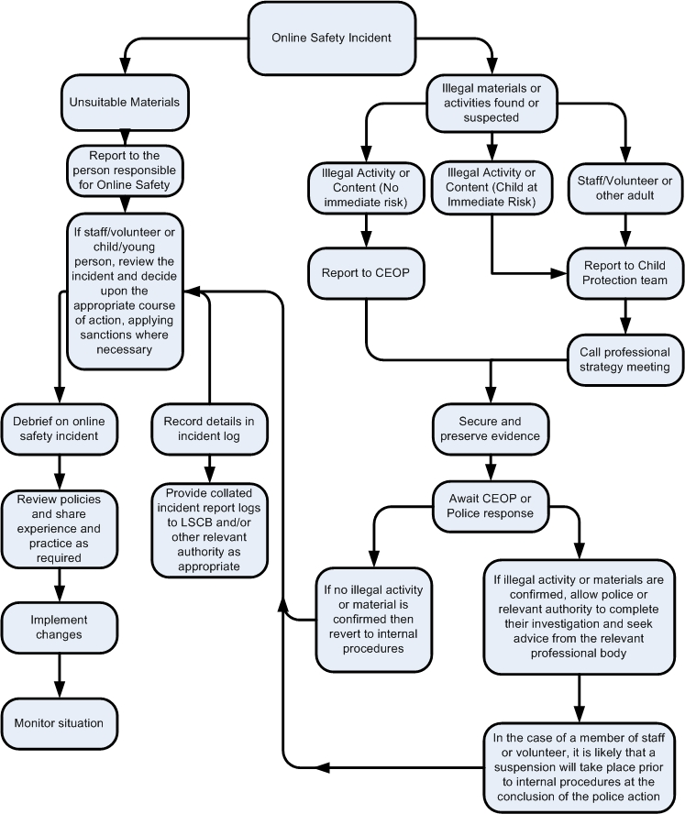

Appendix 3 – Staff Incidents and Sanctions
Staff Incidents | Refer to Line Manager | Refer to Head Teacher | Refer to Local Authority / HR | Refer to Police | Refer to Technical Support (filtering, etc.) | Warning | Suspension | Disciplinary Action
Deliberately accessing or attempting to access illegal material |  | ✔ | ✔ | ✔ |  |  |  | ✔
Inappropriate personal use of the internet / social media / personal email | ✔ |  |  |  | ✔ | ✔
Unauthorised downloading or uploading of files | ✔ |  |  |  | ✔ | ✔
Careless handling of personal data (e.g., insecure storage or transfer) | ✔ |  |  |  | ✔ | ✔
Deliberate breach of data protection or network security rules | ✔ | ✔ |  |  | ✔ |  | ✔
Corrupting/  damaging data, hardware, or software | ✔ |  | ✔ |  | ✔ |  | ✔
Sending offensive / harassing / bullying messages | ✔ |  | ✔ |  | ✔ |  | ✔
Using personal email or messaging/social media to communicate with pupils | ✔ |  |  |  | ✔ |  | ✔
Actions compromising professional standing | ✔ | ✔ |  |  | ✔ |  |  | ✔
Actions bringing the school into disrepute or breaching school ethos | ✔ |  |  |  | ✔ |  | ✔
Using proxy sites / other means to bypass school filtering | ✔ |  |  |  | ✔ |  | ✔
Accidentally accessing offensive/  pornographic material AND failing to report it | ✔ |  |  |  | ✔ |  | ✔
Deliberately accessing offensive or pornographic material | ✔ |  | ✔ | ✔ | ✔ | ✔ | ✔ | ✔
Breaching copyright or licensing conditions | ✔ |  |  |  | ✔ | ✔
Repeated infringements after warnings/sanctions | ✔ |  | ✔ |  | ✔ |  | ✔ | ✔

