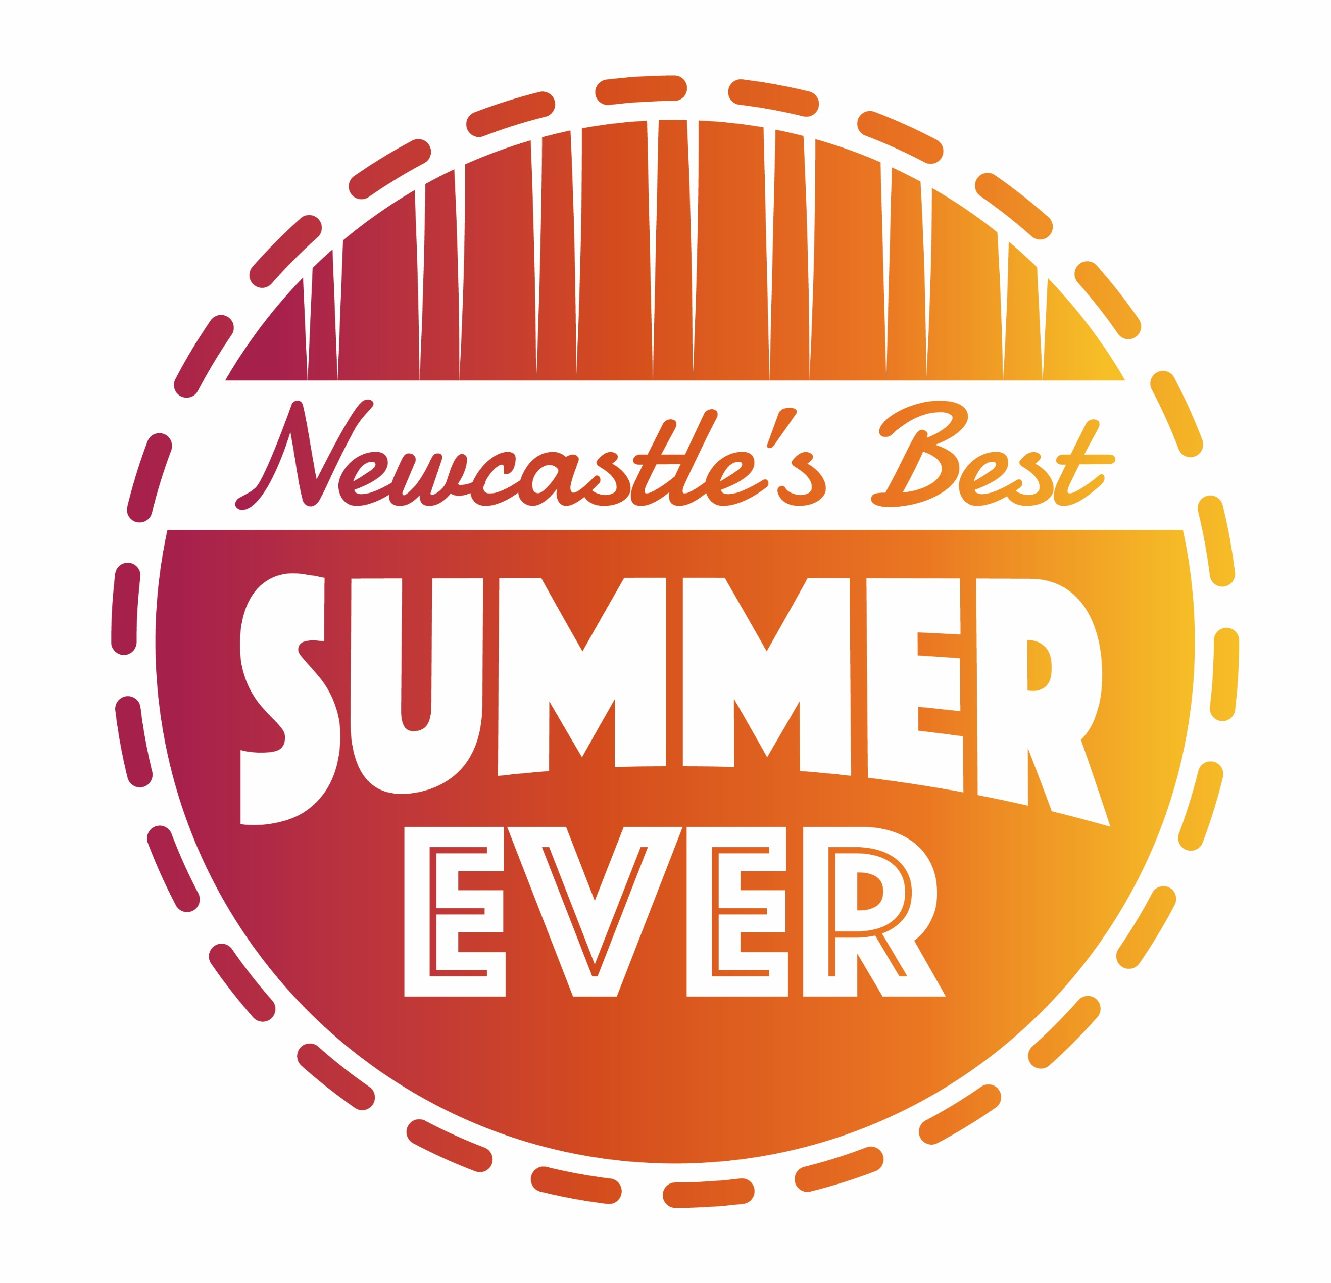
Summer holiday activities in Newcastle

Support for families in receipt of free school meals with young people (aged 4-16)

Over 80 local community projects providing holiday activities and facilities will open during the summer school holidays. These projects will provide activity sessions and a meal for your child. They are fun and free to attend.
Sessions begin Monday 25 July 2022 and are located across the city at various neighbourhood sites. Please be aware that some will have limited places, there are no sessions on 29 August 2022, and they end on 2 September 2022.
Please contact the project directly for more information about holiday activity placements in your neighbourhood.
Here are links to further details on our website: Holiday Activity Fund | Newcastle City Council
For more offers open to all families, please see: Summer holiday activities on the Newcastle Support Directory
Also take a look at the Summer Information Sheet 2022 from Newcastle’s Children with Disabilities Team: SEND friendly Summer Activities Newsletter | Newcastle Support Directory

Specific sessions for children and young people with SEND (age 4-18) from the Holiday Activity Fund

There are also some specific sessions for children and young people with SEND, but free meals will not be available. See table and contacts:

Where | What is available | Times / dates available | Contact details for further information
East End Pool | Family Swim | 1.30pm – 2.30pm  26 July  28 July  2 August  4 August  9 August  11 August  16 August  18 August  23 August  25 August  30 August  2 September | Paul.Gates@GLL.ORG  0191 260 0507  East End Pool  Hadrian Square,  Byker  NE6 1A  East End Pool | Gym, Swimming Pool & Classes in Newcastle | Better
Hadrian School | Rebound  Families taking part are welcome to use the play areas at Hadrian, before or after their Rebound Session, up until 1.30pm. Please note this will not be supervised. | All sessions are 45 minutes long on the following dates:  10.00am - 2 August  10.00am - 4 August  12.00pm - 4 August  10.00am - 9 August  11.00am - 9 August  12.00pm - 9 August  11.00am - 16 August  10.00am - 18 August  11.00am - 23 August  11.00am - 25 August  11.00am - 30 August | Limited number of places per sessions please book in advance contact David Palmer:  0191 273 4440  David.Palmer@hadrian.newcastle.sch.uk  Hadrian School,  Bertram Crescent,  Newcastle upon Tyne  NE15 6PY  Rebound Therapy Centre | Hadrian School
Eldon Leisure | Ten Pin Bowling sessions available to children and young adults with an SEN | Sessions between 10.00am – 12.00pm on  26 July, 2 August,  9 August, 16 August,  23 August, 30 August | Please call to book a timeslot as spaces are limited:  0191 269 9200.  Eldon Shopping Centre  Grey’s Quarter  NE1 7XY  Eldon Soft Play and Bowling | Soft Play & Bowling in Newcastle | Better
NUCASTLE Foundation Centre | SEN only football session  More info to be added soon | 17.00pm – 18.30pm  22 August | For more information contact:  Lee.Scott@nufc.co.uk  NUCASTLE Foundation Centre  Diana Street,  Newcastle upon Tyne  NE4 6BQ  NUCASTLE | Newcastle United Foundation (nufoundation.org.uk)
NUCASTLE Foundation Centre | Premier League Kicks Neurodiversity sessions for young people aged 11-18.  Delivered by staff with ASD specific training and will combine football with mental wellbeing activities.  (This event is not HAF funded.) | 18.00 – 19.00 First Thursday of every month | For more information contact:  Michael.johansen@NUFC.co.uk  NUCASTLE Foundation Centre  Diana Street  Newcastle upon Tyne  NE4 6BQ  NUCASTLE | Newcastle United Foundation (nufoundation.org.uk)
Newburn Activity Centre | Soft play and sensory room for families to come and use. | Tuesdays and Thursdays 10.00am - 12.00pm | Neal Thompson  0191 264 0014  neal.thompson@newburnactivity.co.uk  Newburn Activity Centre  Grange Road  Newburn  NE15 8ND  Home (newburnactivity.co.uk)

