Covid-19 Related Pupil Absence
A Quick Reference Guide for Parents
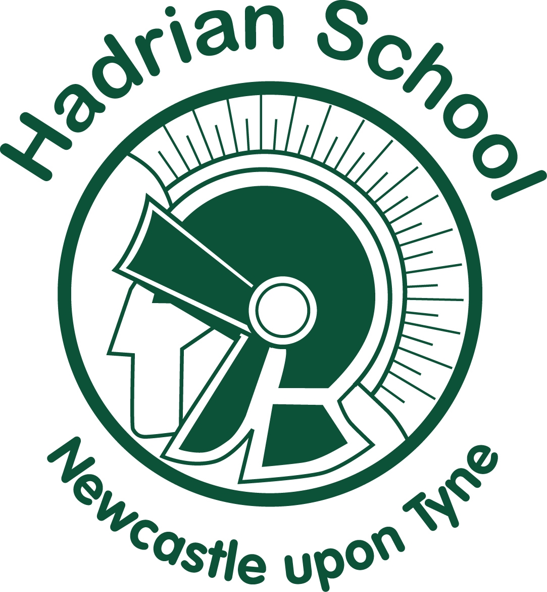

What to do if… | Action Needed | Return to school when…
My child has Covid-19 symptoms  - HIGH TEMPERATURE – this means you feel hot to touch on your chest or back  - A NEW CONTINUOUS COUGH - this means coughing a lot more than an hour or 3 or more coughing episodes in 24 hours  - A LOSS OR CHANGE TO YOUR SENSE OF SMELL OR TASTE - this means you’ve noticed you cannot smell or taste anything | DO NOT COME TO SCHOOL  Contact school to inform us.  Self-isolate the whole household for 14 days.  Get a test.  INFORM SCHOOL IMMEDIATELY ABOUT TEST RESULT | The test comes back negative.
My child tests positive for Covid-19 | DO NOT COME TO SCHOOL  Contact school to inform us  Agree an earliest date for possible return. Minimum of 10 days  Self-isolate the whole household for 14 days.  Bubble isolates remote learning. | They feel better. They can return after 10 days even if they have a cough or loss or taste/smell. These symptoms can last for several weeks.
My child tests negative | CONTACT THE SCHOOL  Discuss when your child can come back to school (same day/next day) | The test comes back negative.
My child is ill with symptoms not linked to Covid-19 | FOLLOW USUAL SCHOOL ABSENCE POLICY | After 48 hours following the last bout of sickness/diarrhoea if this is the cause of absence.
Someone in my household or my child has Covid-19 symptoms | DO NOT COME TO SCHOOL  Contact school.  Self-isolate the whole household for 14 days.  Household members to get tested.  INFORM SCHOOL IMMEDIATELY ABOUT TEST RESULTS | The test comes back negative.
Someone in my household or my child tests positive for Covid-19 | DO NOT COME TO SCHOOL  Contact school  Agree an earliest date for possible return. Minimum of 14 days. | The child has completed 14 days of isolation.
What to do if… | Action Needed | Return to school when…
NHS test & trace has identified my child as being in close contact of someone with symptoms of confirmed Covid-19 | DO NOT COME TO SCHOOL  Contact school  Agree an earliest date for possible return. Minimum of 14 days. | The child has completed 14 days of isolation.
We/my child has travelled and has to self-isolate as a period of quarantine | Do not take unauthorised leave in term-time.  Consider quarantine requirements and FCO advice when booking travel.  Returning from a destination where quarantine is needed.  Agree an earliest date for possible return. Minimum 14 days from return date.  Self-isolate the whole household. | The quarantine period of 14 has been completed.
We have received medical advice that my child must continue shielding | DO NOT COME TO SCHOOL  CONTACT SCHOOL  Shield until you are informed that restrictions are lifted and shielding is paused again. | School inform you that restrictions have been lifted and your child can return to school.
My child’s bubble is closed due to a Covid-19 outbreak in school. | DO NOT COME TO SCHOOL  At home support your child with remote education provided by school.  Your child will need to isolate for 14 days. | School will inform you when the bubble will be reopened.

FOR MORE DETAILS PLEASE READ : https://www.gov.uk/government/publications/covid-19-stay-at-home-guidance/stay-at-home-guidance-for-households-with-possible-coronavirus-covid-19-infection

