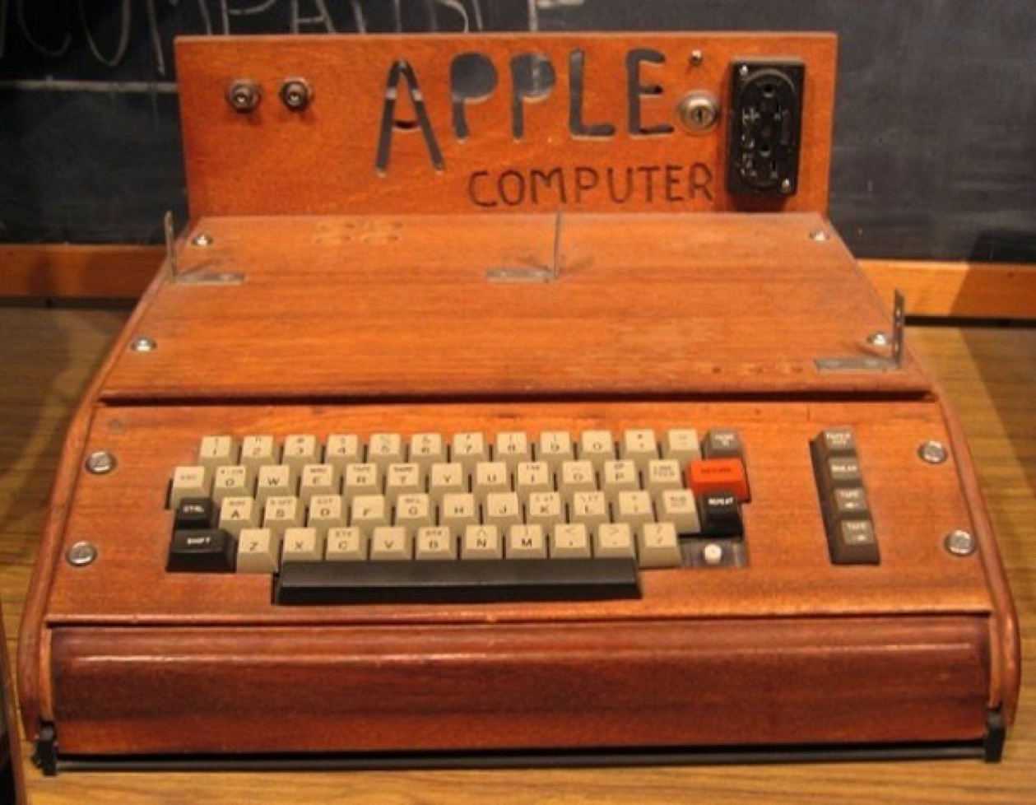
From this…
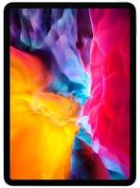

To this…

Special Apps for Very Special Learners

May 2020

from Flo Longhorn

If you would like the June edition, send me an email to flopmld@gmail.com
May 2020

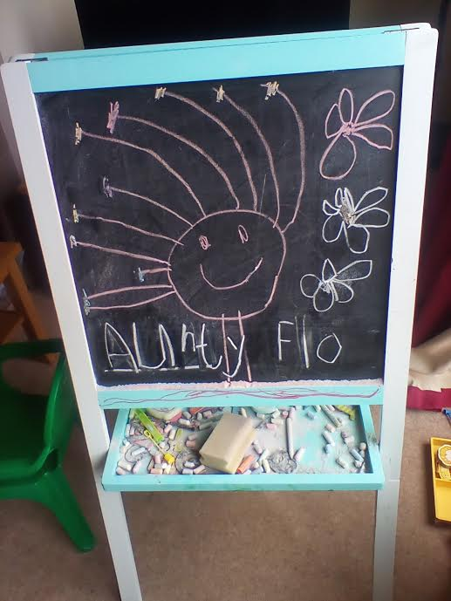
Message from Flo Longhorn:

Hello from Belgium!

These apps are very simple and free as of May 2020. As I have an iPad, they have been researched online at the App store and various other sources. Most of them will be in Android form as well, so Google search from the app titles shown in this document. Links have been provided in most cases. They are for Very Special Learners who are learning to:

- be a valued partner included in the world of exciting technology 2020,
- use simple apps,
- have fun, excitement, and pleasure,
- look, pay attention, focus on the screen,
- listen, watch and listen at the same time,
- swipe randomly, swipe up and down or side to side,
- tapping with fingers, then just a one-finger tap,
- drag across the screen, pinch the screen,
- engage on their own, act independently.

Further excellent ideas and info are available from Ian Bean, the guru of IT for special learners, at: https://www.ianbean.co.uk
And from: https://www.callscotland.org.uk/search-results/?cx=012406468555063456929%3Aa4yvazbi7qw&cof=FORID%3A11&ie=UTF-8&q=ipads

Don’t forget - it is very important to remember that the flat surface of a tablet is not going to develop hands and fingers for basic actions such as grasping, pulling, banging, manipulating or rotating. We need to make sure that there are fun opportunities for hands and fingers to be used in different actions.

It can be as simple as a small washing up bowl filled with water and suds, then emptied and filled with soil, to dig and delve.
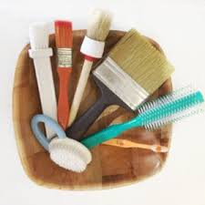
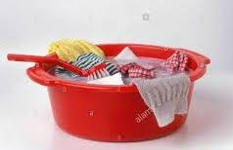

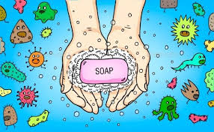
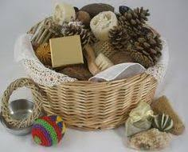
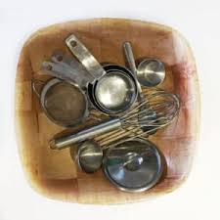
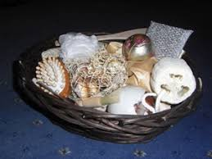
Or use a treasure basket of interesting objects to feel, grasp, and bang.

And don’t forget to wash hands!

Uzu, an interactive light show ($1.99) – Actions: poke, tap, swipe

This is an oldie, but top of my list to buy. You can use any number of fingers and mess around with glowing, coloured specks of light. It is strangely enjoyable. Using all the standard iPad finger motions - pinch, swipe, tap, etc. - creates all sorts of interesting formations with the lights. You can even go beyond one finger, using as many fingers as possible. Experimenting is a major part of the fun. Create beautiful images and they are easy to store and replay as a movie.

See Uzu in action at: https://www.youtube.com/watch?v=KuD5ZPrmztw.
Or get it here: https://appshopper.com/entertainment/uzu

Cosmic Top (£1.99) - Actions: swipe, pinch, hold, multi-touch
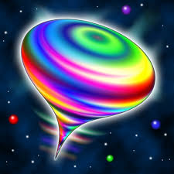
This is a 3D toy top that has sci-fi sounds and glows with limitless colourful shapes. Spins, wobbles and morphs. It is 3D, so as the tablet is moved, you can view it from different angles. See it at:
https://www.youtube.com/watch?v=Jn0inbhhByA
Get it here for iPad/iPhone:
https://apps.apple.com/gb/app/cosmic-top/id401450971

Kaleidoscope Drawing Pad (Free) – Actions: finger, circular movements, drag
Magical kaleidoscope effects which build up to a dazzling picture. There are 8 modes, about 10 different brushes and choice of vivid colours. There is also movie mode, so you watch your efforts replayed.

See it at: https://www.youtube.com/watch?v=UUTTUKpzCuM

Kaleidoscope Drawing Pad (free) is available for iPad/iPhone here:
https://apps.apple.com/us/app/kaleidoscope-drawing-pad/id525904070

Or get Kaleido is available for Android (€0.92) here:
https://play.google.com/store/apps/details?id=com.slowprog.kaleido&hl=en_US

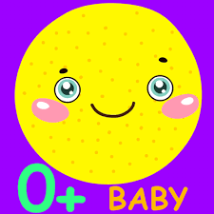
My Funny Rattle for Baby! (free, then £1.99)

Ignore the word ‘baby’. It is fun just to shake, rattle and roll with random sounds, abstract pictures, exclamations, and vibration.
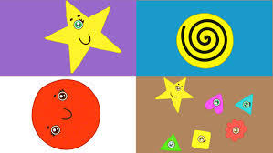

Get it here: https://apps.apple.com/us/app/my-funny-rattle-for-baby/id1183327901

VM Fireworks (free) – Actions: tap, drag

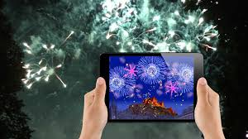
This is a free app especially for Scottish fans! It links into the Edinburgh International festival, sadly cancelled this year. Create your own fantastic firework display to accompany Prokofiev’s ‘Romeo and Juliet’. Layers of stunning visuals as you tap and launch different fireworks to the music. Lots of bangs and exploding fireworks.

See it at: https://www.youtube.com/watch?v=HKYpRaCut34

Get it here: https://apps.apple.com/us/app/vm-fireworks/id906700458

The following sound-related apps are from the company iGreenEarth.

Get them from https://apps.apple.com/us/developer/igreenearth/id351081815

Dog sounds (free) - Actions: tap, listen

Tap on a dog and hear different barks, including wild dogs. Great if the listener has a dog and can generalise to these sounds. Perhaps as part of a programme for desensitization for those scared by dogs. Wuff!
Get it at:
https://apps.apple.com/us/app/dog-sounds-body-talk/id429865406
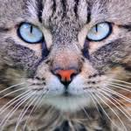

Cat sounds (free) - Actions: tap, listen

Get it at:
https://apps.apple.com/us/app/cat-sounds-tail-talk/id428847314
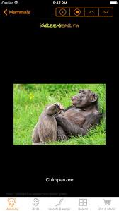

Animal Chatter (free) - includes insects!

Get it at:
https://apps.apple.com/us/app/animal-sounds-and-noises/id393772637

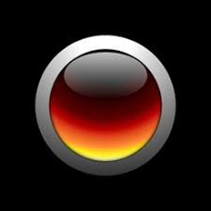
Annoying Sounds and Noises (free or go to Pro)

This is my favourite! Winds up everyone! Yippee!

Soundboards include annoying sounds such as dog whistle, baby crying, mosquito, body sounds, airhorn, sirens, alarms, high frequency sounds, farts, burps, office, animal sounds and many more irritating noises! Get all these fun sounds by downloading the annoying soundboard app!

Get it at:
https://apps.apple.com/us/app/annoying-sounds-and-noises/id430784271

Magic Fingers (free) – Actions: listen, tap, swipe

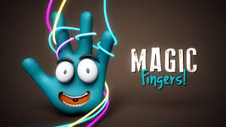
I removed the adverts for 99p, and it was well worth it!

This is a golden oldie from many years ago and still at the app store. Music accompanies the shapes that you create, and also dances to the music as you watch. The tunes are cheery!
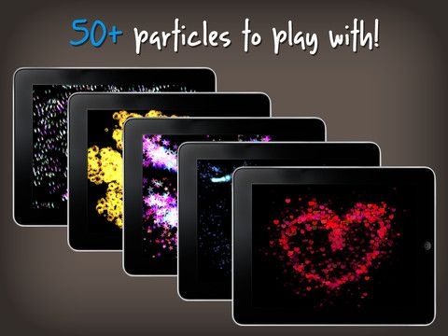

See it at: https://www.youtube.com/watch?v=Tw8wlCWQDXc

Get it here: https://apps.apple.com/us/app/magic-fingers/id483980400

Tap a Tune - Kids Music Maker (free) – Actions: tap and play music

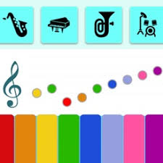
Very simple clear graphics with a coloured keyboard and a choice of instruments. Just tap on an instrument such as percussion drums, guitar and play away. The sounds are realistic and have a very clear resonance.

As each note is pressed, a ball bounces up and goes on to a musical score. Then press the music symbol (a treble clef!) and the tune is repeated back to you. Tremendous for the simple delight of creating music.

Get it here:
https://apps.apple.com/us/app/tap-a-tune-kids-music-maker/id918689041

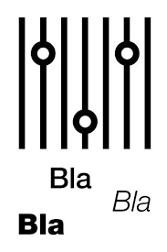
Bla Bla Bla (free) – Actions: sound, voice

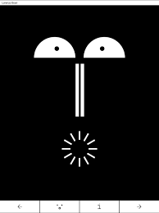
This app has a lovely history. It was created in Venice and Urbino in Italy, by Lorenzo Bravi. It is a sound reactive application for use with students doing ‘procedures of basic design’ using a Parametric mask. Very esoteric! However, it was actually designed for use in speech therapy especially for young children, people with autism and stroke patients.

The images are simple, black and white faces and rather abstract. When you make any sort of noise, they ‘talk back’ to you by changing their expression. If you make a noise such as clicking your fingers, they also talk back.

Get it here for iPad/iPhone:
https://apps.apple.com/us/app/bla-bla-bla/id430815432

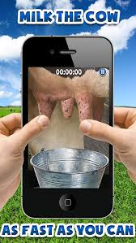
Milk the Cow (free)

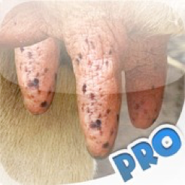
This is a classic free app where you can swipe the udders of the cow and squirt milk into the pail. The pail never fills up, so keep squirting and concentrating! Make sure you have real milk on hand to drink or make a milk shake! There is a Pro version to buy, with milking competitions.

See it at: https://www.youtube.com/watch?v=nRO6ZrmLDTQ

Get it here for the iPad/iPhone:
https://apps.apple.com/us/app/milk-the-cow/id450733533

Get it here for Android:
https://www.appbrain.com/app/milk-the-cow/com.lemondoo.milkthecowfree

The Dexteria group of apps, such as for fine motor skills (fingers and hands), eye hand coordination, letter reversal and simple maths learning, are well worth a look. Visit:
https://www.commonsense.org/education/app/dexteria-fine-motor-skill-development-teacher-review/4018471

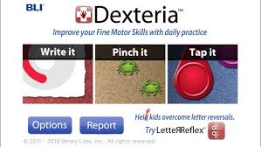
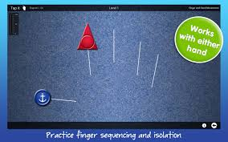
At the Dexteria Jr. website - http://www.dexteria.net – it says: “We're pleased to announce a new addition to our family of apps: Dexteria Jr. New research shows that early fine motor skill development improves math, reading, and science scores later on. Inspired by our award-winning app Dexteria, we created a brand-new app for smaller hands and younger minds. We added music, characters, sprite animations, and some surprises to make it fun and engaging for pre-schoolers and toddlers. It's a great addition to the Dexteria family of apps for occupational therapy. They are favourites of OTs, teachers, and parents using iOS devices (the iPad, iPhone, and iPod touch) as therapeutic tools. All of our apps feature automatic reporting and tracking to identify time on task and progress. Multi-user versions are available as an in-app purchase.”
Category - Fine motor development to build strength, control and dexterity using the hands.
Tablet Skills - For the adult, there is built in reporting and tracking for an individual learner.
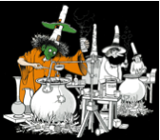
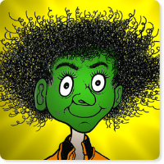
Meet Heckerty (free) – Actions: story time and telling, tapping.

This is a UK children's story starring Heckerty, who is a zany, 409-year-old, upside-down-on-her-broomstick witch with a green face. She has a sidekick cat called Zanzibar.

The graphics are super, very detailed and interesting. Most pages have a simple animation to encourage participation even if the learner is not reading, it is the beginning of listening and attending. The book can be read by itself or have the voice of Jan Ziff, the author, read the story. Each page is filled with at least one ‘tap’ element that will jump, move or make a noise when touched.

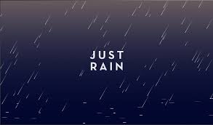
Just Rain Free (free) Action: non-demanding rain noise

A favourite of mine to nod off to sleep. It is just rain … simple as that. There is also the potential for involvement in toilet training, it has an effect on the interoceptive sensing system.
Get it here for iPad/iPhone: https://apps.apple.com/us/app/just-rain/id669287925 or here for Android: https://apkpure.com/just-rain/net.robysoft.justrain
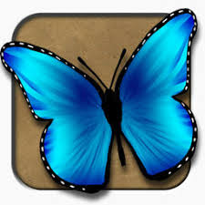
This app is MAGIC!

Live Butterflies (free) – Actions: magic cause and effect, interactive
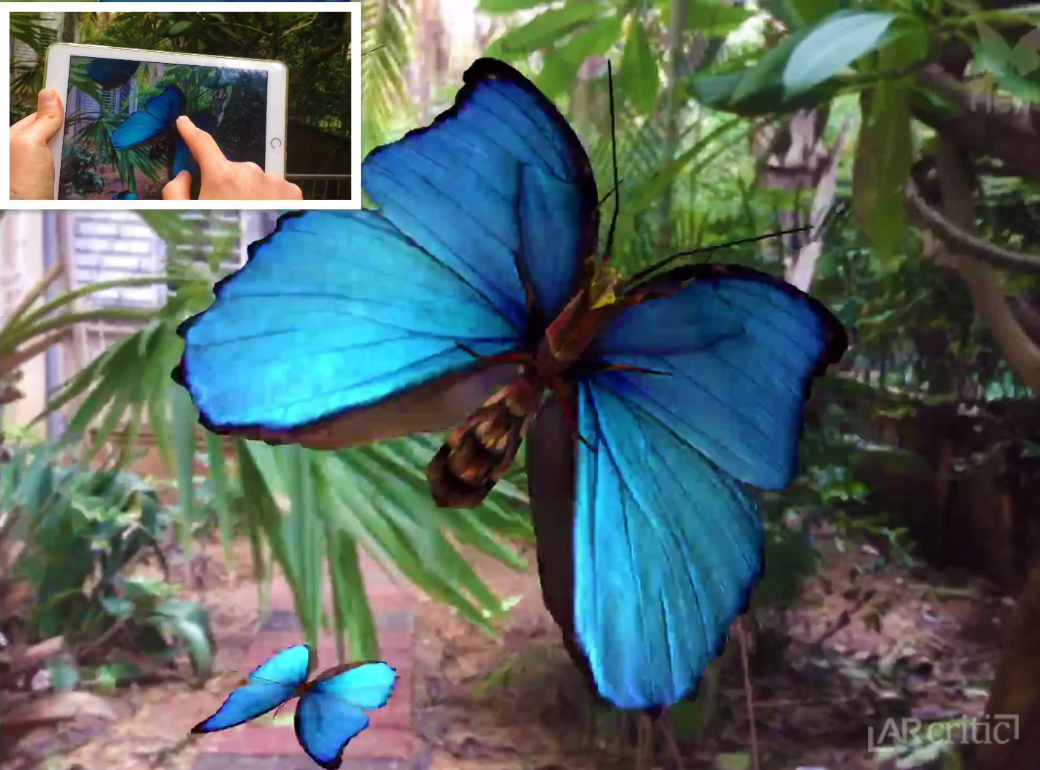
This is a simple app but with lots of potential. Choose a selection of butterflies and then select the viewer. Look around using the viewer. This will show the chosen butterflies flying around anywhere you point the iPad! Magically, if you touch the screen, a butterfly will hover and then perch on the end very gently. There is a background noise of natural sounds that can be switched off if required.

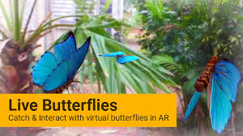

Get it here: https://apps.apple.com/gb/app/live-butterflies/id414352623
Balloon Pop for Kids Free (free) – Actions: tap, pointy finger

This is so simple, watch balloons moving upwards and pointy finger ready - pop!

See it here:
https://www.youtube.com/watch?v=1v_r-e_U1Rw
Get it for iPad at:
https://apps.apple.com/us/app/balloon-pop-for-kids-free/id990059175
Get it for Android here:
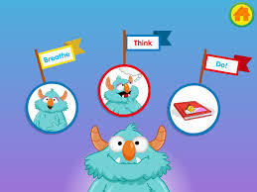
https://play.google.com/store/apps/details?id=se.appfamily.balloonpopfree&hl=en

Breathe, Think, Do with Sesame (free) Actions: relax, breathe, wellbeing
This is for the adults as well, for wellbeing and stress reduction. The description follows:

‘Frustration is a normal part of life, but it can overwhelm and bring up a lot of big feelings. You can help them ( and yourself!)to use the “Breathe, Think, Do” strategy to calm down, identify their feelings, and work to solve their problem.
Breathe - First, help calm down.
Encourage them to put their hands on their bellies and slowly take three deep breaths, in through the nose and out through the mouth. Ask them to whisper “calm down” (or another encouraging phrase) to themselves.
Think - Next, help them understand their problem and think about a plan to solve it.
Encourage them to tell you how they are feeling and why. You can help them find the words by telling them what you notice (“It seems like you feel frustrated because you’re having trouble putting on your sweater.”). Help come up with a few different plans for solving the problem (such as unbuttoning the top button).
Do - Encourage them to choose a plan and try it out.
Ask, “Which plan is best? Let’s try it!”. If the plan doesn’t work, ask, “How else could you do this?” and then try the next plan.
Remind them that learning new things takes practice. It is not that they can’t do it; it’s that they can’t do it yet. Get it for iPad/iPhone here:
https://apps.apple.com/gb/app/breathe-think-do-with-sesame/id721853597
or for Android here:
https://play.google.com/store/apps/details?id=air.com.sesameworkshop.ResilienceThinkBreathDo&hl=en
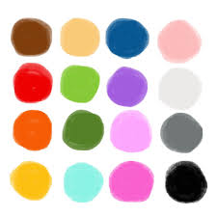
Scribbaloo Paint Free (free) Actions: creative, taps, and swipes

This is the simplest of creative activities with no complicated instructions and clear graphics.

See it at: https://www.youtube.com/watch?v=OGMMlM7aABE12
Get it here for iPad/iPhone:
https://apps.apple.com/us/app/scribbaloo-paint-simple-easy-to-use-painting-app-for/id959974785
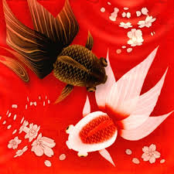
Wa Kingo LE Goldfish Pond (free, then upgrade for 99p) Actions: relaxation, tap

I did upgrade to keep this app as it is simple and keeps me relaxed as I tap the swirling water or change the background. This is a simple as it gets. You do not have to cultivate fish or do anything else obscure!
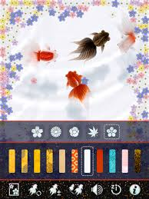
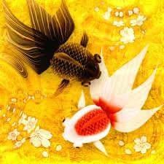

Watch Kitchi the cat play with the goldfish on YouTube!
https://www.youtube.com/watch?v=5NuEaYBp9Ig

Get it for iPad/iPhone here:
https://apps.apple.com/au/app/wa-kingyo-le-goldfish-pond/id333192368
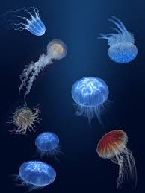
Jellyfish Heaven (free) – Actions: relaxation, UVL, images, visual

Another lovely relaxation app. I did not upgrade it as it was way too expensive, but the free version is just right for special watchers, including me. The jellyfish drift change UVL colour and can be dragged in the sea. The music is icky, but someone will like it!

Get Jellyfish Heaven for iPad/iPhone here:
https://apps.apple.com/us/app/jellyfish-heaven-relax-time/id548498631
And on Android here:
https://play.google.com/store/apps/details?id=kakumei.jellyfishheaven&hl=en_US
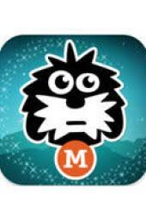

Millie Was Here - ‘Meet Millie’ (book 1 free) - You can purchase further adventure books story with interaction on every page

Here is Millie the dog:
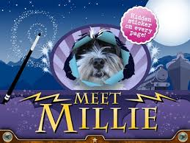
https://www.youtube.com/watch?v=sPhJH4qtGq8

This is one of my FAVOURITE interactive story books from 9 years ago. Gulp, Millie must be in doggie heaven by now! Interesting story, good modern graphics and Millie springs to life with her photos.

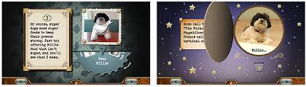
This is one of the first apps to captivate most special learners, including me!

Here is a vintage video of Kaiden using an iPad for the first time and then watch his progress in three months. It was made by his parents and is truly amazing. The way they encourage errorless learning through their tiny prompts, is a lesson to us all.
https://www.youtube.com/watch?v=Rjrl4HjojbM
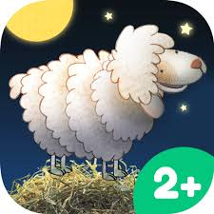
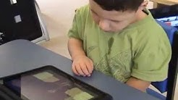
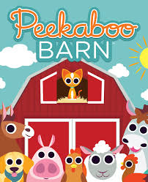
Peekaboo Barn Lite (free) - There is a bundle of Peekaboo apps at the app store – Actions: story, interactive, tap, drag

One of the first apps to be released, since 2008, Peekaboo Barn has been downloaded over half a million times and played over 70 million times worldwide. It has been a top 20 educational game on the iTunes store nearly every day since its launch and has been featured by Apple often.
Get it here for iPad/iPhone:
https://apps.apple.com/au/app/peekaboo-barn-lite/id302386835
And here for Android:
https://www.amazon.com/Night-Day-Studios-Inc-Peekaboo/dp/B00OJPNO96

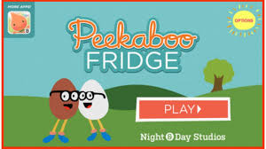

There are others in the series, such as Peekaboo Fridge.

See it here: https://www.youtube.com/watch?v=6qL-KixvcRo

Get it for the iPad/iPhone here:
https://apps.apple.com/us/app/peekaboo-fridge/id554188081

And for Android here:
https://www.amazon.com/Night-Day-Studios-Inc-Peekaboo/dp/B00H5CGSDO
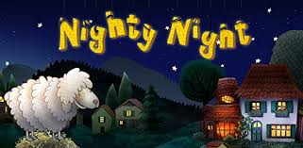
Nighty Night (£3.99) – Actions: story, interactive

Ignore the 2+ info, this is for everyone. I have used it for 8 years and still enjoy it. Below is the story on YouTube. The deeply male emotional voice adds to the charm.

See it on YouTube here: https://www.youtube.com/watch?v=6Bc-HBcV7SE
Get Nighty Night for the iPad/iPhone here:
https://apps.apple.com/us/app/nighty-night/id434756152
And for Android here:
https://play.google.com/store/apps/details?id=com.foxandsheep.nightynight&hl=en

Fluidity (free) Actions: drag, swipe, listen

A favourite with special learners as you cannot fail to make things happen with swirling images and music.

Get it for iPad/iPhone here:
https://apps.apple.com/us/app/fluidity-hd/id399403909

For more of these sorts of apps, have a look at the amazing Richard Hirstwood’s visual stimulation apps clip on YouTube. An oldie but goody! Well done Richard!
https://www.youtube.com/watch?v=sWj2YsTltYc

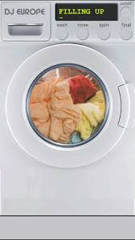
Washing Machine (free) – Actions: obsessive compulsive viewing

Such fun, wash, rinse, spin clothes and listen to the DJ and his music.

‘Get your clothes bright and clean, put your clothes in my washing machine!’

Get the app here:
https://apps.apple.com/us/app/washing-machine/id450145274
And Now for Something Completely Different!

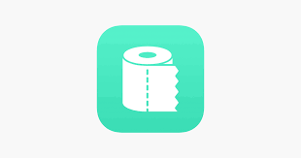
Flush Toilet Finder (free) - interoceptive system

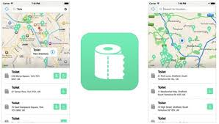
Flush Toilet Finder is the quickest, simplest way of finding a public bathroom or restroom. Simply open the app and it will display the nearest toilets to you. It is free, no in-app purchases, and has over 190,000 bathrooms in its database. You can even search for restrooms without an internet connection!

Get the app here – and never be caught short again!

https://apps.apple.com/us/app/flush-toilet-finder-map/id955254528

