

**EXERCISE PUTTY PROGRAMME**

**1. Rolling**

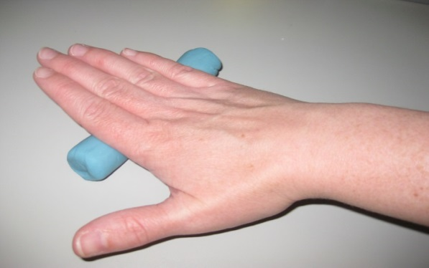

**3. Ball using all fingers**

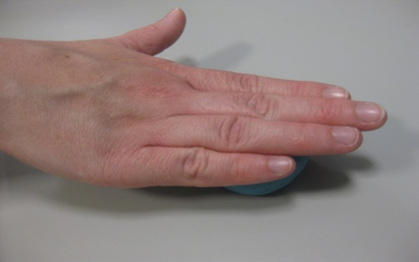

**5. Small balls and squeeze together**

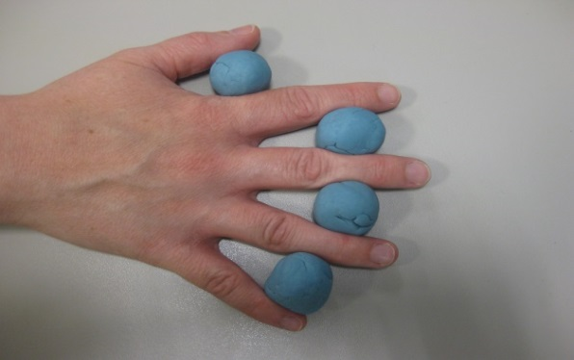

**2. Pinching with each finger**

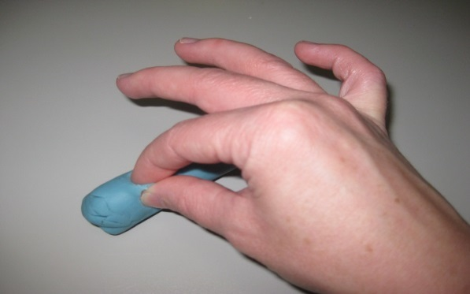

**4. Squash Ball**

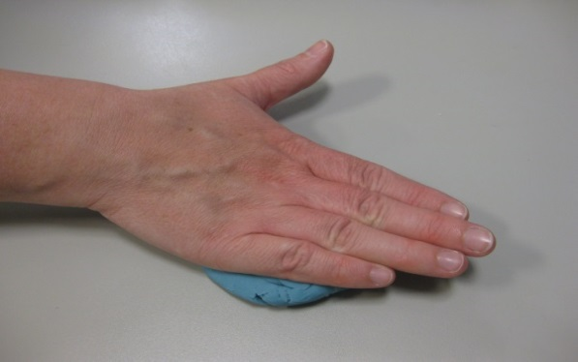

**6. Small ball in palm – squeeze each finger**

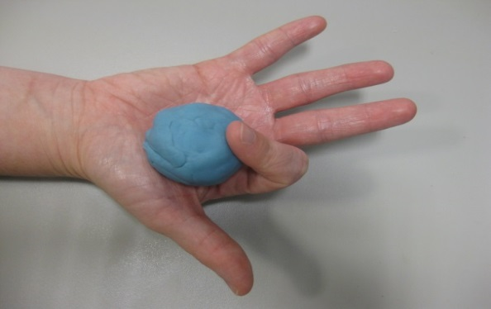

**7. Squeeze through fingers**

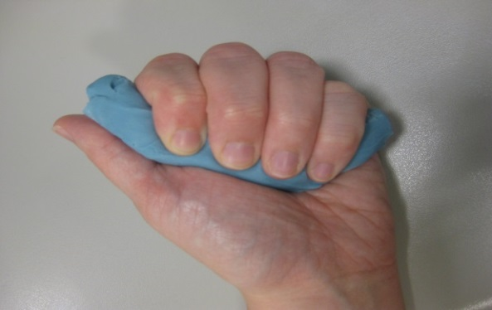

**9. Donut ring and push fingers outwards**

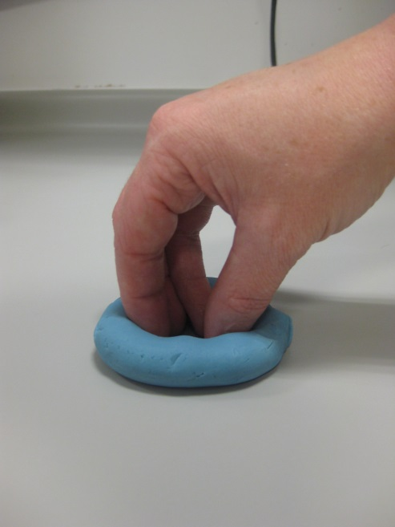

**Community Paediatric Occupational Therapy**

Newcastle upon Tyne Hospitals NHS Foundation Trust

Building 15, Campus of Ageing and Vitality, Westgate Road, Newcastle upon Tyne, NE4 6BE

**Tel: 0191 2823452**

**Email: physicaltherapyservices@nuth.nhs.uk**

**Community Paediatric Occupational Therapy**

Newcastle upon Tyne Hospitals NHS Foundation Trust

Building 15, Campus of Ageing and Vitality, Westgate Road, Newcastle upon Tyne, NE4 6BE

**Tel: 0191 2823452 Email: physicaltherapyservices@nuth.nhs.uk**

**Community Paediatric Occupational Therapy**

Newcastle upon Tyne Hospitals NHS Foundation Trust

Building 15, Campus of Ageing and Vitality, Westgate Road, Newcastle upon Tyne, NE4 6BE

**Tel: 0191 2823452 Email: physicaltherapyservices@nuth.nhs.uk**

**Community Paediatric Occupational Therapy**

Newcastle upon Tyne Hospitals NHS Foundation Trust

Building 15, Campus of Ageing and Vitality, Westgate Road, Newcastle upon Tyne, NE4 6BE

**Tel: 0191 2823452 Email: physicaltherapyservices@nuth.nhs.uk**

**8. Roll again**

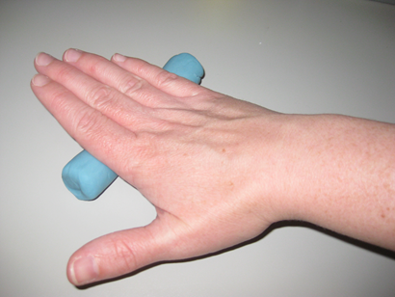

**10. Finish**

**Squeeze together**

**and return to tub!**

**Community Paediatric Occupational Therapy**

Newcastle upon Tyne Hospitals NHS Foundation Trust

Regent Point, Level 3, Regent Farm Road, Gosforth, Newcastle upon Tyne, NE3 3HD

**Tel: 0191 2823452**

**Email: physicaltherapyservices@nuth.nhs.uk**

**Community Paediatric Occupational Therapy**

Newcastle upon Tyne Hospitals NHS Foundation Trust

Building 15, Campus of Ageing and Vitality, Westgate Road, Newcastle upon Tyne, NE4 6BE

**Tel: 0191 2823452**

**Email: physicaltherapyservices@nuth.nhs.uk**

**Community Paediatric Occupational Therapy**

Newcastle upon Tyne Hospitals NHS Foundation Trust

Building 15, Campus of Ageing and Vitality, Westgate Road, Newcastle upon Tyne, NE4 6BE

**Tel: 0191 2823452**

**Email: physicaltherapyservices@nuth.nhs.uk**