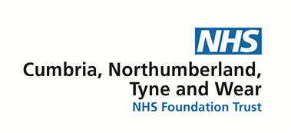

Community Team Learning Disability

Benton House
136 Sandyford Road
Newcastle upon Tyne
NE2 1QE
Tel: 0191 210 6868
27th March 2020

Contact information from Paediatric Speech and Language Therapy

Dear Parent/Carer
Due to Coronavirus we have been advised by our NHS trust to keep clinical contact to essential need only, in order to ensure the safety of your children. However, currently we are still available to offer support and advice over the phone or to send written information to you which may be useful.
If you need support from a Speech and Language Therapist you can contact us at Benton House on 0191 210 6868 and we will be happy to return your call.

Other contact numbers that you may find useful:
Children’s Community Nursing Team: 0191 28 23450
Paediatricians: 0191 282 1156
Dietitians (for orally fed children): 01912824812
Dietitian (for non orally fed children): 0191 2823557
Regional Communication Aid Service: 0191 287 5240
Children and Young People’s Service: 0191 246 6934

Please get in touch if there is anything that you feel we can support you with during this time.

Yours sincerely
Paediatric Speech and Language Therapy Team

