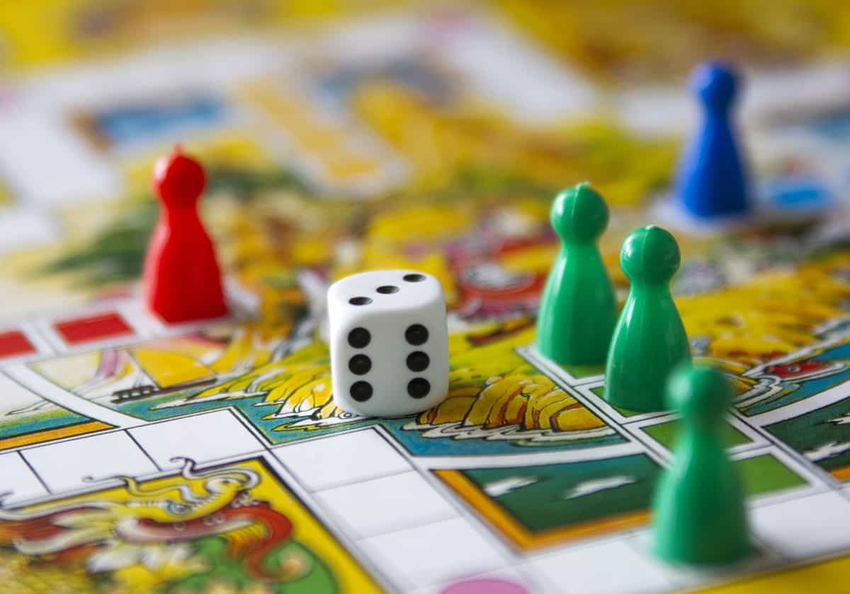

Winning and Losing

Playing games is fun
A lot of the time, playing games and winning is all about luck
If I play a game, there is a chance I might win or lose
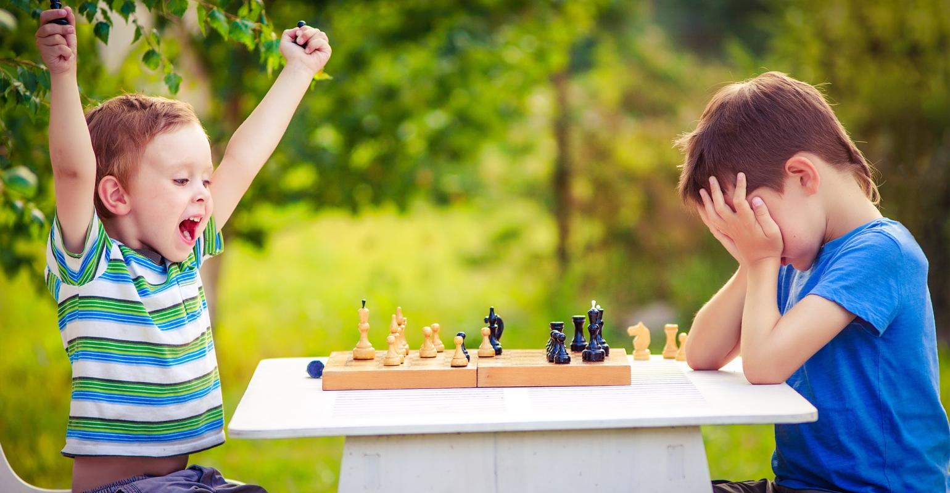

It has nothing to do with whether I am good or bad at the game. Winning and losing is out of my control
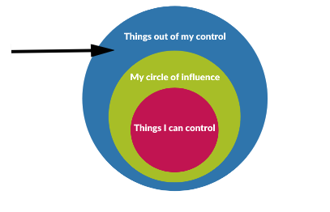
When I lose, it can make me feel frustrated, angry or upset

It is important to remember that it is just a game
I need to remember to use kind hands and kind words when I am playing a game

My friends might win, but my friends might also lose

If they win, I can be happy for them

If they lose, I can comfort them
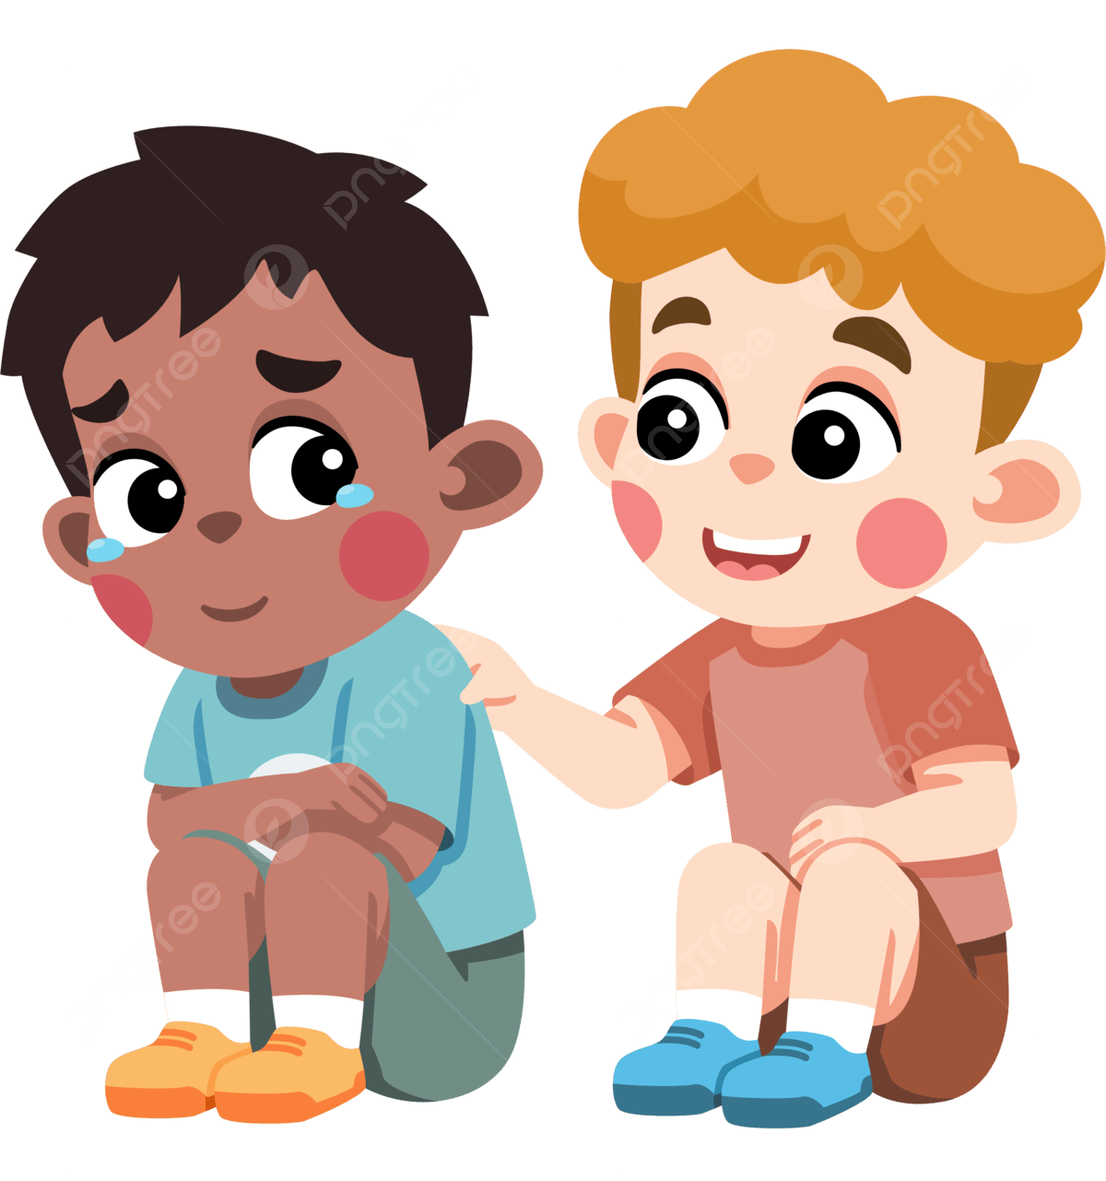

I should be kind to everyone around me when I am playing a game. We can all have fun!
