I go to Gesher School in Pinner. To get there I need to go in a taxi. The taxi takes me to school and also brings me home again after school.

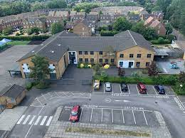

I share the journey with some other children from my school.

There is a driver and also an adult, to keep us safe and make sure we are OK.

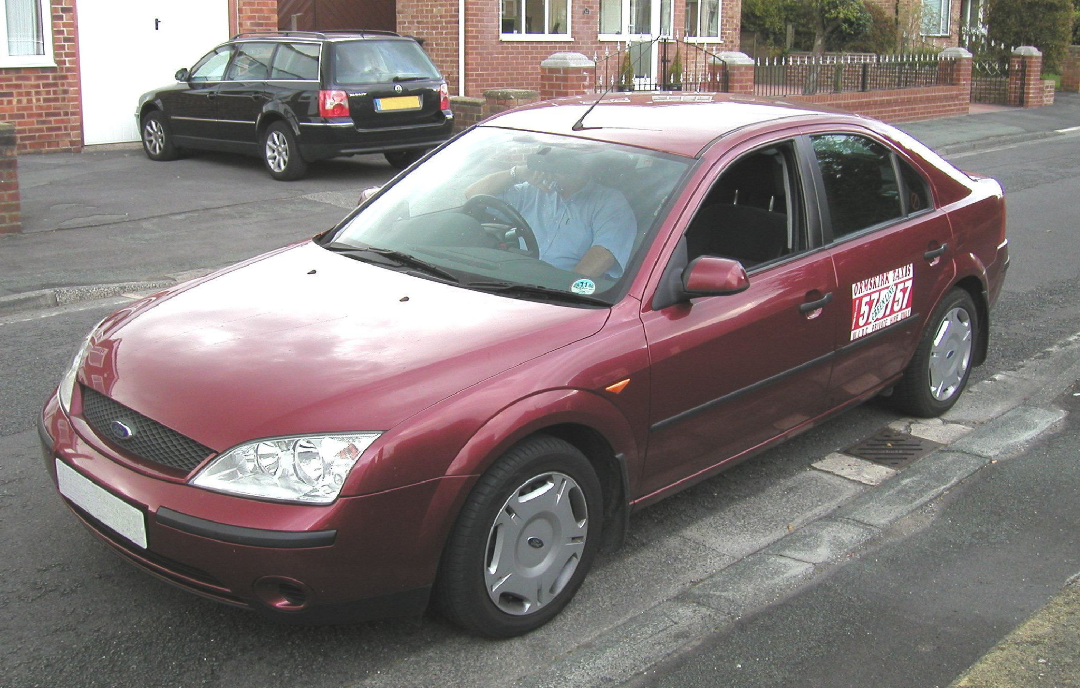

It takes about an hour to get to and from school.

I can look at my phone, I can play games on my phone and I can listen to music.

I can look out of the window.
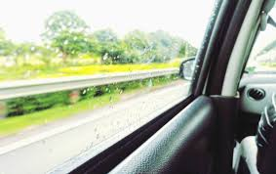

I can talk to my friends and the adults in the car.

Sometimes there are traffic jams. Traffic jams are when the traffic has to queue because there has been an accident or there are men digging up the roads.
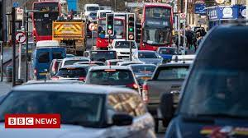

Traffic jams are very common when you live in a big city like London.

Traffic jams do clear up and the traffic can move again.

Sometimes a traffic jam means my taxi is a bit late to pick me up. This is OK.

There is nothing the taxi driver can do to make the traffic clear quicker.

The other children in my school are sometimes also a little late to be picked up because of traffic. This is OK.

If I am late, it is OK. My taxi is doing his best to get to me.
He will pick me up as soon as he can and take me home. This is OK.

Noone will worry and no one will be cross.

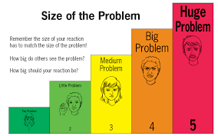

This is a little problem.

