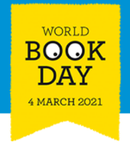
WORLD BOOK DAY
Thursday 4th March 2021

Good morning, here are a list of resources and suggested activities for you to complete today.
Please do not feel you have to complete everything, as long as your children spend some time today reading, talking about stories and enjoying themselves that is all we want!

We would love to see any photos and activities so send them to year1@hartonprimary.co.uk

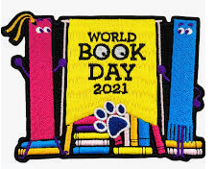
- Take part in a live virtual World Book Day event! Share A Story Live is taking place from 3rd to 5th March with authors and illustrators on YouTube and the World Book Day website.
- Redesign the cover for your favourite book.
- Instead of dressing up, can you decorate an item at home however you like, as long as it relates to a book.
You could choose a paper plate, potato, pebble, wooden spoon, shoe box, lolly stick, paper lantern, pillowcase, t-shirt, poster - the options are endless!
- DROP EVERYTHING AND READ….. at lease once today we want you to stop what you are doing, curl up in a comfy place and read a story of your choice.

Lots more resources and activities are available below:
https://www.worldbookday.com/resources/primary/

https://www.bbc.co.uk/teach/live-lessons/world-book-day-2021-live-lesson/z2thm39

https://www.bbc.co.uk/teach/teach/world-book-day-teaching-resources/z6nt47h

https://www.twinkl.co.uk/search?term=world+book+day

