Reception Exposure to texts.
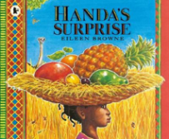  Handa’s Surprise – Eileen Browne | 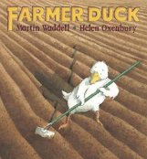  Farmer Duck –  Martin Waddell | 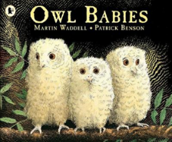  Owl Babies –  Martin Waddell | 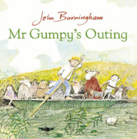  Mr Grumpy’s Outing – John Burningham | 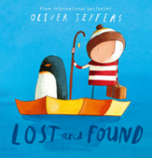  Lost and Found –  Oliver Jeffers | 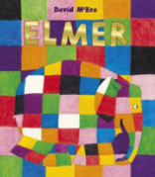  Elmer –  David McKee | Reception texts
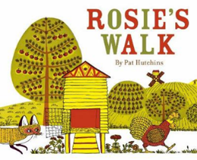  Rosie’s Walk –  Pat Hutchins | 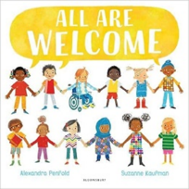Diversity  All Are Welcome –  Alexandra Penfold | 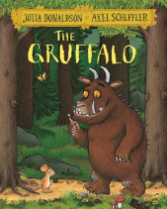  The Gruffalo –  Julia Donaldson | 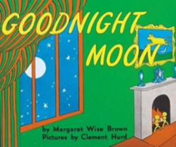  Goodnight Moon –  Margaret Wise-Brown | 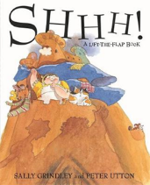  Shhh! –  Sally Grindley | 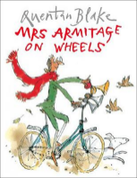  Mrs Armitage on Wheels –  Quentin Blake | 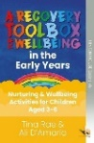  Wellbeing toolkit Early years (3-6) – Tina Rae
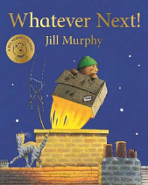  Whatever Next! –  Jill Murphy | 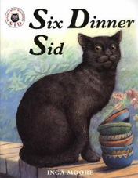  Six Dinner Sid –  Inga Moore | 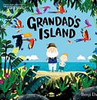  Grandad’s Island – Benji Davies | 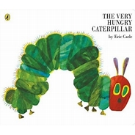  The Very Hungry Caterpillar – Eric Carle | 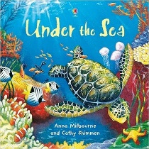  Under the Sea – Anna Milbourne & Cathy Shimmen | 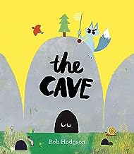  The Cave – Rob Hodgson | 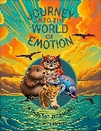  Journey in to the World of Emtion – Herve Rangapen
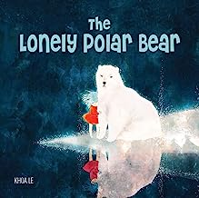  The lonely Polar Bear - Khoa Le | 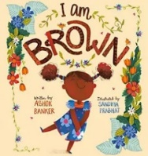  I am Brown – Ashok Banker | 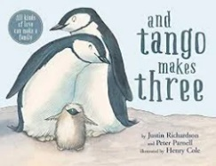  And Tango Makes Three – Justin Richardson and Peter Parnell | 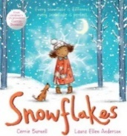  Snowflakes – Cerrie Burnell | 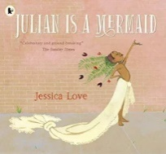  Julian Is A Mermaid – Jessica Love | 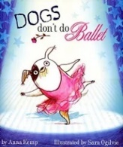  Dogs Don’t Do Ballet – Anna Kemp | Diverse lives and people celebrated
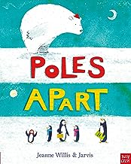  Poles Apart - Jeanne Willis and Jarvis | 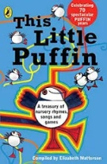  This Little Puffin – Elizabeth Matterson | 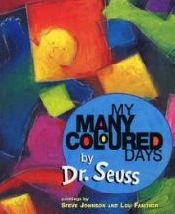  My Many Coloured days – Dr Seuss | 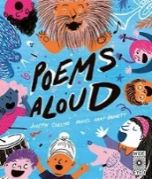  Poems Aloud – Joseph Coelho | 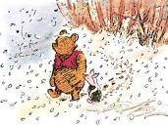  The more it snows – A.A. Milne  Single poem – not a book! | 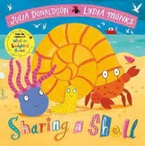  Sharing a Shell – Julia Donaldson | Poetry reception
Year 1 Exposure to texts.
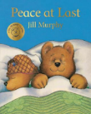  Peace at Last – Jill Murphy | 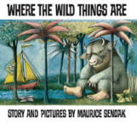  Where the Wild Things Are – Maurice Sendak | 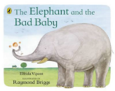  The Elephant and the Bad Baby – Elfrida Vipont | 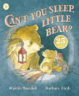  Can’t you sleep little Bear? – Martin Waddell | 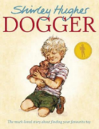  Dogger – Shirley Hughes | 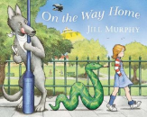  On the Way Home – Jill Murphy | Year 1 texts
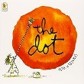  The Dot – Peter H. Reynolds | 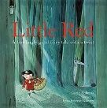  Little Red – David Roberts and Lynn Roberts | 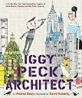  Iggy Peck Architect – Andrea Beaty and David Roberts | 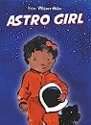  Astro Girl – Ken Wilson-Max | 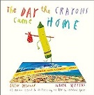  The Day The Crayons Came home – Drew Daywalt | 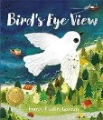  Bird’s Eye View - Frann Preston-Gannon
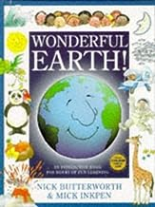  Wonderful Earth – Nick Butterworth | 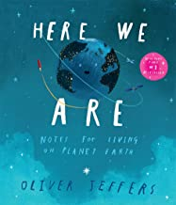  Here We Are – Oliver Jeffers | 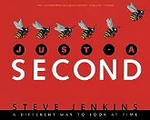  Just a Second – Steve Jenkins | 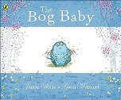  The Bog Baby – Jeanne Willis and Gwen Millward | 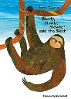  Slowly, slowly, slowly said the sloth – Eric Carle | 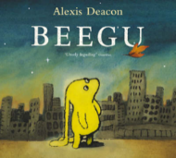  Beegu – Alexis Deacon
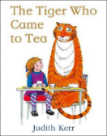  The Tiger Who Came to Tea – Judith Kerr | 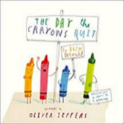  The Day The Crayons Quit – Drew Daywalt | 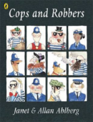  Cops and Robbers - Janet and Allen Ahlberg | 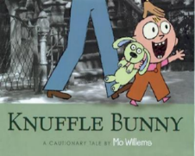  Knuffle Bunny – Mo Williams | 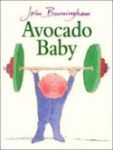  Avacado Baby – John Burningham
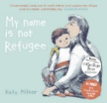  My Name is Not Refugee – Kate Milner | 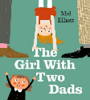  The Girl With Two Dads – Mel Elliot | 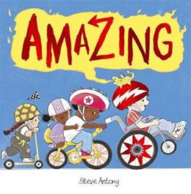  Amazing – Steve Antony | 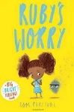  Ruby’s Worry – Tom Percival | 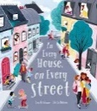  In Every House on Every Street – Jess Hitchman | 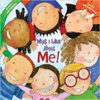  What I Like About Me! – Allia Zobel Nolan | Diverse lives and people celebrated
 |  | 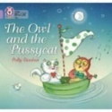 The Owl and the Pussycat – Edward Lear  Single poem – not a book! | 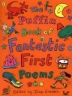  The Puffin Book of Fantastic First Poems – June Crebbin | 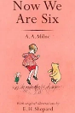  Now We are Six – A.A. MIlne | 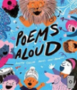  Poems Aloud – Joseph Coelho | Poetry Y1
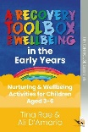  Wellbeing toolkit Early years (3-6) – Tina Rae | Non- Linear Sequence 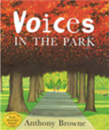  Voices in the Park – Anthony Browne | Narratively Complex 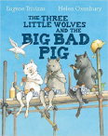  The Three Little Wolves and the Big Bad Pig – Eugene Trivivas | Resistant Text    The Book wit No Pictures – B.J. Novak | Archaic Text  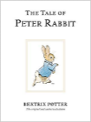  The Tale of Peter Rabbit – Beatrix Potter | Symbolic Text 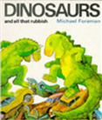  Dinosaurs and all that Rubbish – Michael Foreman | Y1 & Y2 shared genres
Year 2 Exposure to texts
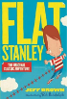  Flat Stanley – Jeff Brown | 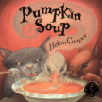  Pumpkin Soup – Helen Cooper | 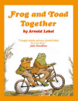  Frog and Toad Together – Arnold Lobel | 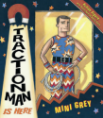  Traction Man is here – Mini Grey | 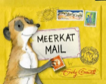  Meerkat Mail – Emily Gravett | 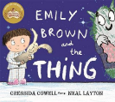  Emily Brown and the Thing – Cressida Cowell | Year 2 texts
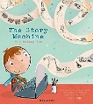  The Story Machine – Tom McLaughlin | 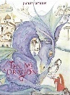  Tell me a Dragon – Jackie Morris | 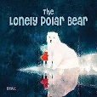  The Lonely Polar Bear – Khoa Le | 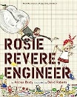  Rosie Revere Engineer - Andrea Beaty and David Roberts | 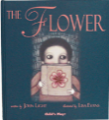  The Flower – John Light | 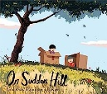  On Sudden Hill - Linda Sarah and Benji Davies
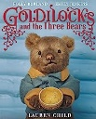  Goldilocks and the Three Bears – Lauren Child | 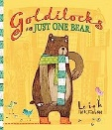  Goldilocks and just the one bear - Leigh Hodgkinson | 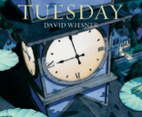  Tuesday – David Wiesner | 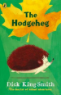  The Hodgeheg – Dick King-Smith | 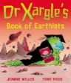  Dr Xargle’s Book of Earthlets – Jeanne Willis | 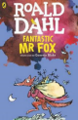  Fantastic Mr Fox – Roald Dahl
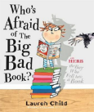  Who’s Afraid of the Big Bad Book? – Lauren Child | 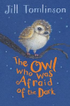  The Owl Who Was Afraid of The Dark – Jill Tomlinson | 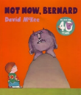  Not Now, Bernard – David McKee | 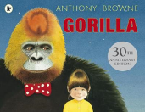  Gorilla – Anthony Browne - | 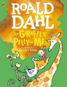  The Giraffe, The Pelly and Me – Roald Dahl | 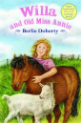  Willa and Old Miss Annie – Berlie Doherty
 |  |  | 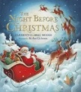  The Night before Christmas – Clement Clarke Moore | 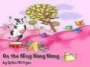  On the Ning Nang Nong – Spike Milligan  Single poem – not a book! | 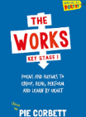  The Works KS1 – Pie Corbett | Poetry Y2
Wellbeing toolkit Early years (3-6) – Tina Rae |  | 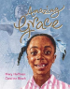  Amazing Grace – Mary Hoffman | 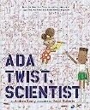  Ada Twist Scentist - Andrea Beaty and David Roberts | 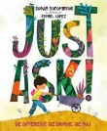  Just Ask – Sonia Sotomayor | 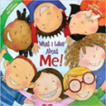  What I Like About Me! – Allia Zobel Nolan | Diverse lives and people celebrated
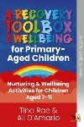  Wellbeing Toolkit Primary (7-11) – Tina Rae | Non- Linear Sequence  Voices in the Park – Anthony Browne | Narratively Complex  The Three Little Wolves and the Big Bad Pig – Eugene Trivivas | Resistant Text  The Book wit No Pictures – B.J. Novak | Archaic Text  The Tale of Peter Rabbit – Beatrix Potter | Symbolic Text  Dinosaurs and all that Rubbish – Michael Foreman | Y1 & Y2 shared genres

Year 3 & 4 Exposure to texts over 2 Years
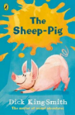  The Sheep Pig – Dick King-Smith | 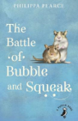  The Battle of Bubble and Squeak – Philippa Pearce | 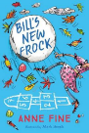  Bill’s New Frock – Anne Fine | 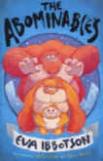  The Abominables – Eva Ibbotson | 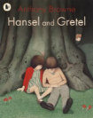  Hansel and Gretel – Anthony Browne | 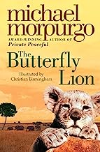  The Butterfly Lion – Michael Morpurgo | Year 3 & 4 texts
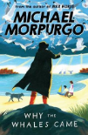  Why the Whales Came – Michael Morpurgo | 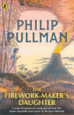  The Firework-Maker’s Daughter – Philip Pullman | 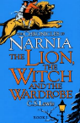  The Lion, The Witch and the Wardrobe – C.S. Lewis | 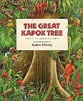  The Great Kapok Tree – Lynne Cherry | 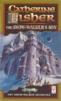  The Snow-Walker’s Son – Catherine Fisher | 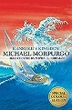  Kensuke’s Kingdom – Michael Morpurgo
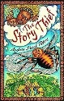  The Story Theif - Andrew Fusek Peters | 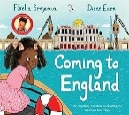  Coming to England – Floella Benjamin | 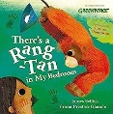  There’s a Rang-tan in my bedroom - James Sellick and Frann Preston-Gannon | 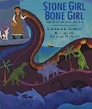  Stone girl, Bone girl - Laurence Anholt | 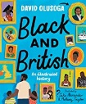  Black and British - David Olusoga | 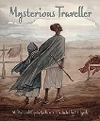  The Mysterious Traveller – Mal Peet and Elspeth Graham
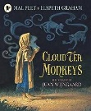  Cloud Tea Monkeys - Mal Peet and Elspeth Graham |  | 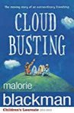  Cloud Busting – Malorie Blackman | 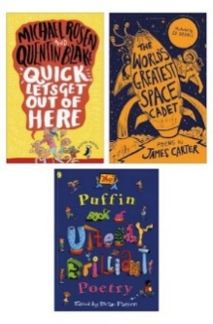  Puffin book of Utterly Brilliant Poetry – Brian Patten | 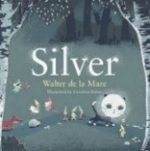  Silver – Walter De La Mare  Single poem – not a book! | 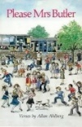  Please Mrs Butler – Allen Ahlberg | Poetry
 | 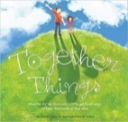  Together things – Michelle Vasiliu | 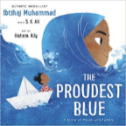  The proudest Blue – Ibtihaj Muhammad | 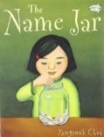  The Name Jar – Yangsook Choi | 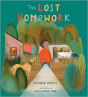  The Lost Homework – Richard O’Neill | 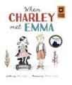  When Charley Met Emma – Amy Webb | Diverse lives and people celebrated
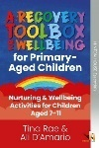  Wellbeing Toolkit Primary – Tina Rae | Resistant Text  Cloud Busting – Malorie Blackman | Symbolic Text  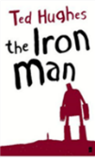  The Iron Man – Ted Hughes | Non-Linear Sequence  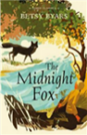  The Midnight Fox – Betsy Byars | Narratively Complex  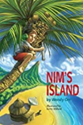  Nim’s Island – Wendy Orr | Archaic Text  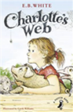  Charlotte’s Web – E.B. White | Y3 & Y4 Range of genres

Year 5 & 6 Exposure to texts over 2 years
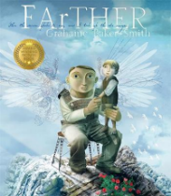  Farther – Grahame Baker-Smith | 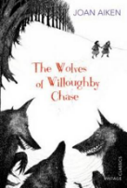  The Wolves of Willoughby Chase – Joan Aiken | 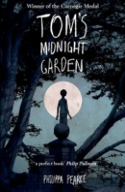  Tom’s Midnight Garden – Philippa Pearce | 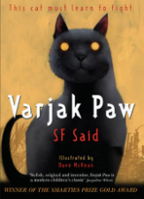  Varjak Paw – S. F. Said | 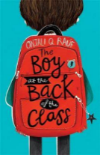  The Boy at the Back of The Class – Onjali Rauf | 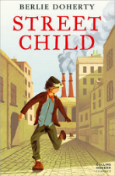  Street Child – Berlie Doherty | Year 5 & 6 texts
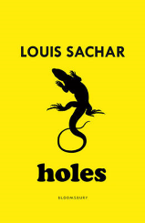  Holes – Louis Sachar | 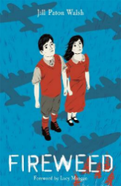  Fireweed – Jill Paton Walsh | 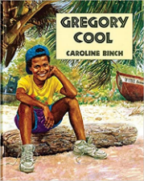  Gregory Cool – Caroline Binch | 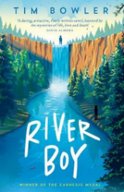  River Boy – Tim Bowler | 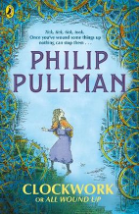  Clockwork - Philip Pullman | 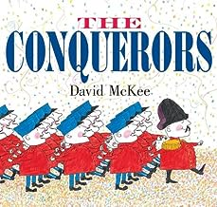  The Conquerors – David McKee
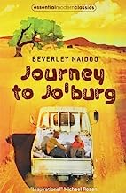  Journey to Jo’berg - Beverley Naidoo | Black and British - David Olusoga | 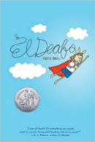  El Deafo – Cece Bell | 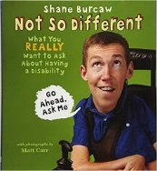  Not so Different – Shane Burcaw | 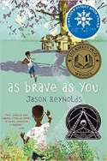  As Brave As You – Jason Reynolds | 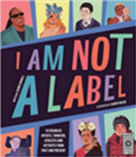  I am Not a Label – Cerrie Burnell | Diverse lives and people celebrated
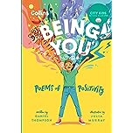  Being You! Poems of Positivity – Daniel Thompson and Collins Kids | 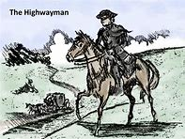  The Highwayman – Alfred Noyes  Single poem – not a book! | 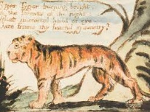  The Tyger – William Blake  Single poem – not a book! | 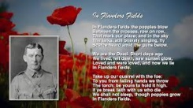  In Flanders Fields – John McCrae  Single poem – not a book! | 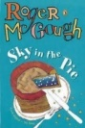  Sky in the Pie - Roger McGough | 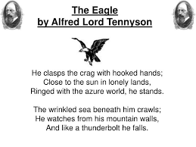  The Eagle – Alfred Lord Tennyson  Single poem – not a book! | Poetry
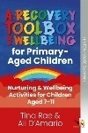  Wellbeing Toolkit Primary – Tina Rae | Non- Linear Sequences 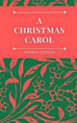  A Christmas Carol – Charles Dickens | Narratively Complex  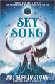  Sky Song – Abi Elphinstone | Resistant Text  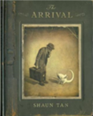  The Arrival – Shaun Tan | Archaic Text  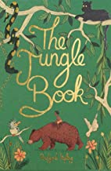  The Jungle Book – Rudyard Kipling | Symbolic Text  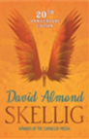  Skellig – David Almond | Y5 & Y6 Range of genres

