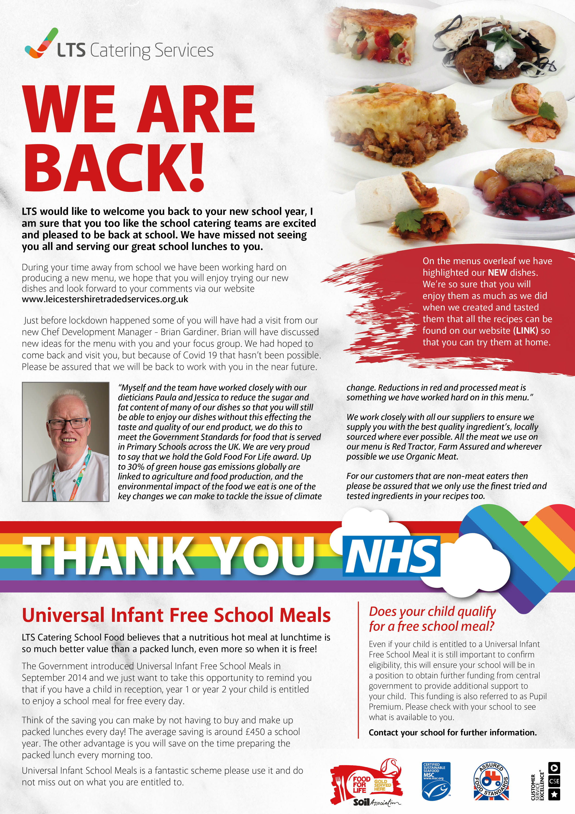

®

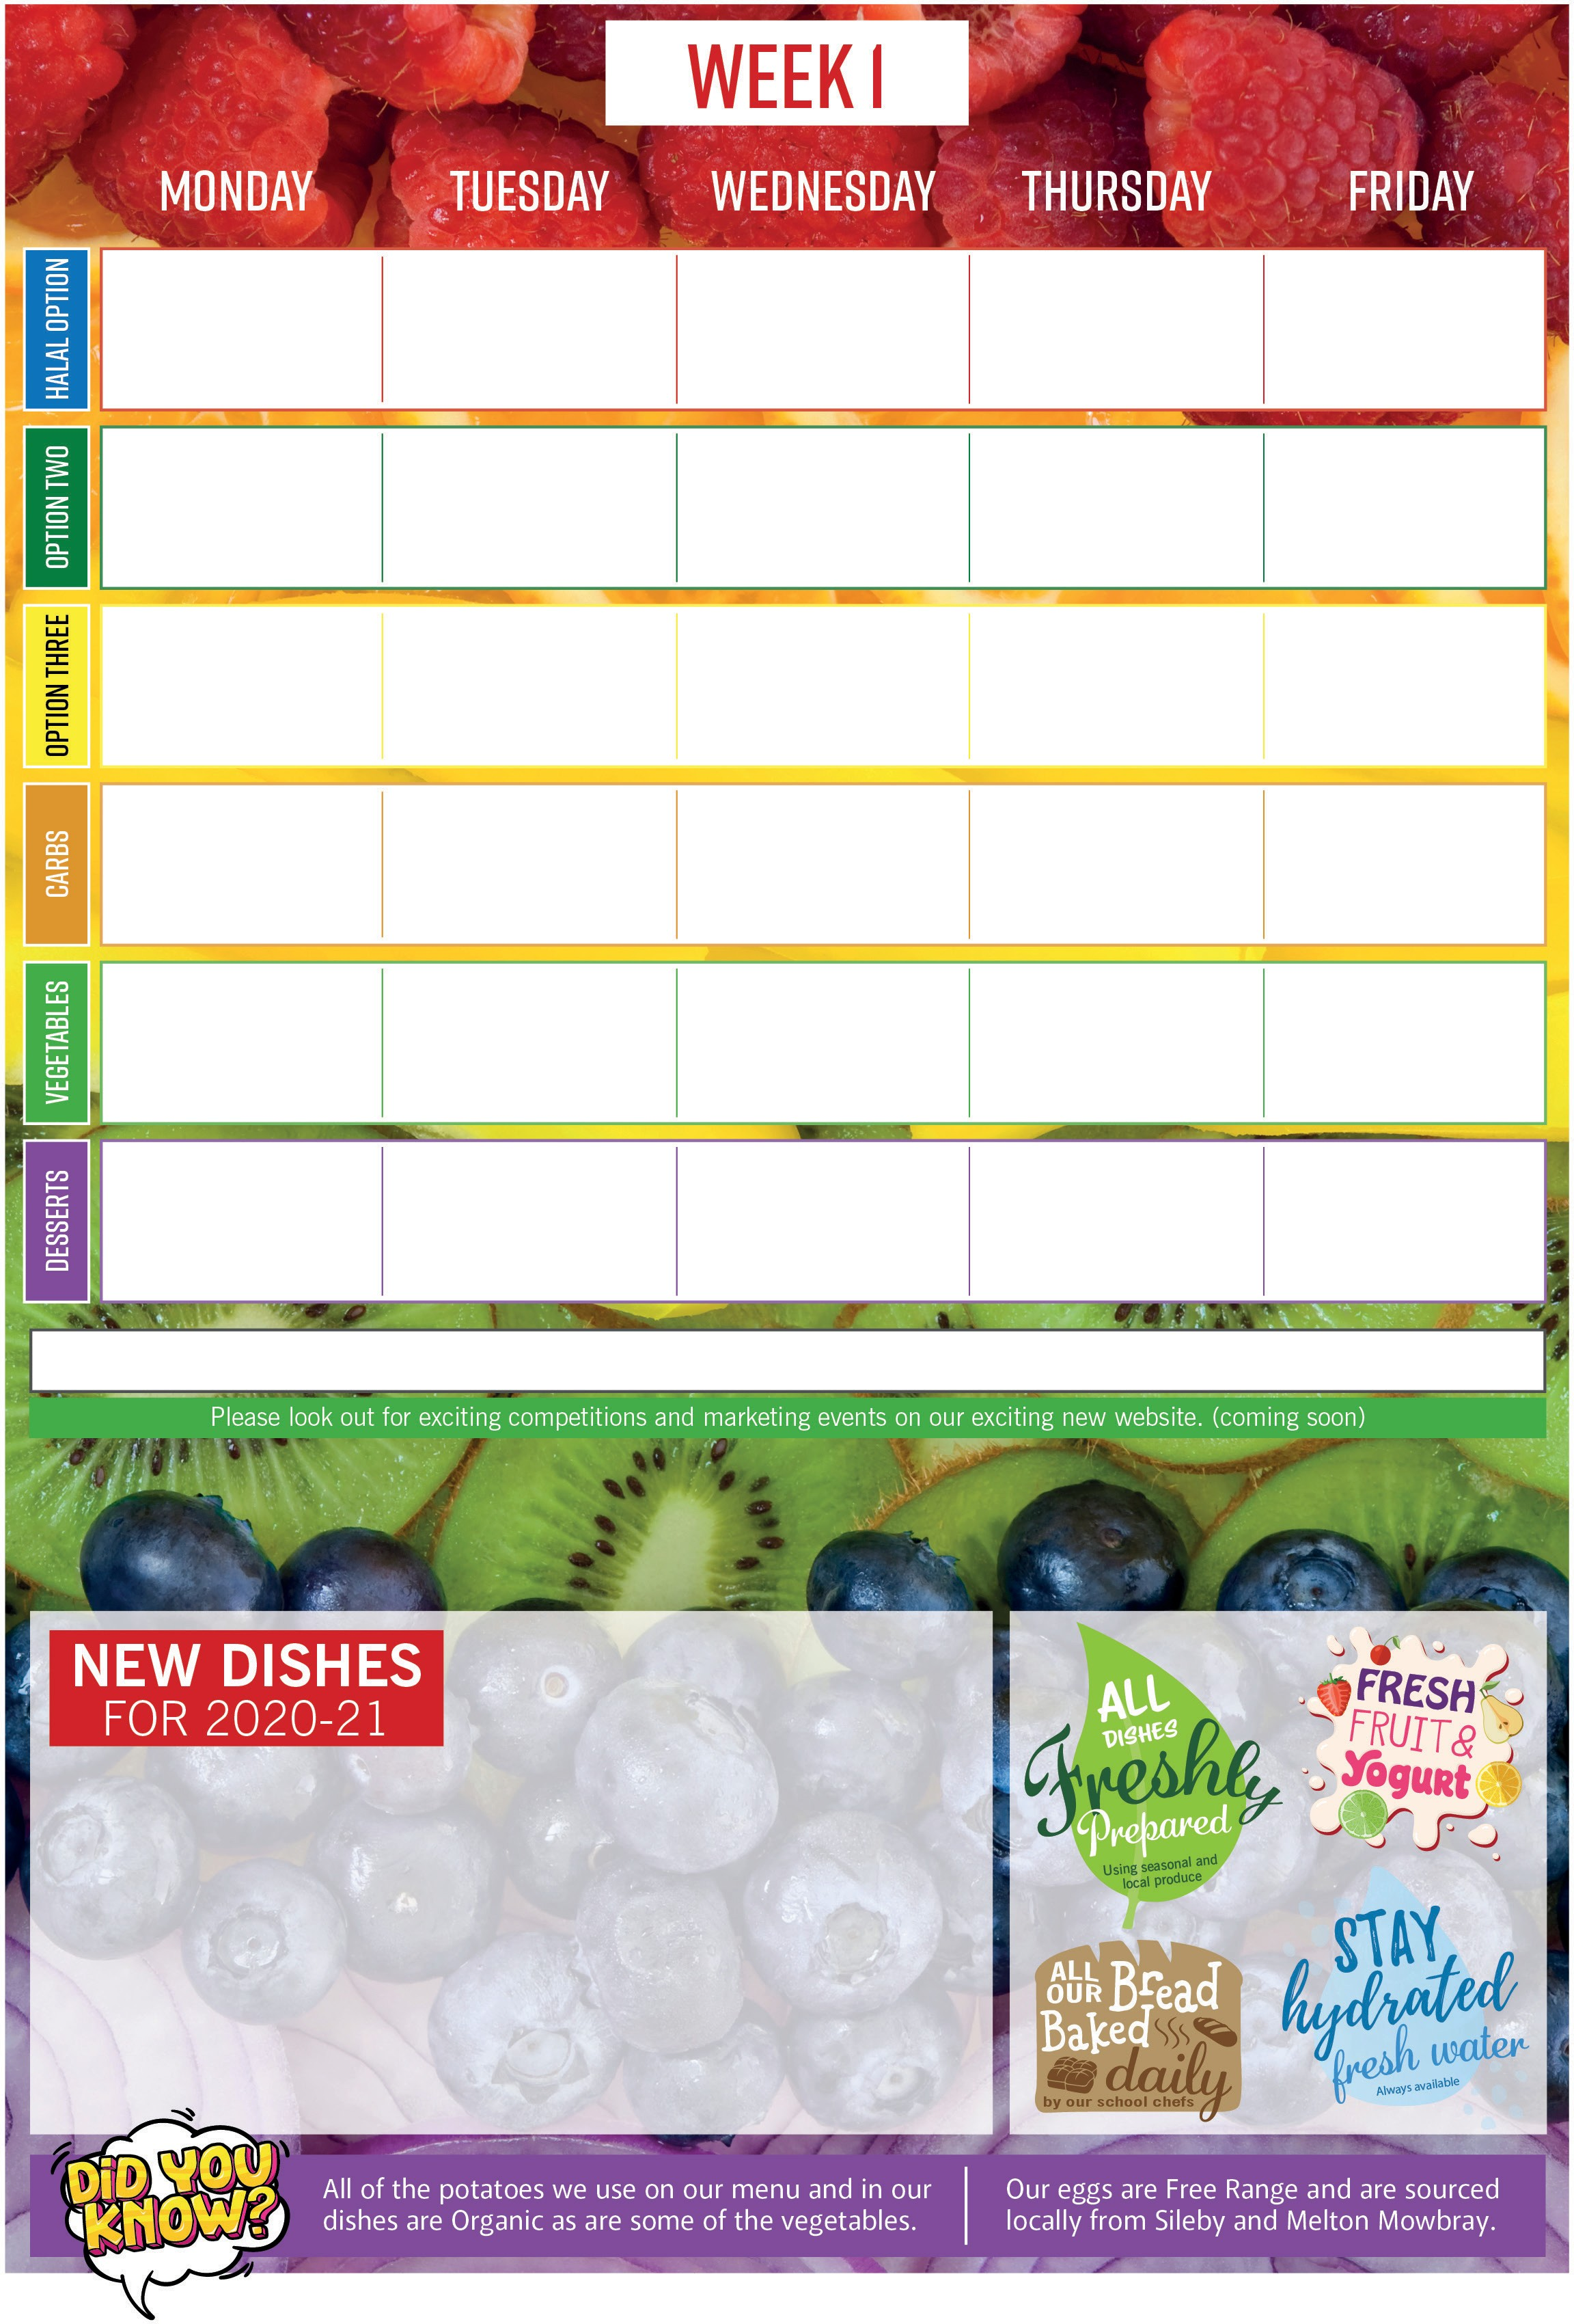

**PEACH & RASPBERRY COBBLER WITH CUSTARD**

*An old favourite of grandmas.*

Juicy peaches and raspberries with a biscuit topping.

**APPLE CAKE**

A light fluffy sponge with the addition of fresh apples.

**HOMEMADE BBQ BEAN WRAP**

Baked beans in a homemade BBQ sauce, served in a soft flour tortilla.

**RED PEPPER & CHEESE FRITTATA**

An egg based Italian dish with fresh red peppers and a cheese topping.

**POTATO & COURGETTE BAKE**

Layers of organic sliced potatoes and courgette bound in a rich white sauce all topped with cheese and baked.

**MEATY MAC CHEESE**

*The makeover of a timeless classic.*

A lamb bolognaise with a homemade creamy macaroni cheese topping.

**LAMB KOFTA**

*A Middle Eastern dish with aromatic spices.*  Minced lamb with added spices, shaped and served in a healthy pitta and

accompanied with a refreshing yoghurt and mint dip.

Vanilla Ice Cream

Flapjack Slice

Iced Bun

Strawberry Jelly & Cream

Chocolate Shortbread

Carrot Cake

Peach & Raspberry Cobbler with Custard

Toffee Crispy Cake

Apple Cake

Granola & Yoghurt Fruit Sundae

Peas

Baked Beans

Salad Bar Selection

Medley of Seasonal Vegetables

Salad Bar Selection

Fresh Cabbage Fresh Carrots

Salad Bar Selection

Green Beans Roasted Vegetables

Salad Bar Selection

Sweetcorn

Homemade Crunchy Coleslaw

Salad Bar Selection

Chips

Half a Jacket Potato

Garlic Bread

Parsley Potatoes

Creamed Potatoes

Fluffy Rice

Fluffy Rice

Half a Jacket Potato

Pasta in Tomato Sauce

Potatoes in their Skins

**Sustainably Caught (MSC) Battered Fish** with Tomato Ketchup

**Halal Lamb Meaty Mac & Cheese**

**Halal Roast Chicken** with Sage and Onion Stuffing & Gravy

**Halal Lamb Kofta** Served in a Pitta with a Yoghurt & Mint Dressing

**Jacket Potato with Baked Beans & Homemade Crunchy Coleslaw**

**Margherita Pizza**

**Roasted Pepper & Tomato Pizza**

**Jacket Potato with Vegetarian Bolognaise**

**Lentil & Sweet Potato Curry**

**Potato & Courgette Layer Bake**

**Quorn Dippers**

**Margherita Pizza**

**Red Pepper & Cheese Frittata**

**BBQ Bean Wrap**

**Sustainably Caught (MSC) Tuna Pasta Bake**

**2021** - 26th Apr, 17th May, 7th Jun, 28th Jun.

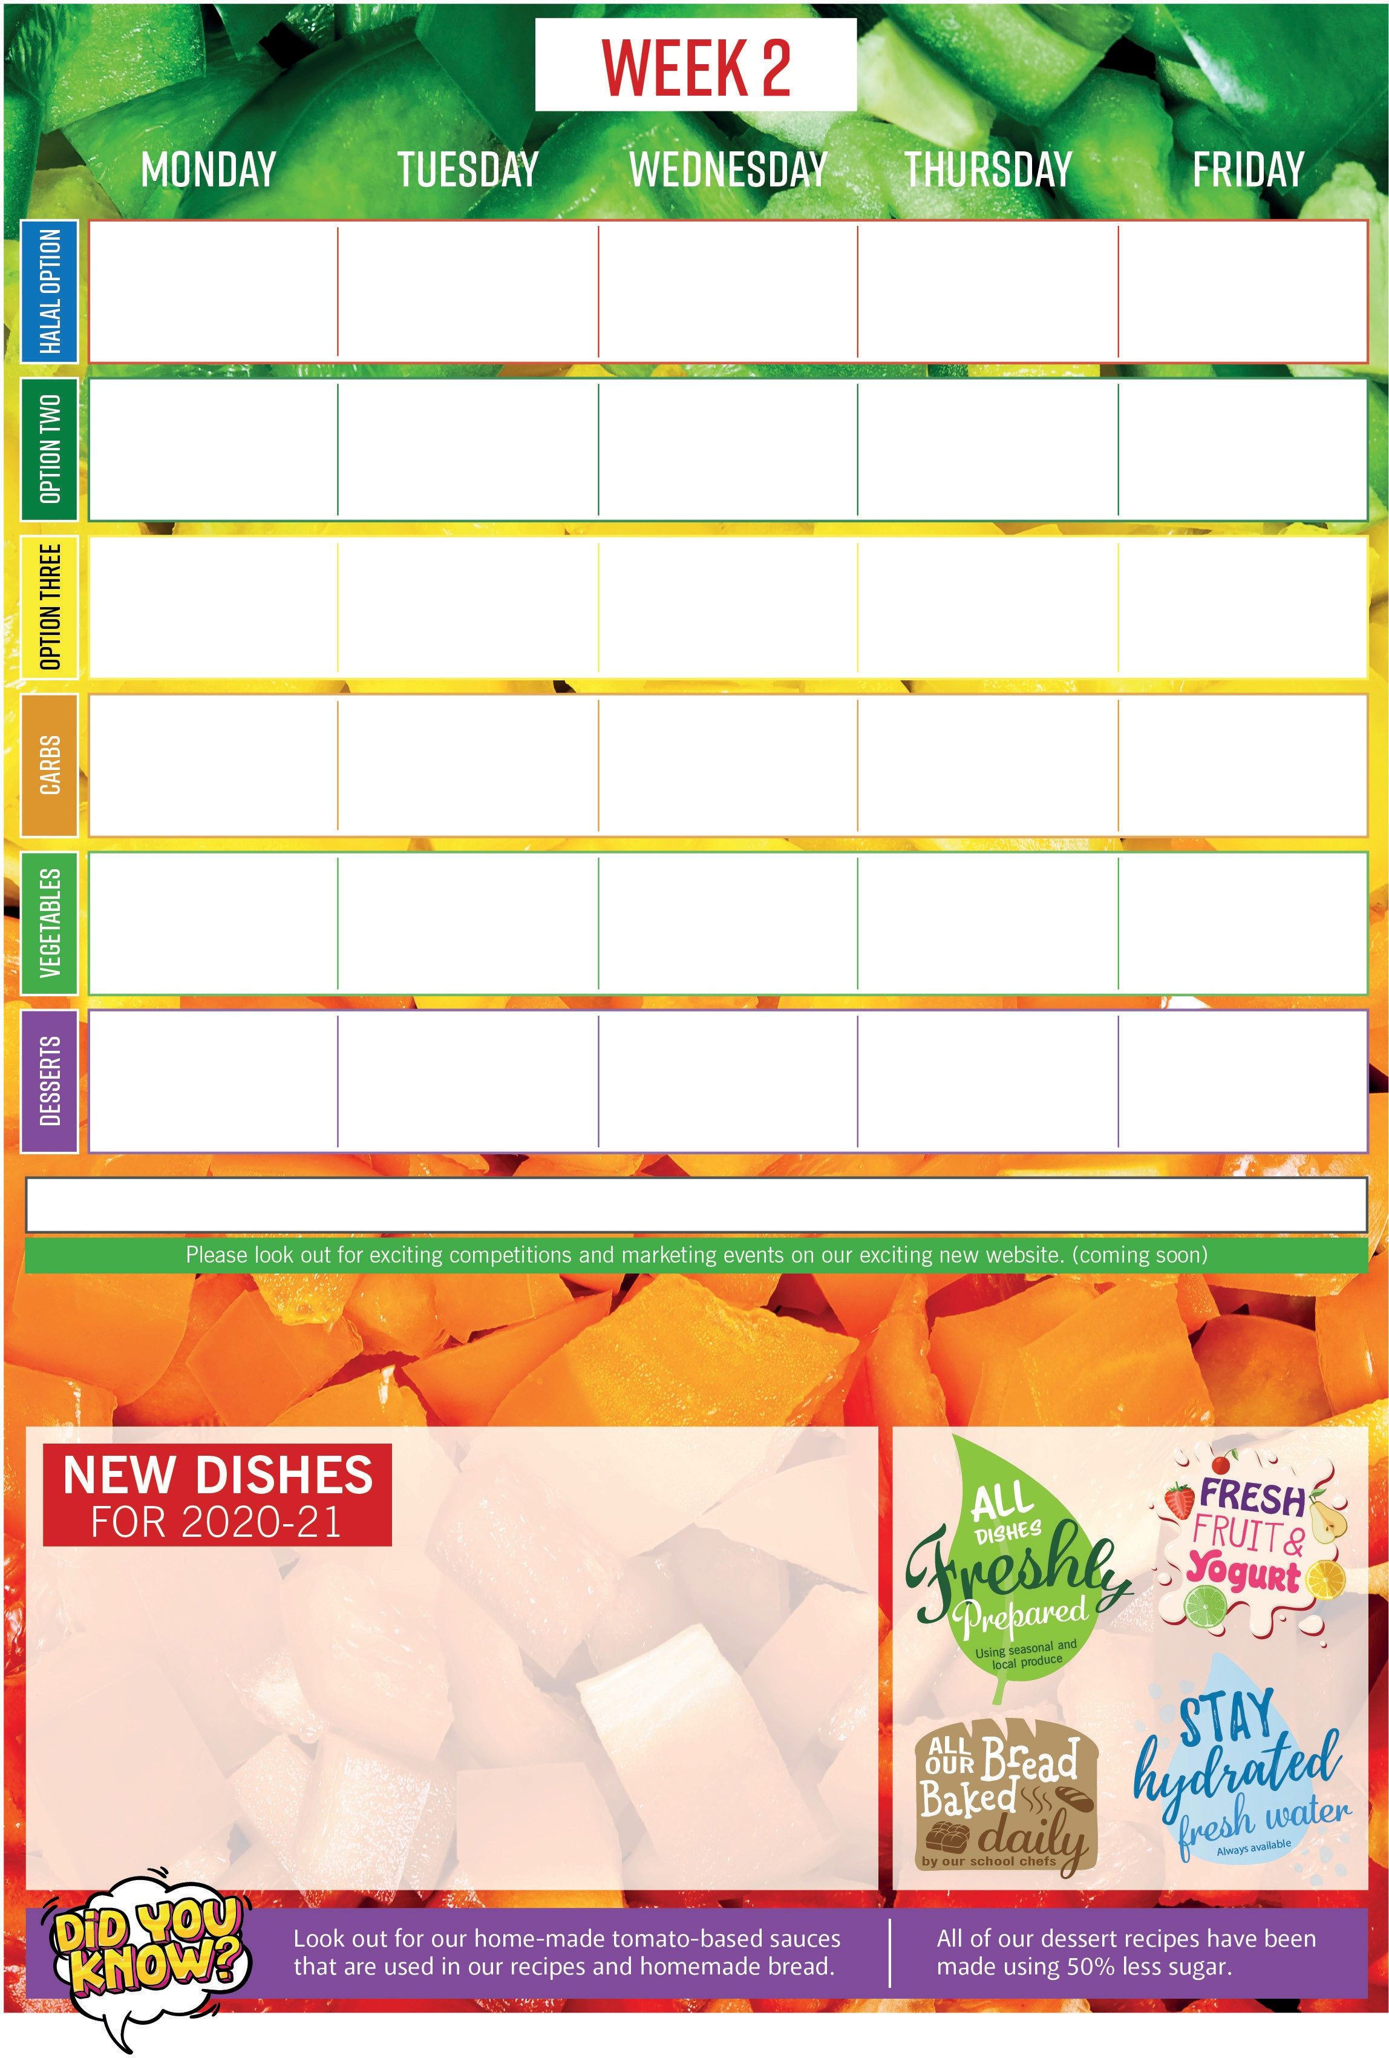

**PEAR SPONGE & CUSTARD**

A light sponge with a base of sweet pears.

**CINNAMON SWIRL**

A sweet flavoured pastry with cinnamon, rolled and cut into a swirl, delicious served warm.

**SWEET POTATO & PEA RISOTTO**

Rice sautéed with sweet potato, peas and onions.

*A northern Italian dish with lots of Flavour Enjoy!*

**GARLIC MUSHROOM PIZZA**

A light dough spread with a homemade rich tomato sauce, topped with vegetables, Garlic Mushrooms and Cheese.

**CHOCOLATE & BEETROOT BROWNIE**

This gooey centred brownie has the addition of earthy beetroot counting as one of your 5 a day! *Sweet and delicious, what’s not to like!*

Cinnamon Swirls

Vanilla Ice Cream

Lemon Drizzle Cake

Banana Flapjack

Pear Sponge with Custard

Oaty Cookie

Cheese & Biscuits

Seasonal Fruit Oaty Crumble with Custard

Chocolate & Beetroot Brownie

Strawberry Whip

Peas

Baked Beans

Salad Bar Selection

Apple Coleslaw Fresh Carrots

Salad Bar Selection

Broccoli Fresh Carrots

Salad Bar Selection

Sweetcorn Peas

Salad Bar Selection

Carrots Green Beans

Salad Bar Selection

Chips

Pasta

Herby Jacket Wedges

Jewelled Couscous

Potatoes in their Skins

Garlic Bread

Fluffy Rice

Parsley Potatoes

Mashed Potatoes

Half a Jacket Potato

**Margherita Pizza**

**Sweet Potato & Pea Risotto**

**Spanish Omelette**

**Jacket Potato** with Baked Beans

**Cheese & Onion Potato Cake** with a Homemade Tomato Sauce

**Sustainable Caught (MSC) Fish Fingers** or **Salmon Fish Fingers**

**Halal Chicken & Sweetcorn Pizza**

**Halal Roast Chicken** with Sage and Onion Stuffing & Gravy

**Halal Chicken Sausages**

in Onion Gravy

**Quorn Stir Fry**

**Vegetarian Sausages** in Onion Gravy

**Traditional Cheese Flan**

**Sweet Chilli Pasta**

**Garlic Mushroom Pizza**

**Vegetable Fingers**

**2021** - 12th Apr, 3rd May, 24th May, 14th Jun, 5th Jul.

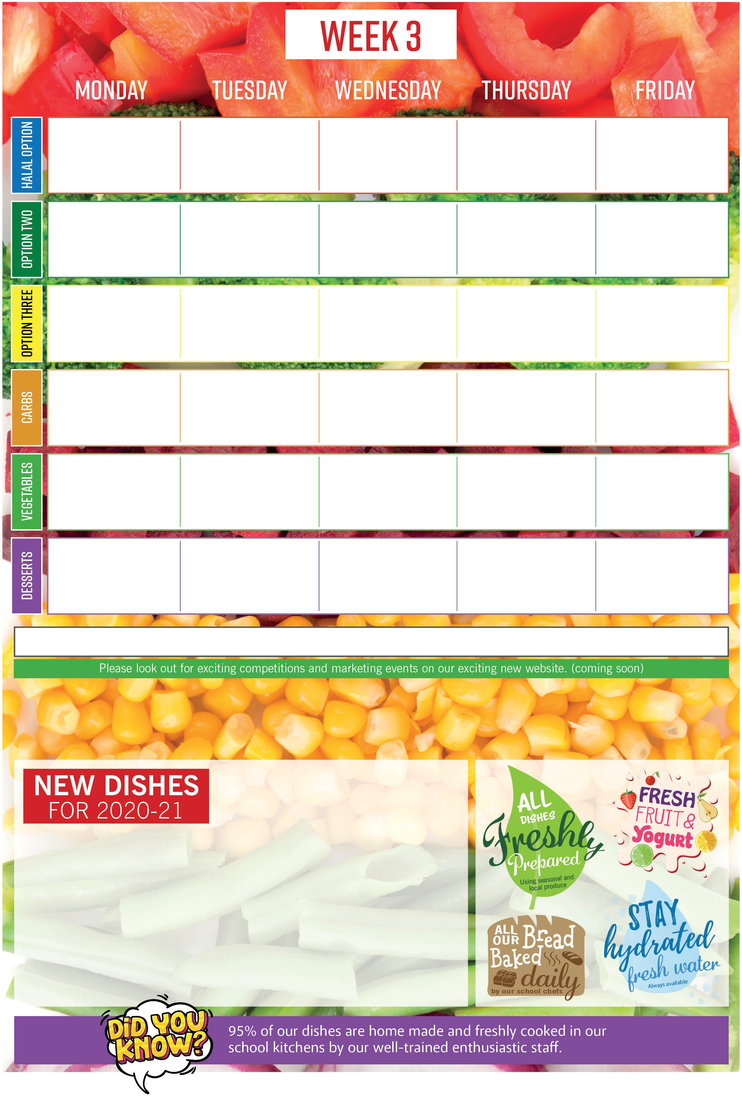

**SPINACH & CHICKPEA MASALA**

*An Asian Mild Spiced Curry.*

Wholesome chickpeas with leafy green spinach, mixed in a homemade curry based sauce.

**DUTCH APPLE CAKE**

A light sponge infused with fresh apples, sultanas and a hint of cinnamon. Served with a hot creamy custard.

**GINGER SYRUP SPONGE WITH CUSTARD**

A gooey syrup base with a light ginger sponge top, sweet and tasty served with a creamy custard.

**JERK CHICKEN**

*A hint of Jamaica bringing the Caribbean to our kitchens.*

Farm assured chicken coated in our homemade jerk marinade. Tasty but not to hot!

Chocolate Ice Cream

Viennese Whirls

Orange & Mandarin Jelly with Whipped Cream

Banana Cake

Ginger Syrup Sponge with Custard

Chocolate Cornflake Cakes

Courgette & Lime Cake

Cherry Shortbread

Dutch Apple Cake with Custard

Butterscotch Whip

Peas

Baked Beans

Salad Bar Selection

Roasted Vegetable Medley

Salad Bar Selection

Sweetcorn Peas

Salad Bar Selection

Cauliflower & Broccoli Cheese

Fresh Carrots

Salad Bar Selection

Carrots Broccoli

Salad Bar Selection

Chips

Half a Jacket Potato

Jacket Wedges

Rice & Peas

Pasta Shapes

Garlic Bread

Potato & Carrot Mash

Fluffy Rice

Half a Jacket Potato

Roasted Vegetable Couscous

**Butter Bean & Spinach Wrap**

**Vegetable Lasagne**

**Margherita Pizza**

**Jacket Potato** with Baked Beans

**Jacket Potato with Vegetarian Chilli**

**Courgette sausages**

**Sustainably Caught (MSC) Fish Fingers** with Tomato Ketchup

**Halal Jerk Chicken** with a Fruity Salsa

**Sustainably Caught (MSC) Tuna Pizza**

**Homemade Halal Lamb Meatballs** in a Homemade Tomato Sauce

**Halal Roast Chicken** with Sage and Onion Stuffing & Gravy

**Macaroni Cheese**

**Spinach & Chickpea Masala**

**Vegetarian Cottage Pie**

**Homemade Spicy Bean Burger**

**2021** - 19th Apr, 10th May, 31st May, 21st Jun, 12th Jul.