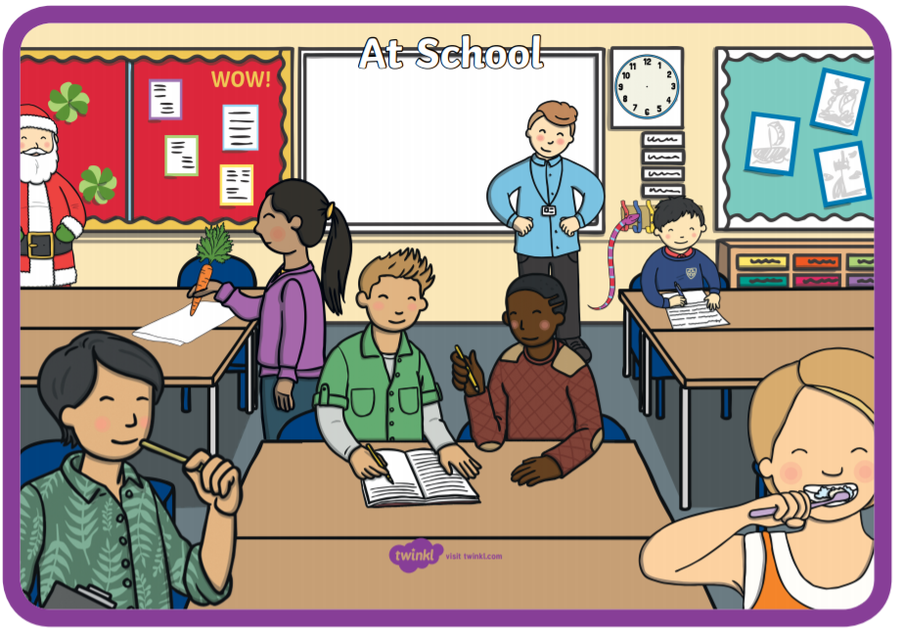
What is Wrong in the Picture?
Activity
- Look at the picture together.
- Name the objects that you can see – e.g. teacher, clock, table, Santa.
- Talk about the colours and people. Who could they be?
- Model additional language to your child. For example, if they say ‘them’ and point to a person, you could say ‘yes, they are the teacher. He is a man’.
- Ask questions about what you can see. For example, ‘What is the boy doing?’ If your child points and says ‘that’, respond by saying ‘yes, he’s writing in his book’. Can you say that?’ Encourage your child to offer additional vocabulary throughout.
- Ask questions about what the people are doing – ‘What is the girl doing?’ – ‘She’s brushing her teeth’. ‘Do you brush your teeth in school?’
- Encourage your child to talk about who is a girl or a boy in the picture.
- Talk about what is wrong in the picture – ‘should Santa be in the classroom?’
- Link to your experiences of going to school – ‘What would you do in school?’
‘Does your classroom look like that?’

