Year Group: 2

Week commencing: February 8th 2021

Teacher’s email address: contact email - mgilbert@marsdenprimary.org.uk

Hello Year 2, Well who can really believe that we are on Week 6 of our home learning and I need to tell everyone how super proud and pleased I am of our fantastic, special class. You are sending me some amazing examples of work and I am also receiving some brilliant photos of activities that you are doing to keep busy. You are really inspiring me to try new things too. This week with the rainy weather I am exercising more indoors and I found this fantastic cardio workout video to keep our hearts healthy. It is such fun that Rosie and I have completed it every day, so I have included it on our daily exercise. It is called “Would you rather” -the link is below. This week we are beginning to try out our new google classroom, so I am very excited to see how that goes too. Friday is our well- being day, I think we need it, so I have added some lovely activities to try out at home, look on the Y2 well- being folder on the Marsden Website for some super ideas. Remember next week there is no school so please continue to try new things for your well –being and relaxation
So Y2 keep busy, keep reading and keep safe. Love Ms Gilbert x
You might like to try…
Reading Oxford Owl Reading Scheme- all of the Y2 children have made amazing progress last term and I would like this to continue. This scheme is similar to theY2 reading scheme. Download READING SCHEME e books on this free site
https://www.oxfordowl.co.uk/api/digital_books
This site is free for parents just login and create a password
Children know their colour reading level and there is a huge range of good texts on this site. I would recommend- Oxford Reading All Stars as a new and exciting range of fiction stories, Tree Tops and some non-fiction texts. Try and complete two or three books this week, reading everyday if you can.
here are lots of extra challenges added to the school website to keep you busy too - http://www.marsdenprimary.org.uk/ I have also included daily powerpoints and videos on the school website with worksheets and answer sheets. Can you be mini teachers Y2 and mark your own maths work.
Well- being Activities from the Institute of Positive Education
https://www.teachpeec.com/wp-content/uploads/2020/03/Weekly-Wellbeing-Phase-2.pdf
Reducing Screen time for children increases well-being. Try some of the activities in the Y2 Well- Being Folder

Phonics and Spelling
Day | Learning objective | Activities – suffixes er/ est | Any other information  Challenges
Monday | I can identify root words and add the suffix er / est to words ending in y | https://www.youtube.com/watch?v=ibq_bWQDluQ  Watch the video for rules when adding suffixes  Activity – complete task below Stage 2 –Monday  Remember a root word is the base word ,eg happy and the suffix that you add can be er/ est | Log on to Spelling Shed to complete games  Any problems accessing site please email me
Tuesday | I can identify and spell words with the el sound which come after a consonant | Complete the activity below- Stage 2 Tuesday  Think about the size of your handwriting and practice your joins please.! | Challenge: https://www.phonicsbloom.com/uk/game/suffix-factory-set-1?phase=6  Try this game which allows you to practice different spelling rules when adding suffixes.  See if you can recognise the spelling rule
Wednesday | I can sort words looking closely at the suffix | Complete the activity below – Stage 2 Wednesday  Remember the spelling rule as you sort out your words.  Can you choose two words from each bucket and write a full sentence please? | Challenge- https://www.bigbrownbear.co.uk/suffix/  This helps to reinforce spelling rules - good practice  .
Thursday | I can spell and write words from memory which contain the er / est suffix | Complete the activity below for Thursday Stage 2  Create your word search using this week’s spellings- how difficult can you make this word search- see if anyone can complete it in your family | Challenge-  https://www.phonicsplay.co.uk/resources/phase/6/tumbling-tumbleweeds  username:jan21  password: home  This game will reinforce the teaching of adding the suffix ing
Friday | Well Being Day
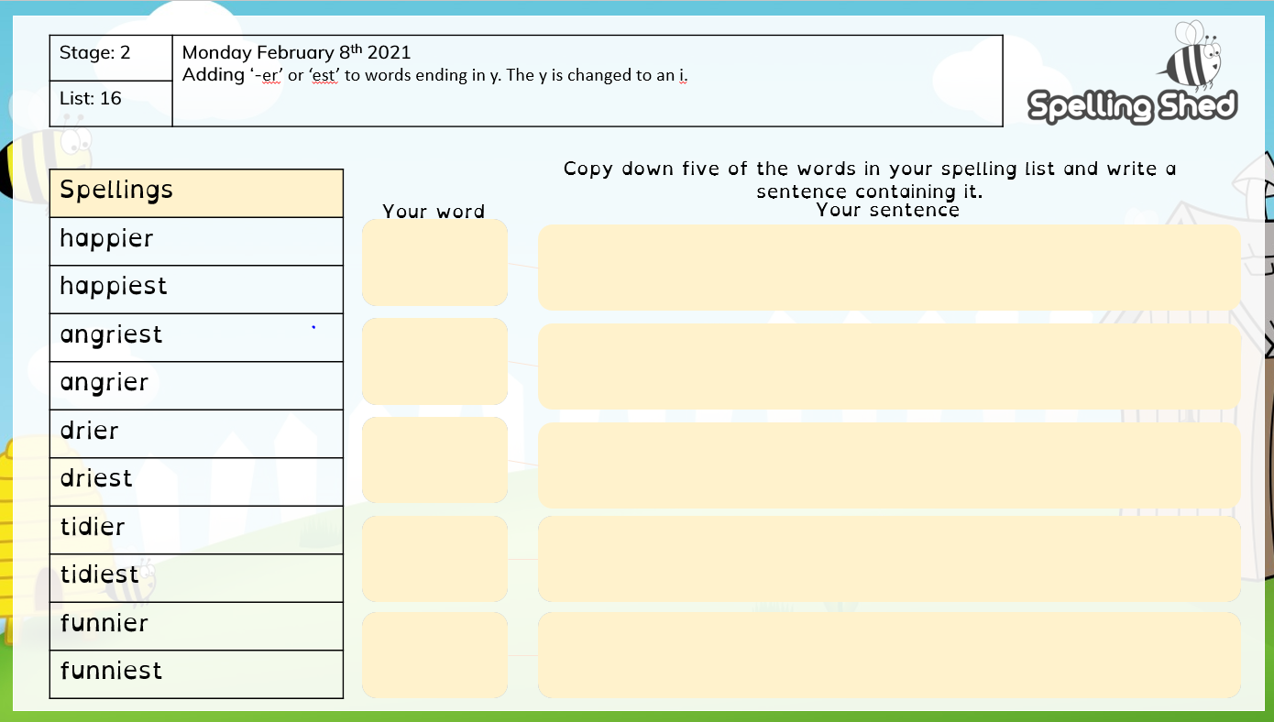

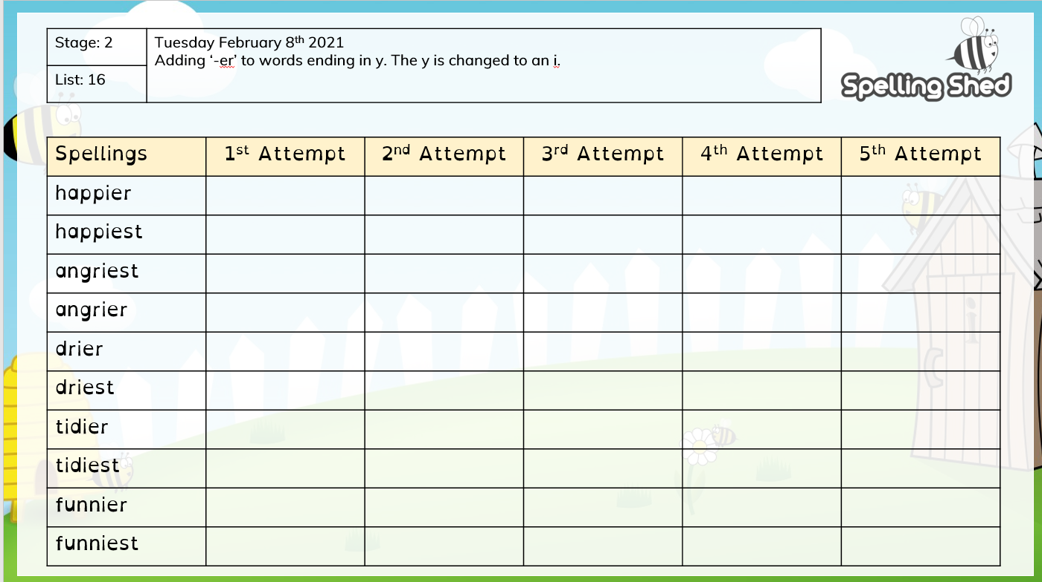

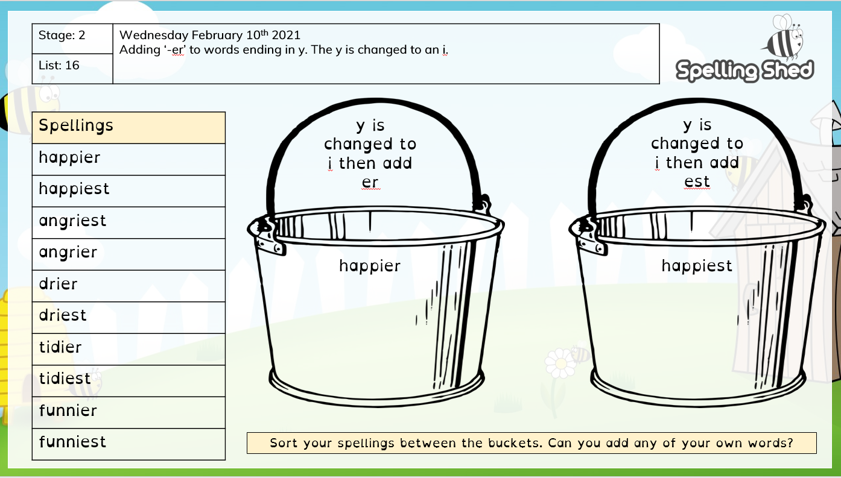

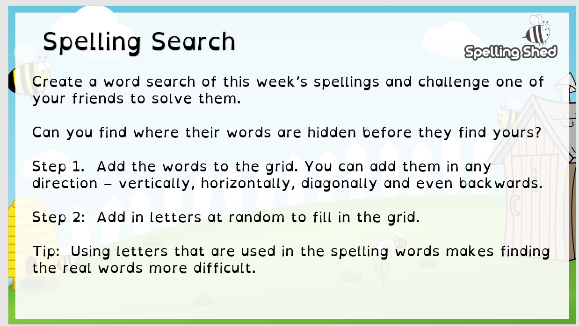

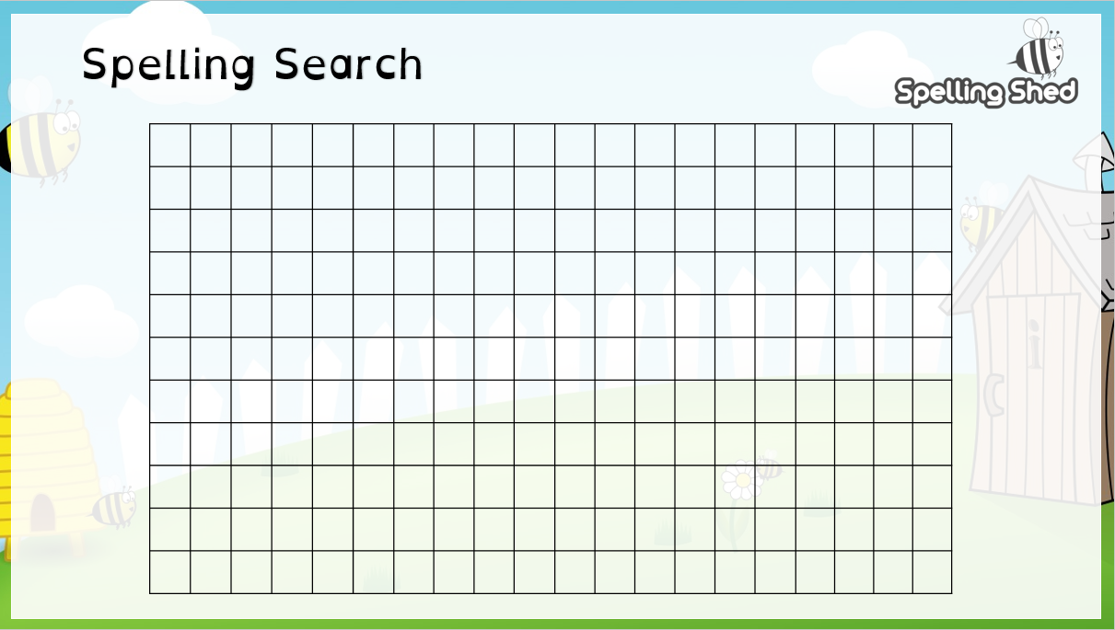

Day | Learning objective | English-Activity- The Unlucky Man  Story Telling – Exploring Characters | Any other information
Mon | I can listen, respond and understand an unfamiliar story | https://classroom.thenational.academy/lessons/to-listen-and-respond-to-a-story-64rpar?activity=video&step=1  Lesson 1- Spelling Activity- I can spell words ending in a suffix when the spelling of the root words changes (rule drop the y and add ied) Remember what is a consonant  Activity- Listen to a story and recreate a plot matrix to help understand story | Challenge – Do you feel lucky or unlucky?  Look around you and draw a picture about how you feel.  Will you write two or more sentences telling me if you feel lucky or unlucky.
Tues | I can tell a story from memory | https://classroom.thenational.academy/lessons/to-tell-a-story-from-memory-c4wkat?activity=video&step=1  Lesson 2- Activity – What do we know about the Unlucky Man?  Draw a story map to order the story and think about the main events and characters. As you create your story map can you write key words to help you remember parts of the story.  Talk through your story.  Can you retell the story of the Unlucky Man to someone in your house? | Challenge- In the video we read the words impatient, greedy, ungrateful, selfish and foolish. Can you find out what each of these words mean? Then write an interesting sentence using each of these words, please remember capital letters and full-stops in your sentences.
Wed | I can explore characters from different  perspectives | https://classroom.thenational.academy/lessons/to-explore-character-6rtp6t?activity=video&step=1  Lesson 3- Spelling Activity- to add the suffix er to root words-(rule drop the y and add ier) Remember an adjective is a describing words.  Activity 1 – to write a “song” to describe how the wolf felt about the unlucky man.  Activity 2- to become an interviewer and ask questions to one of the characters | Challenge- Can you now write three questions that you (as an interviewer) would ask the Unlucky Man about his experiences and time on the mountain
Thur | I can use different sentence types- diary entries | https://classroom.thenational.academy/lessons/to-show-not-tell-how-a-character-is-feeling-6mr66d?activity=video&step=1  Lesson 4–Grammar - Reinforce sentence types, to help I have uploaded a powerpoint to remind you about sentence types  Activity- To write a diary entry about one of the characters in this week’s story | Challenge – There is no school next week, to keep you busy why don’t you write a diary about what you do and how you feel next week when there is no school and we are all still in Lockdown
Fri |  | Well being day

English Monday February 8th 2021 – The Unlucky Man – Plot Matrix

Where? | Who? | Problem?
Solution? | Ending? | Learning?

Thursday February 11th 2021–
Cut out the sentences and sort into the 4 sentence types – question, command, exclamation, statement
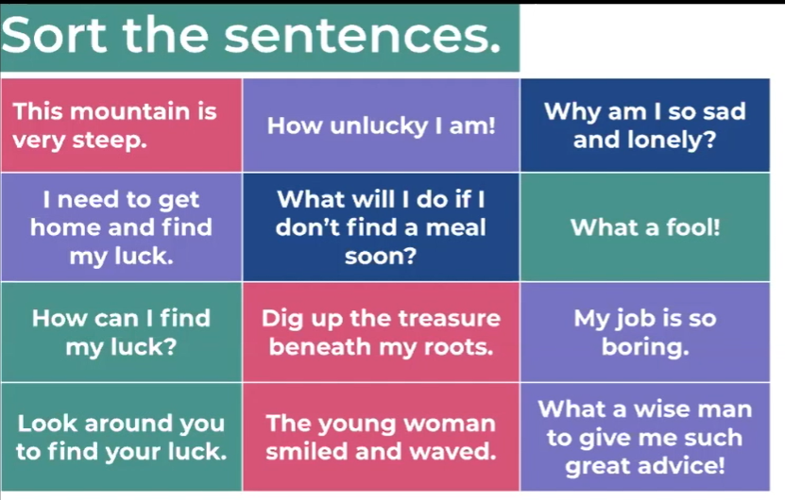

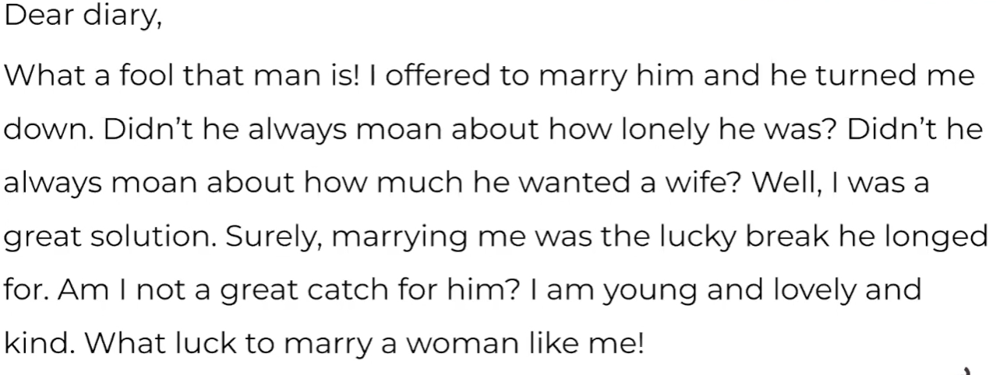

Use 4 coloured pens or pencils to highlight the four different sentence types.

Maths
Day | Learning objective | Activity- Statistics | Any other information
Mon | I can draw pictograms using 2s/ 5s/10s | Starter- tallying and pictograms involves counting in 2s/ 5s/ 10s confidently, can you practice counting to 100 in a variety of ways  https://vimeo.com/504480875  Complete the activity below – Colourful Charts | Challenge-  Can you create two questions about the information that you have found using your pictogram
Tues | I can draw pictograms | Watch the White Rose Video https://vimeo.com/504483835  download and complete the worksheet  Mark your work – can you add smiley faces to calculations you found easy and a sad face if you found the problem difficult. | Reasoning Challenge-  Complete the challenge below
Wed | I can interpret pictograms | Watch the White Rose Video https://vimeo.com/504484570  Complete the activities below linked to the video.  A pictogram is a simple chart that gives us information about groups and amounts(this is called data) The pictogram is always is shown in a visual form- this makes it such fun for the children to create but watch carefully for the key! | Problem Solving Challenge –  Complete the challenge below- think carefully as each circle represents 10 vehicles-
Thurs | I can draw pictograms | Watch the video https://vimeo.com/501673699  then download and complete the worksheet  Mark your work – | Challenge-
Friday |  | Well Being Day

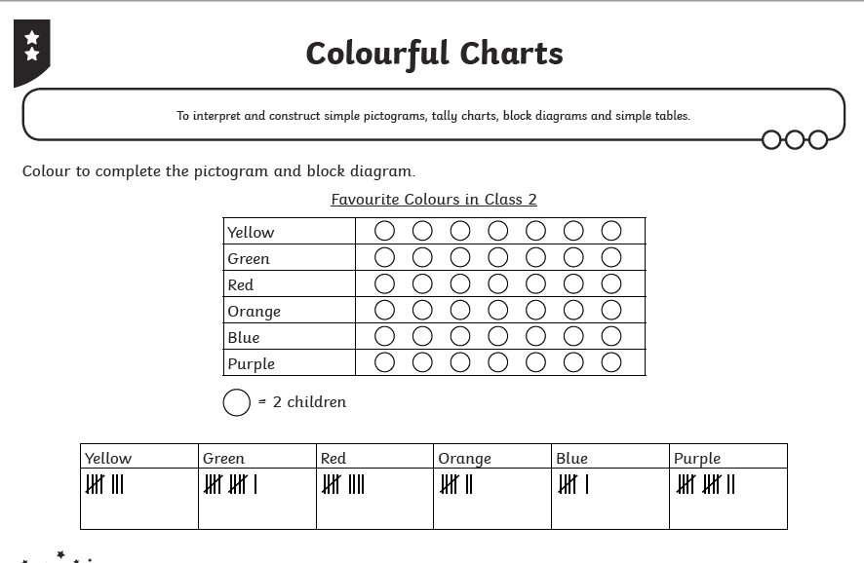

Tuesday Challenge

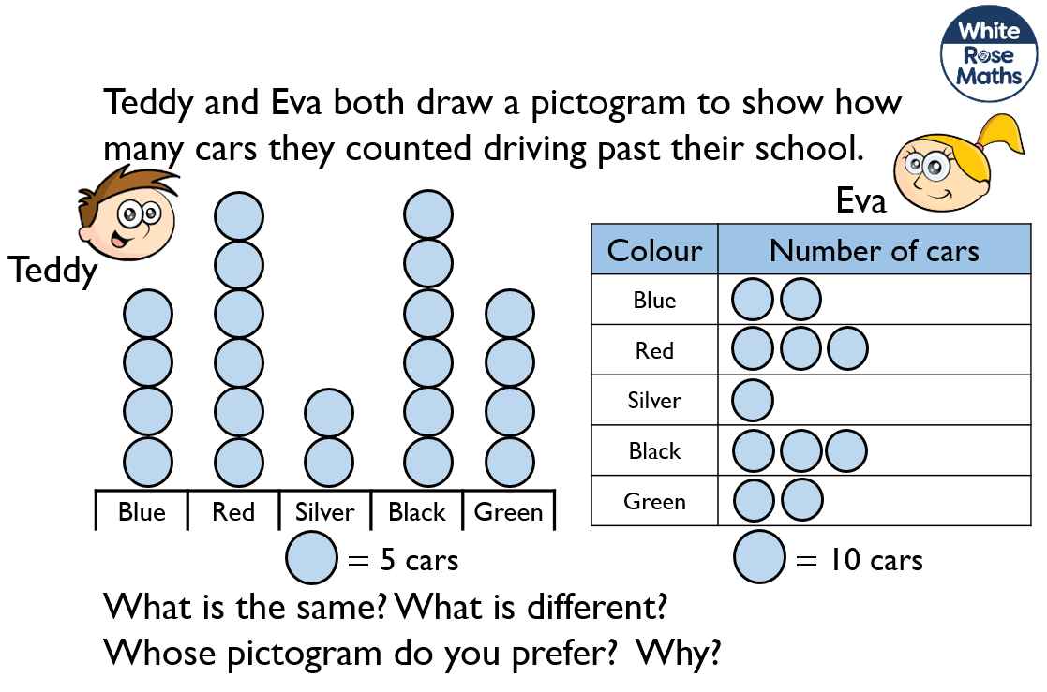

Wednesday Challenge-

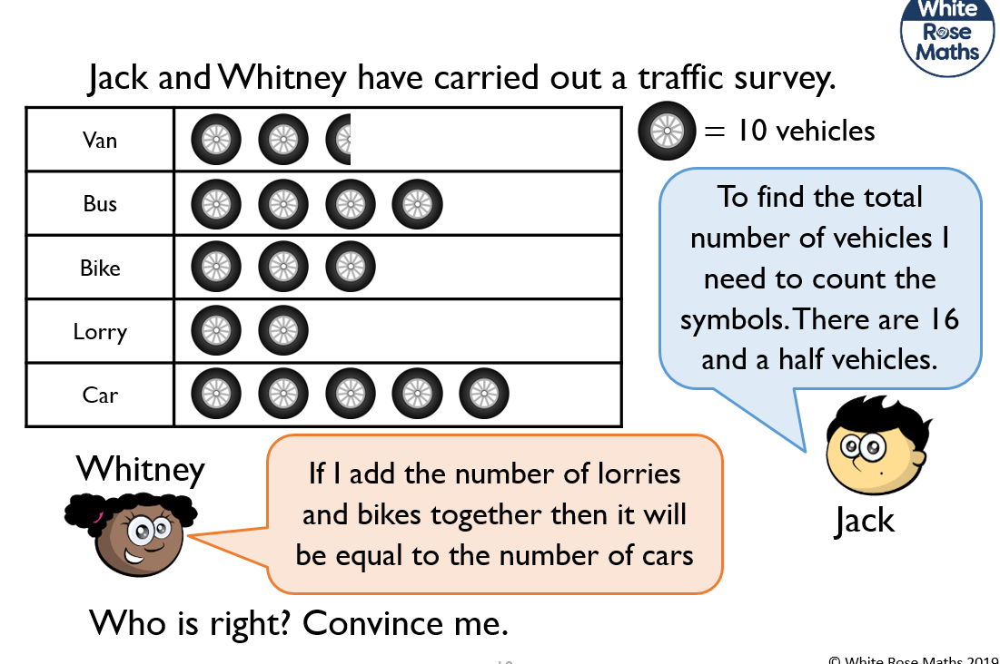

Thursday Challenge

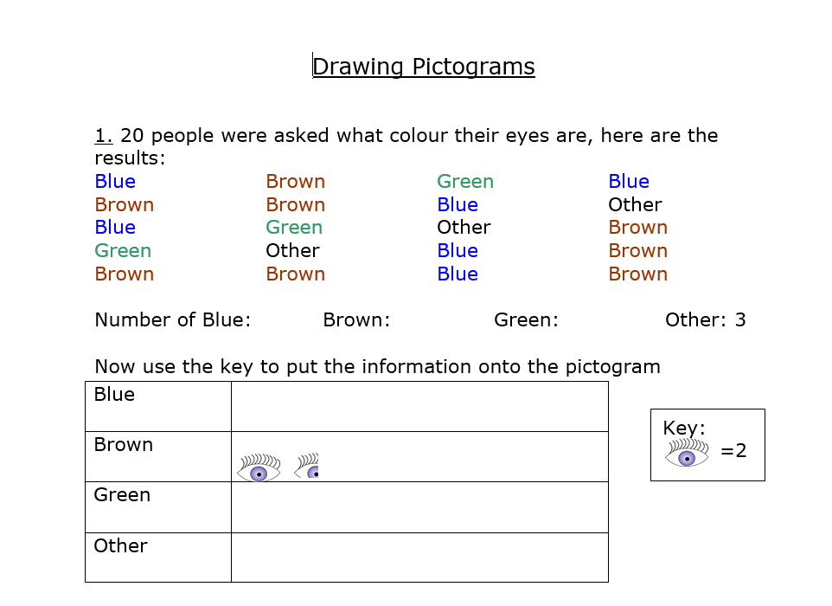

Foundation Subjects
Day | Learning objective | Activity
Monday  R.E | I can find out about bible stories –  The First Story  Adam and Eve | This half term we are going to learn about the Bible and some of the stories from the bible. Today’s story is from the Old Testament in the Bible, it was the first story.  Vocabulary – Christian , Old Testament, Garden of Eden Jesus, Creation, Tree of Knowledge  Today’s Story- Adam and Eve  In this story today I want you to think about how lucky Adam and Eve were. Look in the Garden of Eden, what do you see? Were they lucky or unlucky, what do you think? Download and watch the Twinkl powerpoint about the story of Adam and Eve  Activity –This story is about looking around you and seeing and understanding good and evil  Think about the questions and tell someone in your house what you think.  Draw a picture about the Garden of Eden – see below, look at good and evil  What is good about the Garden of Eden?  Was there any evil in the garden?  RE Challenge –Christians believe that Adam and Eve should have obeyed God. They believed that Adam and Eve were lucky to have the Garden of Eden and that they should have been thankful to God  Think about your life. What are you lucky to have? Think about being thankful and grateful for what you have around you, including the love of your family and friends.  When you have thought about this try creating this “Thankful Tree” to remind you of how lucky you are
Tuesday  Science | I can find out raw and synthetic materials  Key Question  What is the difference between raw and synthetic materials? | This half term we are going to be learning about Materials. Today we are looking at how absorbent materials are  Oak Academy Science- https://classroom.thenational.academy/lessons/which-materials-are-absorbent-c5j6ar?step=2&activity=video  Thinking Activity:  -Watch the Video and complete the quiz- check your answers  Star words – materials, raw materials, synthetic materials, man-made, natural  A raw material is a natural material which has not been changed by humans- natural material, a material that comes from nature  A synthetic material is a material which has been changed by human beings- a man-made material  Answer the key question- Where do raw materials come from? Listen to the video and find out the answer  Which materials are absorbent?  What is the opposite of absorbent?  Practical Activities I can sort materials into groups?  Exploring a variety of materials to see which materials are raw or synthetic  Complete the activity below and check your answers.  Complete the end of lesson quiz.  Challenge Questions- What do you think?  Watch this video clip about plastics and the second clip is about glass  https://www.bbc.co.uk/bitesize/clips/zsys34j  https://www.bbc.co.uk/programmes/p0117vlq  Is plastic a raw or synthetic material?  How is glass changed from a raw material sand into a synthetic material glass.?  Remember to use the words liquid and solid when describing how glass is made into a synthetic or man-made material  What do you think about man changing raw materials into synthetic materials?
Wednesday  History | I can find out about a key inventor | This week we are looking at Thomas Edison. He is an American inventor who is famous for inventing the electric light system. Can you imagine what it would have been like to live without electricity? Have a look around your home. What items need electricity?  Edison also invented many other key inventions. Show powerpoint.  Activity: Using the internet research Thomas Edison. What can you find out?  Write a fact file using the information you have learnt about Edison.
Thursday  Geography | I can find out about London. | We have been learning all about the United Kingdom. Can you remember what the four countries are called? Can you remember what is in each country? We have been focusing on London. London is England’s capital city. Can you remember any other facts?  Watch Oak Academy Video: https://classroom.thenational.academy/lessons/what-are-the-landmarks-in-london-71k3cc  Activity: Choose one London Landmark and create an information poster. Can you include a title, picture and some facts about your chosen landmark?  Key Words: United Kingdom, England, Scotland, Northern Ireland, Wales, capital city, landmark.
Friday  Art | I can find out about a key artist.  Suggested well being | We have been looking at Kandinsky. This week is our final week looking at his work. Kandinsky is a Russian artist famous for his abstract work and love of colour.  Watch: https://www.youtube.com/watch?v=SIWjR3otGvM  Activity: One of Kandinsky’s most famous pieces was his work with circles.  This week I would like you to choose a different shape. (eg, heart, triangle, square) and create your own Kandinsky inspired piece.  Be imaginative and use anything you have in your home.

Monday Feb 1st 2021 RE

This story is all about what is good around us and what could be not so good. Can you draw pictures of the good things that you notice in the Garden of Eden and what you see as “not so good” or evil in the garden

Good things in the Garden of Eden | Not so good things that happened in the Garden of Eden

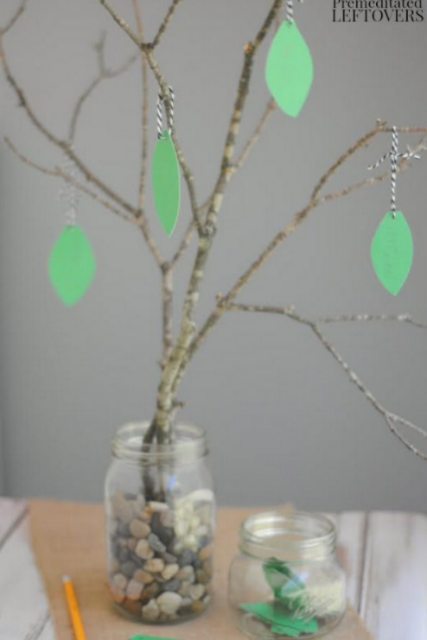Create your own tree of thankfulness to help you remember what you can be grateful for and how lucky you are!
You will need a plastic container, some small stones, some twigs, paper,pen and string.
Put the stones in the container and balance your twig in the container. Cut your paper into leaf shapes and on each leaf write one thing that you are grateful for, or lucky to have. Hang it on your tree. Every day you can look at your tree and remember how lucky and grateful you are. You can also add a new leaf each day when something happens in your life and you think “wow how lucky am I” Send me some photographs of your thankful trees, I would love to see them!

Tuesday Feb 2nd 2021 Science- Cut out the pictures and words of the materials below and sort them into their correct circle
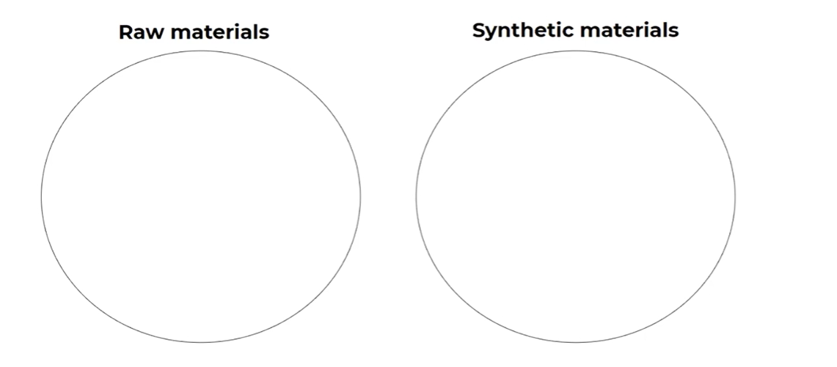

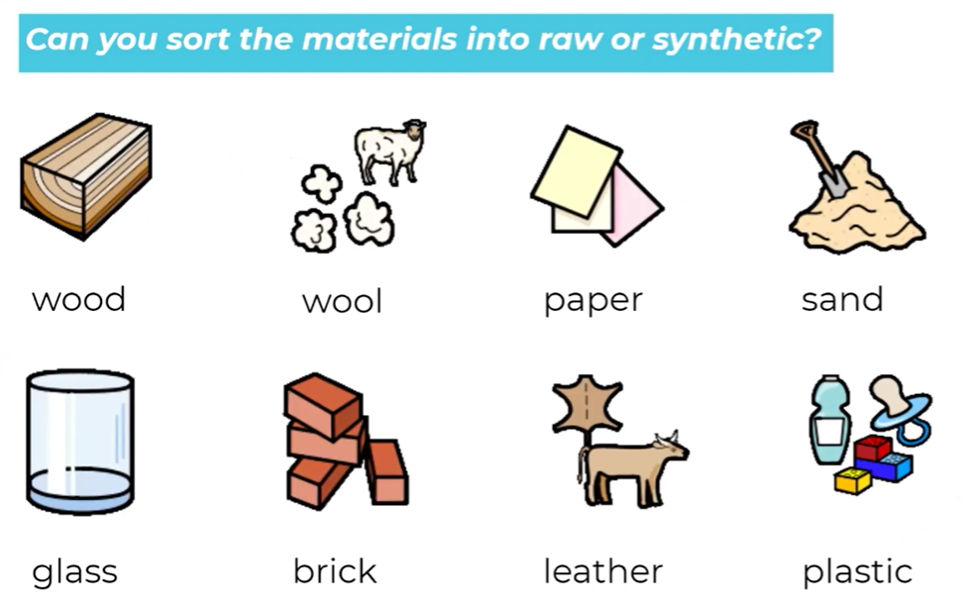

Day | PE – Daily Exercise  Daily Exercise is so important it keeps you fit and healthy and helps promote positive mental health. Here are some daily activities you could try.
Monday | PE with Joe Wicks 9AM  https://www.youtube.com/user/thebodycoach1
Tuesday | Cosmic Kids Yoga- inspiring kids  https://www.youtube.com/watch?v=VWIt7mVwbD0
Wednesday | PE with Joe Wicks 9AM  https://www.youtube.com/user/thebodycoach1
Thursday | Would you rather – a cardio- workout for kids  https://www.youtube.com/watch?v=XUk6cidBCNU
Friday | PE with Joe Wicks 9AM  https://www.youtube.com/user/thebodycoach1

Super Spellers – Spelling Shed last 7 days | Marvellous Mathematicians - TT Rockstars
Aimee – 82 | Millie – 8,820
Harriet - 39 | Harriet - 950
Isaac-35 | Aldo -272
Well done to all of you who have made it on the Y2 Leader Board this week!
See if you can get on next week- 82 is an amazing score to beat for Spelling Shed! Well done Aimee, you have been out winner for two weeks. Can anyone beat this score next week? Come on Y2 GAME ON!!!
Millie, who will ever beat yet another amazing score- WOW!,
Well done to Harriet too, you made it on both Leader Boards again- super effort!
Good to see Isaac and Aldo on the Leader Board , well done to you both!

