Year Group: 3

Week commencing: 8.2.2021
Teacher’s email address: lcarr@marsdenprimary.org.uk

Messages:

Hi Year 3,
I hope you are enjoying the challenges set for your home learning and here are some more for you to complete this week. I am happy to help if you need it, just send me an email or ring the school and I will answer any questions you have.
Keep sending in pictures of you at home, it doesn’t just have to be of you completing your learning it could be pictures of you doing things in your free time – such as baking or playing a game.
We have fallen to the bottom of the leader board on spelling shed and I have been keeping a close on who has been helping to move us back up to the top. Try to practise your spellings year 3 and help us, as a class, to creep up the leader board – who will be the leaders this week?
Keep up the excellent work year 3 and I hope to see you all soon.

We are going to start using Google Classroom for home learning instead of setting it on our school website and I have put Tuesday and Wednesday’s remote learning onto Google Classroom this week to see that you can all access it with no problems.
Let me know if you have any issues accessing it and they can be corrected before we make the permanent move over to the classroom.

It is the last week of half term. You have all been working incredibly hard. As a reward I have not scheduled any lessons for Friday, Friday is
‘FEEL GOOD FRIDAY!’

There are all sorts of activities you could try.

-You might want to complete Jenn’s gymnastics videos from last week’s remote learning folder.
-Follow this link to a Mindfulness activity and take some time for yourself. https://www.youtube.com/watch?v=ZBnPlqQFPKs
-You could do some baking - I have shared a recipe for Mars Bar cakes in our remote learning folder.
-You could make some salt dough ornaments, again I have shared instructions in our remote learning folder.
-Go for a walk on the beach and collect shells, stones and driftwood. I wonder what you can create?
- Go for a ride on your scooter or bike.

I bet you can think of lots of other activities to try. This might be a great opportunity to try something new and apply for your Blue Peter Badge.
Mrs Carr
You might like to try…
https://www.spellingshed.com/en-gb/
I will set a weekly spelling rule each week so please practise these spelling daily if possible or whenever you can.

https://play.ttrockstars.com/auth/school/teacher
Try to continue to develop times table recall by using TTRockstars when possible also – challenge yourself and practise the tables you are less confident on (x4, x8, x3).

https://www.bbc.co.uk/bitesize/this-terms-topics
The BBC have many activities, games and videos for all topics if you would like to practise key skills or learn something new.

https://www.phonicsplay.co.uk/
Phonics play – daily practise of phonics will help to improve spelling
User name: march20 pass: home

English
Day | Learning objective |  | Activity |  | Any other information
Monday | I can compare settings. |  | Read the description of ‘Jub’s’ Cosy hole and the description of the forest on the next page. Do they sound like the same forest? Which description gives the impression of a pleasant forest? Which one gives the impression of a sinister forest? List vocabulary and phrases onto the table which show the change in mood and compare the two forest settings. |  | Challenge  Can you write sentences to describe either a sinister or pleasant forest? Ask someone in your house if they can draw a picture of the forest based on your description.
Tuesday | I can create a story map. |  | Read the pages of the books far. What do you think is going to happen next? Whose is the voice? What is she going to do? How will the story end? Using your ideas draw pictures of the next parts of the story to create a story. |  | Challenge  Add key words / phrases / sentences to your story map. Retell your story to someone in your house and use your tone of voice to create the atmosphere.
Wednesday | I can visualise a character based upon the description given. |  | Read the part of the story describing the old woman. Visualise in your head what you think she looks like.  Draw a picture of the character and add colour to show your thoughts. Add key adjectives and phrases to describe her.  Do you think she is going to be a good character or a bad character? Why? (Google Drive) |  | Challenge  Write a character description of the character using detailed sentences and adventurous vocabulary.
Thursday | I can compare ‘Goodies’ and ‘Baddies’. |  | Show an image of Jub and the old woman. Does Jub look like a good character? Why? Does the old woman look like a baddie? Why?  Make a list of Jub’s ‘goodie’ qualities and the old woman’s ‘baddie’ qualities based upon the pictures given.  Which other goodie and baddie characters do you know?  Draw a picture of each character and write key words, phrases or sentences about what makes them a ‘goodie’ or a ‘baddie’. I have chosen two characters for you to use if you would like to. |  | Challenge  Design your own goodie and baddie characters and describe them.
Friday

Maths
Day | Learning objective |  | Activity |  | Any other information  Challenges
Monday | I can draw a bar chart. |  | Watch the online video and complete the matching activities.  https://vimeo.com/501677687 |  | 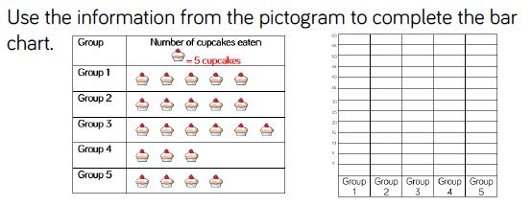
Tuesday | I can interpret bar charts. |  | Watch the online video and complete the matching  https://vimeo.com/502337848 |  | 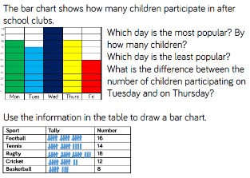
Wednesday | I can read and interpret tables. |  | Watch the online video and complete the matching activities.  https://vimeo.com/502338566 |  | 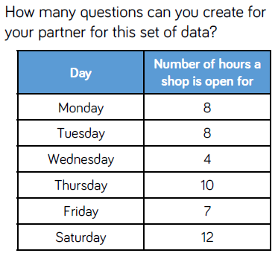
Thursday | I can measure length. |  | Watch the online video and complete the matching activities.  https://vimeo.com/503131096 |  | 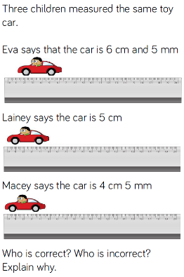
Friday | I can measure length (m). |  | Watch the online video and complete the matching activities.  https://vimeo.com/504466031 |  | 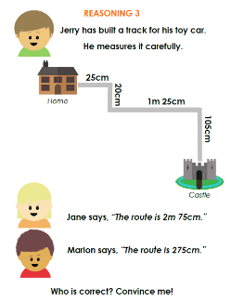
Foundation Subjects
Day |  | Learning objective |  | Activity
Monday |  | PSHE  Lesson 4:  I identify different roles and responsibilities within families. |  | Look through the PowerPoint and list the responsibilities you have within your family.  You could draw pictures of the responsibilities you have which you complete and the responsibilities you have which you don’t like to do and sometimes forget.  Create a job description advert for a responsible child. You can use the given format or choose to draw one of your own.
Tuesday |  | Science  I understand how the heart works. |  | Read the PowerPoint and learn all there is to know about how the heart works.  Science Experiment – try to build your own heart following the instructions and examine how the heart pumps blood around the body.  Challenge – draw your own diagram of a heart and add colour, key words and phrases to it.
Wednesday |  | Art  I can create a background using Pointillism. |  | Look through the PowerPoint. What have you learnt about Pointillism and Georges Seurat so far?  Look at the pieces of his artwork and discuss your likes and dislikes about them.  Which one of them is your favourite? Why?  Design your own background in the style of Georges Seurat, using pointillism. You could copy the given template onto paper to complete of use lines to create your own background.  Use any medium (pens, pencils, crayons, etc) to add patterns and colours.  Please send them to me – I would love to see your completed artwork.
Thursday |  | RE  I understand how the Bible is organised.  OR  History  I can see how changes in 20th century technology affect our lives today. |  | Read through the power point. When you have finished make some notes about what you know about the Bible. If you have a Bible at home explore some of the stories. Do you have a favourite Bible Story? Perhaps you could re-tell it or draw a picture.  OR  Have a look at the power point. Work through slides 1-7. When you get to slide 3 you will need to watch this video - https://vimeo.com/18743950  Challenge: Gaming has changed even more since this video was made. How?  If you fancy an extra challenge complete the activity on slide 8.
Friday

