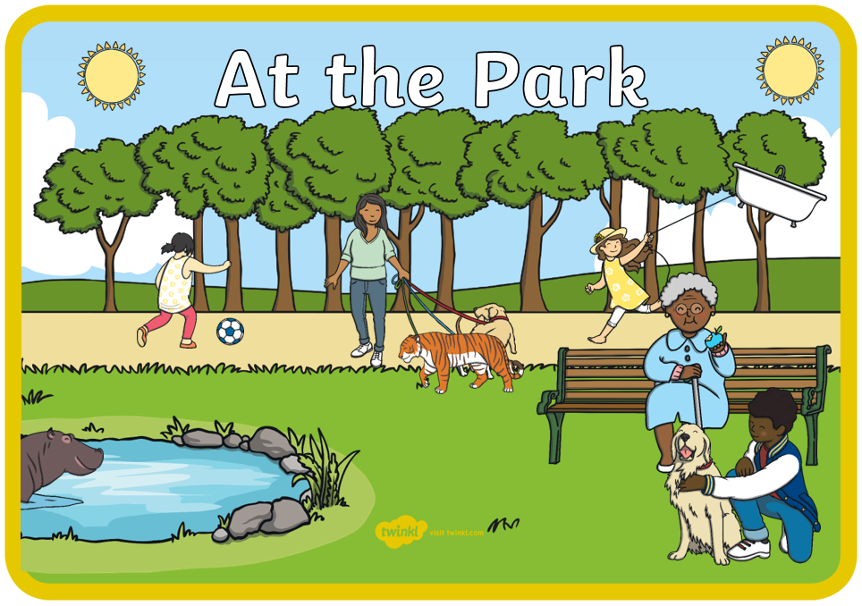
What is Wrong in the Picture?

Activity
- Look at the picture together.
- Name the objects that you can see – e.g. sun, football, girl.
- Talk about the colours and animals that they can see.
- Model additional language to your child. For example, if they say ‘sun’ you could say yes that’s the round, yellow sun.
- Ask questions about what you can see. For example, where is the sun? If your child points and says ‘there’, respond by saying ‘it’s in the sky. Can you say that?’ Encourage your child to offer
additional vocabulary throughout.
- Ask questions about what the people are doing – ‘What is the boy doing?’ – ‘He’s stroking the dog’.
- Encourage your child to talk about who is a girl or a boy in the picture.
- Talk about what is wrong in the picture – should a tiger be walking in the park?
- Link to your experiences of going to the park – what do we normally see? ‘People don’t walk tigers, they walk….dogs!’

