YEAR 3 HOME LEARNING
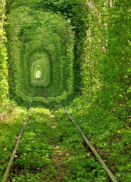  ENGLISH  WRITING  - Answer the questions in full  sentences:  Where does the pathway lead?  Who uses the pathway?  How long has the pathway  been there?  What is at the end of the pathway? Does it lead to a different world? What is the world like where the pathway leads to?  - Create a mind map for the pathway. What would you smell, hear, touch, see? Remember to use interesting adjectives when describing. If you can, use an online thesaurus to improve your adjectives.  - Using the mind map, write a description of the pathway as if you were walking along it.  Quietly, I walked along the pathway and all I could see was illuminous, small, green leaves surrounding me. Brightly, the light shone through the tiny leaves and all I could hear was the crunch of the leaves beneath my feet.  - Write a story about walking through the light at the end of the pathway and entering the world on the other side. Remember to include details about your thoughts and feelings about entering the other world. Describe the place where you are and create characters that you meet.  Reading  This is a great opportunity to read some good books. Try to read daily.  Create a new book cover and blurb for your favourite book that you have read.  Reading Comprehension  Answer the questions below about a book of your choice that you have read.  Who are the main characters?  Which character is your favourite? Why?  Where is the story set?  Would you have changed the ending? Why?  Create an alternative ending for your story.  Twinkl – more texts and comprehension questions can be found at the website below:  https://www.twinkl.co.uk/home-learning-hub  SPaG  Go to Spelling Shed online and complete the set spellings – I am setting new spellings each week to learn and practise. I am keeping a close eye on the leagues | Dear Parents and Year 3,  I hope you are staying safe and working hard also. Here are more activities for you to complete this week and I would love to see pictures of you working hard on the Marsden Website. I am missing you all very much Year 3 and can’t wait to see you all soon!  Parents please email me if there is anything that you need me to explain or help with.  Year 3 I can’t wait to see your writing, science experiments, improved times tables score and more!  You can send them to:  info@marsdenprimary.org.uk or post them on the website in home learning if you would like to show me your hard work at home.  Mrs Carr |  | MATHS  - How fast can you complete the multiplication grid? Complete the grid daily and see if your score decreases.  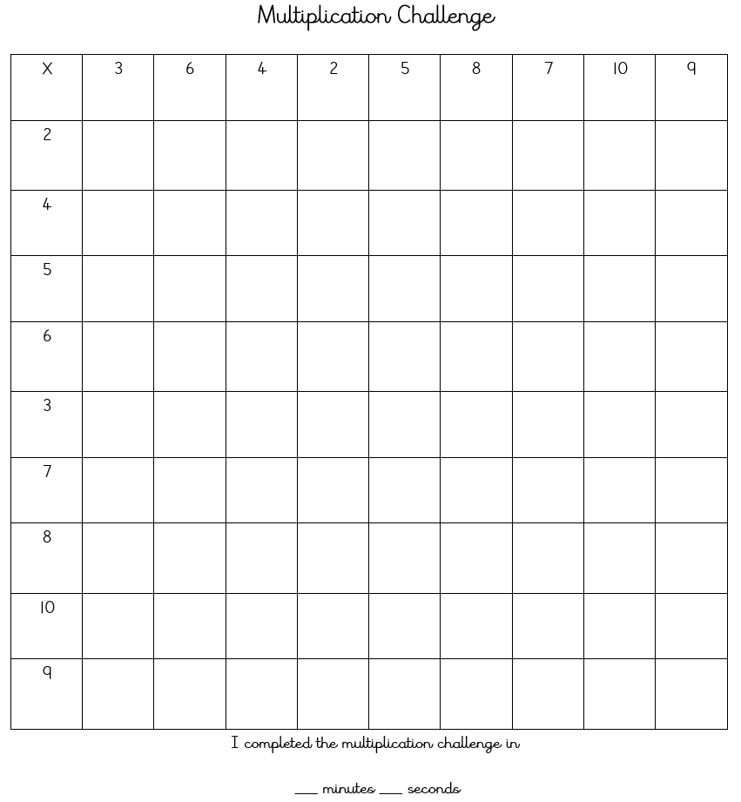  - Create a set of maths challenge cards / questions for someone in your house to complete. Make them as tricky as you like but you have to record the answers so you can mark the them once the cards have been completed.  - TTRockstars. Help improve your multiplication grid time using TTRockstars to practice and learn multiples from 2-12. Let’s see how many coins you can earn in a week!  - Always, Sometimes or Never?  The sum of three odd numbers is an odd number. You must show 10 examples to prove whether this statement is always true, sometimes true or never true.  - Countdown  Use the numbers below and any number operation (+ - x or divide) to reach the target number. How many ways can the target number be reached?  Target Number = 167  Numbers to use – 52 10 5 2 3 11
 | SCIENCE  - Plant Hunt – draw pictures of plants you find in your garden or of plants that you know.  - Label parts of the plant using the website below to help you. https://www.bbc.co.uk/bitesize/topics/zy66fg8  - Write sentences about the function of each part of the plant.  - Dissect a plant and see what find. | GEOGRAPHY  - Draw a compass and label the compass points, north, south, east, west, north east, north west, south west, south east.  - Create a rhyme for remembering north, east, south, west. For example, ‘Never Eat Shredded Wheat.’
ART:
This term we would have looking at the vanishing village of Marsden in Geography.
Draw a landscape of Souter Lighthouse. You can use any medium you would like to add some colour or shading – pencils, pens, crayons, paint etc.

ONLINE VIDEO HELP:  MATHS: www.bbc.co.uk/bitesize/subjects/z826n39 has lots of guides to help you.  SPAG: www.bbc.co.uk/bitesize/topics/zwwp8mn (grammar)  www.bbc.co.uk/bitesize/topics/zvwwxnb (punctuation)  SCIENCE: https://www.bbc.co.uk/bitesize/topics/zy66fg8 |  |  | PE  Joe Wicks Workouts  www.youtube.com/watch?v=d3LPrhI0v-w

