YEAR 2 HOME LEARNING
ENGLISH  Reading –  As we are learning about animals I thought you might like to read this poem all about Ronald the Rhino- see the text below  Reading Comprehension  Can you complete the reading comprehension about Ronald the Rhino – see below, you could write your answers in a notebook or your homework book.  SPaG- Spelling and Grammar  Go to Spelling Shed online and complete the set spellings.  Y2 are fab at WRITING  Can you choose an animal that Ronald wanted to be. Draw that animal and write a description about the animal- remember to use adjectives from the text. Check your spelling, capital letters and handwriting. I know that this work will be fabulous as I love to read your writing. | Dear Parents and Y2 Children,  Here is an overview of the learning I would like the children to complete over the next week. Marsden Primary School are committed to ensuring your child is still learning as much as possible and endeavour to do our absolute best to keep this happening. We are going to practise lots of spellings, times tables and practising telling the time. Missing you so much Year2, keep safe and WASH YOUR HANDS and be as good at home as I know you all can!  Thank you and lots of love  Ms Gilbert xx  ONLINE VIDEO HELP:  MATHS: hKS1 - BBC Bitesizehttps://www.bbc.co.uk/bitesize/levels/z3g4d2p as lots of guides to help you.  SPAG: Spelling and Grammar-Spelling - KS1 English - BBC Bitesize https://www.bbc.co.uk/bitesize/topics/zcgv39q |  | Y2 LOVE MATHS  Fluent in 5 – practising times tables  5x6 7x5 8x5  2x15 2x7 2x10  10x4 7x10 11x10  Challenge  4x4 3x3 4x6 3x6  Skills- telling the time  Reinforcing 0’clock/ half past. Teaching quarter past and quarter to  https://www.bbc.co.uk/bitesize/topics/tellingthetime  https://www.ictgames.com/mobilePage/hickoryDickory/  Free APPS- learn to tell the time with analogue clock  Telling time made simple  Times Tables  /https://www.topmarks.co.uk/coconut multiples- 2s/ 5s/ 10s table extend to 3/ 4  Fractions- parents tips  To help to tell the time it is vital that children understand fractions- try this fraction sheet below- you can complete this practically with the children using household objects or stones etc- share into groups of fours to calculate the quarter then add up three groups to find three quarters etc
HISTORY - Famous People  – during this pandemic our hospital workers are amazing. Florence Nightingale was a famous nurse from the past. Today lots of new hospitals have been built using her name such as The Nightingale Hospital in Sunderland. Try and find out about Florence Nightingale- can you draw a picture of this famous lady and find out three facts about her life. | Reading for Fun  Remember Y2 you are all fantastic readers. Continue reading your chapter books at home or download some new reading. The authors which we are going to learn about are Anthony Browne- try reading or downloading “Gorilla” on you tube and David Walliams – remember “The Hippo on the Moon” Story. | PE  Join live pe lessons with Joe Wicks or catch up with PEwith Joe on youtube- | SCIENCE  We are going to learn about animals- choose your favourite animal and research all you know about it and create a poster all about your animal include facts such as where your animal lives, what it eats etc You can use the computer or paper and pens. My favourite animal is a tiger. I have had great fun creating my poster, look below for some ideas. You could pop your poster on the website, we would love to see it.
Fractions- Remember one quarter is one part/ two quarters is two parts etc
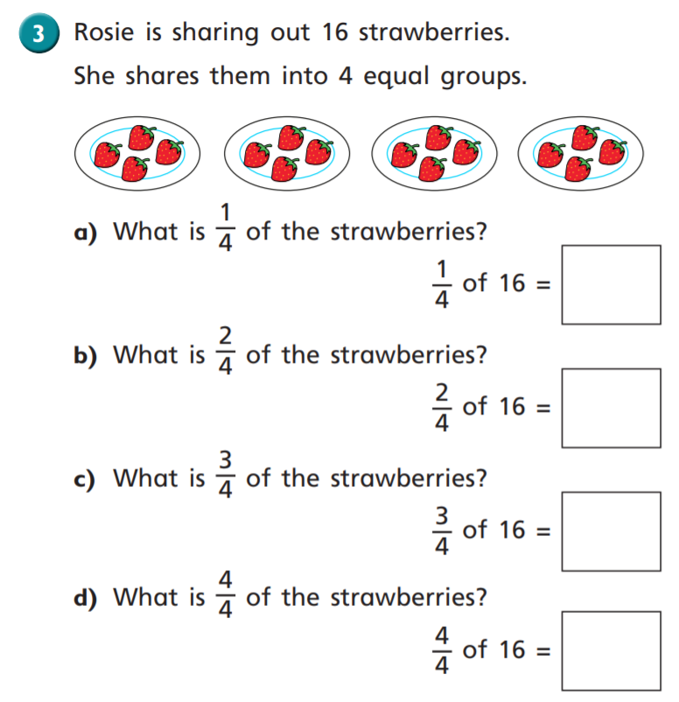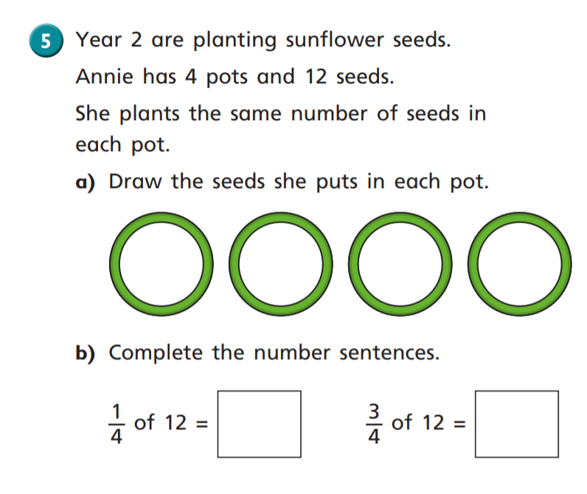

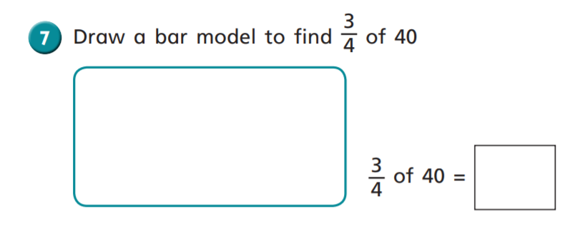
Try this bar model below to help you – you need to share 40 into 4 groups.
Challenge - What have you found out? Which times table has helped you?

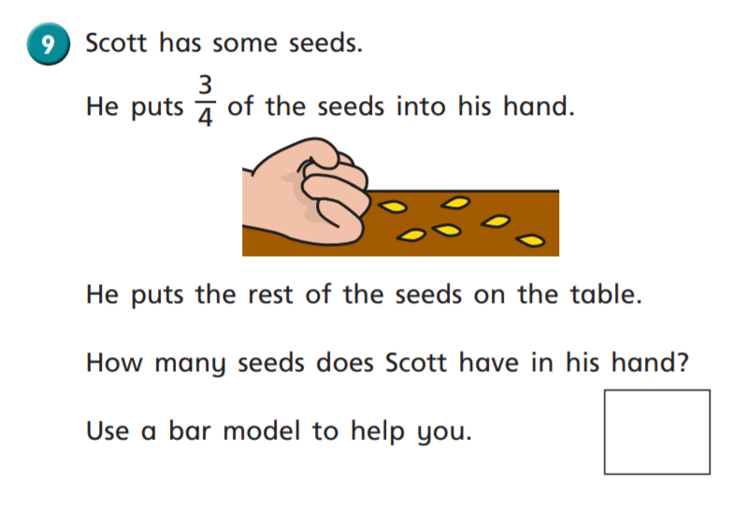
Challenge- Could you try calculating this word problem using a different number?
Can you work out which times table has helped you?
