Great Gamer  Create your own Easter board game and write a set of rules.  Play your Easter game with your family and see who wins.  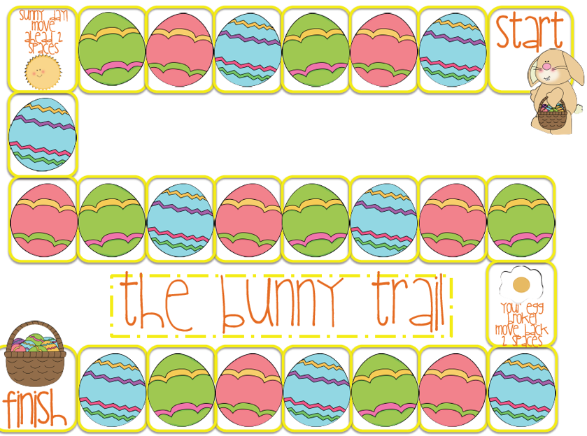 | Easter Traditions  Make a list of Easter traditions which you would usually do together as a family. – keep the list in a safe place and hopefully you can do the traditions together soon!  Which tradition is your favourite? Why? Draw and write an explanation of your favourite Easter tradition and explain why its’s your favourite one. | Spring Code Breaker  Below is a list of maths questions to answer with secret answers. The question answers match a letter to e=reveal the words.  Challenge: Create your own code breaker for someone in your home to complete. | Easter Modelling  Make an Easter model using junk or materials you have in the house.  It could possibly be an Easter bunny, chick or a house for the Easter bunny - you decide.  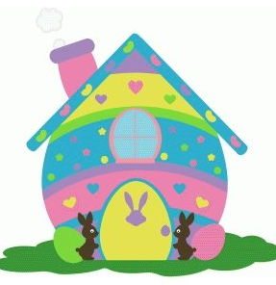
Spring Senses Poem  Write an ‘I can’ poem using the five senses for spring.  Spring smells like _______________  Spring sounds like_______________  Spring feels like _________________  Spring looks like_________________  Spring tastes like ________________  Remember to use adventurous vocabulary and interesting adjectives for each sense line. | Amazing Animals  Create a fact file about a Spring Animal of your choice. Write a description of the animal and facts about their diet and habitat. Research the animal and record any interesting facts you find.  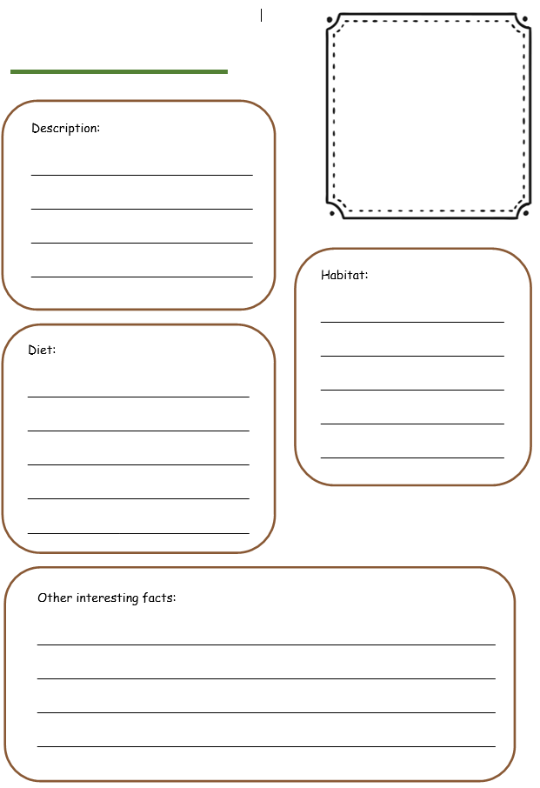 | Treasure Hunt  Hide 10 objects inside or outside and write a set of clues for someone to solve and find the objects.  Remember to write a list of the objects you hide and where you have hidden then – just in case you forget where they are!  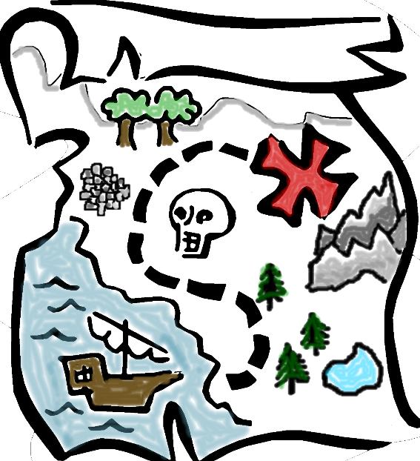 | Bunny Bonanza!  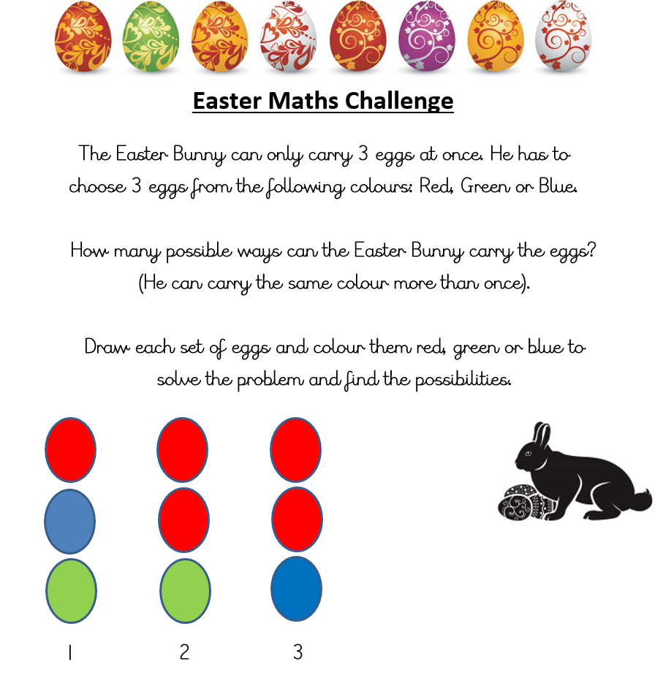
Design a parachute  Create a parachute for an egg to land safely on the floor.  Before you begin creating you must draw and label your parachute and write a list of materials needed.  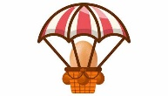  Challenge: Once you have created the parachute write a list of instructions for someone to follow to make your parachute. | Easter around the world!  Research how Easter is celebrated in a different country. Create a poster explaining the celebrations and traditions in that country.  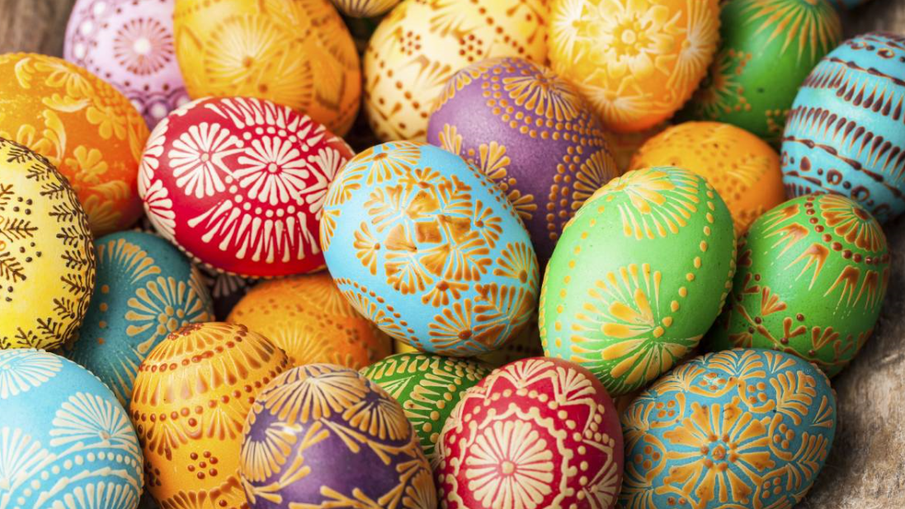 | Quick Read- Recipe for Hot Cross Buns  Read the text and answer the questions.  Challenge: Can you bake an Easter treat with a grown up in your house? Recipe ideas and instructions are below.  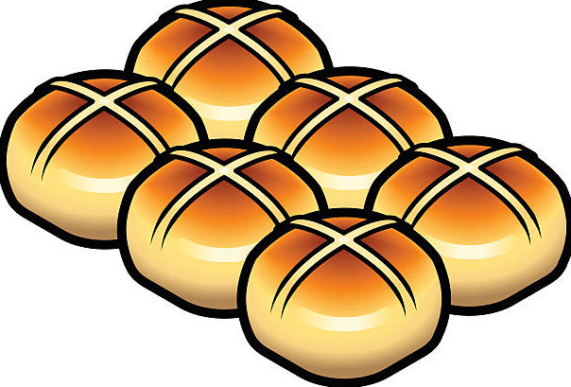 | Easter Boggler Puzzle  How many 3 letter or more words can you create using the letters below.  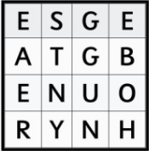  Can you create your own boggle puzzle for someone in your house to complete?

Daily Activity Suggestions:
Maths
White Rose Maths offers a short daily challenges for Year 3 children - https://whiterosemaths.com/resources/schemes-of-learning/primary-sols/
Twinkl has many maths investigations using number skills - https://www.twinkl.co.uk/resources/wellbeing-parents/year-3-to-year-6-ages-7-11-home-learning-area/english-activities-age-7-11-home-learning-school-closures-parents/2
TTRockstars will help children learn multiplication tables - https://play.ttrockstars.com/auth/school/teacher
English
You can access a wide range of eBooks for free by signing up to https://www.oxfordowl.co.uk/for-home/find-a-book/library-page. Choose a book that you think will suit your child’s reading ability and then share it together. You could read a different book each day or you could read a page per day – whichever works best for you.
Spelling Shed will have spellings set by me every week - https://play.edshed.com/
