Reading Comprehension  Spring is on the way, so why don’t you read this lovely Spring has Sprung Poem and write your answers in a little note-book. As you are all amazing artists draw a fantastic Spring picture too.  Keep all of your lovely work to show me when we are back in class. | Rainbow Colour Hunt  Can you make your own artists rainbow using crayons. Then look around your house or garden for objects that are exactly the same shade as your rainbow. | ICT Why don’t you try taking some photographs on your Ipad or phone. You could share them with us on the Marsden Primary Website! See “The Fantastic Photo” activity below. | Being Kind  Make a list of seven kind things you could do for someone else. This could be helping the people you live with by clearing the table or helping with the beds. You could also send someone who doesn’t live in your house a photograph of a drawing or write a poem for somebody you miss. Each day do one kind deed from your list..
Acrostic Poems- Remember those fantastic acrostic poems you all wrote for your Mother’s Day Cards. Why don’t you try writing your very own Spring Acrostic Poem- you can try the one below or challenge yourself to write your own.    Lego Challenge  Can you build a lego Spring farm?  You could include horses stables, fences, animal pens and a farm house. | Maths  David bought 5 boxes of marshmallow bunnies. If there were 7 bunnies in each box, how many marshmallows did he buy?  You can draw this out or why don’t you try and draw a bar model to work out the answer.  Maths Challenge- Can you write your own word problem and give it to someone in your house to try and work out? | . TT Rockstars  Can you continue to collect 300 coins in two weeks on TTRockStars? Remember keep practicing your times tables with Times Tables 2-12 Kool Kids You Tube www.youtube.com/watch  Bracelet Making  Try making rainbow bracelets. You will need some tube pasta, string or wool and paints or felt pens. Colour the tubes of pasta, thread and then tie around your wrist. You could make bracelets for your family too. | Musical Instruments.  While we have been lockdown our doctors and nurses have been amazing. This week can you make your own musical instrument, maybe a shaker or drums and next Thursday at 8.00pm show your appreciation to our NHS by playing your homemade instrument  Music and Dance  Make a playlist of your favourite feel – good music. Each day add one more song to your play list . that makes you feel happy. Each day spend some time dancing to your play list. Maybe you could face-time someone and dance together
Keep fit dice game just below the grid. Have fun Keeping Fit  Rosie and I love this game, why don’t you try it. You need one dice and lots of energy.  Keep Fit Dice Game  Roll the dice and find out which exercises you need to complete.  You must keep rolling that dice to keep fit! | Roll a 1  You need to do one quick twirl. | Roll a 2.  You need to do two very high tuck jumps. | Roll a 3  This time you need to complete three press-ups
Roll a 4  Can you complete four star jumps? | Roll a 5  This time you need to complete five jump stretches- stretch up high then touch the floor- 5 TIMES | Roll a 6  This time you need to6 jumps punching high into the air with your arms. | KEEP FIT CHALLENGE  Why don’t you use your times tables and when you throw the dice- double the number eg 3x3=6 press ups OR times your dice by 5 . Are you fit and fast enough?

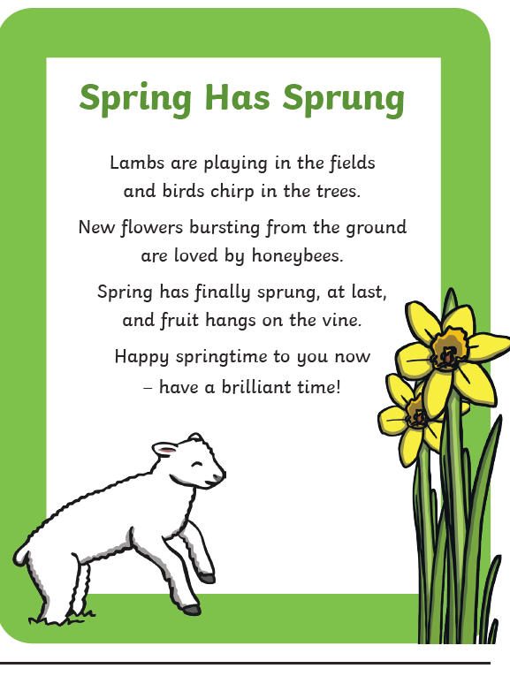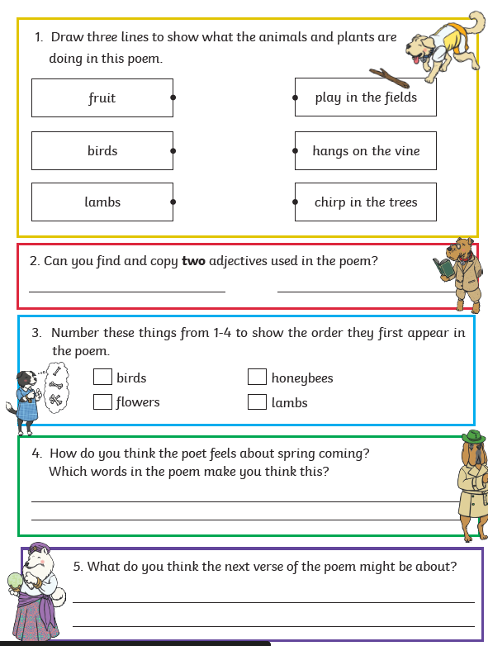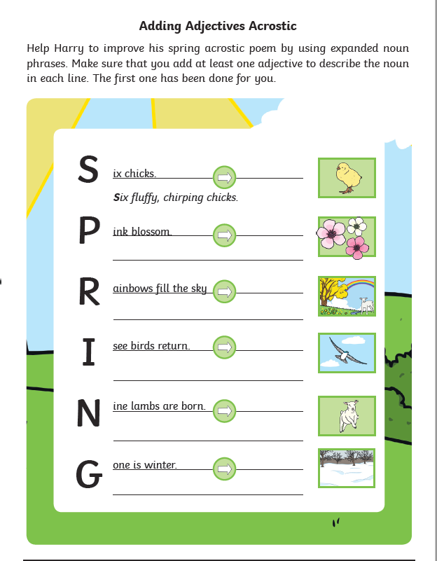

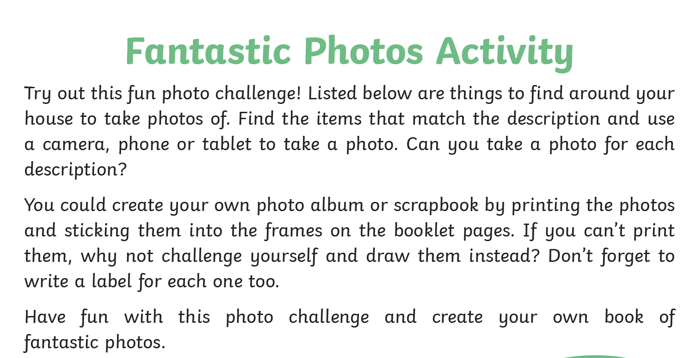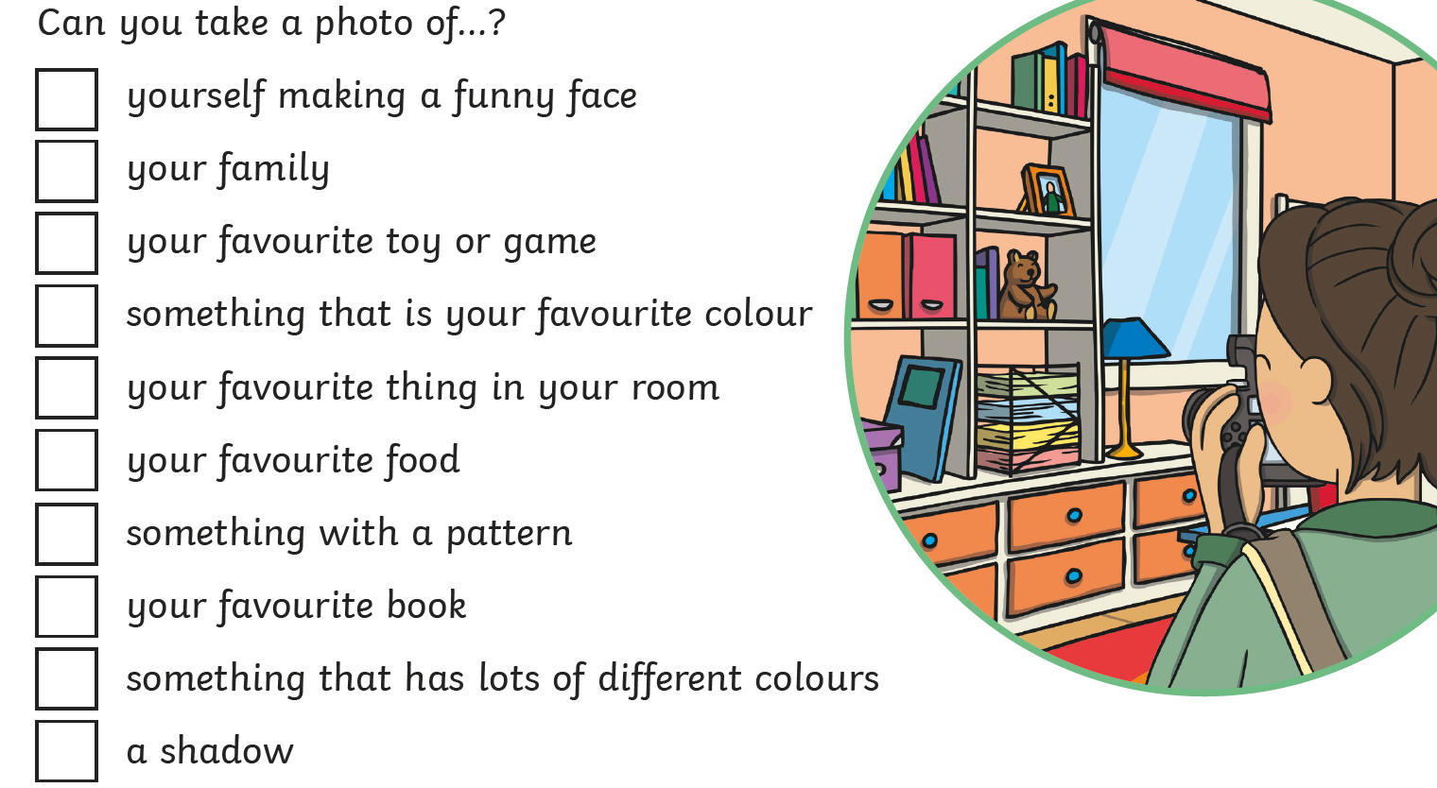

Daily Activity Suggestions:
Maths
TTRockstars will help children learn multiplication tables - https://play.ttrockstars.com/auth/school/teacher
English
You can access a wide range of eBooks for free by signing up to https://www.oxfordowl.co.uk/for-home/find-a-book/library-page. Choose a book that you think will suit your child’s reading ability and then share it together. You could read a different book each day or you could read a page per day – whichever works best for you.
Spelling Shed will have spellings set by me every week - https://play.edshed.com/
Phonics
Use Mr Mc and Mr Thorne does Phonics to learn a new Phase 3 sound each day:
https://www.youtube.com/channel/UCTcZnvuTeovlznioLRo0GOA
https://www.youtube.com/user/breakthruchris
You could practise writing the sound in the air/ on the ground and then you could play a game using that sound on https://www.phonicsplay.co.uk/ (Username: march20 Password: home)

Remember to keep up-to-date with information by looking on the school website as often as possible and please leave comments so that we can keep it touch. It’s lovely to hear from you and to see how hard you are all working! You could also send photographs of the children completing their challenges to info@marsdenprimary.org.uk and we will add these to our ‘Home Learning’ section on the website.

