YEAR 2 HOME LEARNING- Summer 2 Week 6 -Madagascar –July 6th 2020
ENGLISH  Reading – Reading Oxford Owl  Download READING SCHEME e books on this free site  https://www.oxfordowl.co.uk/api/digital_books  This site is free for parents just login and create a password  Children know their colour reading level and there is a huge range of good texts on this site. I would recommend- Oxford Reading All Stars as a new and exciting range of fiction stories, Tree Tops and some non-fiction texts. Try and complete two or three books this week , remember to write the titles in your yellow reading diary.  Reading This week we are going to learn about the film Madagascar. Can you watch the first film then answer the questions on the Madagascar Powerpoint which I have uploaded on the home-learning web-site  Then complete the questions below  Writing –A Newspaper Report  Can you imaganine that you are a reporter for the New York Times and write a newspaper report about the animals break-out from the zoo. Remember to include a catchy title to grab the attention of the reader.I have included a template below.  SPaG- Spelling and Grammar  Go to Spelling Shed online and complete the set spellings for this week.  New spellings for this week based on animals- giraffe, elephant, penguin, rhinocerous, hippopotamus  English Skills- Look at the Year 2 grammar revision powerpoint on the home learning site and complete the tasks.  I have copied the verb tasks below- think about the suffixes you have used. Is there a pattern to them ? | Dear Parents and Y2 Children,  Hello everyone, I have received some excellent art work from Y2 which I have uploaded onto our Children’s Art Gallery on the home –learning site  The theme for the week was “Art in the Natural World” I have put a link in Art to the National Art Gallery which shows an exciting collage project. Why don’t you give it a go and if you have any amazing art work, please email it to me mgilbert@marsdenprimary.org.uk  This week we are beginning to learn about Madagascar so keep going with your home-learning everyone as we only have two weeks left and everyone who is working is completing amazing work. Please send me your work, I would love to see it.  As always missing you all so much. Be good and as always and keep safe. Lots of Love Ms Gilbert xx  ONLINE VIDEO HELP:  SPAG: Spelling and Grammar-Spelling - KS1 English - BBC Bitesize https://www.bbc.co.uk/bitesize/topics/zcgv39q | Y2 LOVE MATHS  Fluent in 5 – Try this weeks mad minute maths- We are revising sharing or dividing by 5? Try one column each day - see below.  Something to think about  When you divide by 5 do you always hacve a zero and a five in the answer explain your answer  .Maths – White Rose Week 11- Revision litres, temperature and time  Access White Rose daily maths lessons using the  following link: https://whiterosemaths.com/homelearning/year-2/  Try to complete the set lesson each day. There are 4 lessons. Watch the videos and complete the given matching questions on the ‘Activity’ sheets- I have uploaded all worksheets onto our homelearning site . Answers can also be checked on the matching ‘Answer’ sheets on the website.  These lessons now link to the BBC Bitesize daily maths lessons for extra support. MATHS: hKS1 - BBC Bitesizehttps://www.bbc.co.uk/bitesize/levels/z3g4d2p as lots of guides to help you.  Maths Skills – Challenge-  Try these time challenges below  Can you create some of your own to ask members of your family?.  Please keep going with TT Rock Stars- try 15 minutes dailyand I have set My Maths tasks also for this week if you need your password please email me – Well done to everyone who has made it on our new leader board see below.
Art in the Natural World – project until the summer
We are continuing this Natural Art Project with a theme of Animals and their habitats.
Here are a few ideas you might wish to try:
Henri Rosseau was a French Artist who painted “Tiger in a Tropical Storm” in 1891- see below, perhaps you could copy his work., using pencils, pens, paint.
You could also login to the National Art Gallery to view his work and an artist –ideas how to make and create his painting using collage it really looks amazing https://www.nationalgallery.org.uk/paintings/henri-rousseau-surprised
Maybe you could create your own natural jungle or rainforest in your garden using stones, branches etc .
Sketch copies of work by other artists- see below some examples I found in the Tate Art Gallery
Create your own natural collage using items found in the garden or park.
Please email your work to me so I can include your work in our Art Gallery mgilbert@marsdenprimary.org.uk
Geography- Comparing locations in the world- Madagascar  Look at the powerpoint on the home-learning web-site Y2, Madagascar Geography – complete the task on the final sheet  THEN fill in the sheet below which looks at comparing the settings in the film.  Challenge: Can you compare and contrast Madagscar the country with New York City ( the city where the animals lived)  Remember to think about the climate, the environment – is it rural or urban? Is it a city, what are the features of the city?  Is it rural/ physical/ natural - are there volcanoes, mountains, coastlines?  What foods the animals could eat in each environment?  Could you draw your ideas, remember send me any work I would love to see it? | Music  As we are learning about Madagascar listen to the sound track from the film https://www.youtube.com/watch?v=LdO9hId2XOM  Challenge:  Think about the musical journey which track did you like best and why?  One musical track used words and the other was instrumental, why do you think the composer used that method?  What tracks would you use to create a Madagascar Musical Journey?  PE  I love yoga, so why don’t you try this cosmic kids yoga class called Lulu the Lion Cub  https://www.youtube.com/watch?v=wyvyO7bgNKg  Think carefully about the poses and shapes you have learnt today  What did you like best?  Which poses did you find easy/ difficult- think about how flexible your body is? | SCIENCE- Animals and their Habitats  This week we are going to consider whether animals should be kept in zoos or their natural habitat. Look at the powerpoint on the home-learning web-site “It’s a Zoos Life” and complete the task. I have also created a copy below for you to complete,  Look at this BBC Clip “What are zoos for?”  https://www.bbc.co.uk/teach/what-are-zoos-for/z649f4j  Challenge: Can you explain to an adult your opinions about animals been kept in zoos or in their natural habitat. Remember there is no right or wrong answer as it is YOUR OPINION but you must be able to explain your reasons?

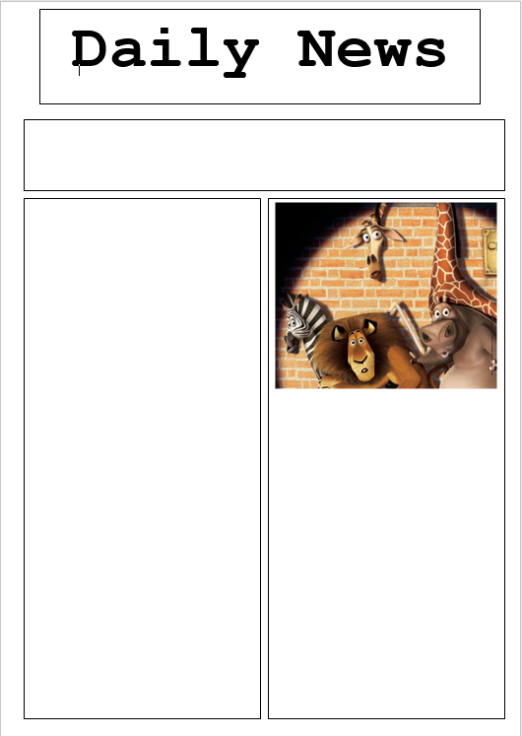
Science - Avantages and Disadvantages of Zoos
Advantages of Zoos | Disadvantages of Zoos

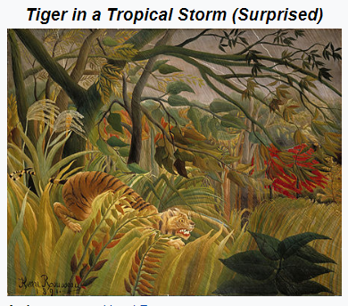

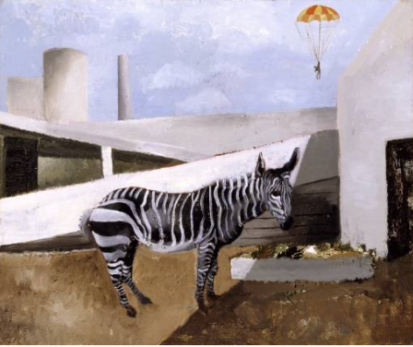
Out of Nature – Zebra and Parachute created by Christopher Wood 1930- displayed in Tate Art Gallery- https://www.tate.org.uk/art/teaching-resource/animals-art
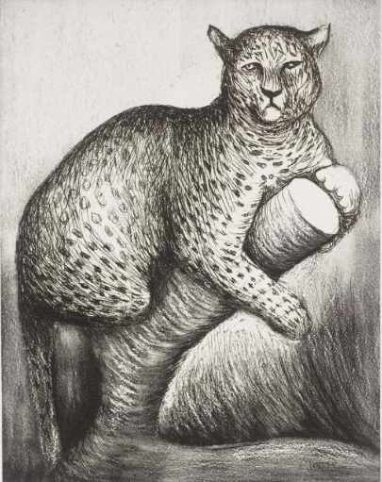
Leopard created by Henry Moore 1981- displayed in Tate Art Gallery- https://www.tate.org.uk/art/teaching-resource/animals-art
  - 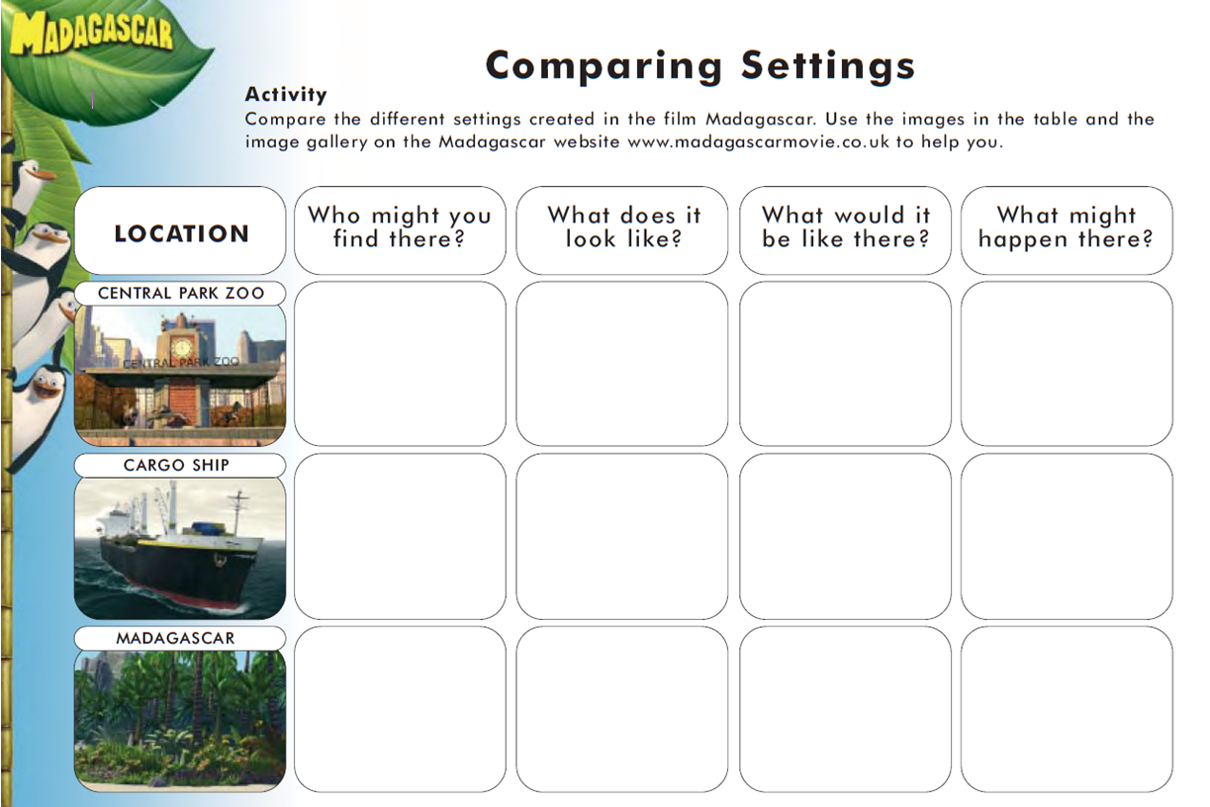
MAD MINUTE MATHS –

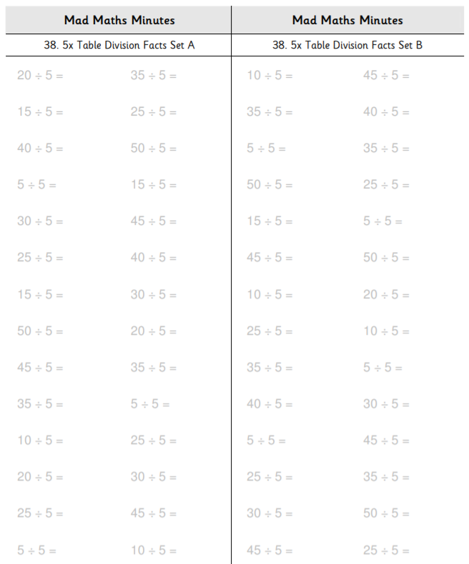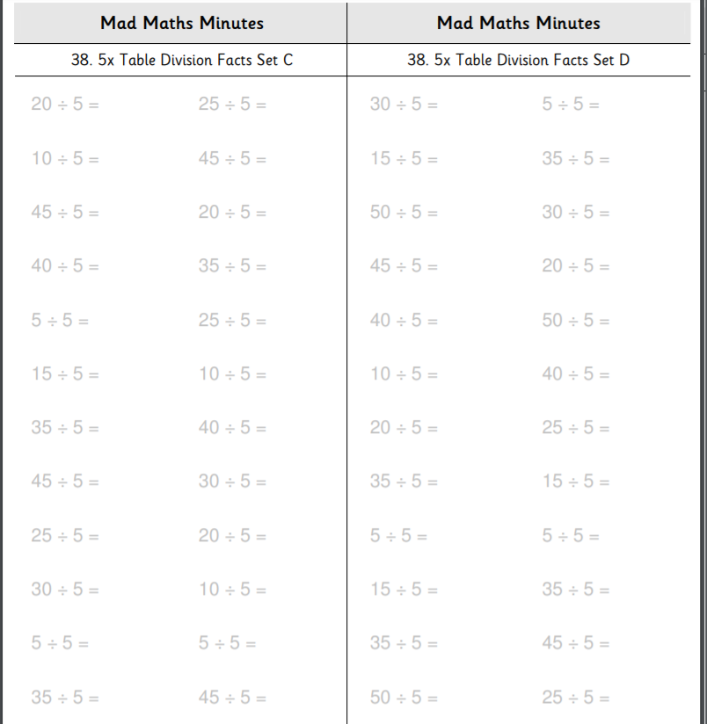
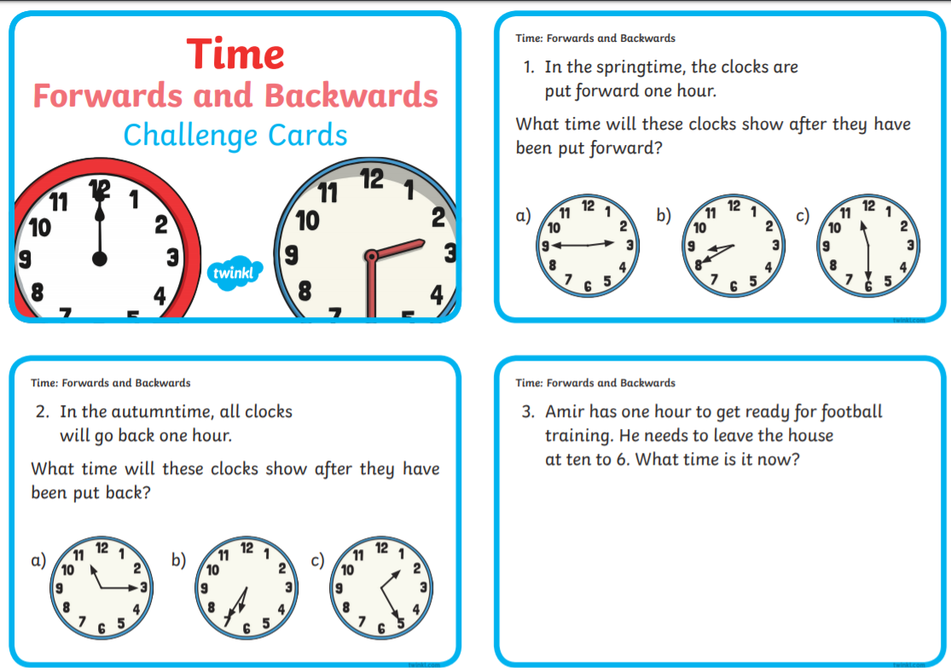
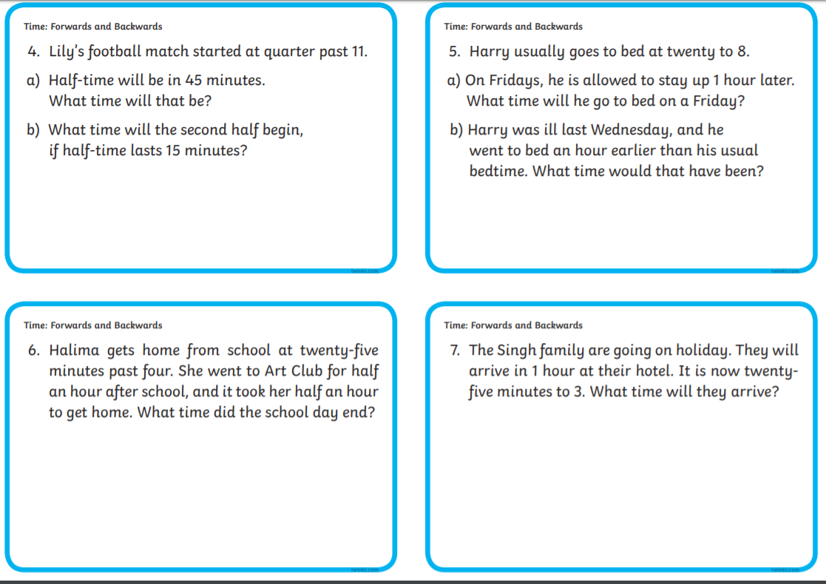

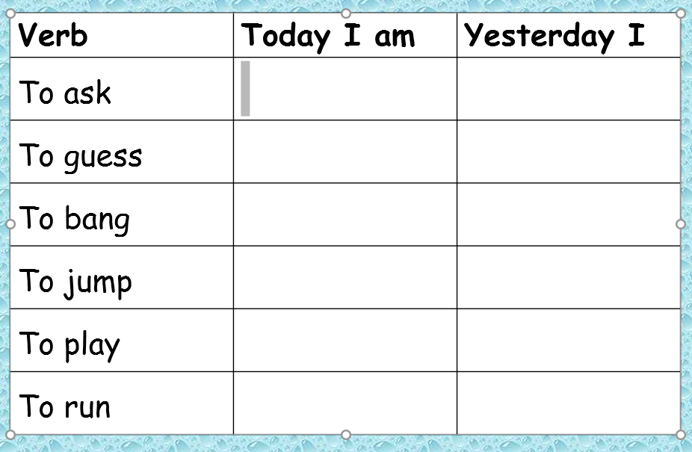

.

Maths Challenge – Maths
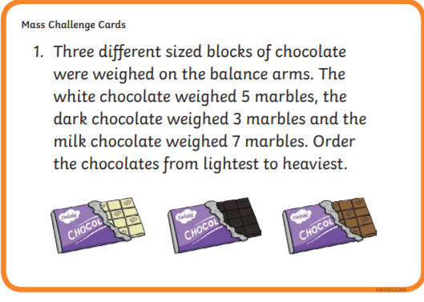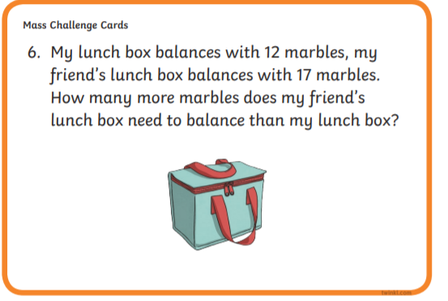
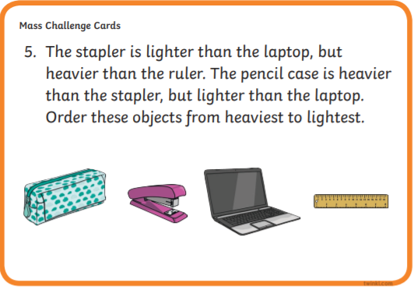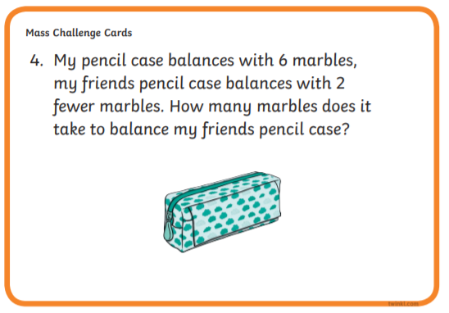

Geography- Kenya

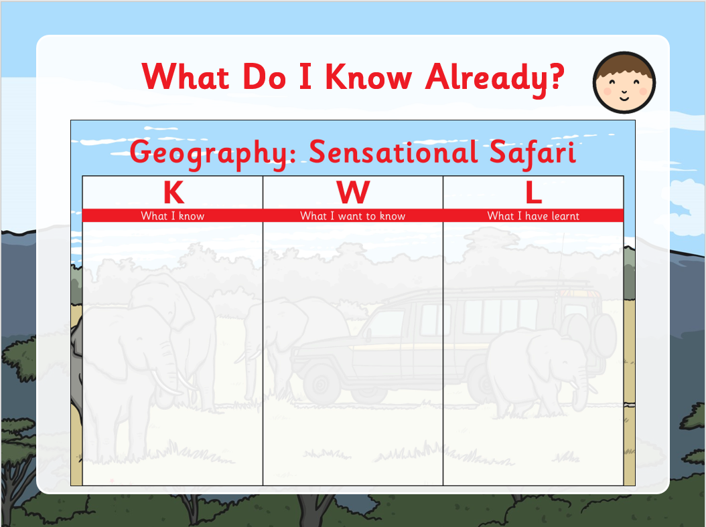

Year 2 – Top 9 Spelling Shed Leader Board for until Thursday 2nd July
Dylan- Super score Dylan. This was a really close week between the top 5, well done everyone the competition is good
Scarlett
Anais
Finlay
Thea
Matthew
Layla
Ruby
Georgie

Year 2 – TT Rock Stars - best effort in the last 7 days
Dylan – wow Dylan, an amazing score 1,890- super work this week.
Anais
Layla
-Thea
Well done, to all of you who made the leader board- great to see some new names too, see if you can improve with extra effort this week! The competition is on !!!!

MY Maths –Top 5 children who accessed most home learning in My Maths during lockdown
Scarlett- 27 out of 28 tasks completed amazing work Scarlett. You should be so proud of yourself!
Thea
Georgie
Layla
Finlay
Amazing effort to these 5 children, I am super proud of their commitment.

