YEAR 1 HOME LEARNING- Summer 2 Week 6–July 6th 2020

English- writing  This week we are going to think about writing about characters from “Finding Nemo”  When writing about your favourite character think about adding these details  Where your character lives.?  What does your character see where he lives, ? -describe the ocean.  What does your character do all day-? who are his friends.  What does your character like to eat?  I have included a writing template below and a template for you to draw an amazing illustration of your favourite character. |  | English- Reading Comprehension  Look at this clip “Dory’s First Day at Nemo’s School”  https://www.youtube.com/watch?v=c0pv-s6jDh8  Then try to answer the questions below see reading comprehension.  Challenge- could you create two questions of your own about the clip you have looked at. |  | Hello Year One,  We only have two weeks left in Y1, so this week I have created some fun learning.  We are going to look at the movie “Finding Nemo” as our theme until the end of term Can you watch the movie as it will help with all of your home learning this week. We are also collecting art work so if you have any home learning art work that you would like on our Art Gallery please email me at sstothard@marsdenprimary.org.uk  ,Missing you all lots.  Mrs Stothard xx | Phonics- Daily Phonics lessons  Visit here every day to watch a daily Year 1 Phonics lesson.    https://www.youtube.com/channel/UCP_FbjYUP_UtldV2K_-niWw/playlists  Reading and Spelling  Look at the fish who has common exception words on all of his fins. Can you read these words? Then practice spelling the words- if you can read, write and spell the word colour that fin in green- how many words did you read, write and spell correctly.
Maths- White Rose Year 1- Week 11 – fractions halves and quarters  Access White Rose daily maths lessons using the  following link: https://whiterosemaths.com/homelearning/year-1/  Try to complete the set lesson each day. There are 4 lessons. Watch the video and complete the given matching questions on the ‘Activity’ sheets- I have uploaded on our home-learning web-site. Answers can also be checked on the matching ‘Answer’ sheets on the website.  These lessons now link to the BBC Bitesize daily maths lessons for extra support.  Challenge – Try this interactive game to practise quick- fire doubling  https://www.topmarks.co.uk/maths-games/hit-the-button |  |  |  | This week White Rose focuses on finding halves and quarters  Can you look at the power point uploaded on the home-learning site and answer the questions?  Mad Minute Maths-  Can you complete the activity below testing yourself on doubles- why don’t you time yourself?  Also try doubling on; https://www.topmarks.co.uk/maths-games/hit-the-button | English-spelling and phonics  Watch the ue phonics videos  https://www.youtube.com/watch?v=7nUZi3AKuTU  Can you practise these ish spellings?  Fish  Wish  Swish  Dish  Squish  Starfish  Can you write sentences using these words?
Art – summer portfolio  We are continuing to build up an art portfolio as part of National Children’s Art Week  For our summer art project this week you could try:  If you like lego create an under the sea- creature using lego bricks- see below for patterns and colours  Create a 3d sculpture using recycled boxes and materials of a sea creature- see below for ideas  Create your very own Under The Sea Painting  Please email me your work so I can display it on our digital art gallery.  When we go back to school we could share your portfolios with Ms Gilbert in Y2, she would love to see them!! | PE-  Try this yoga visit to the London Sea life Aquarium  https://www.youtube.com/watch?v=bIziRyUtj-c  Think hard about the shapes and poses that you create.  Which was your favourite? Explain why |  | Geography –  Watch the you tube clip about the Coral Reef  https://www.youtube.com/watch?v=J2BKd5e15Jc  THEN Create your own Under the Sea Habitat  Use sand, water, food colouring and perhaps you could collect some shells, rocks or seaweed from the beach. You could add glitter and any toy sea creatures that you have.  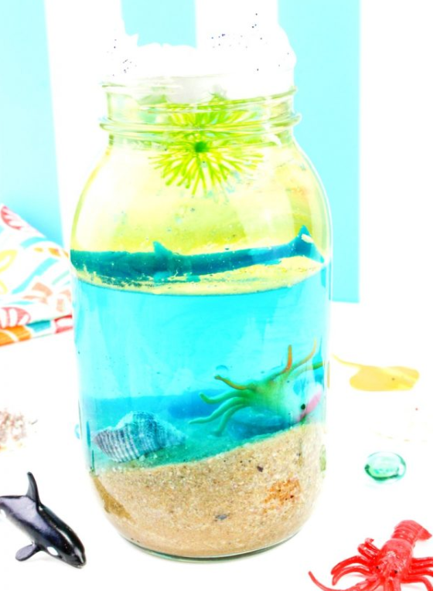 | Science-  Under the sea Habitats  This week we are going continuing think about the creatures which live under the sea and how thety are similar or different to each other  . Look at the powerpoint on the Y1 home-learning web site-  Under the Sea  Answer the questions about each creature then look carefully to see which group different sea creatures belong to.  Challenge  Are all sea creatures fish? Explain your answer  Can you complete the riddles below?  Do you know which each group the sea creature belongs to?  How do you know? | Music  As we are beginning to learn about Under The sea, why don’t you go on a musical journey watching and listening to Finding Nemo music  https://www.youtube.com/watch?v=tmBKlhzrFB8  Challenge:  Think about the musical journey which track did you like best and why?  One musical track used words and the other was instrumental, why do you think the composer used that method?

Useful Websites.
Maths- https://whiterosemaths.com/homelearning/year-1/
TTRockstars- www.ttrockstars.com

Daily Activity Suggestions:
https://www.bbc.co.uk/bitesize/levels/z3g4d2p

Phonics - Daily Phonics Lessons
The Department for Education are releasing daily phonics lesson at 10am, following the ‘Letters and Sounds’ phonics scheme that we use in school. These can be found at: https://www.youtube.com/channel/UCP_FbjYUP_UtldV2K_-niWw
Previous Videos can also be watched as many times as you need. They support children in their blending and segmenting skills and will be very useful to support home learning.
Other Phonics Activities
Use Mr Mc and Mr Thorne does Phonics to look at a Phase 5 sound each day:
https://www.youtube.com/channel/UCTcZnvuTeovlznioLRo0GOA
https://www.youtube.com/user/breakthruchris
https://www.phonicsplay.co.uk/ (Username: march20 Password: home)

Reading
Find more free e-books online at https://collins.co.uk/pages/big-cat-ebooks
- Follow the link and go to ‘Collins Connect’.
- Click on the Teacher portal and enter:
- Username: parents@harpercollins.co.uk
- Password: Parents20!
- Click on Collins Big Cats and then select an e-book. I would initially recommend choosing a ‘blue or ‘green’ level reading book.
If your child reads these with ease and is able to answer questions about the text, then select an ‘orange’ text.

You can also access a wide range of eBooks for free by signing up to https://www.oxfordowl.co.uk/for-home/find-a-book/library-page. Choose a book that you think will suit your child’s reading ability and then share it together. You could read a different book each day or you could read a page per day – whichever works best for you. You could also try Oxford Owl https://www.oxfordowl.co.uk/api/digital_books
This site is free for parents just login and create a password. Children know their colour reading level and there is a huge range of good texts on this site. I would recommend- Oxford Reading All Stars as a new and exciting range of fiction stories

There are lots of extra challenges added to the school website - http://www.marsdenprimary.org.uk/
Well done for everyone that is working hard on TT Rockstars.
Here is this week’s leader board for best effort in the last 7 days . Keep it up everyone!
TT Rockstars Leader board
Harriet – 560 points
- Well done Harriet, lovely to see your name on the board. Come on Y1 let’s get more names on this leader- board for the last two weeks of term.
I know you can all do it!

Art ideas based on the Natural Environment
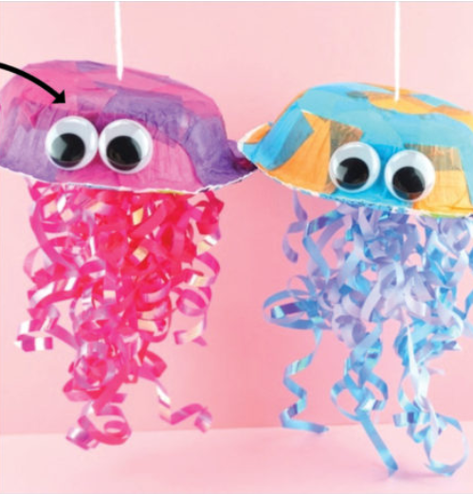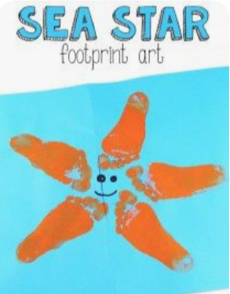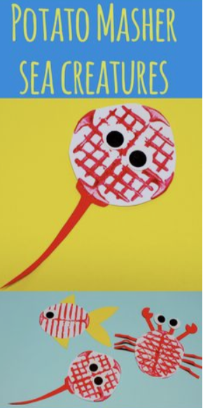

Lego Patterns to create sea- creatures
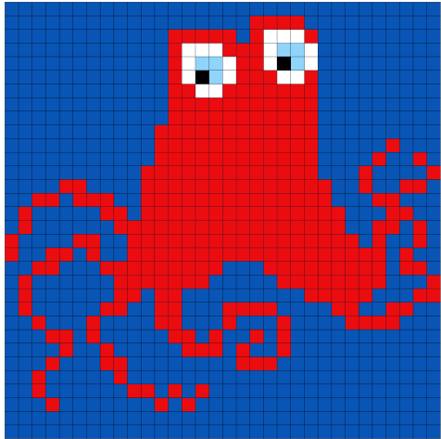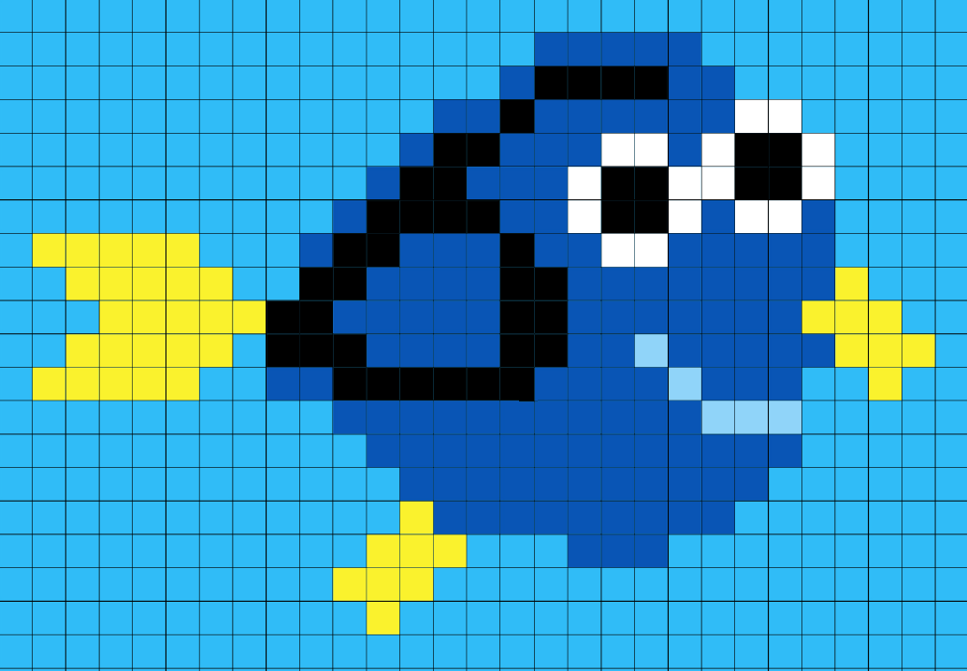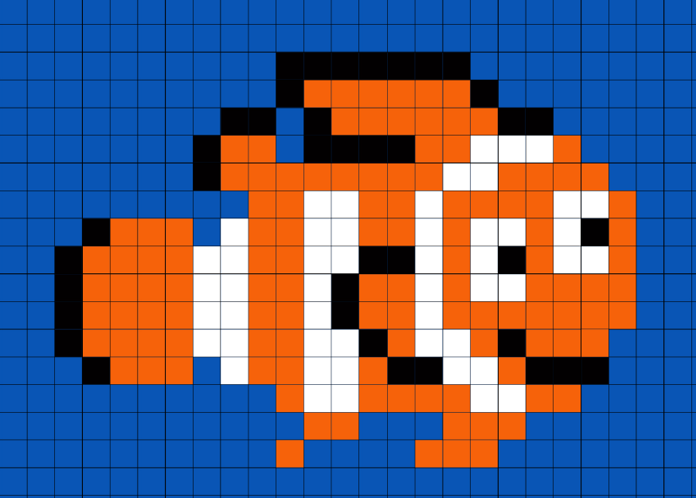
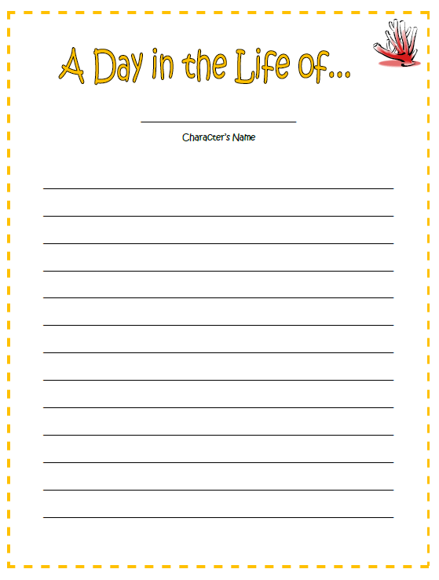
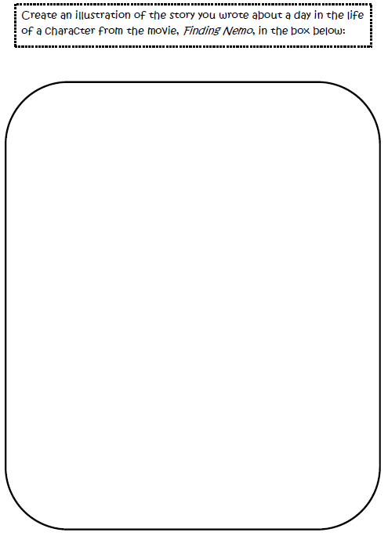
Reading Comprehension
Watch the clip “Dory’s First Day at Nemo’s School” https://www.youtube.com/watch?v=c0pv-s6jDh8
Then answer these questions please:
At the beginning of the clip Dory is told to go back to bed. Why do you think Dory is up so early?
Can you describe what Dory and Nemo look like?
On their way to school the fish are talking about their ocean trip. What did they talk about?
What is the name of the teacher? Why do you think he is called that name?
Nemo tells Dory, that it is best to stay away from the class. Can you find out why he said it?
Did you like this clip or not? Explain your answers.

