Easter Reading  What is Easter?  Read and find out all about Ester by completing the reading comprehension. See how many facts you can remember | TTRockstars  Can you collect 300 coins in two weeks on TTRockStars | Create a jar of positivity. Using a box or jar, decorate it in any way you like and continue to fill the jar daily with things that have made you smile each day DT | Dance  We love dancing in our house- try this hip hop dance challenge on you-tube  Easy Kids Choreography - (Hip Hop Dance Tutorial AGES 4+) | MihranTV
Design an Egg  Design a new Easter egg to be sold on the shops.  Write a description of your new egg using adjectives. Remember to make sure your egg sounds delicious to make people want to buy it. | Saving Easter  The Easter Bunny puts some eggs in a pattern pink, yellow ,blue, pink, yellow, blue. One of his Easter Chicks says the 17th egg will be yellow. Is he right? Draw out and explain your answer. | DT  Try to make a model basket to hold Easter treats for your family. You could use an empty cardboard box and decorate it with paints, collage or your own fantastic drawings and colourings | Easter Egg Characters  Design an Easter Egg character on paper. Get an adult to boil an egg for you, let it cool then create your egg-character. Challenge- Why don’t yoy write a character description about your Easter Character, remember to use adjectives to make an interesting description
Spelling  Egg starts with the letter e-what else starts with e? Write a list of other things that start with the letter e. Then challenge yourself to find 10 words which begin with the digraph ea as in Easter? | Easter Sharing  If a packet has 20 sweets and you share equally between you and three feiends, how many will you get each? Draw20 sheets on a piece of paper, sharing them into the four corners THEN challenge yourself to draw a bar- model sharing box. | Food Technology  We celebrate Easter by eating chocolate, buns and cakes. Try making a sweet treat to share with your family. Why don’t you share a photograph of your treats on our web-site… I would love to see them! | Yoga  Why don’t you try this rabbit yoga adventure- I love cosmic yoga… hope you like it too! You will find this on you tube  Sheriff Updown the Rabbit | A Cosmic Kids Yoga Adventure!

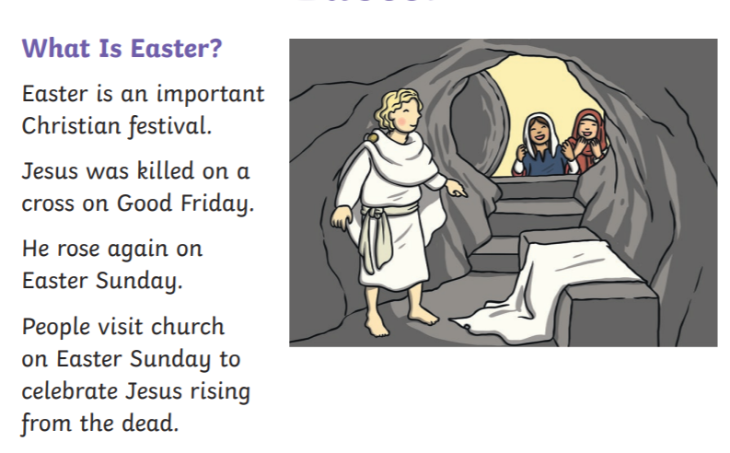
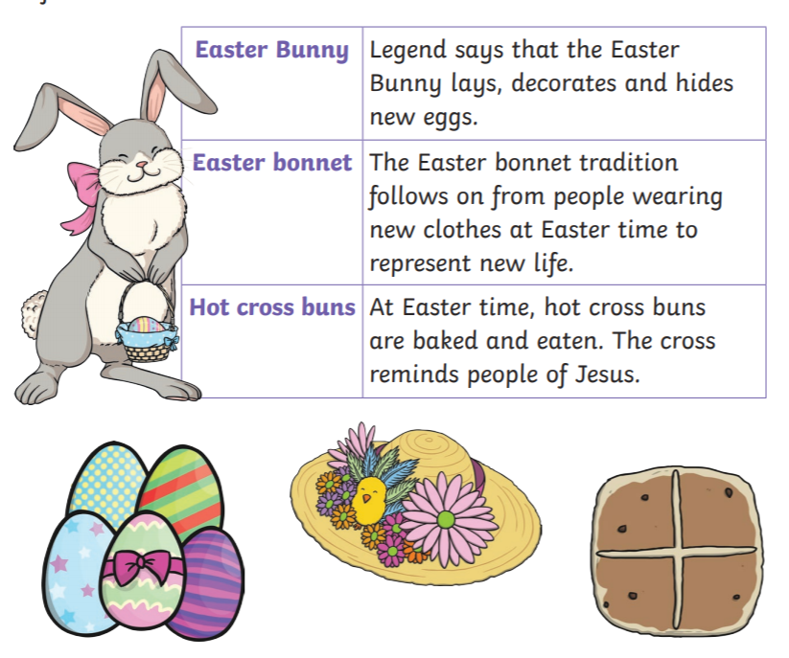
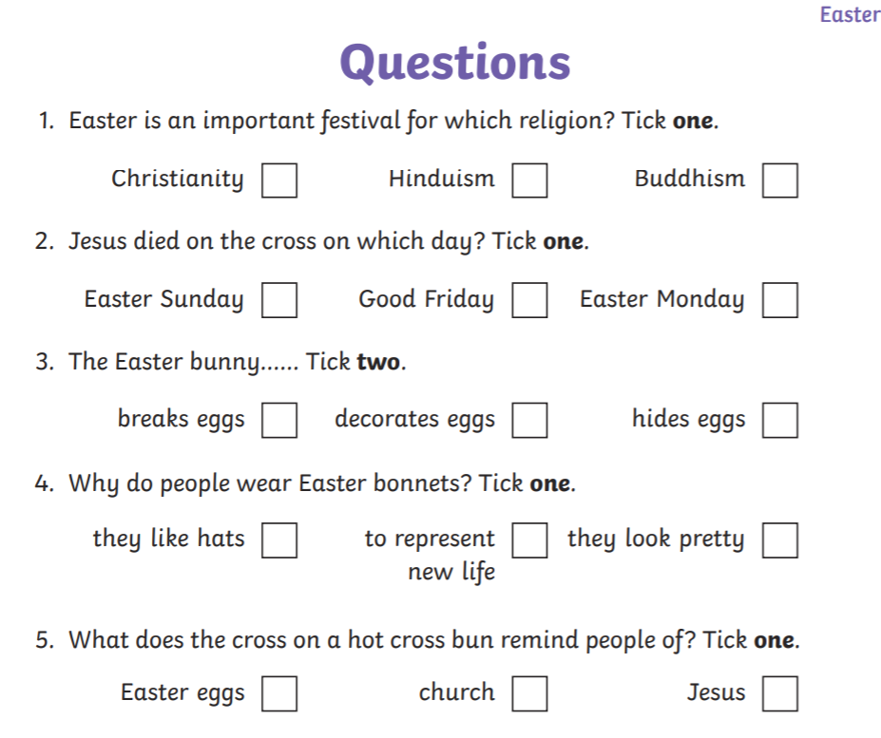

Other fun ideas !
Egg Hunt Bunny Markers
Draw some bunnies, eggs and carrot shapes on some card or the back of an empty cereal packet. Decorate your shapes and write a number within 10 on the back of each shape, these numbers are the amount of points that shape is worth. Hide the shapes around the house or garden ready for an Easter Hunt. You can then create two teams for the hunt. Give your teams 10 minutes to find each shape. Your job is to add each teams number points together. Whichever team has the most points are the winners. Have fun!
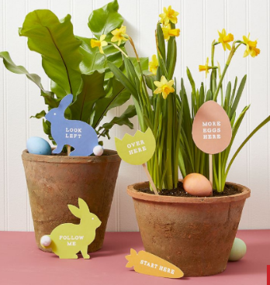
Exploring Eggs – a simple science experiment.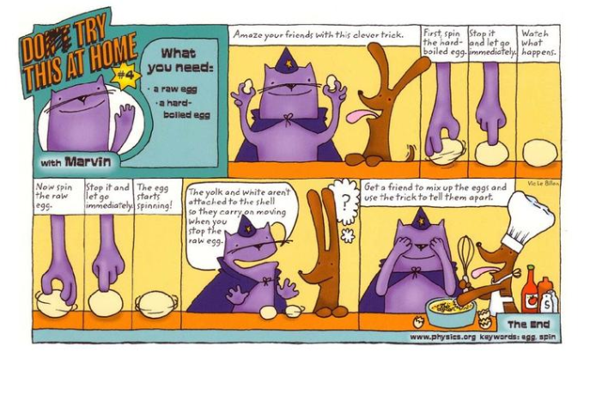
Easter Apps
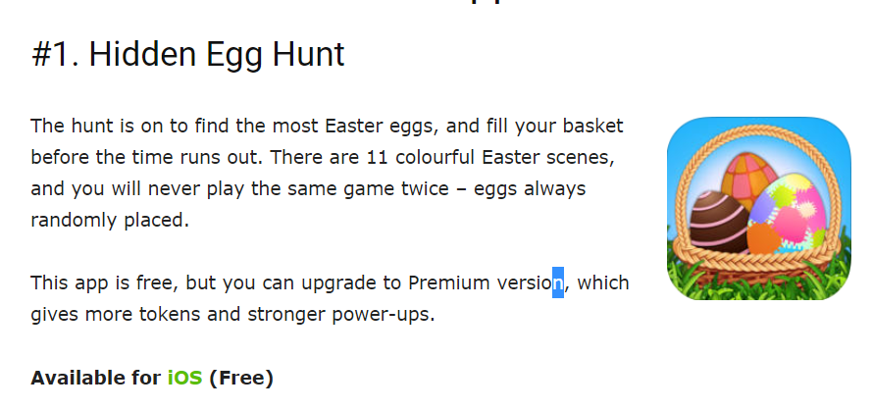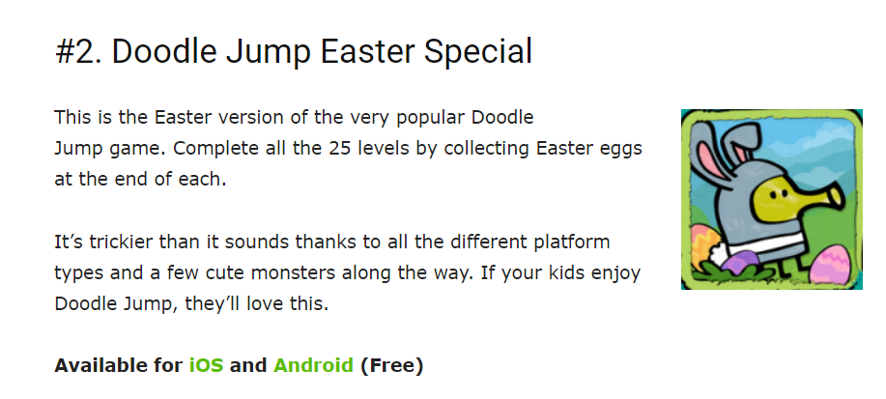

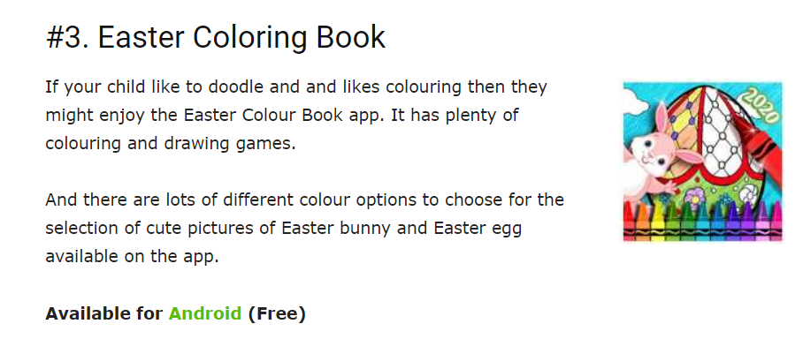
Daily Activity Suggestions:
Maths
TTRockstars will help children learn multiplication tables - https://play.ttrockstars.com/auth/school/teacher
English
You can access a wide range of eBooks for free by signing up to https://www.oxfordowl.co.uk/for-home/find-a-book/library-page. Choose a book that you think will suit your child’s reading ability and then share it together. You could read a different book each day or you could read a page per day – whichever works best for you.
Spelling Shed will have spellings set by me every week - https://play.edshed.com/
Phonics
Use Mr Mc and Mr Thorne does Phonics to learn a new Phase 3 sound each day:
https://www.youtube.com/channel/UCTcZnvuTeovlznioLRo0GOA
https://www.youtube.com/user/breakthruchris
You could practise writing the sound in the air/ on the ground and then you could play a game using that sound on https://www.phonicsplay.co.uk/ (Username: march20 Password: home)

Remember to keep up-to-date with information by looking on the school website as often as possible and please leave comments so that we can keep it touch. It’s lovely to hear from you and to see how hard you are all working! You could also send photographs of the children completing their challenges to info@marsdenprimary.org.uk and we will add these to our ‘Home Learning’ section on the website.

