TTRockstars  Go on TTRockstars online and practice your tables. Try to practice as much as possible on ‘Sound Check’. | Film review  Write a review of your favourite Film.   | Chick Life Cycle  Learn about the life cycle of a chick. Draw a diagram of the 4 stages. Remember to label your drawings.  Use this QR code to find the video:   | DT  Create a jar of positivity. Using a box or jar, decorate it in any way you like and continue to fill the jar daily with things that have made you smile each day.
Music  Listen to your favourite songs and identify the instruments you can hear. | Acrostic poem  Write an acrostic poem for the word Easter. Create detailed and interesting sentences for each letter.  E____________________________  A____________________________  S____________________________  T____________________________  E____________________________  R____________________________ | Create your own Easter Egg Hunt  Within your home and garden create your very own Easter Egg hunt for your family. Provide some clue cards for your hunt! | Easter Extravaganza!  Create your own Easter bunny basket.
Design an Egg  Design a new Easter egg to be sold in the shops.  Write a description of your new egg using adjectives. Remember to make sure your egg sounds delicious to make people want to buy it. | Easter Egg Adventure  Whilst completing your Easter egg hunt you stumble across a magical Easter egg. This egg has the power to transport you on an adventure. Describe what adventure you go on with your magical egg. Make sure that your story has a beginning, middle and end. | Quick Read- Recipe for Hot Cross Buns  Read the text below and answer the questions.(The answers are included in this pack on the following page). | Easter Joke  Complete the times table answers to reveal the answer to the joke.  Challenge: Can you create your own Easter joke using maths questions.

Daily Activity Suggestions:
PE
Keep yourself and your family active with the Joe Wicks daily workouts at 9am https://www.youtube.com/user/thebodycoach1

Maths
Once the children have finished their Spring Maths booklet follow the White Rose Home Learning work set daily. Start on Week 1. Included in this is a short video explaining tasks and questions to follow for the children to complete. This link will take you to the webpage needed: https://whiterosemaths.com/homelearning/year-4/
I have also set an online activity ‘Time Conversions 1’ on MyMaths for the children to complete. This will be available from Friday 3rd April until Friday 10th April.
Twinkl has many maths investigations using number skills - https://www.twinkl.co.uk/resources/wellbeing-parents/year-3-to-year-6-ages-7-11-home-learning-area/english-activities-age-7-11-home-learning-school-closures-parents/2
TTRockstars will help children learn multiplication tables - https://play.ttrockstars.com/auth/school/teacher
English
You can access a wide range of eBooks for free by signing up to https://www.oxfordowl.co.uk/for-home/find-a-book/library-page. Choose a book that you think will suit your child’s reading ability and then share it together. You could read a different book each day or you could read a page per day – whichever works best for you. You might even want to create a book review to share!
Spelling Shed will have spellings set by me every week - https://play.edshed.com/ . This week I have set the children spellings using the suffix ‘tion’. Following this, Spellings will be set weekly at the beginning and throughout the Summer term. Go to Spelling Shed online and click the task ‘The Suffix ‘tion’. This will be available from Friday 3rd April until Friday 10th April.
Remember to keep up-to-date with information by looking on the school website as often as possible and please leave comments so that we can keep in touch. It’s lovely to hear from you and to see how hard you are all working! You could also send photographs of the children completing their challenges to info@marsdenprimary.org.uk and we will add these to our ‘Home Learning’ section on the website. We have also provided various links to activity ideas on our website.

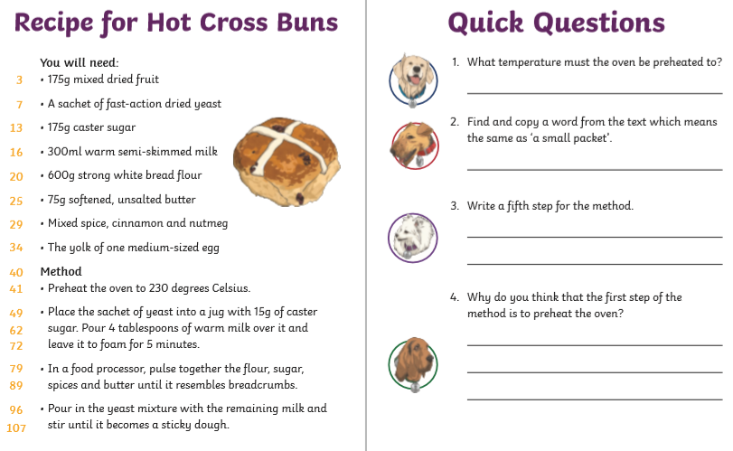
Answers to Comprehension Questions

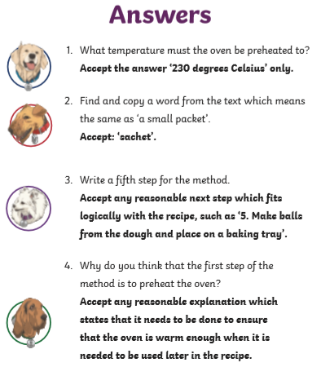

Easter Egg Hunt Cards
