Bosworth Academy Post 16 Registration
Planning your answers

Below are the questions you will need to answer in order to register for Bosworth Academy. Once you have completed your registration form, you will not be able to edit it. Therefore, it is important that you first plan out your answers here first.

Section 1 - Your Information

Question | Your answer
Legal First Name(s)
Legal Last Name
Data of Birth (dd/mm/yyyy)
Your personal email address
(Please do not use your school email as this may become disabled after you finish school in June.)
Parental/Carer email address
Address Line 1
Address Line 2
Town
County
Postcode
Contact telephone number
This should be your main contact number e.g your mobile number.
Current School attended
Inclusivity and personalisation information
Making sure all our students feel included and supported is really important to us. We are a diverse and inclusive school and we want to make sure you are comfortable through all stages of the application process. Please answer these questions to help make sure we greet you in the correct way and to help us understand what support you may require throughout the application process, as well as in school if you are successful in your application.

If the lists below do not provide an accurate description, and you are happy to specify your own, please type it in. We are sorry that it says 'other' - unfortunately we are unable to override the default wording on this form.
Please specify any medical disabilities you think the school should be aware of otherwise, leave blank.
Please specify any learning disabilities you think the school should be aware of otherwise, leave blank.
Which of the following most accurately describes you? | - Male  - Female  - Non-binary  - Transgender  - Intersex  - Gender Fluid  - Prefer not to say  - Other (please specify)
What is your preferred pronoun? | - He/His/Him  - Her/Hers/Her  - They/Theirs/Them  - Other (please specify)

Section 2 continues on next page

Section 2 - Your Qualifications
Add all the qualifications you are currently studying at school. You will also need to add the ones that you have completed and have a result for.

Question | Your answer
Qualifications studying and Predicted Grade.

Please add your qualifications you are currently studying in the following format:
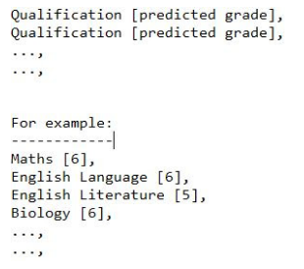
Qualifications you have completed and have a grade in

Please tell us if you have completed any qualifications in the following format. Leave blank if not applicable.
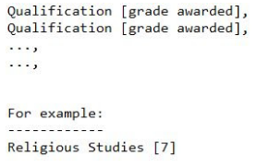
I confirm that the grades I have submitted are entirely accurate | MUST SELECT YES TO CONTINUE.

Section 3 - Work Experience

Question | Your answer
Have you had the opportunity to undertake work experience? | - Yes - I have had the opportunity to undertake some form of work experience (GO TO SECTION 4)  - No - I have not had the opportunity to undertake any form of work experience (GO TO SECTION 5)

Section 4 - Work Experience Detail

Please write about any work experience you have done, any part-time jobs you have or have had and any volunteering you have undertaken, including start and end dates (if known).

Section 5 - Subject Choices
Please identify the subjects you wish to study in order of preference. Our aim is to place you in to your top three choices. Please look at Bosworth Academy's website to understand what subjects are available.

*denotes a required answer. You must select at least four subjects.

Subject Preference 1*
Subject Preference 2*
Subject Preference 3*
Subject Preference 4*
Subject Preference 5
Subject Preference 6

Why have you chosen your courses?

For example, they will lead to a type of career, it's an area that you are interested in etc. if you have chosen different types of courses, you should also explain why. Don't feel you have to write too much here - it just helps during your interview to have something prepared.

Section 6 - Personal Statement

Include interests and hobbies. You could also talk about your favourite subject and careers aspirations. This should make you sound as good as you can be, so don't put anything negative - but be honest at the same time.

Do not write more than 4000 characters for this section.
Personal Statement

Section 7 - Finalising the application

Thank you for considering Bosworth Academy. We love teaching and helping students realise their full potential.

To help us plan our staffing and rooming requirements, it would help us to understand whether you are considering us as your first choice placement.

This will not affect your application in any way. We know people change their minds about where to study and it can be down to personal needs and circumstances. It is important to keep your options open!

Question | Your answer
Is Bosworth Academy your... | - First choice  - Second choice  - Third choice or lower

