Erin Etheridge

- 11 Years
- Year 6

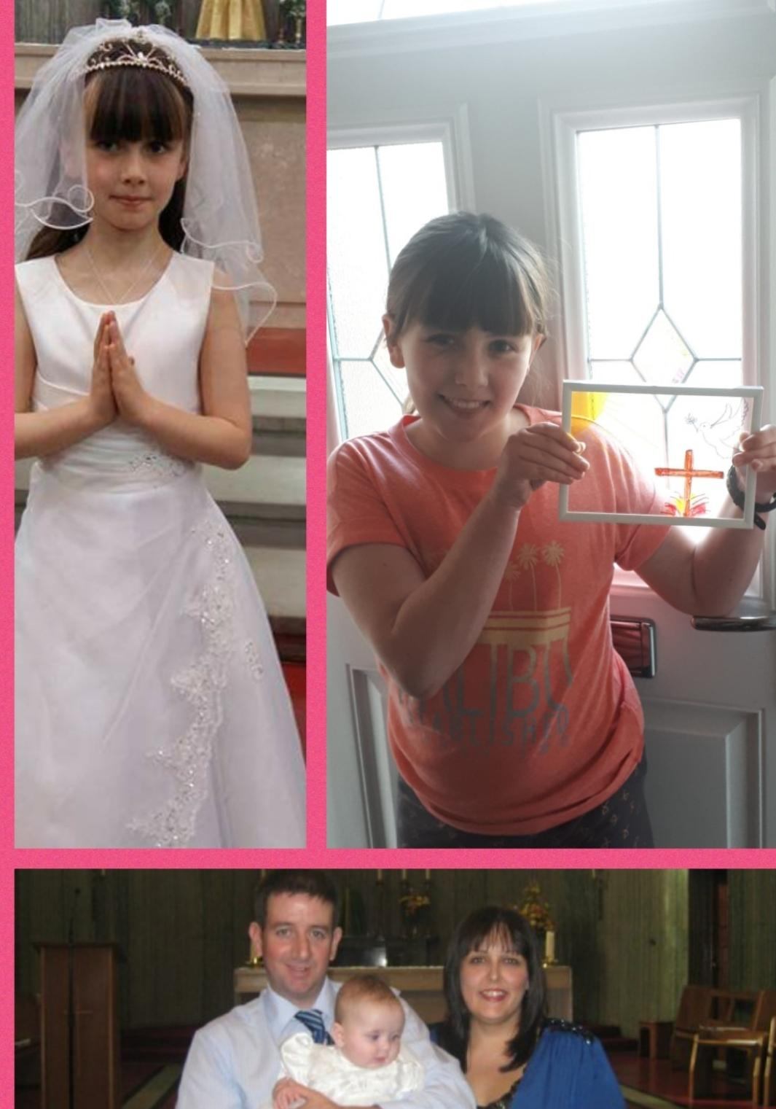

The Church means a lot to me because it's a place where I can come together with my family and the school community. I find All Souls Church a calm and peaceful place where I can reflect and give thanks for the wonderful things in life.

In 2009 I started my catholic journey when I was baptised. All Souls parish has been a part of my family for a number of years attending mass especially at Christmas and Easter. I have done a number of readings and offertory processions and also attended all meetings in preparation for my confirmation.

I feel All Souls Church has been a major part of my life and journey of faith.

