What does All Souls’ Parish mean to me?

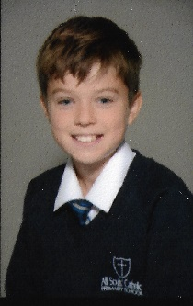
What does my Church and Parish mean to me?

All Souls’ Parish is very important to me because it is has been a constant presence and part of my life since I was born. I have lived in the Parish all my life, it is where I was baptised, took my first holy communion and it is where I will be confirmed. It is where I go every Sunday to celebrate Mass with my family and the Parish community. I also enjoy being part of the team of Altar servers and I help with readings and bidding prayers regularly too.

I know that even when I have left All Souls’ as a pupil, I will still be part of the Parish and will look forward to seeing other children, including my prayer friend when we are at Mass or other church events.
William Groves
Year 6
10 years old

How do I relate to it?

I relate to our Church and Parish as it is where I go to celebrate Mass and pray every Sunday along with my friends and my family. It is a special place to me as it is the place where I have received the sacraments of Baptism and Holy Communion and where I made my First Confession. With my school, I have taken part in weekday masses, the Christmas Nativity and carol service. It was also the place where my dad was confirmed as a Catholic, at the Easter Vigil in 2018. I can relate to my Parish as is a place where I feel happy and content surrounded by people that I have known from school and church and I feel that God is watching over our Parish community.

How does it relate to me?

At the moment it feels quite different as I’m not spending time in church or school and so it is harder to feel physically part of the Parish. However, I know that we are all praying for each other and looking forward to being able to go back to church soon. I am grateful to Father Paul for keeping Mass going online and for his kind words in the letter he wrote to Year 6. I think that Father Paul understands how we are feeling as he is very kind and considerate and also has a family of his own. In difficult times I know that other parishioners are thinking of each other and prating form they and I think this is very important at the moment.

