Origami heart instructions.

1) Get your piece of square paper and fold it in half and then half again. (It needs to be diagonal to start off with. 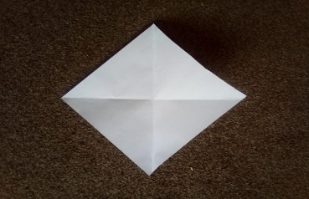
2) Open up the folded square and fold the top corner to the middle point of the square.

3) Now put the bottom corner up so that the corner is at the edge of the folded tab.
4) Fold the left-hand corner to the middle fold and then do it on the right-hand corner. It is a bit like making a paper airplane.
5) Fold the left corner behind and then the right corner.
6)Fold the top left tab behind and then the same for the top right tab.

