Harry Potter and the Order of the Phoenix: Film Review
Director: David Yates
Year it was made: 2007
Age rating: 12A
Key actors: Daniel Radcliffe, Rupert Grint, Emma Watson, Helena Bonham Carter, Robbie Coltrane, Warwick Davis, Ralph Fiennes


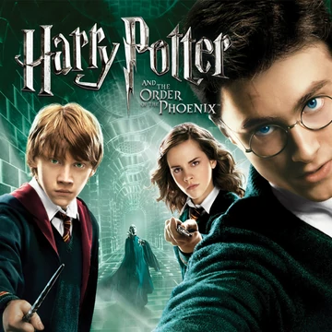
Director of the later four Harry Potter Movies, David Yates started off his Harry Potter collection with a banger. We follow Harry through another difficult (obviously) year at Hogwarts School of Witchcraft and Wizardry. Through his struggles we feel for Harry and can imagine what he is going through. Meeting new challenges and friends on the way this film does not disappoint.
In this film the genre slightly changes and starts to become more of a teen drama. It becomes a bit more gritty and grimier but also has elements of love. It is clear this film was aimed at older children and teens; although, anyone can watch it and enjoy its brilliance.
In the film Harry assembles a group to teach defensive spells to. Delores Umbridge fills the role of defence against the dark arts teacher. She and the ministry believe that a theoretical approach on the dark arts is best as that’s all you need to pass your Ordinary Wizarding Examinations (OWL’s). When Harry returned to Hogwarts, he was shocked to find out nobody believed him that Voldemort was back which he had found out the previous year. He mentors a new group of young wizards also known as “Dumbledores Army” and teaches them all his skills, building up to the moment when they need them most.
I really enjoyed this film as although the genre slightly changed it still portrayed the element of action and adventure in keeping with the style of these films. My favourite characters are Luna Lovegood and Hermione Granger as they are clever, funny and great friends.
The parts I thought could be improved is when Harry has the vision of Sirius and they go to London. There is no real hint that it almost the end and I would have preferred if it would have been a bit more obvious. My least favourite character is Delores Umbridge because after all she gives Hogwarts a lot of grief by upping the rules and using torturous methods for students who barely do anything wrong.
Overall, I really recommend this film to older children and teens upwards because of its element of teen drama and love drip fed through it. Its gripping nature, action and comedy makes it an amazing story great for a holiday film or one to watch with the family. If you are watching the whole Harry Potter Film series the next film you will want to watch will be “Harry Potter and the Half-Blood Prince”.

