


Abercorn Road, Coventry, CV5 8ED ● Tel +44(0)24 7667 5836 ● Fax +44(0)24 7671 7375 ● email scowley@souls.coventry.sch.uk www.souls.coventry.sch.uk Headteacher Mrs Caroline Quinn
 Abercorn Road
Coventry
CV5 8ED
Tel: 024 7667 5836
Headteacher Mrs Caroline Quinn
Caroline.quinn@allsoulsschool.co.uk

22nd February 2016
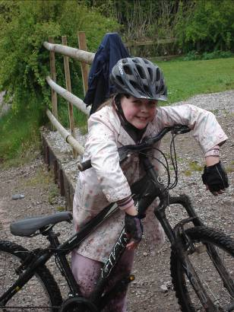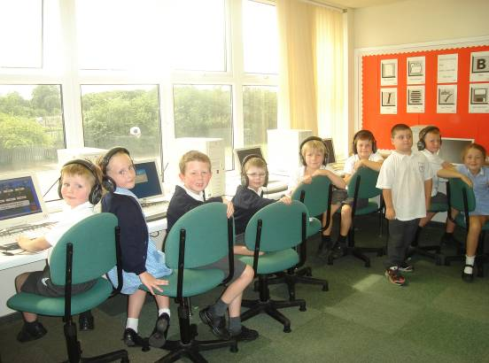

Application: Class Teacher

Thank you for showing an interest in our vacancies. All Souls is a good school, committed to raising standards and ensuring each child achieves their potential through a challenging, creative curriculum, delivered in the spirit of Gospel values.

Please find enclosed:

- CES Application form

- Job description

- Person specification

We believe it is important for you to see All Souls Catholic Primary School ‘in action’ and so visits to our school are strongly encouraged, although not essential for a successful application. These can be arranged by appointment through the school office.

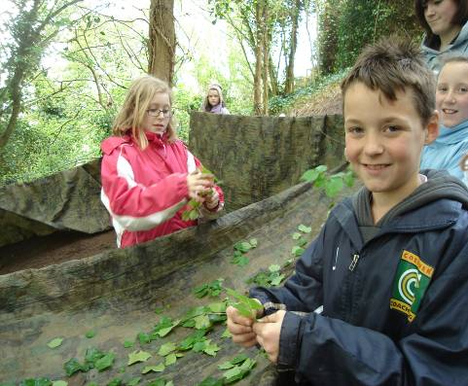

Abercorn Road, Coventry, CV5 8ED ● Tel +44(0)24 7667 5836 ● Fax +44(0)24 7671 7375 ● email scowley@souls.coventry.sch.uk www.souls.coventry.sch.uk Headteacher Mrs Caroline Quinn
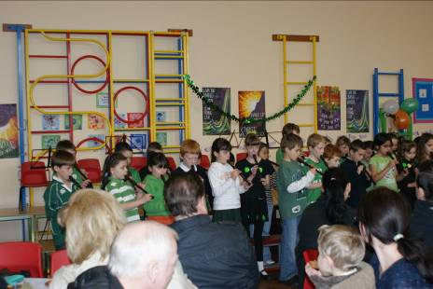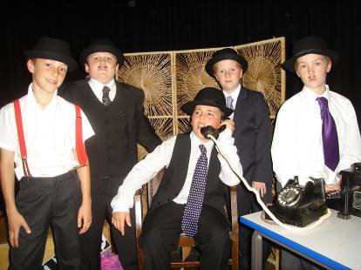

Together with the application form, a clear and concise letter of application is required identifying why you have made the application to All Souls’ Catholic Primary School.

Point 8 on the application form should not exceed 2 sides of A4 and in a font size no smaller than Arial 12.

Please note that the closing date for applications is 12pm Monday 14th March. Interviews will take place between 17th and 24th March.

We look forward to meeting you.

Yours sincerely



Caroline Quinn
Headteacher

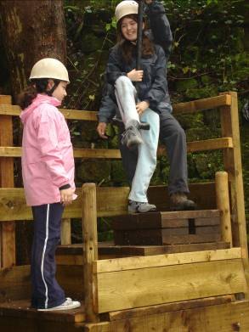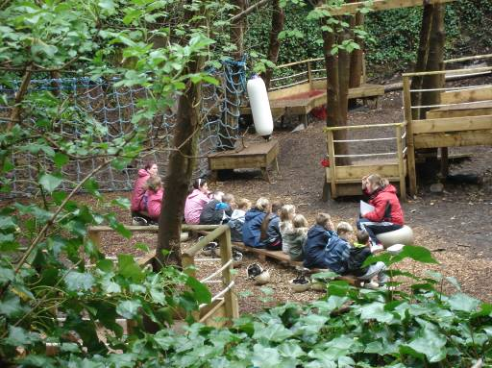

Abercorn Road, Coventry, CV5 8ED • Tel +44(0)24 7667 5836 • Fax +44(0)24 7671 7375 • email admin@souls.coventry.sch.uk www.allsoulsschool.co.uk Headteacher Mrs Caroline Quinn

