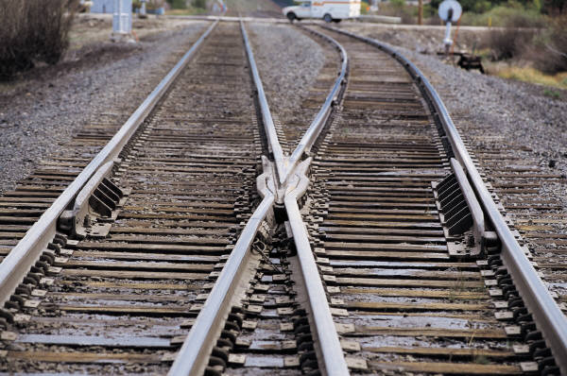j0212957MC900295815[1]

Make your own Road

Try covering a table with paper and ask your child to draw roads for their cars. They could add their own road signs and buildings to it. They can then drive their favourite vehicles around the road map.

Train Track

The above can be adjusted to making a train track.