Newsletter
Helen Gibson Nursery School
January 2020

Helen Gibson


Nursery


Welcome back to a new year at Helen Gibson Nursery School. We have lots of exciting things which will be happening throughout the year so keep an eye on the website and newsletters that come your way. Can we just say a big thank you for all the cards, gifts and best wishes we received before Christmas! We return on the 6th of January 2020.
Nappies and Wipes
If your child is still in nappies could you ensure that we have a good stock of them at Nursery please?

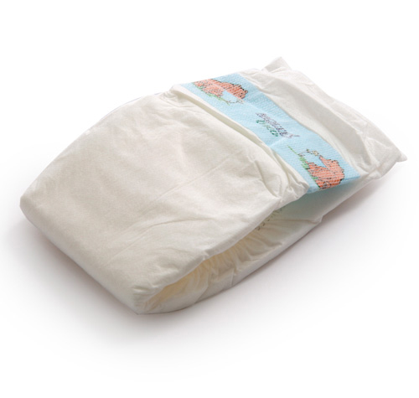

Family Man Day
On Wednesday the 15th of January will be Family Man Day at school. We are inviting any male relatives in to the nursery to enjoy playing with your children, exploring outdoors, reading and so much more! If you would like to join us, please sign up on the sheet in the conservatory.

Giraffe Cake Sale

Giraffe cake sale will take place on Wednesday the 22nd of January. Bring your cakes in Giraffes and your pennies everyone else too!


Tempest Photography
On the 29th of January the photographer will be in to take individual pictures.

Warm Winter Clothes / Names in Clothing
Children will be given lots of opportunities this term to play outside and try out new and exciting activities. In order for us to do this and to ensure your child has a full and enjoyable experience could you please provide them with warm clothing? Could you also ensure that names are in clothing and footwear too. Many thanks!


Children’s Trays
Can you check your child’s tray regularly so that we can ensure that all correspondence gets to you in time?



Update the Profile
If you have a new mobile phone number or emergency contact details have changed could you please inform the office? Also if your child has any new allergies, intolerances or illnesses this must also be noted on your child’s profile.


Have a fantastic January


Questionnaire Feed Back
- Since my child has entered nursery I feel they have made good progress. Strongly Agree 50%
Agree 43%
Disagree
Strongly Disagree
Don’t Know 7%

- My child enjoys coming to nursery
Strongly Agree 79%
Agree 21%
Disagree
Strongly Disagree
Don’t Know

- The nursery keeps me informed about my child’s progress.
Strongly Agree 43%
Agree 36%
Disagree 21%
Strongly Disagree
Don’t Know
I would love to support this more and would welcome any comments on how we can improve in this. We had a very rocky start with the FFI platform and I feel this really put us on a back foot at the start. If any parent would like to have additional parent chats, we are more than willing to accommodate. For parents who don’t see their keyworker on a daily basis as they have to have their lunch at this time please, please tell us which days you would like to see them and they will make themselves available during their dinner. Learning journals are free to go home anytime you would like them but we do need them returned as quick as possible to stop stock piles of observations. Due to the rocky start and staff illness and absences we have been playing catch up and for this I apologise. We are sending all learning journals out for Christmas and intend to more frequently in the new term. We have an open door policy and would love you to pop in at any time to see us.

- The nursery has a good reputation in the local community.
Strongly Agree 64%
Agree 36%
Disagree
Strongly Disagree
Don’t Know

- There is good leadership and the nursery is managed well. Strongly Agree 72%
Agree 28%
Disagree
Strongly Disagree
Don’t Know

- I feel at ease to approach the nursery about any concerns.
Strongly Agree 57%
Agree 43%
Disagree
Strongly Disagree
Don’t Know

- I would recommend the nursery to others.
Strongly Agree 72%
Agree 28%
Disagree
Strongly Disagree
Don’t Know

Any other comments
“My child has settled well and loves coming to nursery.”

“Since starting the nursery I have a happy and confident little boy! Thank you.”

“Absolutely love Helen Gibson Nursery! My child is so happy to come her and staff are so friendly and approachable.”

“Learning Journals could show more detail in progress made, would be good to see more regular. Staff are brilliant and really seem to understand and care about my child, which as a parent, is exactly what you want.” –Ofsted have new criteria’s which we have to adhere to. One is around staff workload (one of the reasons I thought the online versions would help but didn’t). We are told that we must reduce staff workload and support the wellbeing of our staff so it is a bit of a balancing act getting this right at the moment, however we are working together on this and all feedback will be discussed to look at next steps and ways forward.

“Helen Gibson is a fabulous Nursery. All staff are always friendly, helpful and happy. I never worry leaving my child in your care. She is always happy to go to nursery and happy when she come home.”

“The nursery has been absolutely fantastic with my child, couldn’t wish for better. Lovely environment, staff and activities. The outdoor area is just fantastic and perfect for my little explorer.”

“Daily feedback and more opportunities to see learning journals and how they are progressing.” – This is something we are focusing on next term.

“I haven’t answered question 1 as apart from the parent chat, which we were very happy with, there has been no regular photographs or learning journal as mentioned when the online system was withdrawn.” – Again I do apologise for this. Please ask your child’s keyworker anytime you would like to see a journals or discuss updates on progress.

“My child loves coming to Helen Gibson Nursery. She is excited to go in every morning.”

“My child loves nursery and is comfortable with all of her teachers. Can’t praise her keyworker enough. She always takes time to update me on what my child has been doing each day when I pick up. This makes leaving her a lot easier when I know she is happy. Thank you!”

Thank you so much for all of your comments. We value the praise we have received and will work on the things we can do better. In the meantime, I would like to wish you all a very merry Xmas and a happy New Year.

