Newsletter
Helen Gibson Nursery School
January 2019

Helen Gibson


Nursery


Welcome back to a new year at Helen Gibson Nursery School. We have lots of exciting things which will be happening throughout the year so keep an eye on the website and newsletters that come your way. Can we just say a big thank you for all the cards, gifts and best wishes we received before Christmas!
Nappies and Wipes
If your child is still in nappies could you ensure that we have a good stock of them at Nursery please?

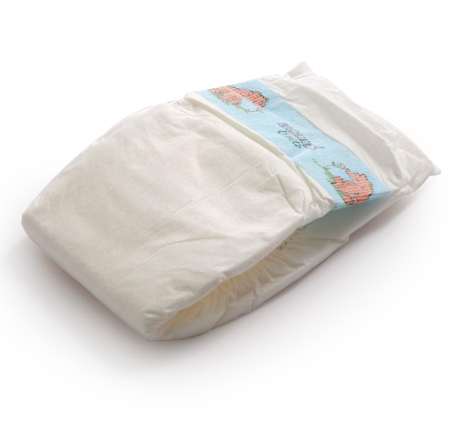

Parent Helper’s
If any parent/carer would like to volunteer to help out 1 session a week in nursery please see Mrs Parker.


Photographer

On the 30th January our photographer will be here to take individual pictures of your children. If you require a family photo please see Mrs Howard for further details.

Snacks
Thank you so much to everyone who brings snacks in for the children. Your support is greatly appreciated!
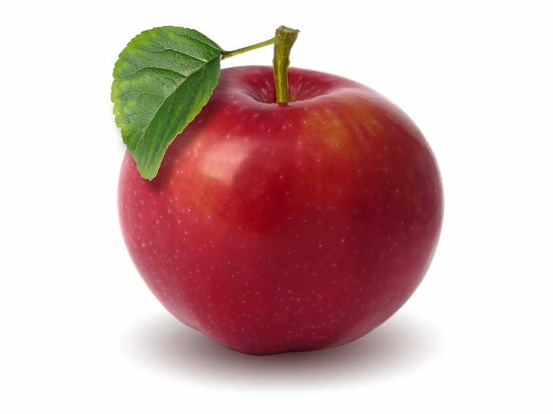

Warm Winter Clothes / Names in Clothing
Children will be given lots of opportunities this term to play outside and try out new and exciting activities. In order for us to do this and to ensure your child has a full and enjoyable experience could you please provide them with warm clothing? Could you also ensure that names are in clothing and foorwear too. Many thanks!

Children’s Trays
Can you check your child’s tray regularly so that we can ensure that all correspondence gets to you in time?

Update the Profile
If you have a new mobile phone number or emergency contact details have changed could you please inform the office? Also if your child has any new allergies, intolerances or illnesses this must also be noted on your child’s profile.


Have a fantastic January


