Mindfulness

Being a friend to yourself

What is mindfulness?

Mindfulness is about being in the moment and paying attention to now..

How can we be in the moment?

We can pay attention through our senses;
1. What we can see ...
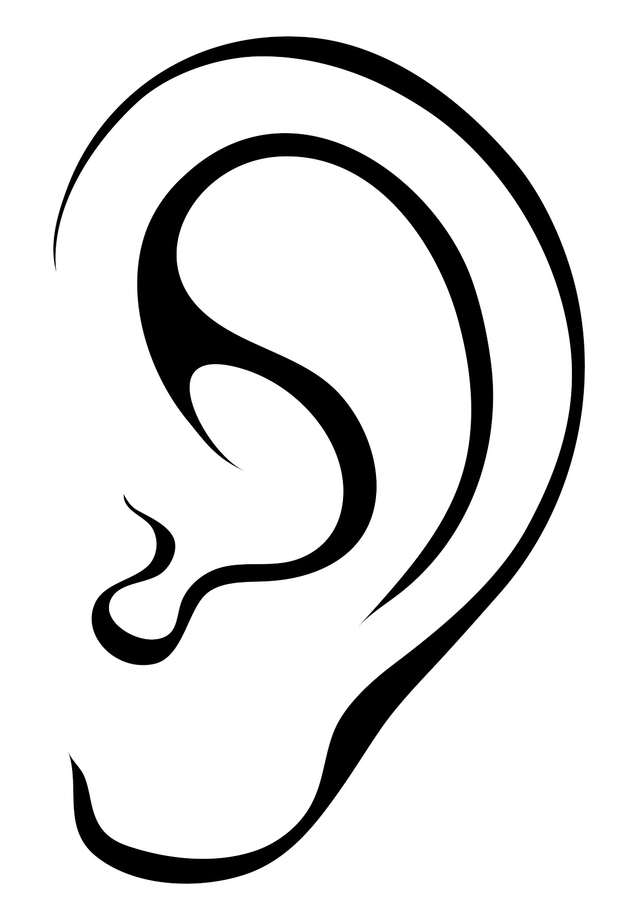
2. What we can hear ...
3. What we can touch …
4. What we can smell …

We can also …

Come back to focusing on our breath
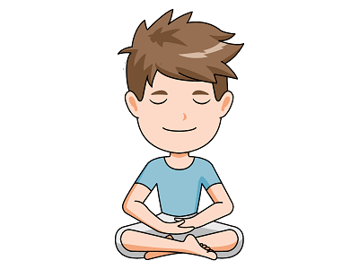
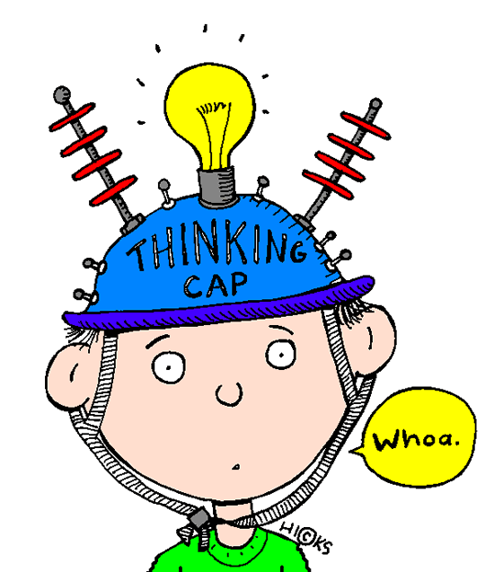
Why should we be mindful?

When we are not in the moment our mind is thinking

Our mind worries and asks questions or makes judgements …

‘Why did she do that?’ … ‘I did that badly’ … ‘Something bad is going to happen’

Being mindful or being ‘in the now’ gives our mind something to focus on.
It helps us stay calm and relaxed.

Practise makes perfect

When we practise something we get better at it!

Every time we are angry … we get better at being angry.
Every time we are anxious … we get better at being anxious.

When we are ‘in the moment’ we get better at enjoying life as it is now!!

See the signs …

Notice when you start to …

- feel tense | - clench your fists / jaw
- worry | - breathe short and shallow
- feel hopeless | - have negative thoughts
- have trouble concentrating | - have a fast heart rate

What to do …

Techniques to help focus the mind and calm you down

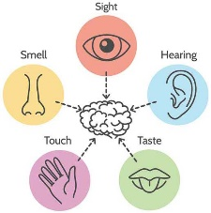
- Grounding
- 5 things you can see
- 4 things you can hear
- 3 things you can touch
- 2 things you can smell
- 1 thing you can taste

- Counting Your Breath

- Sit up straight and take 2 deep breaths (in through the nose, out through
the mouth)
- Feel your stomach fill with air and feel it rise and fall like a balloon
- Count 10 pairs of in and out breaths
- Repeat - but with eyes shut
- As you breathe out, glide your index finger over the fingers of your other
hand.
- Continue the cycle until ready to finish
- Hands in lap - 10 breaths silently in your head

- Explore Emotions
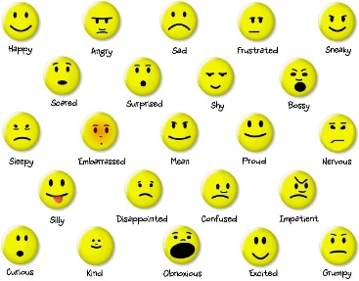
- See how it makes you feel inside when you slowly read these words.
(Spend at least 10 seconds with each word)
- Happy Sad Excited Mad
Stressed Bored Loving Anxious Worried Scared
Jealous Quiet Silly Peaceful

- Happy Memory
- Close your eyes and remember a time when you felt happy.
Maybe someone was kind to you. Perhaps you got a smile from a
friend or your pet was happy to see you.
- Remember a wonderful moment like that.
- Close your eyes and bring it to your mind.
- What did you see and hear? Did you laugh or smile? Who was
there?
- Notice how you feel when you remember the memory?

- Body scan
- Closing your eyes can be helpful to allow you to focus or, if you’d rather, you can always
lower and half-close your eyes.
- Bring awareness to the body breathing in and out, noticing touch and pressure where it
makes contact with the seat or floor.
- Throughout this practice, allow as much time as you need or want to experience and
investigate each area of the body.
- Think about the soles of your feet by pushing them softly against the ground for
a short moment.
- Pay attention to your feet, how they make contact with the ground and your shoes.
- How does it feel? Soft or hard?
- Can you feel your socks?
- How do your heels feel? Your toes? Can you feel the space between your toes?
- Move your toes a little bit and try again.
- Can you pay attention to them one by one?
- Are your feet are warm or cold.?
- Is there a tingling sensation somewhere?
- Can you feel the chair underneath you?
- How about your back resting against the chair?
- How do you feel?
- Can you think of any situations when this exercise could be useful?
- Are you more focused and more calm after the exercise?

- Hand meditation
- Sit up straight like you are a puppet with a string on the top of your head.
- Take a few deep breaths. In through the nose and out through the mouth.
- Start with eyes open and squeeze your hands together on the ‘in’ breath and
release all the tension on the ‘out’ breath.
- Repeat with eyes shut
