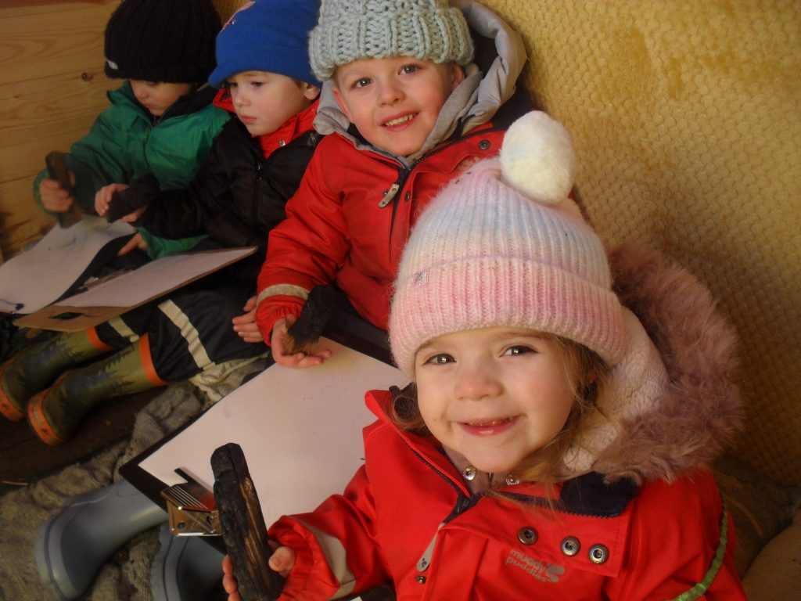

Clervaux Nursery School
Clervaux Terrace, Jarrow
0191 4897358

Executive Head Teacher: Mrs J Parker
(Bphil, GTP in Early Years Education)
Designated person and lead in Child Protection

Teacher: Mrs M Dixon Deputy Designated Safeguarding Lead
Non Teaching Deputy Lead : Miss N Reed
Higher Level Teaching Assistant: Mrs B Stephenson
Teaching Assistant: Mrs L Wood
Teaching Assistant: Miss L Wadey
Teaching Assistant: Miss K Richardson
Teaching Assistant: Mrs C Hamilton
Teaching Assistant: Mrs C Fulton
Teaching Assistant: Miss K Boak
Teaching Assistant: Miss E Hudson
Teaching Assistant: Miss C Cooper
Secretary: Mrs E Collins
Person to direct any queries to
Kids Club Leader: Mrs M Muir
Kids Club Worker: Mrs C Hamilton
Kids Club Worker: Miss L Thorn
Kitchen Assistant: Mrs A Hamilton

Caretaker: Mr J Sharp
Education Authority: South Tyneside
Chairman of Governors: Miss C Aberdeen
Vice Chairman: Mrs E Thompson

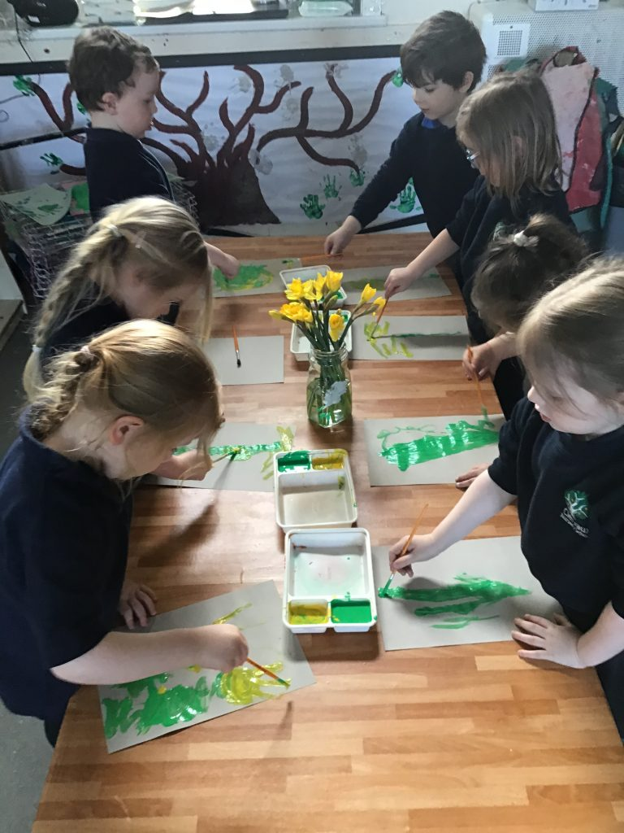

Dear Parents/Carers

We would like to welcome you and your child to Clervaux Nursery, part of the Early Years Nursery School Alliance. We strive to establish good liaison between home and school right from the beginning. As parents you have already been your children’s teachers and know your child better than we do, we therefore find it most beneficial for us all to work together in partnership. We have produced this booklet to provide you with more information about your child’s nursery education. If at any time you have any problems you wish to discuss with us please ask – we are here to help!

Parents are very welcome to come into the nursery at any time, but if you wish to speak to the executive head teacher it is best to check that she is available; as there are times when she is away from the building attending meetings, or working at her other school.

We are looking forward to a happy year of working together.

Yours sincerely

All the nursery staff

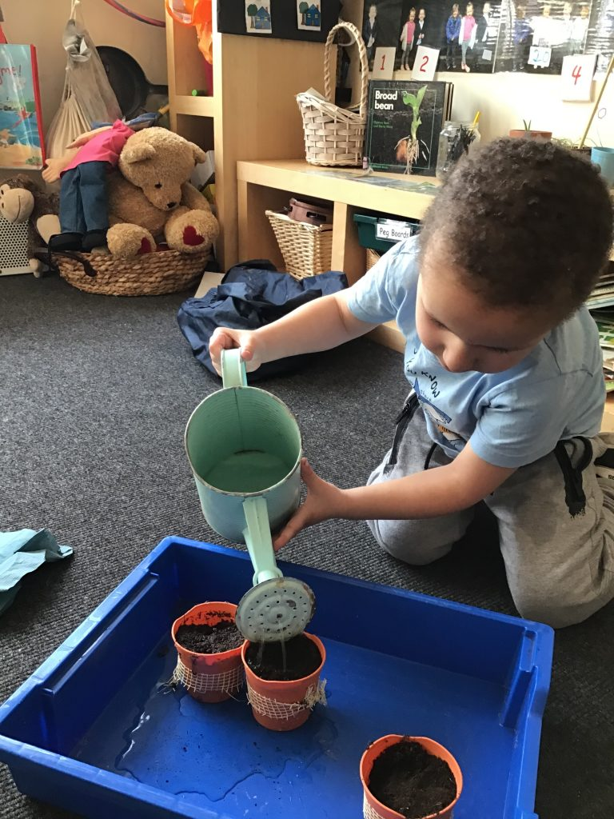

AIMS AND ETHOS OF THE SCHOOL

At Clervaux Nursery School we strive to provide a stable, happy and stimulating environment which will facilitate a smooth transition from home to school for both parents and children.

We aim to offer the children opportunities which will enable them to develop those skills which are required for effective learning; thereby allowing them to develop to their full potential.

We have 8 Key Principle Goals for all of our children. These are for all children :-
To be independent,
To be resilient
To be confident
To be a good friend
To be an interested reader and writer
To be a problem solver
To be a good friend
To be at one with nature
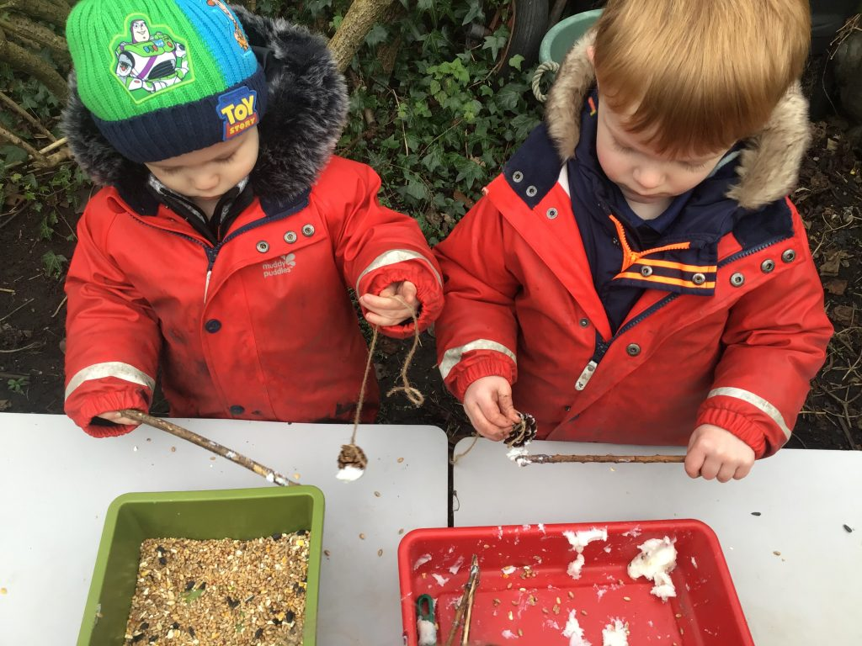

In order to meet the needs of each individual child we aim to: -

Provide love and security

Encourage the development of self esteem, a sense of achievement and self confidence

Give the opportunity for the child to express feelings and to cope with fears, worries and difficult experiences

Develop an awareness of the needs and rights of others

Provide an environment where children can develop their own identity
without racism or prejudice

Provide opportunities for children to make choices and direct their own
learning

Encourage independence and a sense of responsibility

Encourage learning through “hands on” experience

Encourage creativity and use of imagination

Promote communication skills

Develop concentration and listening skills

Develop language and reasoning skills

Develop spatial awareness

Develop manipulative skills / hand eye co-ordination
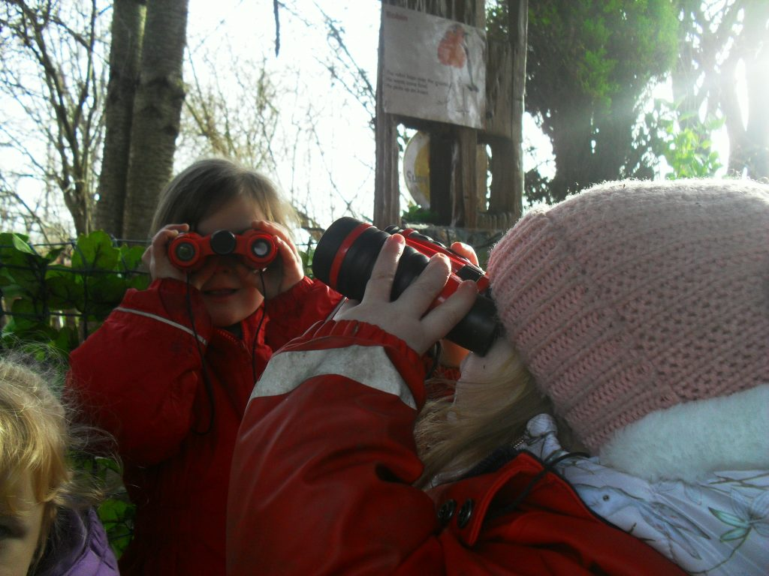

At Clervaux Nursery School our aim to support the development of each and every child to ensure they reach their full potential. We aim to nurture the emotional resilience of every child to prepare them for their next steps in education, life and the future.
We ensure our children have equal access to a rich, broad, balanced and differentiated curriculum
We give first hand experiences to enable to connect with the natural world
We engage children through their interests and bring new and exciting things in to develop and expand their knowledge
We have the highest expectations of our children to ensure they always have high aspirations and try to be the best they can be
We aim to open their eyes to awe and wonder and cause them to marvel at the incredible and fantastic world in which they live.
We provide children with a curriculum which enables them to develop their talents, skills and a love of learning.
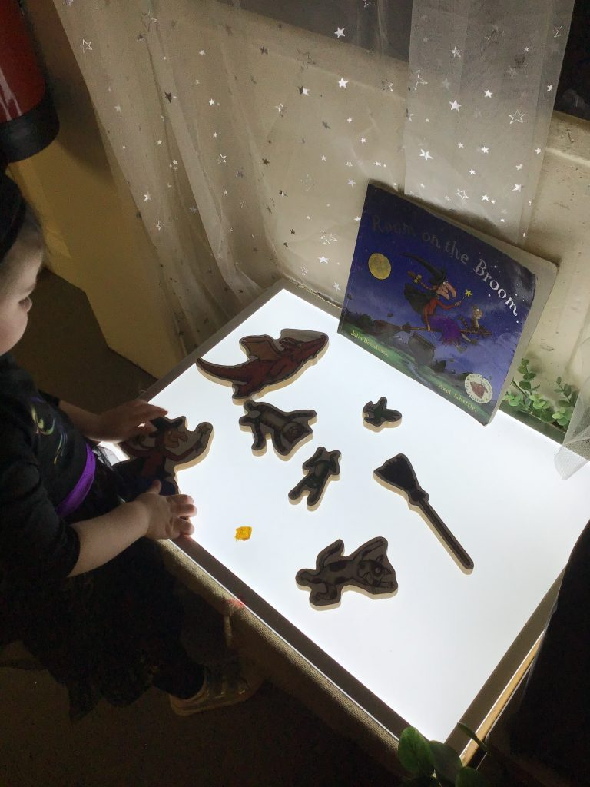

Through daily reflection on children, we ensure that we are continuously planning the next steps for our children. This ensures a robust and sequential approach to learning where no learning opportunity is missed.
Through high expectations of our children, activities are pitched to ensure that all children succeed and not only move knowledge on but also deepen it.
Through the use of a wide range of assessment tools including Launchpad to Literacy teachers spot gaps and quickly put steps in place to support these children to rapidly catch up.

When children leave Clervaux Nursery school their knowledge is embedded and is utilised in all areas of the child’s life
All children, even those who are disadvantaged make at least good and more often outstanding progress.
Our children are ready for Reception and to begin lifelong love of learning.
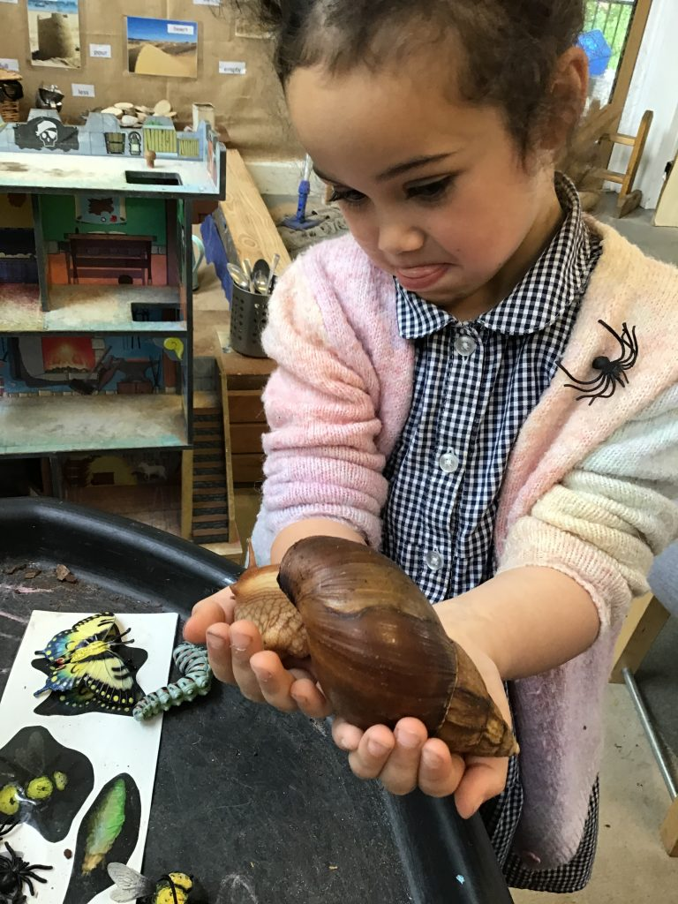

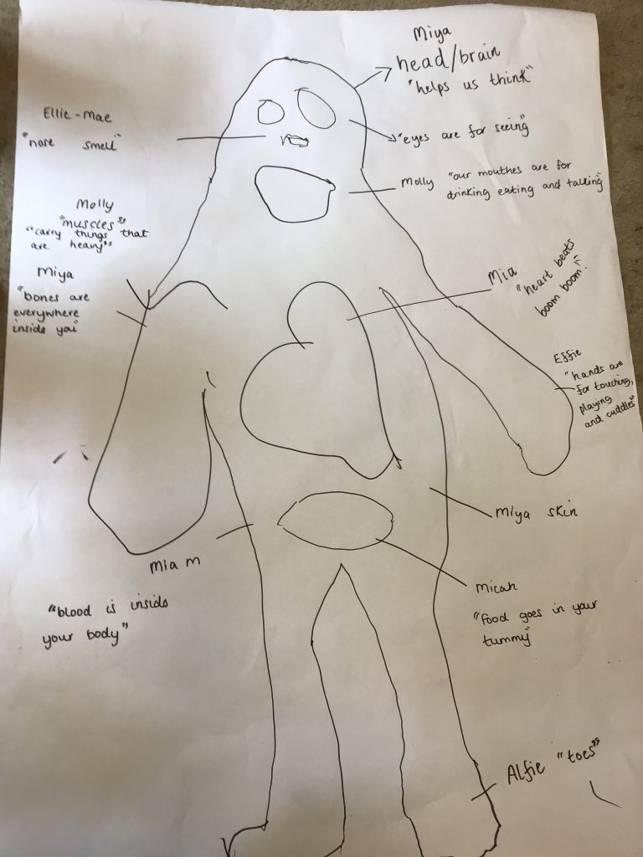

ADMISSIONS

Most of our children are accepted into nursery in the September of the year during which they have their fourth birthday. Children are admitted to nursery according to the following criteria when over subscription occurs:-

Looked after Children
Children with Special Educational Needs
Children with additional professionals involved
Proximity of parental home residence to school

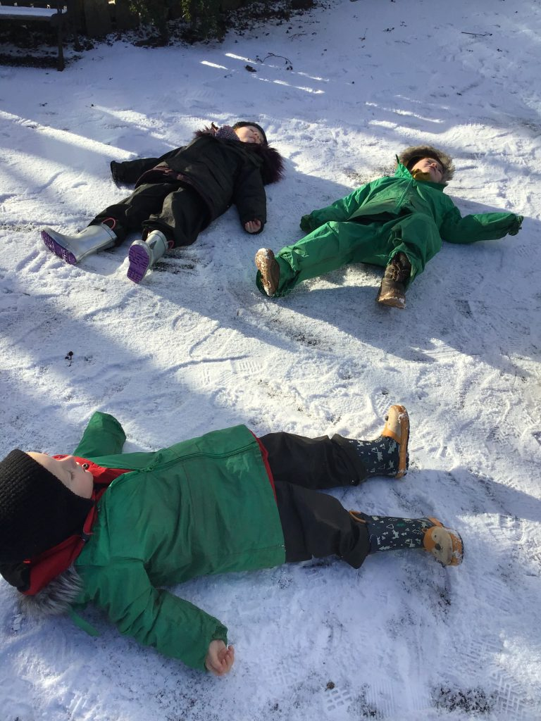

PROGRAMME OF INTRODUCTION TO MAIN NURSERY

January / February:- Letters of allocation are sent out.

September:– Children and parents are invited to visit the nursery. On this occasion parents will be provided with detailed information
Parents will also receive a phone call from your child’s keyworker to have a more in depth discussion about your child. Over the next few weeks we stagger the children in so that we can spend quality time getting to know your child before they come for their full allocated time.

SNUG

Children who join our Snug can start the term after they are two if on the two-year-old offer or as soon as they are two if it is a paid place. We follow the same procedure with a visit to nursery first followed by a gradual build up in time. Once settled they will be able to access their full entitlement.
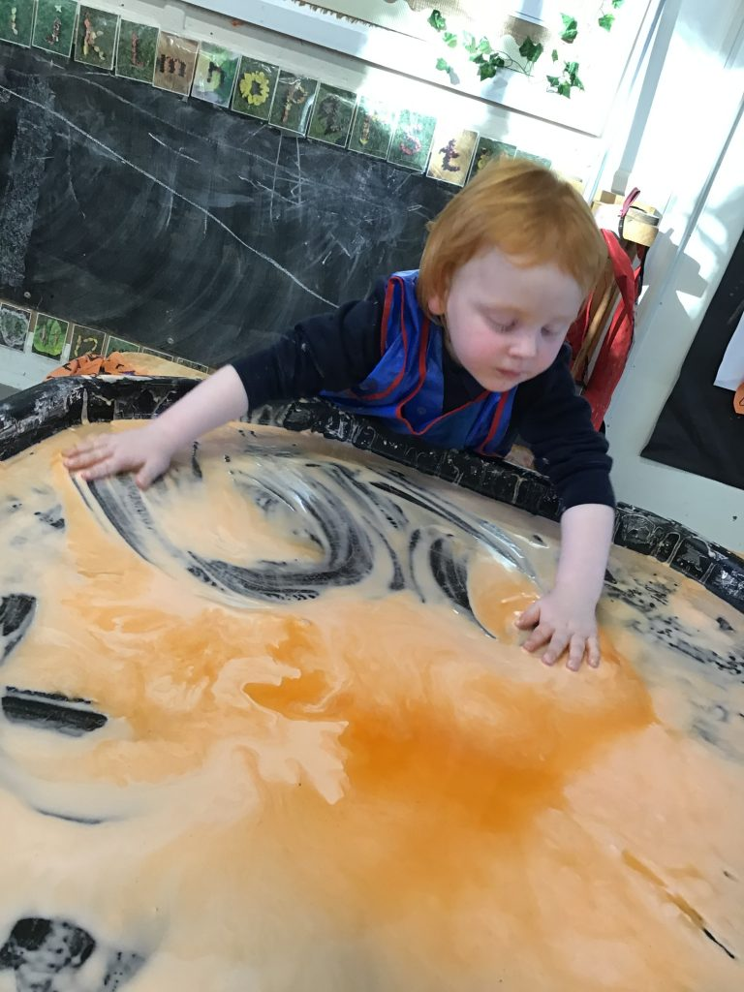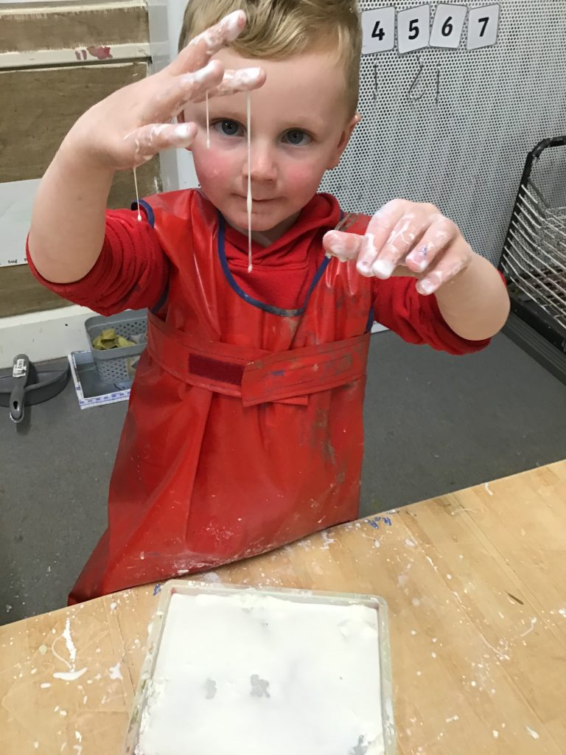

PREMISES

Clervaux Nursery School was built in 1939 and caters for children between the ages of two and four years. The building has been extended over the years and consists of a Snug (2 year old provision), kitchen, large group rooms, small group rooms and a main nursery. We have a separate staffroom and 2 meeting rooms.

Outdoors we benefit from separate play areas for our 2 year olds and 3-4 year olds along with an extensive forest school and small field.

ORGANISATION

We operate on a 1:13 ratio which is recommended by the Department for Education for nursery classes. In our Snug we us a 1:4 ratio for our 2 year children and 1:8 for our rising 3’s.
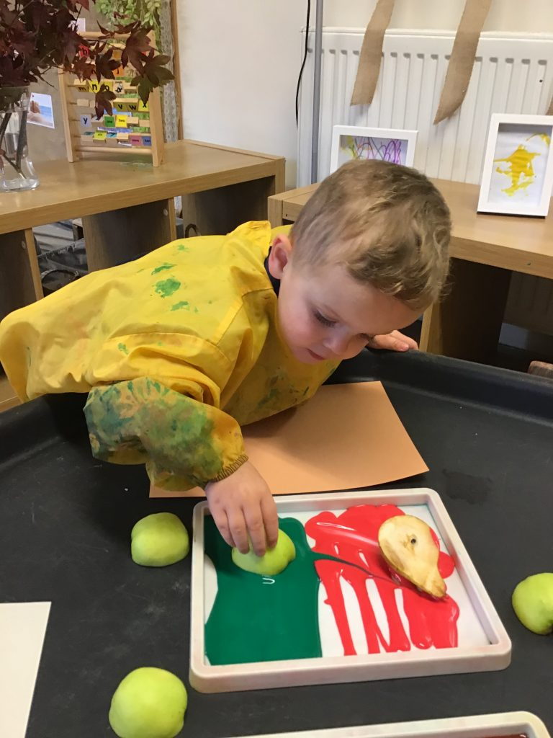
Due to the nature of our curriculum the children do spend an amount of time
working in groups. At Clervaux Nursery School the children are split up into groups with an appointed key worker.

Our children attend mornings, afternoons or 2 ½ day sessions and 30 hours. We do have paid places available in our 2 year old provision.

Please Note we do not provide hot meals anymore at Clervaux Nursery School. If your child is here for a full day they must bring a packed lunch.

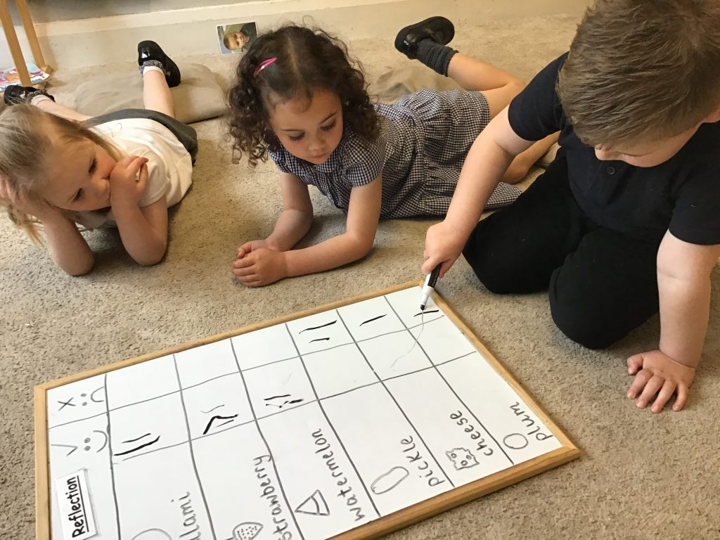

THE EARLY YEARS FOUNDATION STAGE CURRICULUM

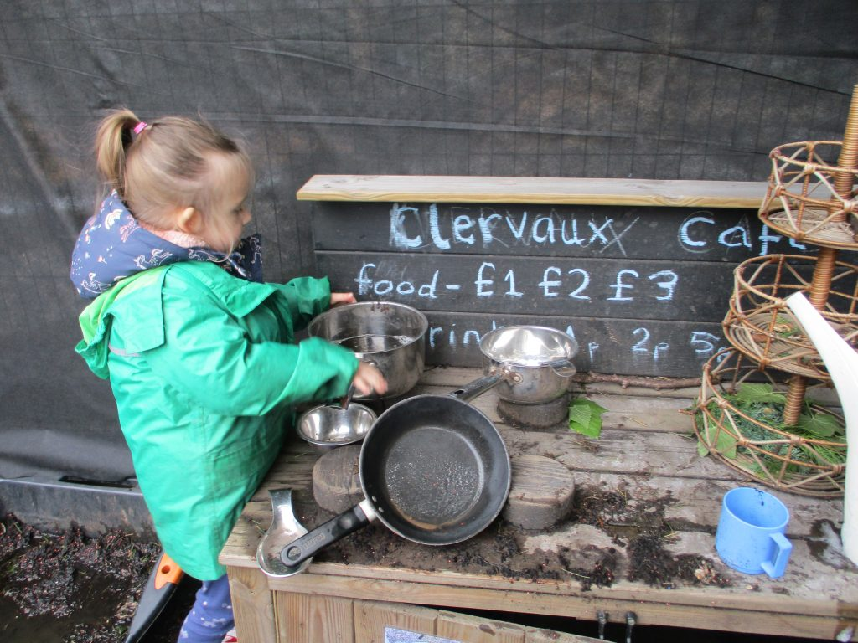
The Early Years Foundation Stage is a phase of education for children from the age of 0 – 5 years.

The Foundation Stage consists of seven areas of learning and development: -

Prime Areas

Personal, social and emotional development.
Communication and language
Physical development
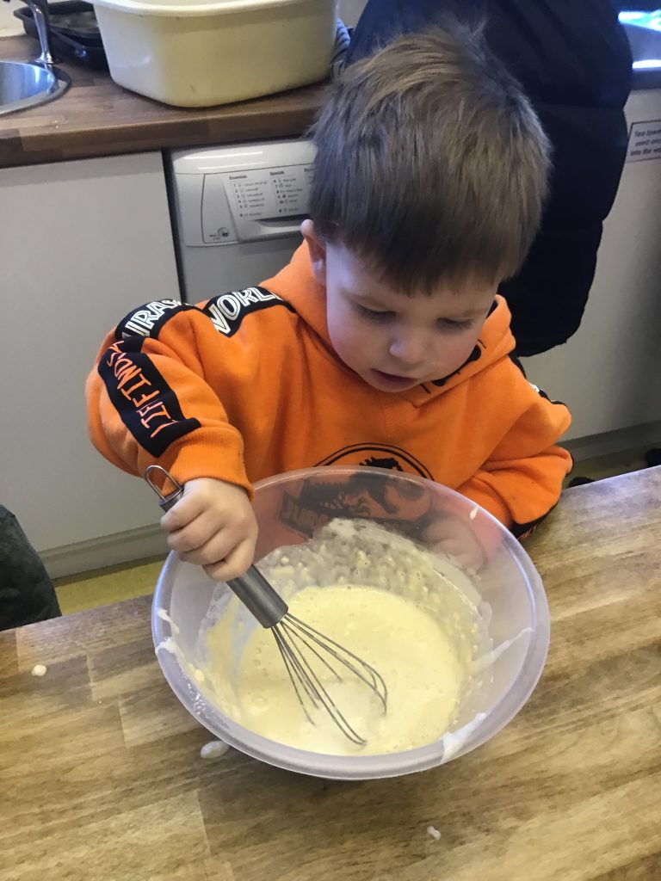

Specific Areas
Mathematics
Understanding of the world
Creative development
Literacy
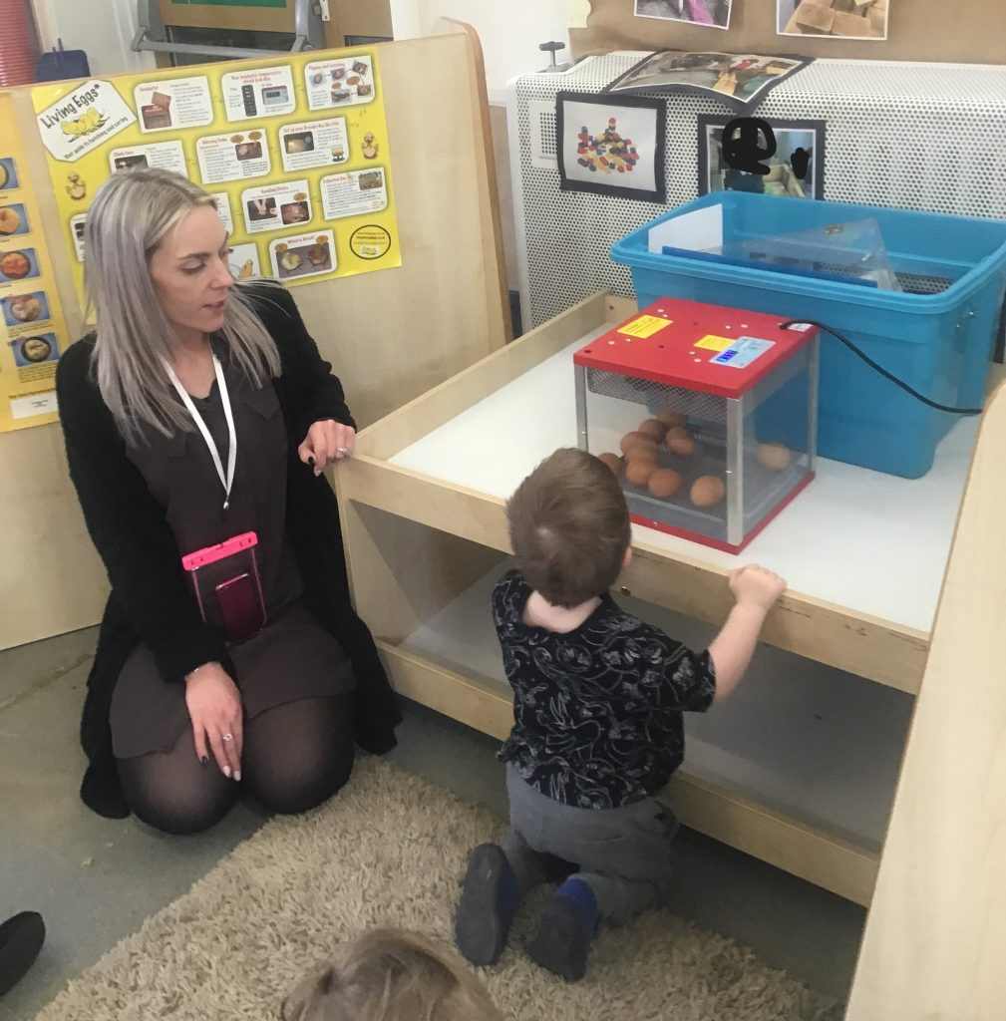
The seven areas of learning and development provide a framework for the early year’s curriculum.

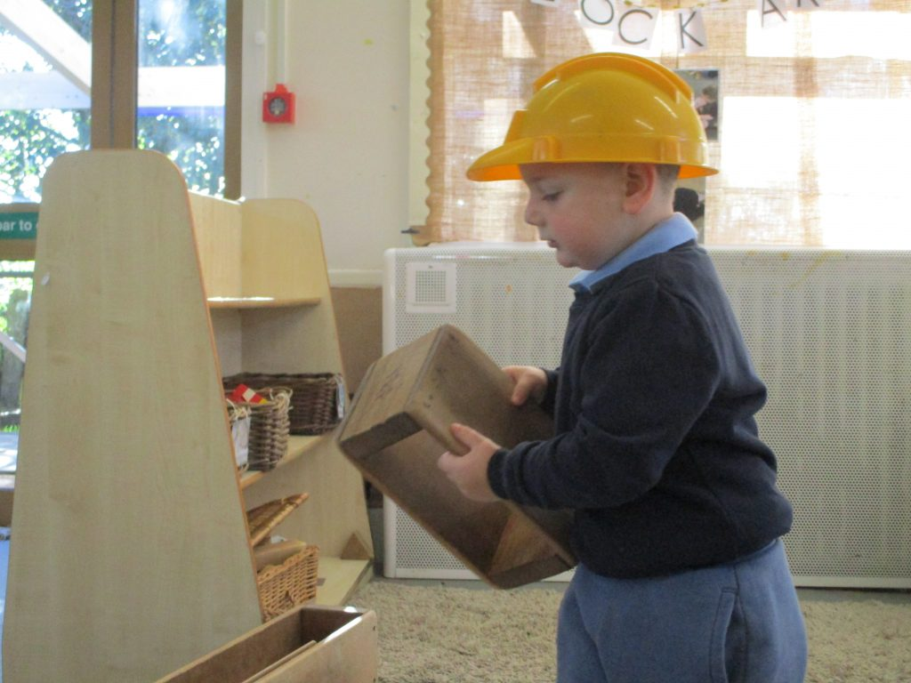

We are very fortunate to have sufficient appropriate resources for all our children, which are all available to them and accessible for them. They can obtain what they need easily, know where to find what they need, and where to put things back at tidy-up time.

The children have a variety of experiences and places to work; they can choose to use any of the areas in the nursery, and may work on their own or with other children. We operate a free flow system which allows children to be inside or out at any given time. If children have a preference all staff ensure that they plan to encourage children to develop in all areas of learning no matter where they choose to play. The areas are constantly reviewed and improved, and resources are checked regularly. Staff in the nursery work as a team, planning ahead at regular staff meetings, daily reflections and discussing ideas for improvements.

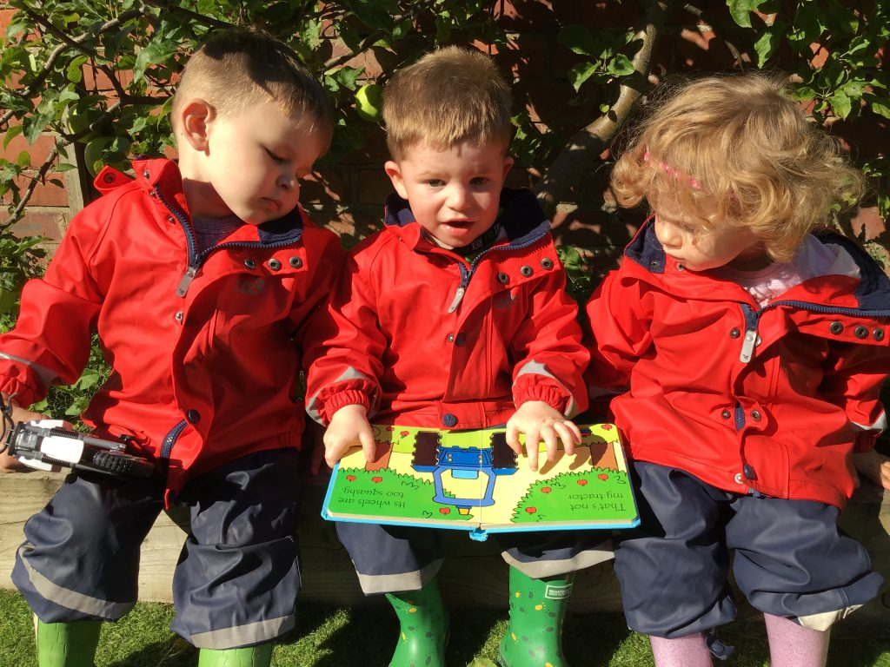

THE DAILY ROUTINE

We have a structured day, to which the children soon become accustomed. We believe that this gives the children stability in the nursery environment, which is very important at their age.

Children in our 3-4 year old provision enter nursery through the main front door. We begin the day with hello time. Children then have a large group time and then plan what they would like to do during work time. Our youngest children have their own separate entrance at the back of the nursery and are met by their key worker.

FOREST SCHOOL

We have our own Forest School on the premises. This supports the children to get a real understanding of the natural world.

The philosophy of the Forest School is based upon the desire to provide young children with an education which encourages their appreciation of the wide, natural world and which will encourage responsibility for nature conservation in later life.

Children learn to:

Respect their environment
Abide by rules and standards of behaviour
Work in teams and respect each other

COLLECTION OF CHILDREN AT HOME TIME

Young children can easily become very upset if they are not collected at the same time as everyone else; therefore could we request that parents/ carers please collect their child on time.

If you realise that you are going to be late, contact us before home time and we will then be able to inform your child and hopefully avoid any unnecessary distress.

Please inform us if anyone else will be collecting your child. Due to safeguarding procedures it is impossible for us to allow a child to be collected by someone else unless we have been previously informed.

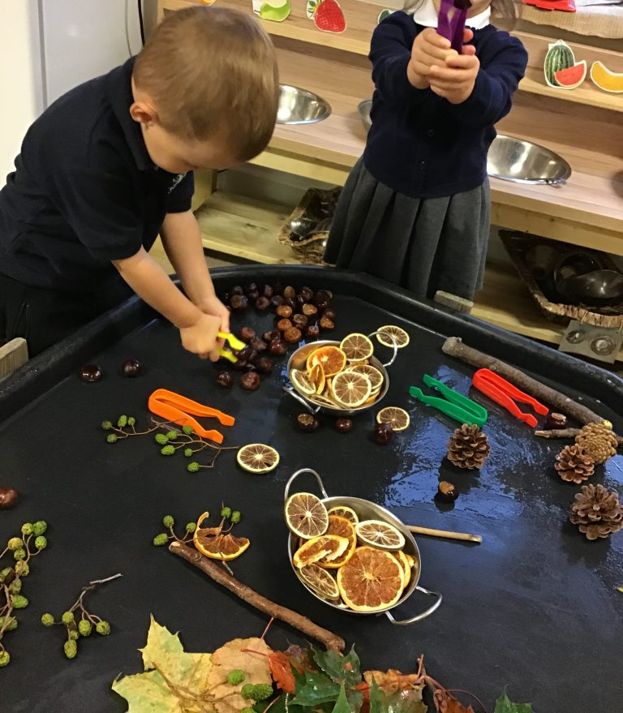

EQUALITY OF OPPORTUNITY

At Clervaux Nursery, we aim to give every child equal opportunities by offering them a broad and balanced curriculum relevant to their needs; regardless of gender, special needs, culture, religion or ability. We are a fully inclusive nursery.

SAFEGUARDING

Clervaux Nursery aims to provide an environment in which all children feel happy, secure and valued, and where they are encouraged to talk, and are listened to. The protection of the children is given the highest priority.

As a school we support fully and play an active role in the multi-agency work carried out in line with the guidance set out by the South Tyneside Safeguarding Children Board.

Our children’s well being and security are of paramount importance and because of this we have an intercom system in place at the front door. Please note that in order to keep our children safe it is important that parents/carers do not open the front door if the door bell rings whilst they are in this entrance. The door will be answered by nursery staff via the intercom.

SPECIAL EDUCATIONAL NEEDS

Clervaux Nursery is an inclusive nursery with facilities to support those children with additional needs.
Other services with whom we may liaise when working with a child with special educational needs are:-

Health Visitors
Educational Psychology Service
Speech Therapy Service
Portage and Pre-School
Physiotherapy Service
Occupational Therapy Service
Children’s Social Care
Outreach support
Service for the audio/visually impaired child
Service for the hearing impaired child

With all our children at Clervaux Nursery, we aim to work in partnership with
parents; consequently if a child is deemed to have a special educational need you as their parents would be the first people whom we would consult.

REPORTING ON AND RECORDING CHILDREN’S PROGRESS

During the nursery year meetings are held to enable parents to discuss their child’s progress with their appointed educator.

If at any time during the nursery year parents wish to discuss their child’s progress with the nursery staff, they are very welcome to do so.

The children’s experiences and achievements are recorded throughout the year by the staff who work as a team.
Key workers will complete either a Learning Journal or a group Floor Book which you will be able to see and contribute towards.

HEALTH AND SAFETY

ABSENCES

If your child is ill or attending a medical appointment, please inform us by telephone or in writing. On the first day of your child’s absence please inform us by telephone of the reason why your child is absent.
We are now required to record the reason for every child’s absence in the register.
In order for your child to gain the best educational benefit from their nursery place it is important for them to attend regularly with as little absence as possible.
If your child is going to be absent due to holiday, please put it in writing and return it to school before you go on holiday.
Children should not return to nursery following a bout of sickness or diarrhoea until they have been clear of the symptoms for 48 hours.
Accidents in nursery are recorded in our accident book and a copy given to parents on the day they occur. Please ask staff if you have any queries with regards to this matter.
We follow an ‘Eyes on the Child’ policy for all children if they are absent. Please see our website for more information.

Clervaux Nursery is a health promoting smoke free school.

MEDICATION

If your child requires specific medication, which has been prescribed by a doctor or pharmacist, parents/carers must fill in a form. Staff will then keep a record of when they administered the medication. If your child requires further care needs, please speak to the Head Teacher or Miss Riley (Medication Lead).

CLOTHING

We have a school sweatshirt which you can buy as well as a polo shirt. This is not compulsory. We ask that you send your child in easy to pull up trousers to help with their independence. We would also request that your child comes to school in wellies with a change of comfy footwear to be stored in their drawers e.g. a pair of slippers. If this is not possible it would be better to have Velcro fastening trainers / shoes to support their independence when changing into wellies outdoors. School uniforms are also available free of charge from our Nearly New rail at the front entrance.
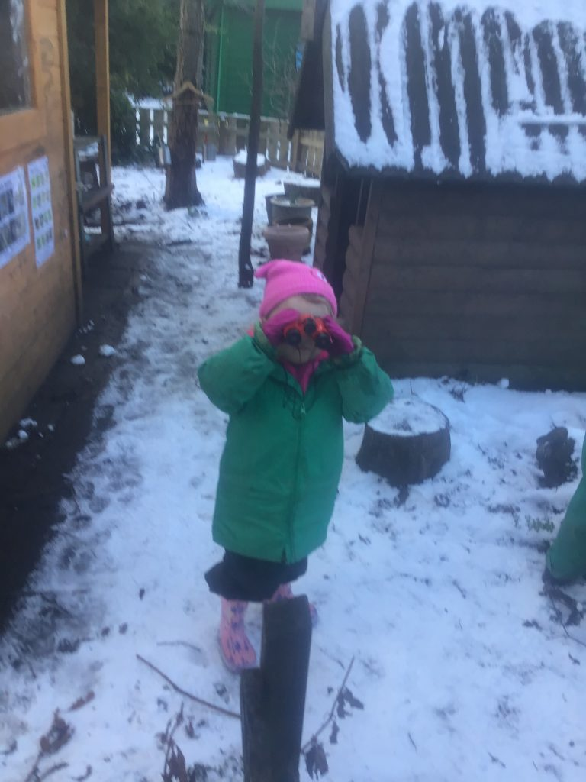

PRIMARY SCHOOL

It is your responsibility to put your child’s name down at the school of your choice and to fill in a parental preference form.

Nursery children do not automatically have a place at our feeder schools. You must apply for this online through schools admissions.
Forms (either online or postal) must be sent in by the December as the closing dates for school applications is usually at the beginning of January.

VISITS

As part of our curriculum we encourage visits. We ask that consent forms are returned promptly.

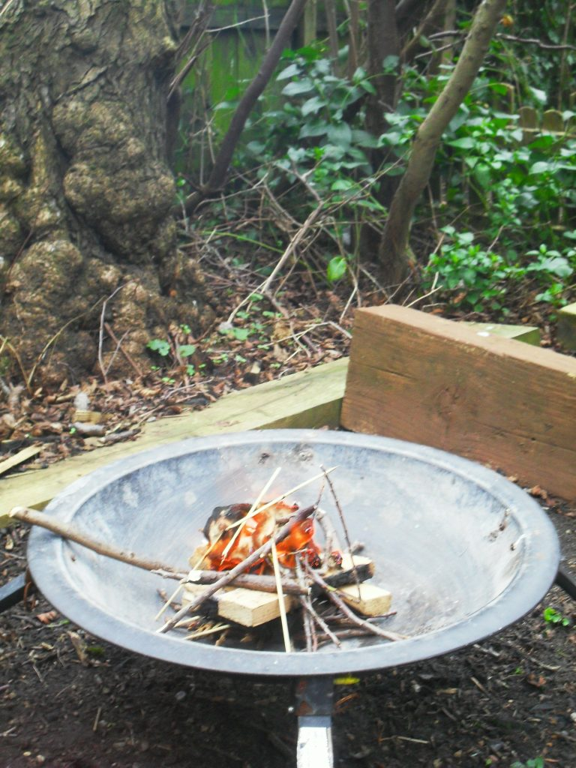

COMPLAINTS PROCEDURE

It is in everyone’s interest that complaints are resolved at the earliest possible stage. All complaints will be referred to the headteacher; hopefully the majority of complaints will be resolved informally. If you require further information please see our website.

SCHOOL GOVERNORS

Clervaux Nursery School is part of a Federation with Helen Gibson Nursery School. There is one governing Board for both schools, which consists of representatives from both establishments.

CLERVAUX KIDS CLUB

Clervaux Kids Club provides out of school child care for children between the ages of 3 – 11 years. It provides support through a Breakfast Club starting at 7. 30 am and an After School Club from 3.30 pm – 6.10 pm. Both sessions are based in Clervaux Nursery. The club also offers a drop off / collection service at Jarrow Cross schools It provides the children with a wide range of activities and resources including art and craft, cooking, sports and games, encouraging the children to interact with each other to develop their social skills.

The Kids Club is jointly Ofsted registered with Clervaux Nursery. The trained staff are all enhanced DBS checked and have up to date certificates in paediatric first aid and food hygiene.

For further information please contact Maureen Muir at Clervaux Nursery on 01914897358.

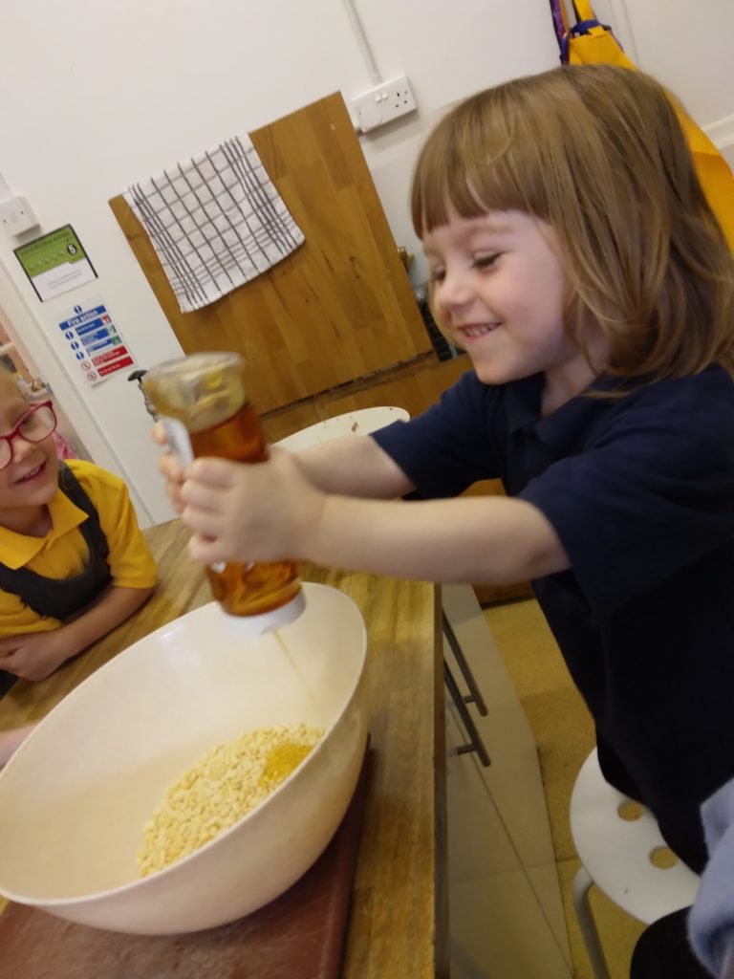

INFORMATION FOR PARENTS

This is displayed in many ways in the nursery. Please look out for our notices and newsletters.

