Float or sink experiment

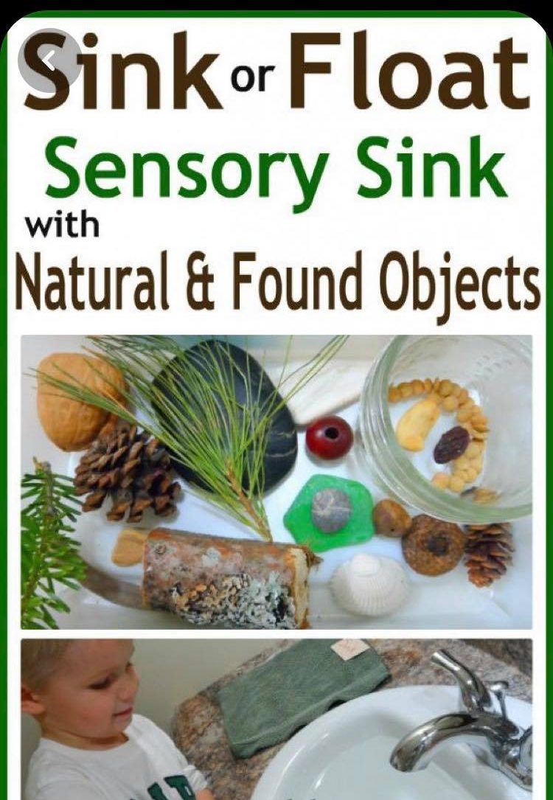
For this activity, you need a range of resources to test. You could use the things you collected from the scavenger hunt or you could collect things from round your home.

Fill up your sink, bath or even a bucket with some water.
Before you put anything into the water make a guess for each item, whether you think it will sink to the bottom or float on the top.
Keep score of how many you guessed right! You could even have a competition with someone in your house to see who gets the most guesses right.

