Indoor Camp Site
Indoor camping make tent with bed sheets

Counting Vehicles
1. On your daily walk take a pen and paper and make a tally of vehicles you see. Total them up promoting maths skills – do a tally sheet for this one

Car Painting
. Car painting. Roll cars through paint or shaving foam and discuss the patterns/marks they make Lori
Indoor Obstacle Course
Obstacle course indoors or outdoors
Hide and Seek Toys
Hide the toy....using clues to find it

Natural Pictures
Make a natural picture in a twig frame JESS

Time Capsule
time capsule,
Pebble Painting
Painting pebbles (if they have any in the garden) Helen

Cleaning Windows

Kitchen Utensil Band
Bottle Shakers
Number/Shape Jump

3.Write shapes/numbers/letters/words on pieces of paper. Encourage your child to ‘find the....” by jumping onto it LORI
Balance Challenge
4.Using chalk/tape makes lines and zig zags for your child to balance along one foot in front of the other
I can Spray a Rainbow
Promote fine motor skills with paint in empty spray bottles. (I’ve collected anti bac bottle and thoroughly cleaned before using) add paint and a little water to the bottles or food colouring if no paint. Discuss colour change when the colour mix
Baking Fairy Cakes
Making Potions
Bottle Bubble Blower

Making bubble wants using a bottle with bottom cut off cover bottom with a sock and seal with elastic band and using fairy up liquid x
Pasta Photo Frame
Meg
Salt Dough Play Food

Salt dough creations .... Meg
Design a Person

Large scale body painting (cover floor in a large sheet first)
Foot Spa
Outside .... Mud foot spa where you use a baking tray or basen fill it with compost and collected objects such as flowers herbs leaves and grass and explore with your child x meg

Story Mask Making
Kimms Game
Story Spoons
Story spoon - using wooden spoon and pens/ paint creat favourite character
Cheerio Challenge
Make a Band
Make own instruments - bobbles on toilet roll tubes, elastic bands on tissue boxes, kitchen roll/Pringles rice shakers etc... Jerine
Sensory Bottles

Sensory Bottles Jerine
Vegetable Face Prints
Making a smiley face with cut up veg SAM
Rockets
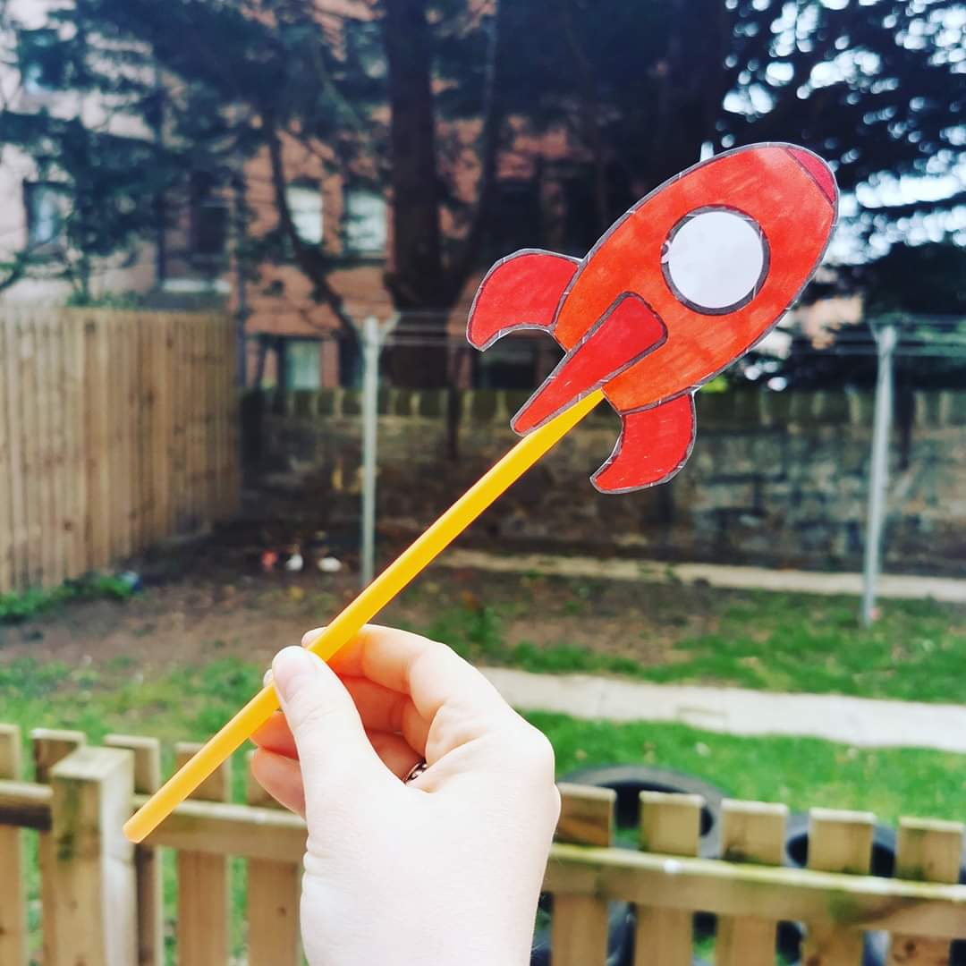

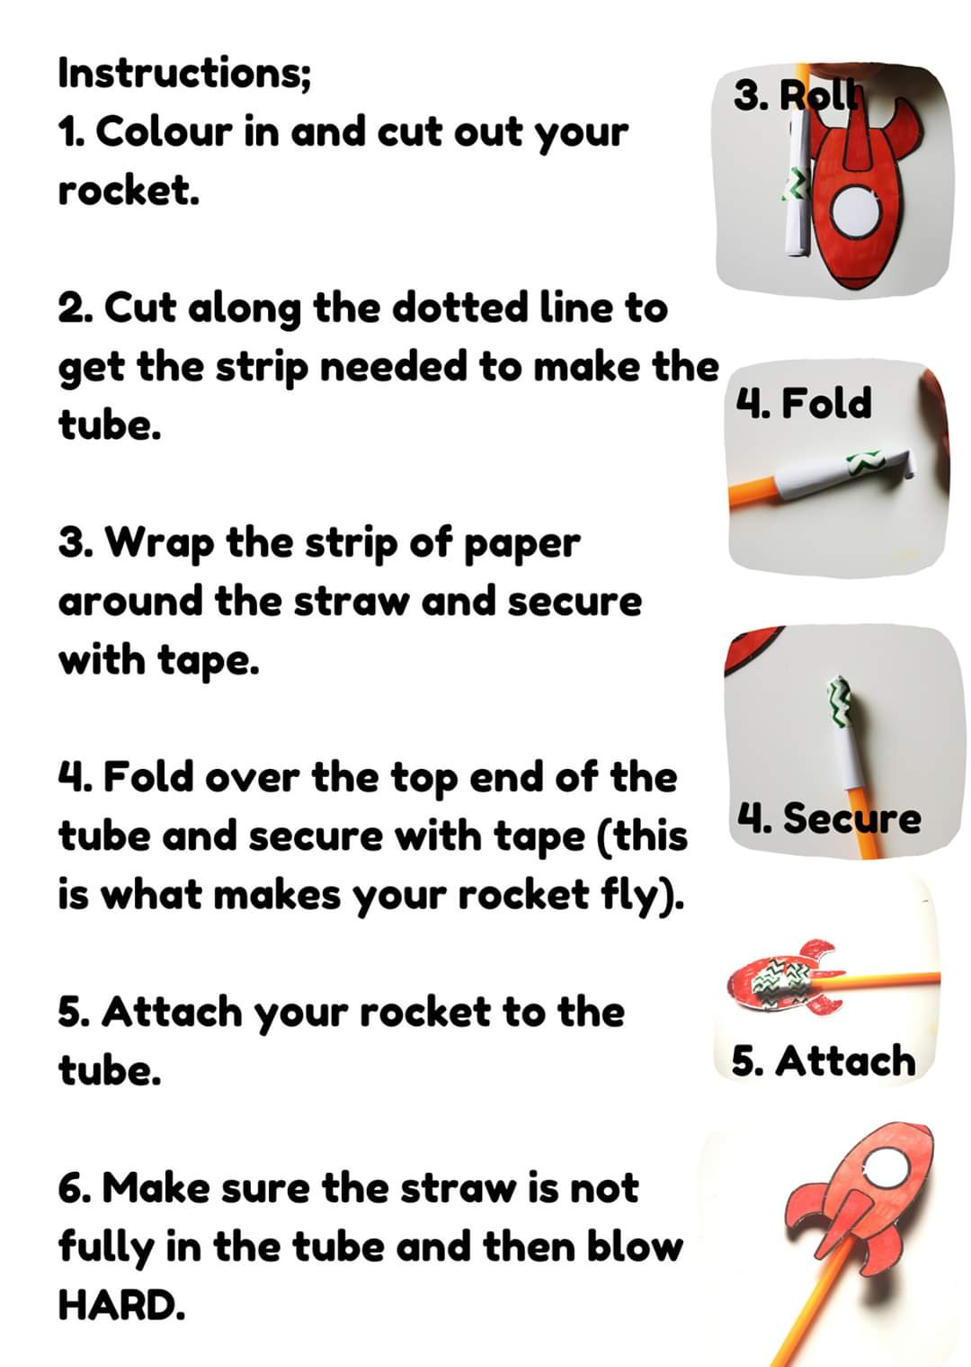
Listening Walk
Funny Faces
You will need:
A magazine, paper, glue and scissors

Cut out facial features from the magazine.
Make a face using the cut out pieces….the stranger the better
Sky Eyes
Fairy Houses
Decorate fairy houses - upside down planters (card board ones are the best , as you can use pens
Bird Feeders
Make bird feeders with string/wool and Cheerio cereal.

Magic Shadows
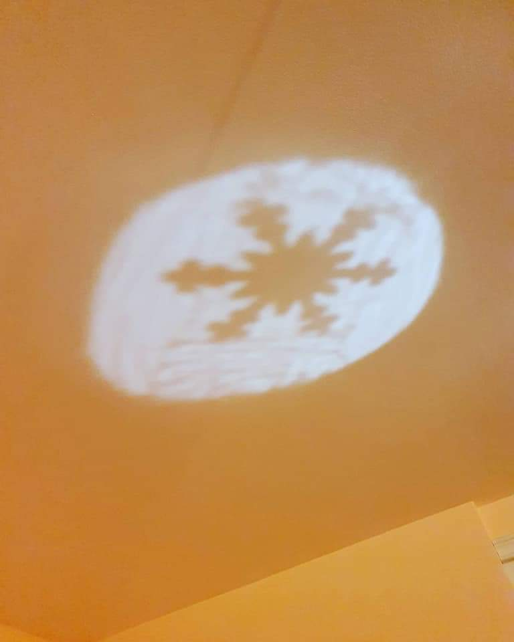
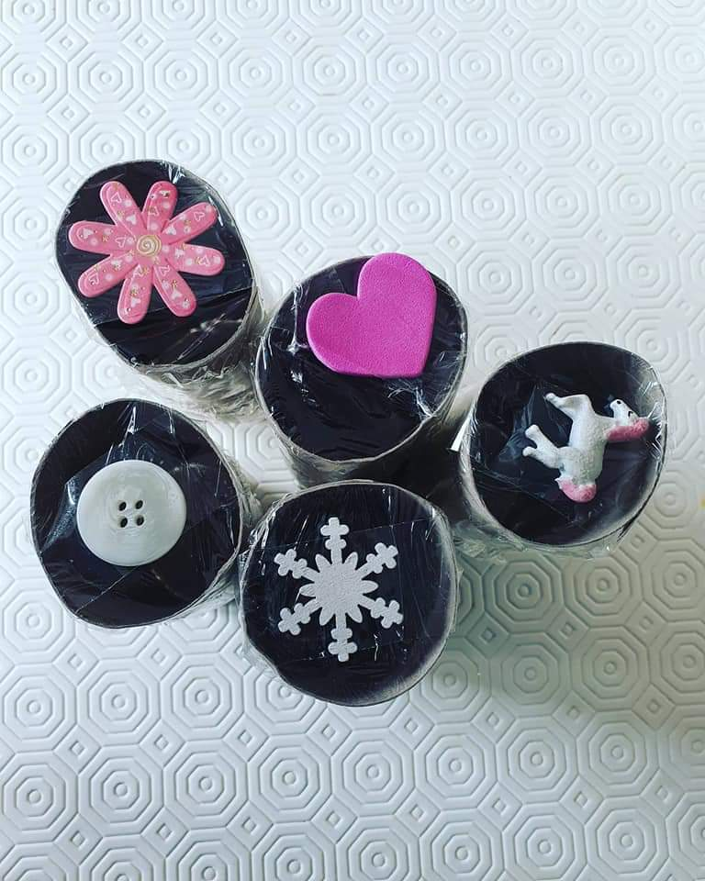
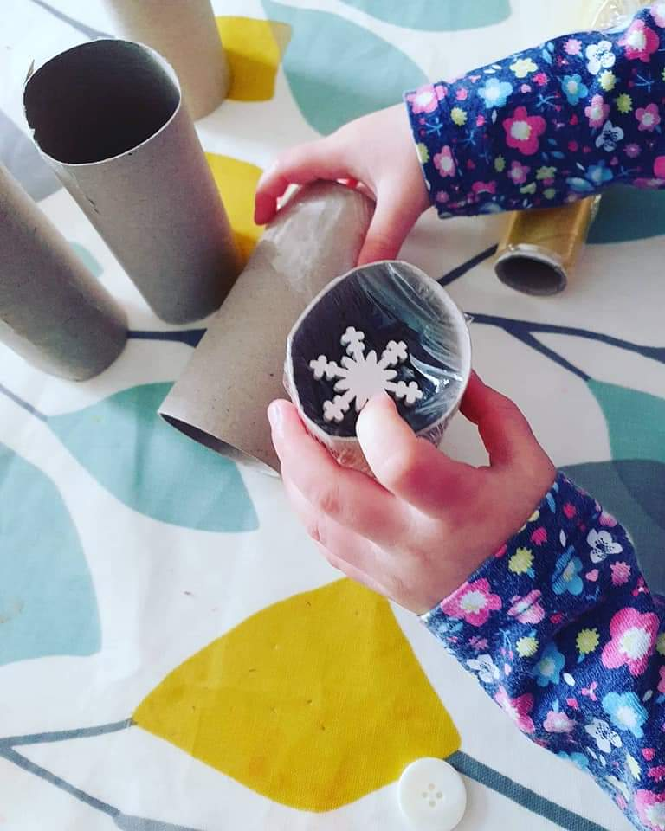
Mud Painting
Floating and Sinking Experiment
floating and sinking; Yvonne
Musical Statues
Simon Says
Pasta Bracelets

