1.Metro Stations
When your child has built a train line, why not add Metro stations? Give your child pieces of card to draw the yellow boxes on and the letter M. Older siblings might want to help with other station names.
Links to the EYFS
Literacy – shows an interest in print in the environment; recognises familiar words and signs; gives meanings to marks as they draw and paint; links sounds to letters, naming and sounding letters of the alphabet.

2.Pebble Lines
Collect some large pebbles when you’re out at the beach, then draw lots of lines on them – some straight, some squiggly – and then let your child use them to make a line to follow with a small car or train. The pebbles can be re-used over and over in different arrangements.
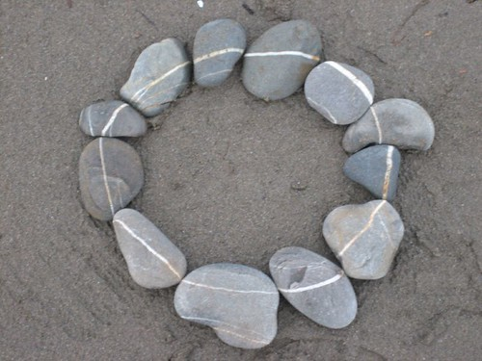
Links to the EYFS
Physical Development – draws lines and circles using gross motor movements.
Personal, social and emotional development – keeps play going by responding to what others (adults or siblings) are saying or doing.

3.Pegs on a Plate Game
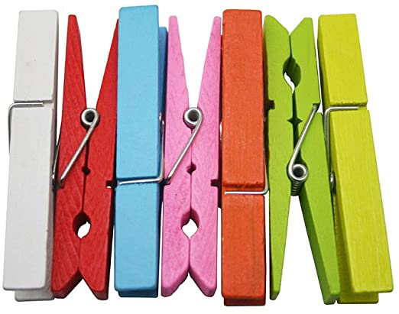
This is a game which the children love playing in Nursery and is fun for both adults and children! Everyone has their own plate and a pile of pegs. Set a minute timer and see who can peg the most pegs onto their plate. Or play slightly differently by giving everyone 20 pegs each and the winner is the first to clip all of their pegs onto their plate. Extend this further by asking your child to take six pegs from the pile to put on their plate. Increase this number as appropriate for your child.
Links to the EYFS
Physical Development – uses one-handed tools and equipment; handles tools and objects safely and with increasing control; shows a preference for a dominant hand.
Mathematics – uses some number names accurately in play; recites numbers in order to ten; counts objects to ten and beginning to count beyond ten; counts out up to six objects from a larger group.
4.Pair the Socks
Remember all the socks that you used in the last booklet of ideas?? Well bring them back out and put them in a big pile in the middle of the room. Set a timer for a minute and see how many pairs of socks your child can match.
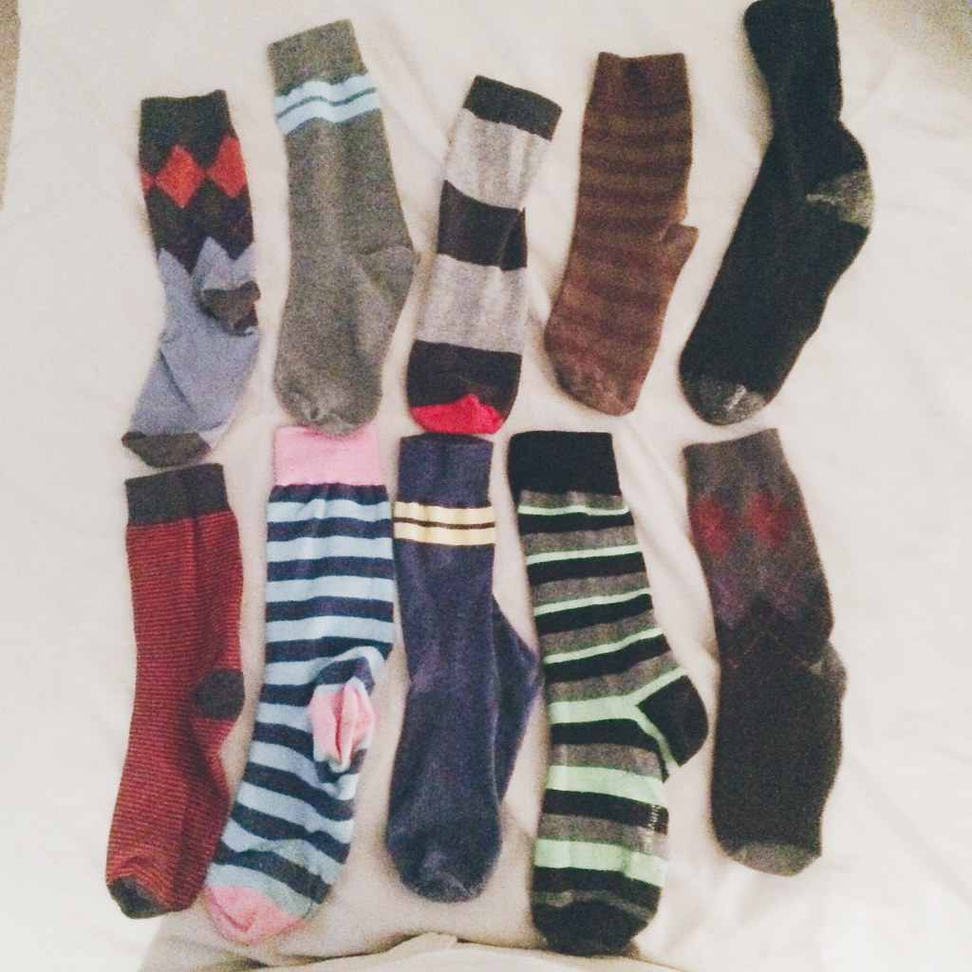
Links to the EYFS
Mathematics – shows interest in shapes in the environment
Communication and Language – responds to simple instructions; beginning to understand ‘how’ and ‘why’ questions; beginning to use more complex sentences to link thoughts; builds up a vocabulary that reflects the breadth of their experiences; extends vocabulary, especially by grouping and naming; links statements and sticks to a main theme or intention.

5.Skittles
An extension to the game of skittles from the last booklet, this time, put numbers onto the bottles so that older children can count up how many points are scored each time the skittles are knocked over – be aware that this can get very competitive!!
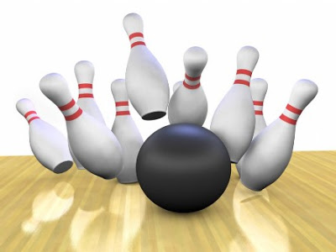
4
2
3
5
Links to the EYFS
Mathematics – uses some number names accurately in play; recites numbers in order to ten; sometimes matches numeral and quantity correctly; finds the total number of items in two groups by counting all of them; in practical activities and discussion, beginning to use the vocabulary involved in addition and subtraction.

6.‘I Can Read’ Books
This activity will give your child a real sense of achievement at being able to read things that are important to them. Collect together carrier bags, magazines, free supermarket magazines, comics etc and go through them with your child, asking them which logos and words they recognise. When your child has cut out those that they recognise, they can stick these into a book, which they can then read to family members. You’ll be amazed at how many they know – ASDA, Cbeebies, McDonalds, Tesco, etc!
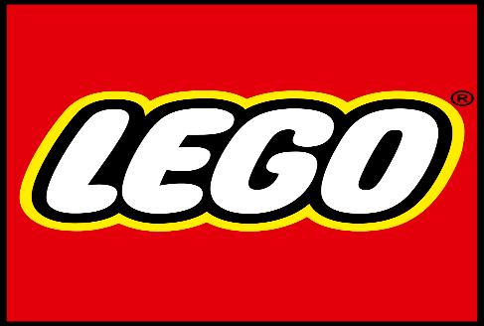
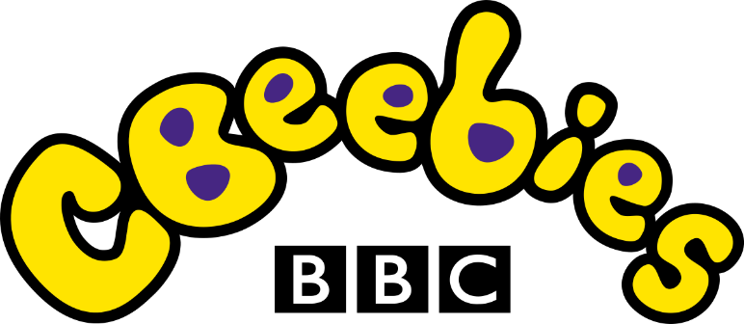
Links to the EYFS
Literacy – knows that information can be relayed in the form of print; recognises words and familiar signs; looks at books independently; holds books the correct way up and turns pages; hears and says the initial sound in words; writes own name and other things such as labels, captions.

7.Make a Fairy Garden
Make the most of the beautiful weather and make a fairy garden. Use either an area in your garden or an old plant pot or seed tray. Make fences with lolly sticks, add sparkles, small flower heads or leaves, pebbles, painted and decorated pebbles, signposts made from card and lolly sticks, and you could even add an old teapot or teacup! Make it as magical as you want!
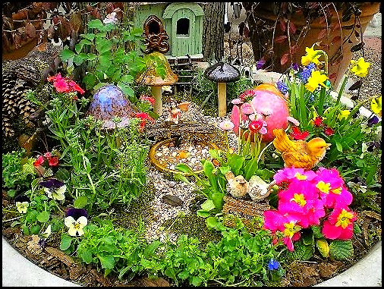
Links to the EYFS
Expressive arts and design – uses various construction materials; join construction pieces together to build and balance; constructs with a purpose in mind, using a variety of resources; manipulates materials to achieve a planned effect; uses available resources to create props to support role play; builds stories around toys; create simple representations of events, people and objects; introduces a storyline or narrative into their play.

8.Painting in the Garden
Children love to paint outside, and this is an easy way to support without having to take loads of bits and pieces outside. First, take some thick card (from a cardboard box) and some plastic milk bottle lids. Cut holes the same size as the milk bottle lids and push the lids into the holes so they fit securely. Then fill the lids with a little bit of paint and you have the perfect paint pallet to use outside! If your child needs an easel (as all great artists do!), then why not try using an old cardboard box for them to lean on.
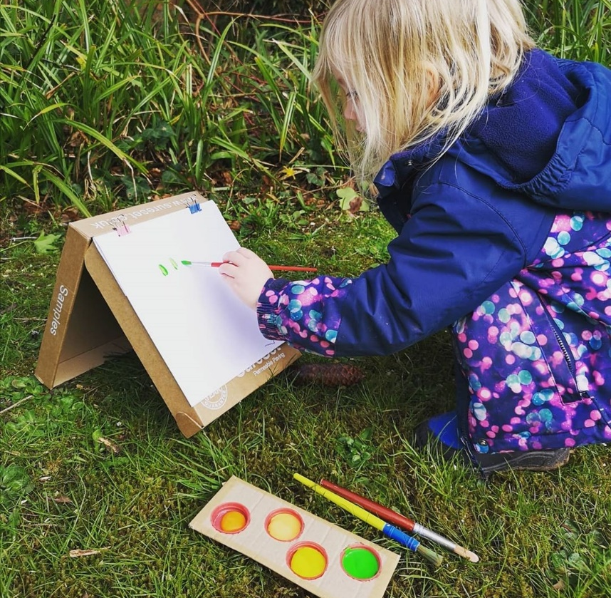
Links to the EYFS
Expressive arts and design – explores colour and how colours can be changed; understands that they can use lines to enclose a space, and then begin to use these shapes to represent objects; explores what happens when they mix colours.

9.Painting with your Feet
This is a great physical activity as well as being lots of fun! Pin some paper or an old sheet up against a wall or fence. Lie your child on their back and paint the bottoms of their bare feet, before letting them dace all over the paper with their painted feet! Keep adding more paint until they are finished their masterpiece!
Links to the EYFS
Expressive arts and design – explores colour and how colours can be changed; explores what happens when they mix colours.
Physical development – experiments with different ways of moving; draws lines and circles using gross motor movements.
10.Stick Whittling
This activity is one which we would have been doing in forest school. Ask your child to collect some sticks from around the garden or while out on a walk. They can then use a vegetable peeler to whittle the sticks. This is as great activity for encouraging risk taking, but we would always recommend an adult supervises the activity. If you whittle really long sticks, then they can be used for skewering marshmallows on and cooking on the campfire (again with adult support!)
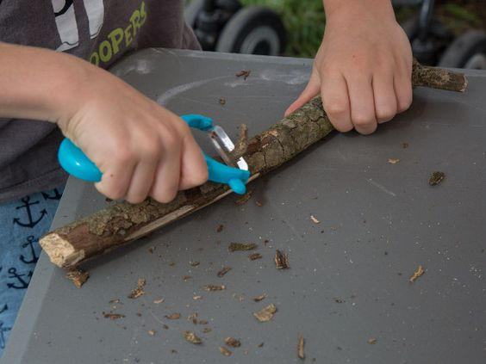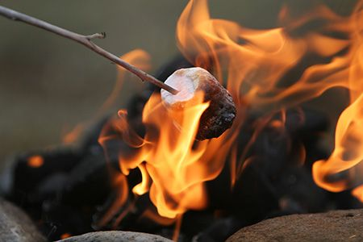
Links to the EYFS
Physical Development – uses simple tools to effect changes to materials; handles tools safely and with increasing control; shows understanding of the need for safety when tackling new challenges, and considers and manages some risks.

11.Plastic Painting
Spread some cling film over a table top and secure with masking tape. Your children can paint on top of the cling film, or you can draw outlines of items or shapes onto the cling film for your children to paint inside. This is also a fun activity to try with bubble wrap. You could even take prints from the cling film or bubble wrap by placing a piece of paper over the painted area and giving it a gentle rub before removing it carefully.
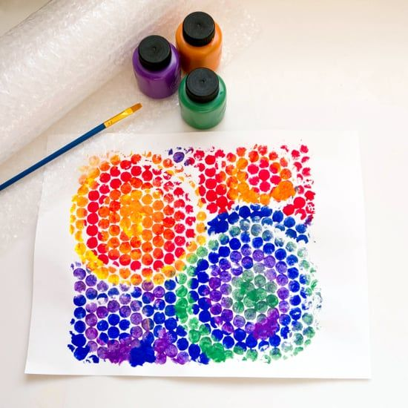
Links to the EYFS
Physical development – draws lines and circles using gross motor movements; shows a preference for a dominant hand; begins to use anticlockwise movement and retrace vertical lines.
Expressive arts and design – understands they can use lines to enclose a space, and then begin to use these shapes to represent objects; beginning to be interested in and describe the texture of things; explores what happens when they mix colours.
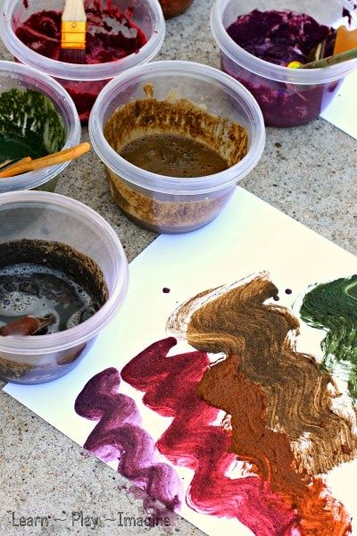
12.Muddy Painting
Make the most of the lovely weather by going outside for this activity. Spread an old sheet on the floor and give the children empty containers to go and fill with soil. Fill empty soap dispensers with water (or use an old jug) and encourage the children to add water to their soil, mixing with paintbrushes to make mud paint. They can then use this to paint onto the old sheet. The sheet can even be left outside in the rain so it is clean and ready to use again! If you want something more permanent, you could add food colouring to the mud paint.
Links to the EYFS
Expressive arts and design – explores colours and how colours can be changed; experiments to create different textures; understands the different media can be combined to create new effects; manipulates materials to achieve a planned effect.

13.Snack Time
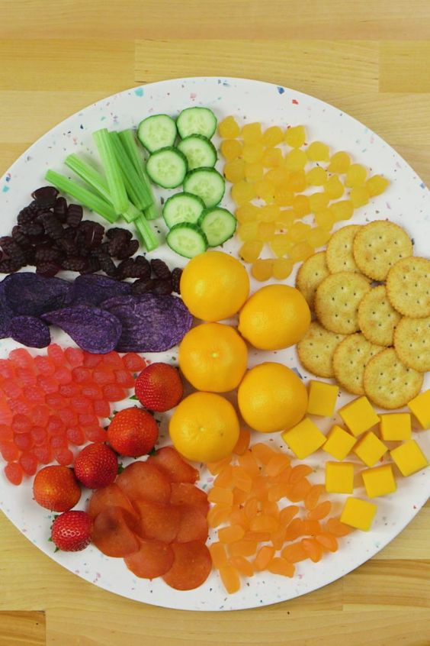
Ask your child to help to prepare some mid-afternoon snacks for the family. Either use what is available, or make a list a couple of days before with your child of their favourite fruit and veg, so they can help with the shopping too. Adult supervision is required for this activity. Talk about the snacks, look at their shapes and sizes, as well as colours and textures. Then encourage your child to help you to chop them up and arrange on a serving plate. Why not try and make a rainbow with the different coloured fruit and veg?
Links to the EYFS
Communication and Language – build up vocabulary that reflects the breadth of their experiences; extends vocabulary, especially by grouping and naming, exploring the meaning and sounds of new words.
Mathematics – beginning to talk about the shapes of everyday objects; uses the language of more and fewer to compare two sets of objects; finds the total number of objects in two groups by counting all of them.
Expressive arts and design – explores colour
Physical development – understands that equipment and tools have to be used safely; eats a healthy range of foodstuffs and understands need for variety in foods.
14.Flower Pictures
This is another lovely activity for doing outside, not least because it can get very noisy! While out on your walk, ask your child to collect different coloured flowers – dandelions and daisies work well – coloured blossom, and leaves. Make sure they don’t pick flowers other than dandelions and daisies, and especially not bluebells which are now protected. Back home, arrange the flowers and leaves between two pieces of cotton – an old sheet cut into smaller pieces works well for this. Lay the pieces on one piece of cotton, cover them with another, and then your child can hit them with either a small hammer or a rock/stone. As they do this, they will start to see the colour coming through and dying the cotton. This is a lovely starting point for discussions about different colours and flower names. An alternative to hammering might be to press some of the flowers that you’ve found. Press the flowers carefully between pieces of paper or card, before holding them down with several heavy books. In a week or two’s time, have a look and see how the flowers are looking. Leave them until they have fully dried out before removing them and using to make pictures.
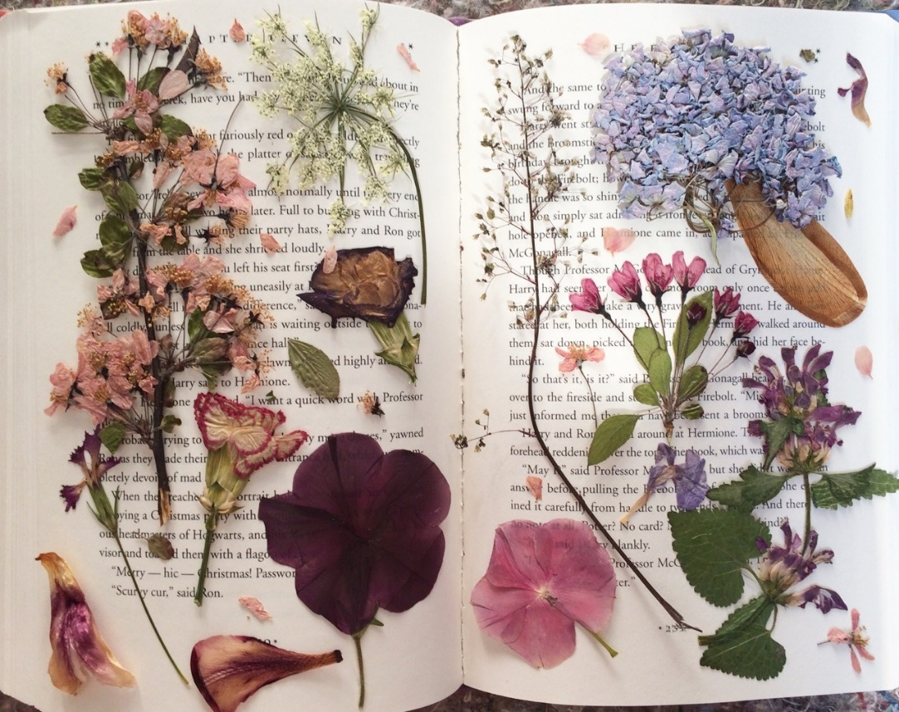
Links to the EYFS
Physical development – uses simple tools to effect changes to materials; understands that tools and equipment need to be used safely; handles tools with increasing control.
Understanding the world – comments and asks questions about aspects of the familiar world; can talk about some of the things they have observed.

15.Printing with Kitchen Utensils
Gather your kitchen utensils together and put some paint onto a tray, then let your child dip the tools into the paint and use them to paint with. Any utensils will do – potato masher, spatula, whisks etc. And don’t worry if you don’t have any paint in the house – fill a washing up bowl with water and let your child print outside on the pavement with this. Talk about the patterns and shapes that have been made.
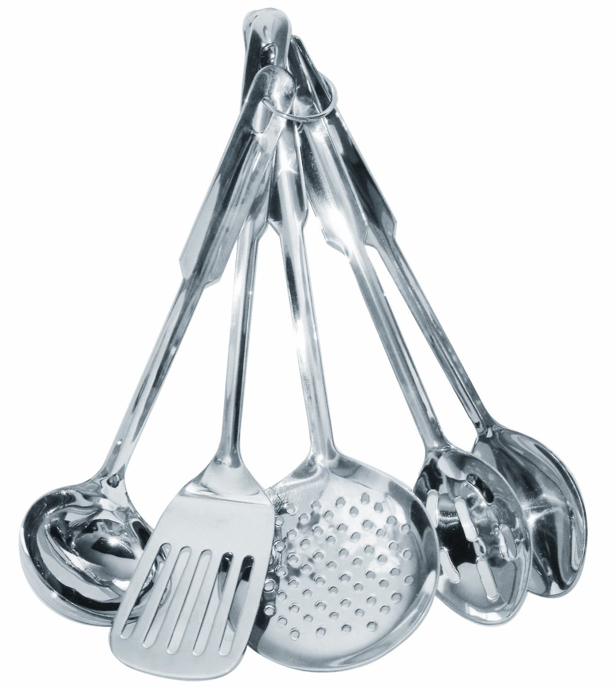
Links to the EYFS
Mathematics – shows interest in shapes by talking about shapes; beginning to talk about the shapes of everyday objects.
Physical development – uses one-handed tools and equipment.

16.Model making
We all have lots of boxes, tubs and tubes that usually go into the recycle bin. Instead of doing this, why not see what your child can make from them. Give them plenty of tape to stick with and support where necessary. We think you’ll be amazed at how imaginative your children can be!
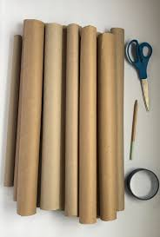
Links to the EYFS
Expressive arts and design – uses various construction materials; joins construction pieces together to build and balance; understands that different media can be combined to create new effects; constructs with a purpose in mind, using a variety of resources; uses simple tools and techniques competently and appropriately

17.Observational Drawing
Spring is a lovely time for changes in the natural environment. Speak with your child about what they have noticed changing in their environment and encourage them to draw what they can see. Look at shapes and colours within the environment and talk about why they think this is happening. You may even want to bring some flowers inside for your child to draw or paint.
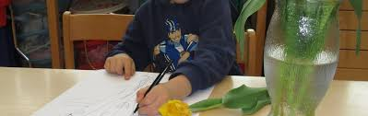
Links to the EYFS
Understanding the world – comments and asks questions about aspects of their familiar world; can talk about the things they have observed; develops an understanding of growth, decay and changes over time; looks closely at similarities, differences, patterns and change.
Expressive arts and design – understands that they can use lines to enclose a space, and then begin to use these shapes to represent objects; explores colour and how colours can be changed.

18. Painting Daisies
This is a lovely calming activity to really focus children, and is a good opportunity to just chat with your child. Often when children are engrossed in something like this, their mind begins to wander and they open up about things that may be on their minds or that are worrying them. Lie in the garden where there are daisies growing. Take the time to really look at the different parts of the daisy – how many petals do you think each flower has? Then, using felt tip pens, carefully colour in each of the white petals. Once finished, why not take a picture of your colourful daisies.
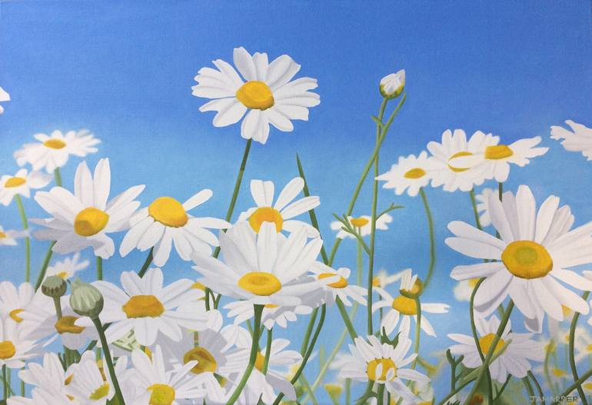
Links to the EYFS
Understanding the world – comments and asks questions about aspects of their familiar world; can talk about some of the things they have observed.
Expressive arts and design – explores colour and how colours can be changed

19.Cleaning Windows
Children love helping with jobs around the house! And cleaning windows is always popular. Have fun with it – they don’t need to do a professional job of it! Let them spray the windows with a squirty bottle of water, or a hose pipe; make lots of bubbles when mixing the soapy water; don’t worry about getting wet when you get splashed! Enjoy the art of working together to get a job done and laugh lots! If you’re feeling extra brave, why not let your child use a small step ladder to reach even higher. Do not leave children unattended if they are climbing step ladders.
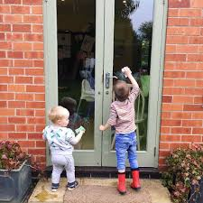
Links to the EYFS
Physical development – moves freely and with pleasure and confidence in a range of ways; mounts stairs, steps or climbing equipment using alternate feet.
Personal, social and emotional development – enjoys responsibility of carrying out small tasks; welcomes and values praise for what they have done.

20. Sorting Washing
Another household job that children like to do is sorting out the washing. They can help you sort it into different colours, sizes, by garment or by texture. Let them decide and see what they do.
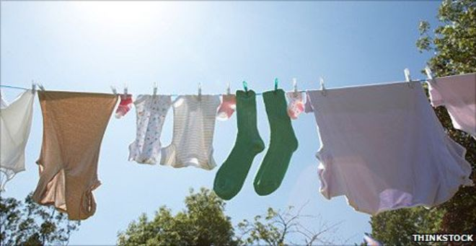
Links to the EYFS
Understanding of the world – looks closely at similarities and differences
Mathematics – counts an irregular arrangement of up to ten objects; compares two groups of objects, saying when they have the same number
Communication and language – uses a variety of questions; uses talk to connect ideas, explain what is happening

21. Colour Hunt
Take your child on a colour hunt around the area you live in or your back garden. Encourage them to look for different colours. You could extend this further by giving your child a piece of paper or card with some blocks of colour drawn on with pen, pencil or crayon. They can then match the colours they find to the colours on the card.
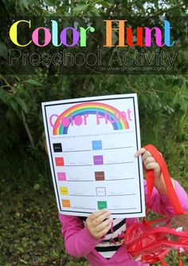
Links with the EYFS
Expressive arts and design – explores colours
Understanding the world – comments and asks questions about aspects of their familiar world such as the place where they live or the natural world; developing an understanding of growth, decay and changes over time

22. Going on a Letter Hunt
While out on your daily walk, ask your children to look for letters that they recognise. They could find them on road signs, street names, buses, registration plates – pretty much everywhere! Once you start looking, you will see letters everywhere. Talk with your child about other letters that you can see and why you recognise them – they are in your name, or they are the same as the beginning of your street name, or the town in which you live.
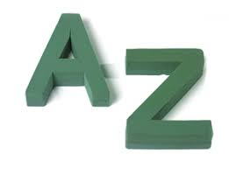
Links with the EYFS
Literacy – shows interest in print in the environment; hears and says the initial sound n words
Communication and language – uses vocabulary focussed on objects and people that are of particular importance to them

23. Make a story-themed target game
If your child loves to throw objects about, why not give them a focus? Ask them to choose five or six of their favourite stories and spread them around the room – these are the targets. Then they need something to throw at the targets - but we don’t want them breaking any ornaments or windows, so let’s think about what we can use! Maybe a couple of socks rolled into a ball? A small teddy or soft toy? Or a small sponge ball? You can then take it in turns to decide which target to go for and see who gets the closest. You could give points and then add them up at the end to see who has won!
Links with the EYFS
Communication and language – responds to simple instructions; uses talk to connect ideas, explain what is happening
Physical development – shows increasing control over an object in pushing, throwing, kicking or catching it
Literacy – enjoys an increasing range of books
24. Make an obstacle course – ninja style!
You could make an obstacle course using furniture and toys OR you could make a ninja-style obstacle course!!! This is much more tricky and your children have to really think about how they are going to get through it! So get a ball of string and make a web with it for your children to get through. The landing is a good place to do this with the banister and doors to tie the string to, but you could also use chairs to attach string to. They then have to weave their bodies through the string without touching it – this is harder than it looks!
Links with the EYFS
Physical development – runs skilfully and negotiates space successfully, adjusting speed or direction to avoid obstacles; travels with confidence and skill around, under, over and through balancing and climbing equipment

25. Make a tinfoil river
Water play is such fun and easy to set up. Take a long piece of tin foil and make lay it on the garden or path. If you have a slope or a hill, even better! Let your children collect any boats they have, or even better, raid the recycle bin for containers that can be used as boats. Then simply fill the tin foil ‘river’ with water and watch your child explore! Or why not give your child a watering can and they can fill the ‘river’ themselves. You could extend this with looking at what floats and sinks and why. Or who’s boat can travel the fastest.
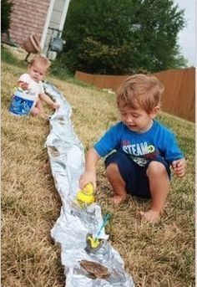
Links with the EYFS
Understanding the world – talks about why things happen and how things work
Communication and language – is able to follow directions; developing understanding of simple concepts; questions why things happen and give explanations

