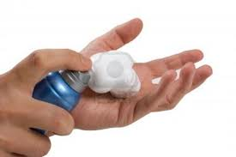
Shaving Foam
Try using shaving foam on a table or a window. Your child will love drawing on it, rubbing over what they have done, making swirls and may even try to write their own name.

