Dear parent/carer,
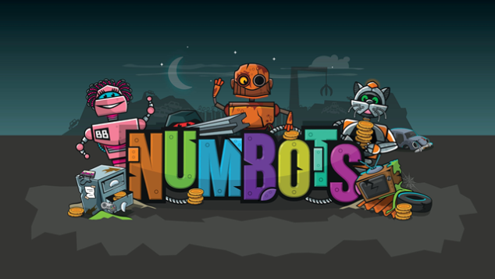

The creators of Times Tables Rock Stars have produced a platform for boosting addition and subtraction skills, called NumBots.

NumBots is an online game (currently only playable at play.numbots.com or through the numbots app) playing little and often will significantly improve your child’s recall and understanding of number bonds and addition and subtraction facts. These are critical foundations in maths so we are excited by the impact NumBots will have.

Logging In
The children have log in cards and access the resources using the same log on as Times Tables Rockstars.

Little and often
In order to get the best out of NumBots children should regularly play for short bursts so we would ask you to give them 5 minutes on Saturdays and 5 minutes on Sundays (or more!)

Game Types
Story Mode – the emphasis is on learning the ideas and concepts behind addition and subtraction so it features more diagrams, shapes and question styles.

Challenge Mode – the emphasis is more on speed of recall of key facts, like number bonds to 10, doubling small numbers or adding & taking away in your head.

Important: Please don’t allow siblings, friends or family to answer for them but do support your child if they’re stuck.

If you have any questions please do not hesitate to ask.

Thank you
Miss Exley

